Derrick Richards-CST 2407-Spring 2016-CityTech

**Company Description**

The company’s name is ***Apollo Systems***. It is New York City based company with 5 locations (3 in Manhattan and 1 in Brooklyn and 1 in Queens) with roughly 430 employees. All of the locations will benefit from it. Their gross annual revenue has hovered around 34.5 million. They create, sell, and maintain programs and hardware based on their clients specific needs. They are known for their professionalism and efficiency and normally handle huge contracts with major companies or institutions. Their transactions normally include storage, usage, and manipulation of data according to their client’s wishes and the buying, selling, maintenance and labor of installation of software and hardware. These are the main transactions that drive the company’s operations. Each transaction occurs on average 150 times a day. Each transaction takes approximately 15 minutes on average. We have heavy data archiving and an immense amount of throughput requirements due to the way our main transactions occur. Our clients are individuals who outsource their storage of data, who need the trends analyzed and submitted and who require software and hardware that can increase the productivity of their company. We supply specialized servers and desktops and in-house streamlined custom software both of which are to our client’s particular needs. Our suppliers are people who sell us the material we need to build the hardware we sell and companies that assist us in the maintenance and upgrades to our data storage facilities since our dependence on our archiving abilities is paramount. The company’s three main offices are in Manhattan and our branches in Queens and Brooklyn are fairly new. Both new locations main focus are to the main transactions of our business. Unfortunately, each one focuses on one aspect of our business (Queens Branch focuses on maintenance of hardware/software contracts while Brooklyn branch focuses on data archiving and analyzing). The main branch in Manhattan are the offices which hold HR, finance, acquisitions, IT, and management. The second branch in Manhattan is mainly a shipping building while the last building solely focuses on data archiving. Our three main clients are CHASE, LOGAN MAURY, and FRITO-LAY. Our three main suppliers are MICROCENTER, NEWEGG and FELGRAND IT SOLUTIONS.

**Scope Definition**

The information system being proposed to be designed is one that streamlines that our interactions with our multiple locations, clients and suppliers. It will streamline by implementing a log in with credential authentication accompanied by options that automate access to certain portions of information relevant to that user. With the two newer branches being across boroughs, our current system is not fast enough to keep up with the amount of work that we currently have. In addition, our current system is outdated and difficult to use and requires employee input every time a client or supplier has inquiries. The system will prioritize popular data search requests made by suppliers, clients, and staff. The new system will also utilize our data storage capabilities to save each type of user’s data and will include a login system. Both of which will increase the company’s productivity. The system itself will take 10-12 months to design. Testing phases will begin shortly after it is designed but the actual tests will be developed before the system. After 3 months of testing the system in the Main Manhattan branch and the Shipping branch, it will be implemented throughout all of the branches. The installation cost will be approximately 38,000 as the system would be configured to be compatible with our current system and the software should be easy to implement. We would need a total of 45-55 people working on the coding, design and ultimately the installation of the hardware and software necessary to implement the system. Paying all the designers and technicians for the allotted time constraint would cost 3.9 million. The numbers are the average salary times the number of the employees involved in the project.

**Problem Analysis**

***1:*** With the current system, our employees have to call the Shipping branch in order to inquire about products that have been ordered as Shipping’s system is disconnected with the system throughout the company. The new system will allow better communications between the Shipping branch and all other branches to better increase productivity. The branches will have a better idea of when which pieces of material will arrive at their branch so they will be able to plan accordingly. We want to have a 20% increase on hardware building productivity

***2:*** With the current system, clients have to schedule updates on the projects that Apollo Systems has in progress. The upgrades to the system will also allow the employees of the company and client’s will have easier access to the client’s data which will increase customer relations as less time will be spent waiting for the information. We want to have a 15% decrease in time spent on trouble calls from clients.

***3:*** With the current system, Apollo Systems interaction with suppliers suffers due to the inadequate capabilities of the system. With the new system, we will have a better defined idea of our suppliers, how much they are charging, options in regards to which materials we can buy, and overall reliability of specific suppliers. With this, we want to cut back on order times by 25%.

***4:*** With the current system, external agents have trouble navigating the system and often have to call a branch directly to get necessary information. Due to the system speed increase, we should have overall better productivity. We want transactions to be increased from 150 times a day to 300 times a day on average.

***5:*** With the current system, all the branches are not connected well through the network. With the new system, our employee’s should be able to access and process the information inside our data archives. We want trend analysis time to be cut down by 35%.

**Requirements Analysis**

***Features used by Clients:*** Live updates on their transaction progress and immediate notifications of completed transactions

***Features used by Suppliers:*** They can see an entire history of what we have purchased from them in one place and they can see how much of their specific supplies we have left.

***Features used to Administer the system*:** The system will be handled through a combination of network-based software and a mobile app. System admins will be adding or removing user privileges and creating and deleting user accounts.

***Features used to Analyze the company’s operations*:** The employees will need to see a total count of transactions completed in 30 days (1 month) increments and a total data transfer rate for that month from our data archives.

**Logical Design**

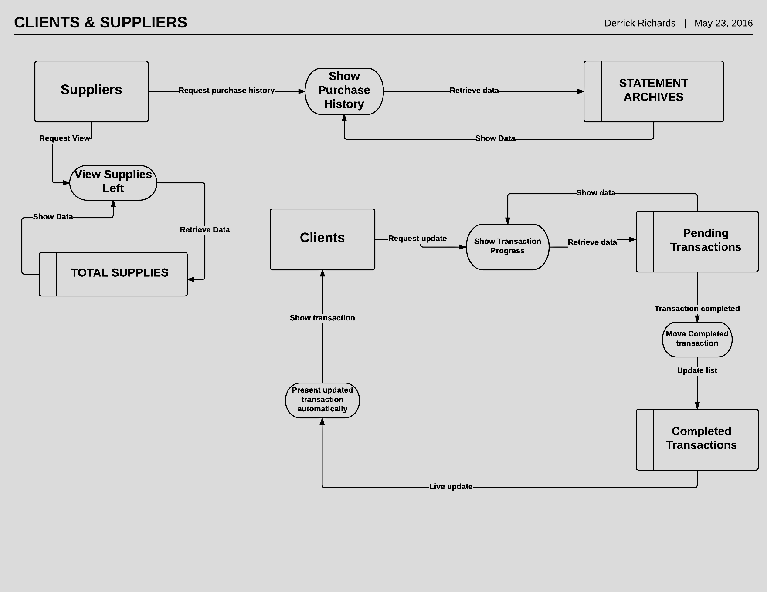

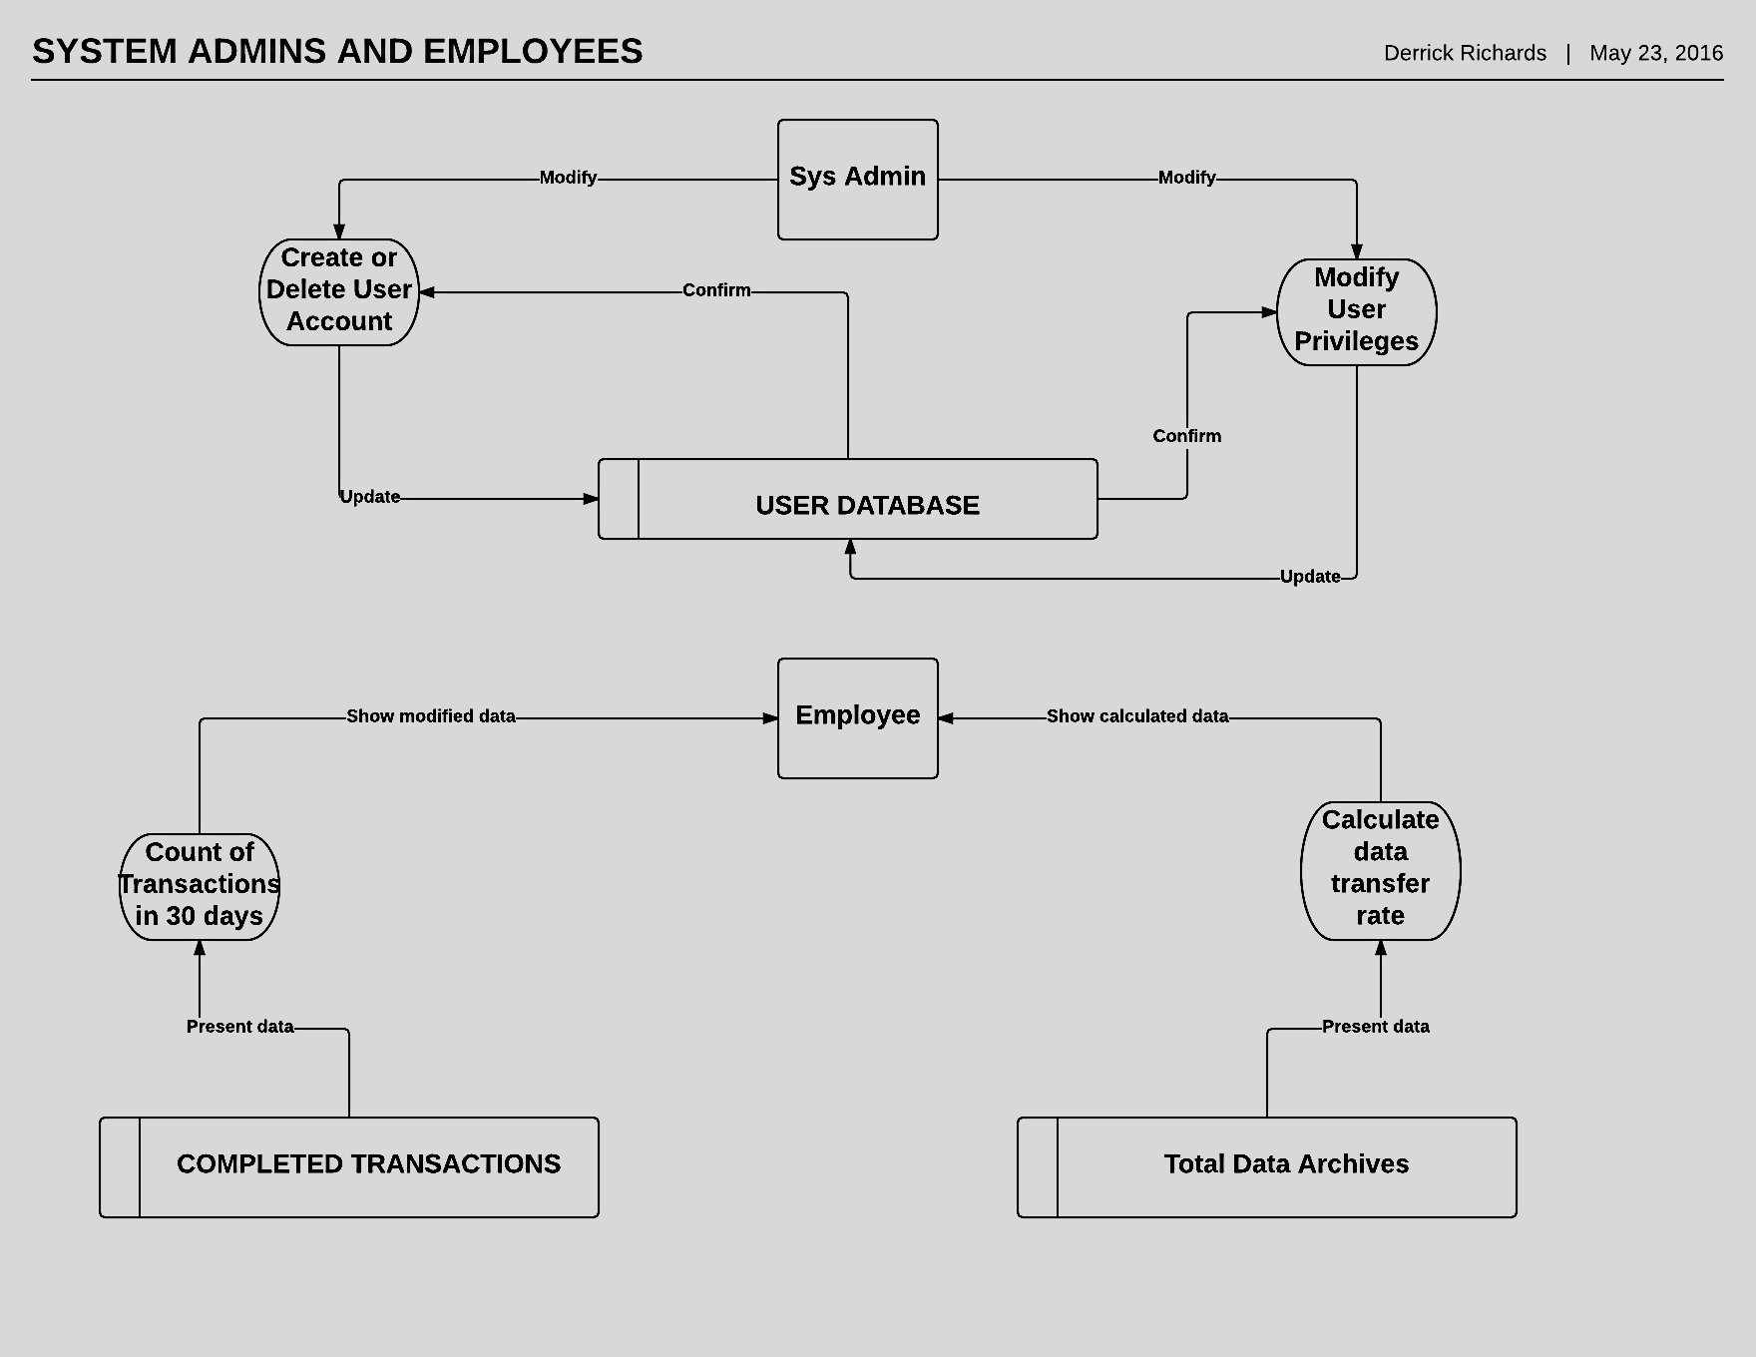

**Decision Analysis**

***Technical Feasibility***- The new system being created uses a logon UI and pulls information from the servers for clients and suppliers alike. This project can be accomplished if we have 30-35 junior developers, 5-10 senior developers and 10 technicians working on it. The creation of these types of systems is not too complicated and Apollo systems already have the resources available to help create the system.

***Operational Feasibility***- As the underlying issue with the current system is its inability for seamless data acquisition, most if not all users of the proposed system should benefit. By making data acquisition just a click away, the company should experience a jump in productivity across the board. It should shave off unnecessary time spent for users and essentially make their work environment much less stressful.

***Economic Feasibility***- The current system does not have the capabilities needed to fully satisfy our customers. Most of the capabilities that the new system will solve were done manually by our employees, which took them away from doing their normal workloads. In regards to the creation of this new system taking away from our current workload, we have a solution for that. The third building in Manhattan that focuses on data archiving will be used as the development site as the Brooklyn branch can cover the work that was being done.

***Schedule Feasibility***- We have approximately 10-12 months to work on the system with 3 months for testing and deployment. As there are already ways to access the information that this proposed system accesses, acquiring data will not be an issue. Also, with the amount of manpower and resources available, reaching this deadline won’t be an issue.

**Physical Design and Integration**

**Client Method Signatures:** String updateProg(bool trans), String notifCompTrans( bool trans)

**Supplier Method Signatures:** String viewHist (bool purch), String supplLeft( bool suppl)

**System Admin Method Signatures:** boolmodifyUser( bool info), bool credelUser( bool info)

**Employees Method Signatures:** double transMonth( double trans), double transRate(double archives)

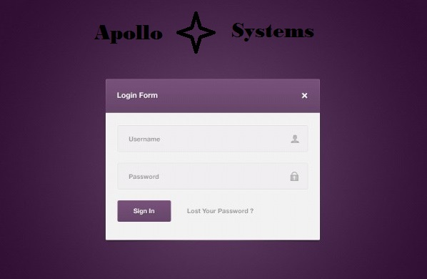

**Construction and Testing**

**Clients Processes:** Live updates on transaction progress can be tested by having a module continuously pull transaction progress until completion 100 times in a row and record its results. Another way to test it is by having a module post data for viewing and check if it’s the correct data values 100 times in a row and record its results. For immediate notifications of completed transactions, we can test it by using a module to send a notification every time data is uploaded 100 times in a row and record its results. Another way to test it is by having a module check to see if a transaction is completed continuously until completing 100 cycles and record the data.

**Suppliers Processes:** Testing the viewing of the entire history of what was purchased can be tested by continuously pulling the purchase history 100 times and checking 100 times if the pulled data for viewing matches up with the data currently in the database and recording the data for both. For testing how much of supplies we have left, we will have a module pull total supplies data 100 times and record the results. Another way to test it is for a module to test, 100 times, how much data can be posted for viewing and record the results.

**System Administrator Processes:** Modifying users privileges can be tested by having a module modify privileges on a dummy account and verify the changes and testing modified user privileges on a protected data store to see if it can access it. The test would be run 100 times and the results recorded. To test the creation and deletion of account, a module would create a dummy account 100 times and delete the dummy account 100 times and record the results.

**Employees Processes:** Modules can be created that continuously post counts for transactions for the past 30 days until 100 cycles are completed and pulling data from past the 30 day period and negating it 100 times over and recording the results for both. For testing of the total data transfer rate, modules can be created to continuously post pulled data from the data archives for 100 cycles and pulling data from past the 30 day period and negating it 100 times over and recording the results for both.

**Installation and Delivery**

The system being set up will be designed in house in direct connection to Apollo Systems servers. After successful testing, the software will be installed by field technicians to the rest of Apollo Systems sites, as well as client’s and supplier’s sites. The software can be installed without physically being there.

After our system admins and technicians set up a client’s user account, they should be able to login and access certain portions of the system. Once they log in and their credentials are verified, they will immediately get notifications of any recent completed transactions. After that, they can request a live update for any pending transactions.

After our System admins and technicians set up a supplier’s user account, they should be able to

login and access certain portions of the system. After their credentials are verified, they can request

to view an entire history of what Apollo Systems has purchased from them. They would also be able

to request to see how much of their specific supplies we have left.

Our System Administrators will be able to control all aspects of a user’s account. By granting access

to certain user’s, certain portions of data can be made available to said user’s. They can also use the

new system to create new accounts for new users or delete accounts for users that aren’t relevant to

Apollo Systems.

Employees of Apollo Systems will use the system to make their work days much easier. By accessing

the system, they can use its capabilities to automatically do transaction reports and view data rate

transfer from the data archives. Both of these capabilities would take considerable time to do and

usage of the system will increase productivity as the employees will have more time to focus on

other things.