Much of the hardware in astronauts’ inventory of custom tools are actually modified versions of common tools[1](https://www.nasa.gov/mission_pages/hubble/servicing/series/cats.html).

* sockets
* socket extender bars
* handheld temperature sensor
* handheld infrared camera

*Specialty Tools*

**Pistol Grip Tool (PGT)**

Half drill-driver,half ratcheting torque wrench

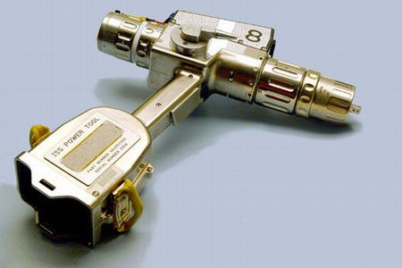

**Tool Bag**

Box which folds up and can be stored in the shuttle’s mid-deck locker that astronauts can fill up with tools for any task.

**Handheld Paddle**

About the size of a ping-pong paddle which holds the patching material for repairing cracks.

**Modified Mini-Workstation Tool Stowage Caddy (MMWS)**

Tool belt designed to easy space use. It wraps around the astronaut and has retractable tethers with clips that attach to the tools. Prevents tools from floating away.

**Tools used to service NASA’s Hubble Space Telescope**

* (Right) Pistol Grip Tool
* (Foreground) Card extraction and insertion tools for electronic cards
* (Top Center) Pistol Grip Tool - plastic version
* (Center Left) Bit Caddy

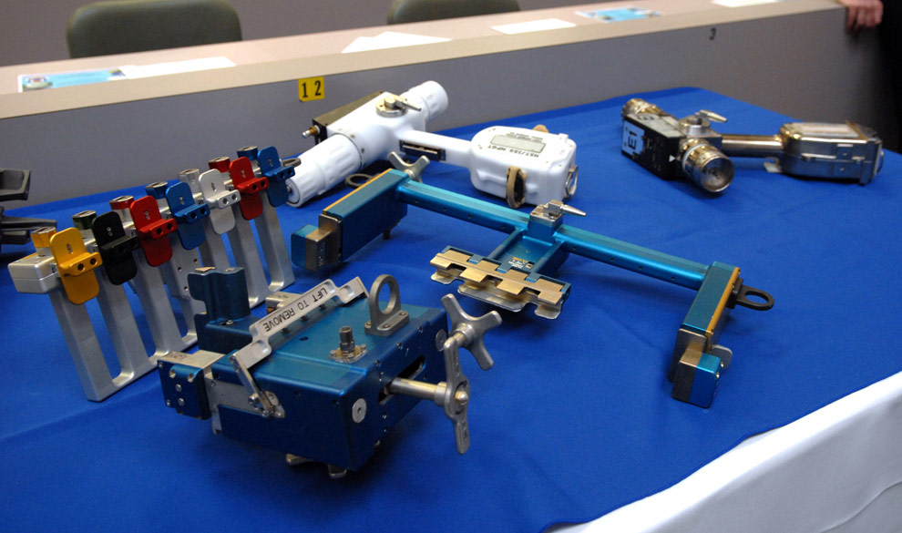

**Mini Power Tool** (a.k.a Drill)

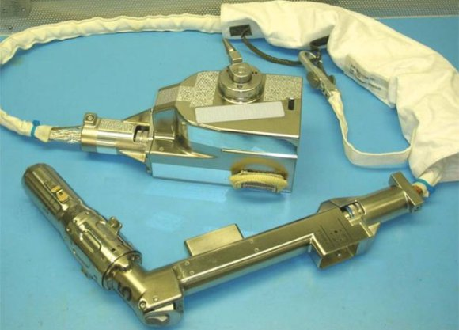

**Rate Sensing Units Changeout Tool**

Special tool to remove old insulation from the telescope so that new protective thermal insulation could be installed. Can reach inside the telescope without entering it and capture and restrain a sensor unit by pulling a trigger.

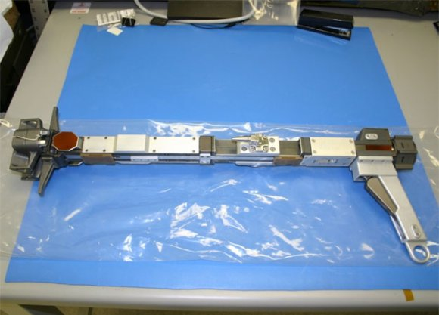

**Battery Extractor**

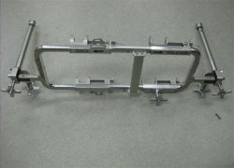

**EVA Tools and Equipment Reference Book**

<http://ssco.gsfc.nasa.gov/documents/5_EVA_Tools_and_Equipment_Reference_Book_Nov_83.pdf>

**Modified Mini-Workstation Tool Stowage Caddy (MMWS)**

<http://www.cram.com/flashcards/eva-small-tools-1320426>

*Modular Baseplate Assembly*

mounting point for MMWS system components

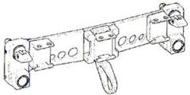

*Modular Gimbal Assembly*

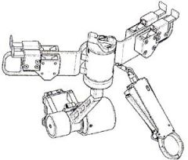

*Retracting End Effector Assembly*

capability to lock onto a handrail, tether point, or tether loops

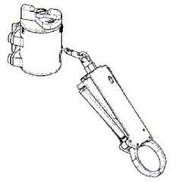

*Swing Arm Assembly*

Contains two bayonet receptacles per swing arm. Each bayonet receptacle has a slide lock to secure the equipment in the receptacle. Allows stowing hardware behind the EMU while translating and then swing the hardware out in front.

