**Week 9 Views and Triggers**

**Part 1: Views (1%)  
A** . The inventory department wants a list of low inventory items. Create a view with items that have 20 or less in stock Include category, item name and inventory

CREATE VIEW low_stock_items

AS SELECT category, item, inventory

FROM stock_items

WHERE inventory <= 20;

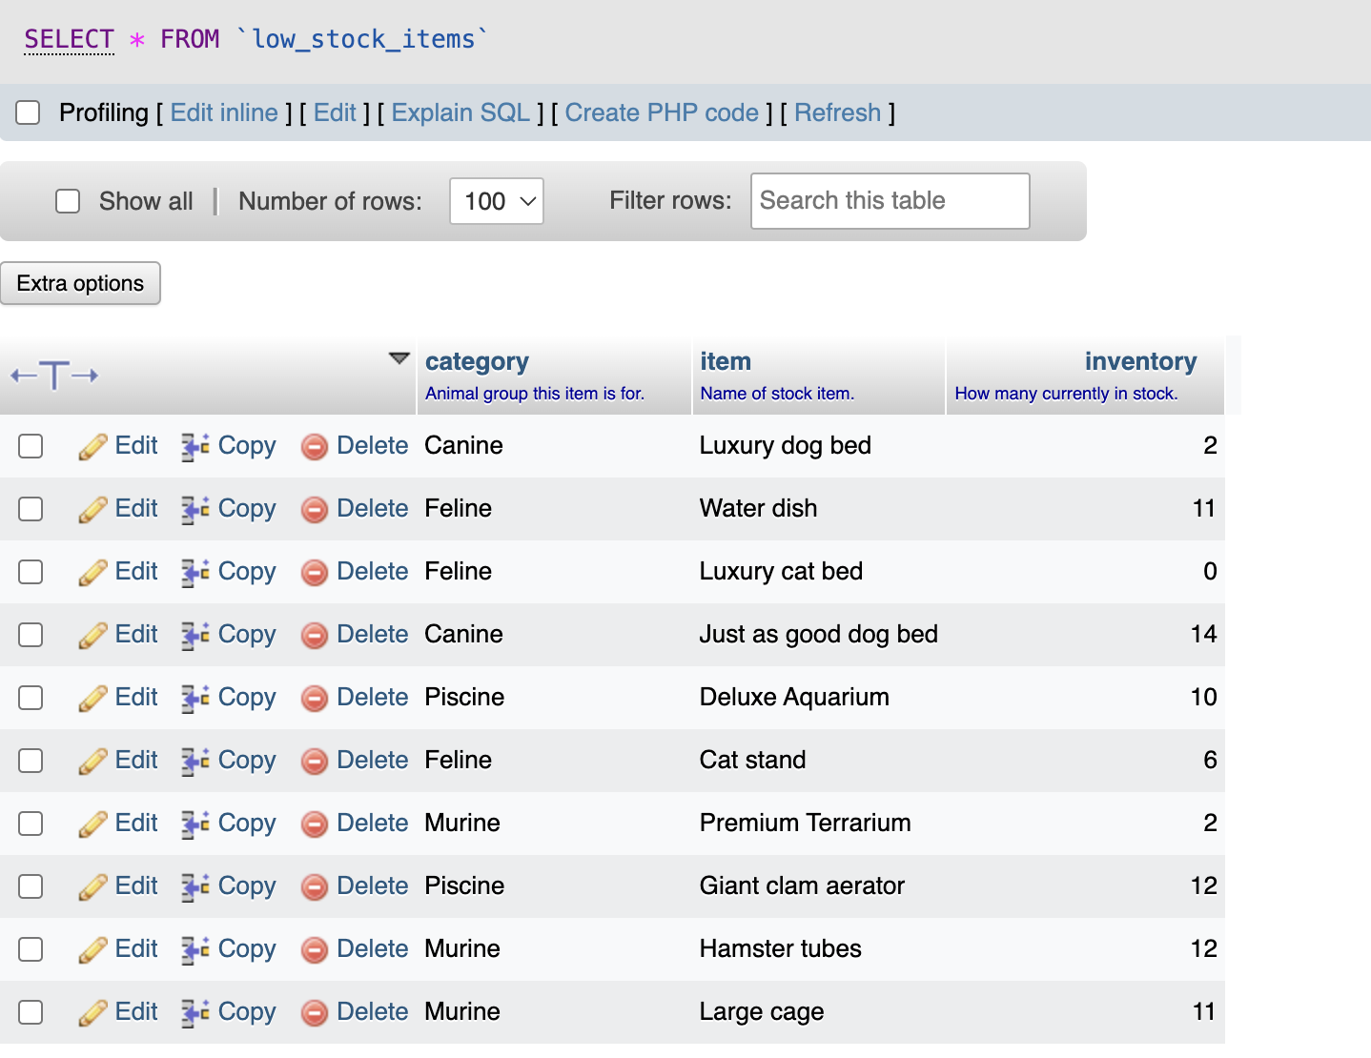

**B:** The manager has requested a list of all sales employees who have made sales. Create a view showing their name (first and last name) and total sales (in dollars) by descending order (highest sales at the top).

CREATE VIEW total_sales_per_salesperson

AS SELECT e.first_name, e.last_name,(SUM(i.price))

FROM sales s

JOIN stock_items i

ON s.item = i.id

JOIN employees e

ON s.employee = e.id

WHERE role = "sales"

GROUP BY e.first_name, e.last_name

ORDER BY SUM(i.price) DESC;

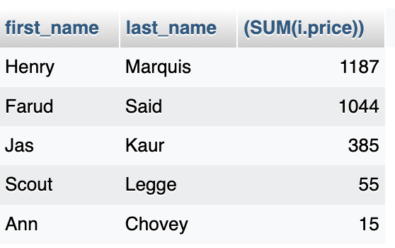

**Part 2: Triggers (1%)**

**Part A** : An update in a table will log that change in the data_log table

CREATE TRIGGER

log_employee_new

AFTER INSERT ON employees

FOR EACH ROW

INSERT INTO data_log

(timestamp, action, first_name, last_name, pay_per_hour)

VALUES (NOW(), "new hire", NEW.first_name, NEW.last_name, NEW.pay_per_hour);

INSERT INTO employees (id, last_name, first_name, sin, phone, role, email, pay_per_hour)

VALUES (120, "Turner", "Alex", 729451940, 4168291563, "Stock", "alexturner@httppetstore.com", 22.00);

**Part B** : Deleting a row in a table will log that change in the data_log table

CREATE TRIGGER

log_employee_delete

AFTER DELETE ON employees

FOR EACH ROW

INSERT INTO data_log

(timestamp, action, first_name, last_name, pay_per_hour)

VALUES (NOW(), "resignation", OLD.first_name, OLD.last_name, OLD.pay_per_hour);

DELETE FROM employees WHERE id = 120;

