This was build using of the following:

**Apache & PHP**

# PHP Version 7.4.15

XAMPP for Windows 7.4.15

<https://sourceforge.net/projects/xampp/files/XAMPP%20Windows/>

**MS SQL**

Microsoft SQL Server 2019 (RTM) - 15.0.2000.5 (X64)

Sep 24 2019 13:48:23

Copyright (C) 2019 Microsoft Corporation

Developer Edition (64-bit) on Windows 10 Pro 10.0 <X64> (Build 19043: )

<https://www.microsoft.com/en-au/sql-server/sql-server-downloads>

**Front-end framework**

Bootstrap 4.1

<https://getbootstrap.com/docs/4.1/getting-started/introduction/>

**Plug-ins**

Zebra Datepicker

<https://github.com/stefangabos/Zebra_Datepicker>

DataTables

<https://datatables.net/>

**Icons**

Font-awesome

<https://fontawesome.com/v5.15/icons?d=gallery&p=2&m=free>

**Configuring XAMPP – Apache to include the sqlsrv functions**

## Go to <https://www.microsoft.com/en-us/download/details.aspx?id=100922> to download the Microsoft Drivers 5.8 for PHP for SQL Server.

1. Run the downloaded exe file.
2. The below screenshot is the interface when you run the exe file.

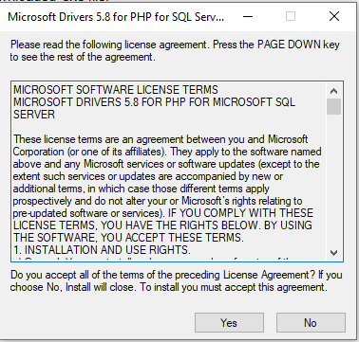

1. Click ‘Yes’ and proceed to the next and this will be the appearance.

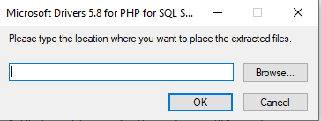

1. Then click browse, go to xampp > php > ext and extract the file.
2. Go to XAMPP Control Panel then click the apache config button the click PHP(php.ini)

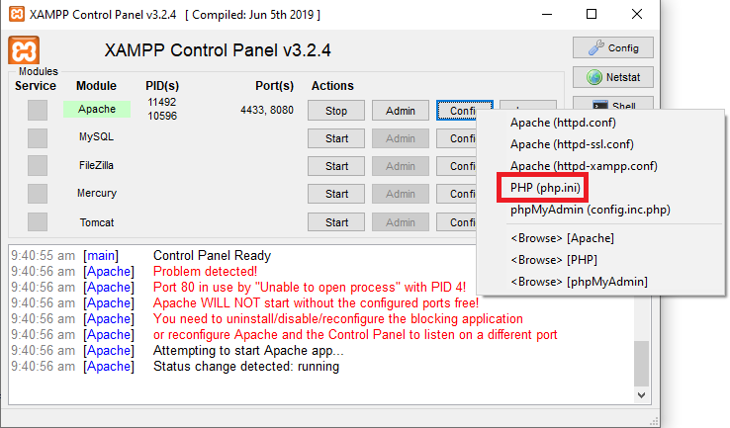

1. The php.ini file will open and append this:

extension=php_sqlsrv_74_ts_x64.dll

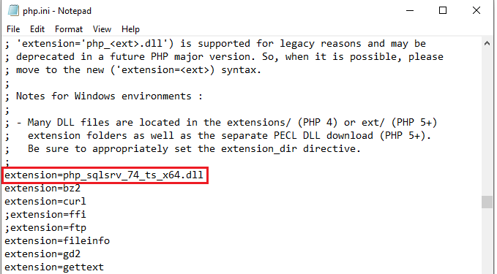

1. Save and restart the XAMPP – Apache.
2. To check if the extension is successfully added, access:

<http://localhost/dashboard/phpinfo.php>

Then find “sqlsrv”, and if found, the extension is successfully added and the MRS will be able to access the MS SQL Database through sqlsrv commands which is used in this system.

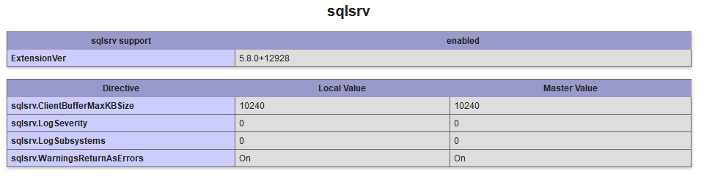

**How to run/test the system**

1. Download the zip file of this repository.
2. Open the zip file and extract the folder in xampp > htdocs.
3. Rename the folder from “MRS-main” to “MRS”.
4. Double check the XAMPP control panel if the apache is already running (started).
5. To test the system, run the following files in chronological order in the MS SQL Server Management Studio inside the SQL Folder of this repository.

* mrs_db.sql – for creation the database of the system.
* test_data.sql – for the test data, especially for login credentials
* schedule_job.sql – for the scheduled job

Important note: Please make sure that the SQL Server Agent is initiated for the scheduled job to be executed.

1. To run the system, access it via web browser and type in the URL : localhost/MRS.