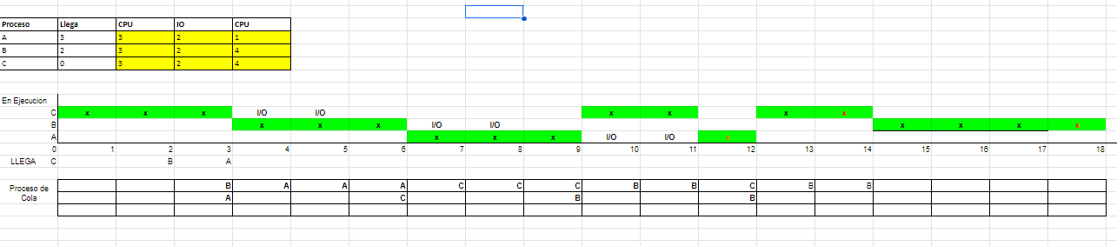

Cuando cambia el algoritmo a SJF sin desalojo sigue priorizando el proceso más corto pero hasta que no finaliza, no ejecuta otro..

| variables_compartidas a = b = 1;  semáforos mutex : mutex_a = mutex_b = 1 | | |
| --- | --- | --- |
| Proceso 1 | Proceso 2 | Proceso 3 |
| variable_local d = 1;    While (TRUE){  Wait(mutex_a);  a = a + d;  Signal(mutex_a);  d = d * d;  Wait(mutex_b);    b = b – d;  Signal(mutex_b);    } | variable_local e = 2;    While (TRUE){  Wait(mutex_b);  b = b * e;  Signal(mutex_b);  e = e ^ e;    Wait(mutex_a);  a++;  Signal(mutex_a);  } | variable_local f = 3;    While (TRUE){  Wait(mutex_a);  a = f * a;  Signal(mutex_a);  f=f+5;  Wait(mutex_b);  b=f+2;  Signal(mutex_b);  } |

a) Determine por medio del algoritmo del banquero si la configuración llega a un estado seguro.

|  | **(A)Adjudicados** | | | **(Z) Necesarios** | | |
| --- | --- | --- | --- | --- | --- | --- |
|  | **R1** | **R2** | **R3** | **R1** | **R2** | **R3** |
| P1 | 1 | 1 | 3 | 0 | 3 | 1 |
| P2 | 0 | 3 | 1 | 1 | 0 | 0 |
| P3 | 2 | 0 | 0 | 3 | 0 | 5 |
| P4 | 1 | 2 | 1 | 1 | 0 | 3 |

| RM = A + Z |  |  |  |
| --- | --- | --- | --- |
|  |  |  |  |
| RA + RD >= RM |  |  |  |
|  |  |  |  |
| Disponibles | 2 | 0 | 1 |

| P1 | | | |  |
| --- | --- | --- | --- | --- |
| RA | 1 | 1 | 3 |  |
| RD | 2 | 0 | 1 |  |
| RA+RD | 3 | 1 | 4 |  |
| >= | >= | >= | >= |  |
| RM | 3 | 2 | 2 |  |
| RESULTADO | OK | NO | OK |  |
|  |  |  |  |  |
| P2 | | | |  |
| RA | 0 | 3 | 1 |  |
| RD | 2 | 0 | 1 |  |
| RA+RD | 2 | 3 | 2 | nuevo disponible |
| >= | >= | >= | >= |  |
| **RM** | 1 | 3 | 1 |  |
| RESULTADO | OK | OK | OK |  |
|  |  |  |  |  |
| P1 | | | |  |
| RA | 1 | 1 | 3 |  |
| RD | 2 | 3 | 2 |  |
| RA+RD | 3 | 4 | 5 | nuevo disponible |
| >= | >= | >= | >= |  |
| **RM** | 3 | 2 | 2 |  |
| RESULTADO | OK | OK | OK |  |
|  |  |  |  |  |
| P3 | | | |  |
| RA | 2 | 0 | 0 |  |
| RD | 3 | 4 | 5 |  |
| RA+RD | 5 | 4 | 5 | nuevo disponible |
| >= | >= | >= | >= |  |
| **RM** | 5 | 0 | 5 |  |
| RESULTADO | OK | OK | OK |  |
|  |  |  |  |  |
| P4 | | | |  |
| RA | 1 | 2 | 1 |  |
| RD | 5 | 4 | 5 |  |
| RA+RD | 6 | 6 | 6 | Total |
| >= | >= | >= | >= |  |
| **RM** | 2 | 2 | 4 |  |
| RESULTADO | OK | OK | OK |  |

P2- P1-P3P4 Estado Seguro

b) Elabore el diagrama de grafos en función de las siguientes matrices.

