Prepared for:

**Centers for Medicare & Medicaid Services and Office of the National Coordinator for Health Information Technology**

**CMS Alliance to Modernize Healthcare  
Federally Funded Research and Development Center**

Technical Authority for the Unified Clinical Quality Improvement Framework

Bonnie User Guide

Initial Draft

Version 0.2

April 13, 2015

The views, opinions, and/or findings contained in this report are those of   
The MITRE Corporation and should not be construed as official government position, policy, or decision unless so designated by other documentation.

This document was prepared for authorized distribution only. It has not been approved for public release.

© 2015, The MITRE Corporation. All Rights Reserved.

Record of Changes

| Version | Date | Author / Owner | Description of Change |
| --- | --- | --- | --- |
| 0.1 | April 15, 2014 | Andre Quina / MITRE | Initial draft |
| 0.1.1 | July 18, 2014 | Cristen Jones / MITRE | Update for Bonnie v 1.1 |
| 0.2 | April 13, 2015 | Cristen Jones / MITRE | Update for Bonnie v 1.3 |
|  |  |  |  |
|  |  |  |  |
|  |  |  |  |
|  |  |  |  |
|  |  |  |  |
|  |  |  |  |
|  |  |  |  |
|  |  |  |  |
|  |  |  |  |
|  |  |  |  |
|  |  |  |  |
|  |  |  |  |
|  |  |  |  |
|  |  |  |  |
|  |  |  |  |
|  |  |  |  |
|  |  |  |  |
|  |  |  |  |
|  |  |  |  |
|  |  |  |  |
|  |  |  |  |
|  |  |  |  |
|  |  |  |  |
|  |  |  |  |
|  |  |  |  |

Table of Contents

1. Introduction 5

1.1 Background 5

1.2 Purpose 5

1.2.1 Application Description 5

2. User Account Creation 7

2.1 Login Page 7

2.2 Creating a New User 7

2.3 Resetting a Password 8

2.4 Account Management 9

3. Measure Dashboard 10

3.1 Overview 10

3.2 Loading a New Measure 11

3.3 Updating a Measure 12

3.4 Creating Synthetic Test Records 13

4. Measure Results View 14

4.1 Overview 14

4.2 Measure Logic 15

4.3 Creating a New Test Record 15

4.4 Calculation Results 16

4.5 Editing a Test Record 18

4.6 Cloning a Test Record 19

4.7 Deleting a Test Record 19

4.8 Sharing a Test Record 19

4.9 Updating a Measure 19

4.10 Deleting a Measure 19

5. Building a Patient Test Record 20

5.1 Overview 20

5.2 Building a Synthetic Patient 21

5.3 Building the Patient History 22

5.3.1 Representing a Cumulative Medication Duration 24

5.4 Incremental Calculation 25

6. Importing Patients from the Patient Bank 26

6.1 Overview 26

6.2 Filtering Patient Results 27

6.3 Using Test Patients 28

7. Additional Tools 30

7.1 Complexity and Change Dashboard 30

8. Feedback and Support 33

9. Frequently Asked Questions 34

List of Figures

Figure 1. Bonnie Login Page 7

Figure 2. Account Registration Page 8

Figure 3. Password Reset Page 8

Figure 4. Account Management Page 9

Figure 5. Measure Dashboard View 11

Figure 6. New Measure Dialog 12

Figure 7. Finalize Measure Dialog 12

Figure 8. Updating Measure Dialog 13

Figure 9. Measure View 15

Figure 10. Expanded Results View 17

Figure 11. Logic Calculation Highlight – Passing Results 17

Figure 12. Logic Calculation Highlight – Failing Results 18

Figure 13. Patient Builder View 21

Figure 14. Building Patient History, including Edit Clinical Element View 22

Figure 15. Editing a Medication 24

Figure 16. Patient Bank View 26

Figure 17. Patient Listing Example 27

Figure 18. Example Filter Usage 28

Figure 19. Patient Result Details 28

Figure 20. Selected Patients 29

Figure 21. Selecting Sets of Measures to Compare 30

Figure 22. Complexity Graph 31

Figure 23. Complexity Grid 31

Figure 23. Measure Complexity Change Details 32

Figure 25. Measure Difference Sorted by Size 32

# Introduction

## Background

Bonnie is a software tool that allows Meaningful Use (MU) Clinical Quality Measure (CQM) developers to test and verify the behavior of their CQM logic. The main goal of the Bonnie application is to reduce the number of defects in CQMs by providing a robust and automated testing framework. The Bonnie application allows measure developers to independently load measures that they have constructed using the Measure Authoring Tool (MAT). Loading the measures into Bonnie converts the measures from their Extensible Markup Language (XML) eSpecifications into executable artifacts and measure metadata. The measure metadata is then used to allow developers to rapidly build a synthetic patient test deck for the measure using the clinical elements defined during the measure construction process. By using measure metadata as a basis for building synthetic patients, developers can rapidly and efficiently create a test deck for a measure. The Bonnie application helps measure developers execute the measure logic against the constructed patient test deck and evaluate whether the logic aligns with the intent of the measure.

Bonnie has been designed to integrate with the nationally recognized data standards the Meaningful Use program uses for expressing CQM logic for machine-to-machine interoperability. This integration provides enormous value to the CQM program and federal policy leaders and stakeholders: this software tool verifies that the new and evolving standards for the Meaningful Use CQM program are flexible and can be implemented in software.

Bonnie was also designed to provide an intuitive and easy-to-use interface based on feedback from the broader measure developer community. A key goal of the Bonnie application is to deliver a user experience that provides an efficient and intuitive method for constructing synthetic patient records for testing and validating CQMs.

Finally, the Bonnie software is freely available via an Apache 2.0 open source license. The Meaningful Use program makes all or parts of the Bonnie software available for inspection, verification, and even reuse by other government programs or federal contractors.

## Purpose

The purpose of this document is to describe the functionality of the Bonnie web application that allows measure developers to test and verify the behavior of their CQM logic. This document provides Bonnie users with step-by-step instructions for testing CQMs by building synthetic patient records.

### Application Description

The Bonnie application provides the capability to import measures defined in Health Quality Measure Format (HQMF) XML. The HQMF specification provides the metadata and logic that describe the specifics of calculating a CQM. The Bonnie application can load the HQMF describing a measure and programmatically convert the HQMF specification into an executable format that allows calculation of the measure directly from the specification.

The CMS Measure Authoring Tool (MAT) is the primary source for HQMF documents the Bonnie application uses. Measure developers use the MAT to build CQMs and export those measures as measure bundles containing both the HQMF and value sets used as part of calculation. These measure bundles can be downloaded from the MAT and loaded into the Bonnie user interface for measure testing.

Once a CQM has been loaded into the Bonnie application, a user can inspect the measure logic and then build synthetic test records and set expectations on how those test records will calculate against a measure. This capability to build synthetic test patient records, set expectations against those records, and calculate the measures using those patient records provides an automated and efficient testing framework for CQMs. Using the Bonnie-supported CQM testing framework allows measure developers to more clearly understand the behavior of the measure logic and validate that the measure logic encodes their intent, and allows for multiple iterations of measure updates to be validated against a test deck. In addition, the development of a test deck as part of measure development provides benefits after the measures are finalized. The test deck build as part of measure development can be used to demonstrate the intent of the measure though the use of patient examples included in the test deck. Furthermore, the test deck provides systems that implement the measures with a means to validate the development of their systems. This validation is provided as a base set of synthetic patient records with known expectations for calculating against the implemented measures. Finally, the test deck could be used to inform the Meaningful Use certification program.

# User Account Creation

## Login Page

Users require a valid account to access the Bonnie application. All measures loaded into the Bonnie application and all synthetic test patients are isolated by account. Therefore, users can only view, access, and modify data that they have loaded under their own account. Figure 1 shows the login screen for the Bonnie application. To log in, a user must provide the email address and password for a valid account.

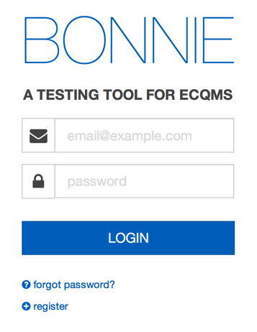

Figure 1. Bonnie Login Page

## Creating a New User

A user can create a new account by clicking the “Register” link on the login page. The register link brings the user to the account creation page (Figure 2). A user can create a new account by filling out the fields in the registration form and clicking the “Register” button. Once an account has been created, the user can log in to the Bonnie application with the email address and password specified as part of account creation.

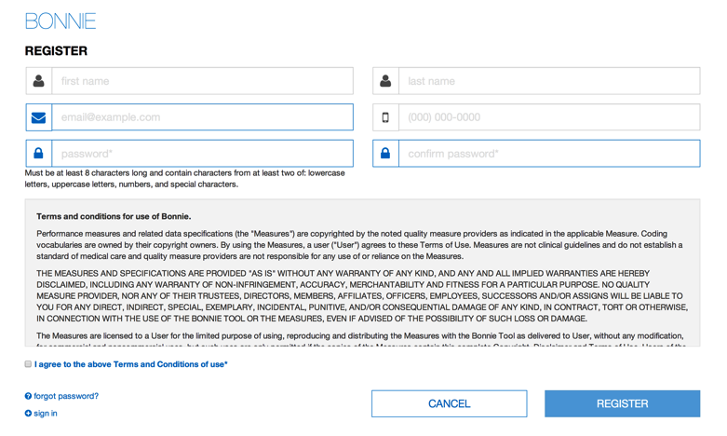

Figure 2. Account Registration Page

## Resetting a Password

In the event that a password is forgotten or an account is locked, the user can reset the password using the password reset page. This page is accessed from the “Forgot Password?” link on the login page (Figure 1). On this page, the user can provide the email address associated with the account and then press the “Send” button. This action will send an email to the registered email address for the account to allow the user to reset the account’s password.

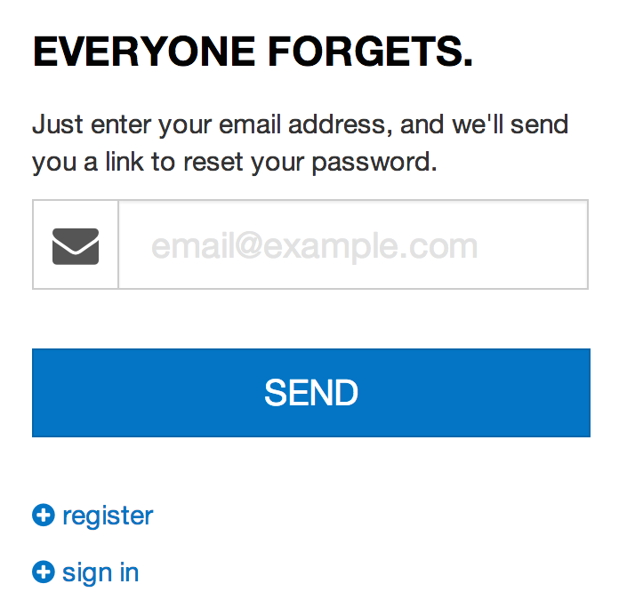

Figure 3. Password Reset Page

## Account Management

Once a user has logged into the application, the user can change the information associated with their account by accessing the account management page (Figure 4). The account management page can be opened by clicking the “Account” link in the application header (shown in Figure 5 and labeled as user interface element number 9). The account management page allows the user to change the information provided during the registration process and select a new password for their account.

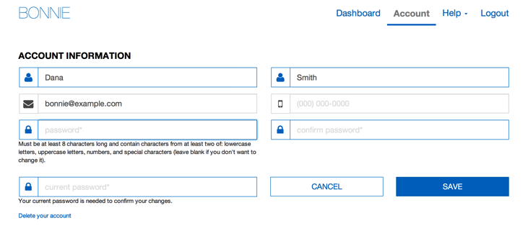

Figure 4. Account Management Page

# Measure Dashboard

## Overview

The Measure Dashboard page, as shown in Figure 5, is the initial page presented to users when they log into the application. This page displays the set of measures the user currently has loaded into the system along with the subpopulations and stratifications associated with the measures.

The Measure Dashboard shows the calculation status of each measure loaded into the system. The calculation status shows how many patients have been built for the measure, whether the measure is currently passing or failing, and how many patients are passing or failing for each measure. The Measure Dashboard also allows users to navigate to the details of individual measures, upload a new measure, or update the definition of an existing measure.

The Measure Dashboard View employs the following user interface (UI) elements (indicated by their item numbers in Figure 5):

1. Header – Allows the user to navigate to different parts of the application, access account information, send a support email (Contact), and log out of the application.
2. Measure Period Date – Displays the measurement period used for calculating measures.
3. Measures Download Button – Allows the user to download a bundle containing all of their measures.
4. Upload Button – Allows the user to upload a new measure.
5. Expected Column – Displays the percentage of passing patients for the measure.
6. Status Column – Displays the current status of the measure (New, Pass, Fail)
7. Test Patient Column – Displays the number of patients passing out of the total number of patients.
8. Measure Title – Displays the title for the measure and allows navigation to the measure view.
9. Subpopulation and stratification titles – Displays the titles for subpopulations or stratifications of a measure.
10. Edit Title Button – Allows the user to rename a subpopulation or stratification.
11. Update Button – Allows the user to update a previously loaded measure.
12. Add Patient Button – Allows the user to start building a new patient for a measure.

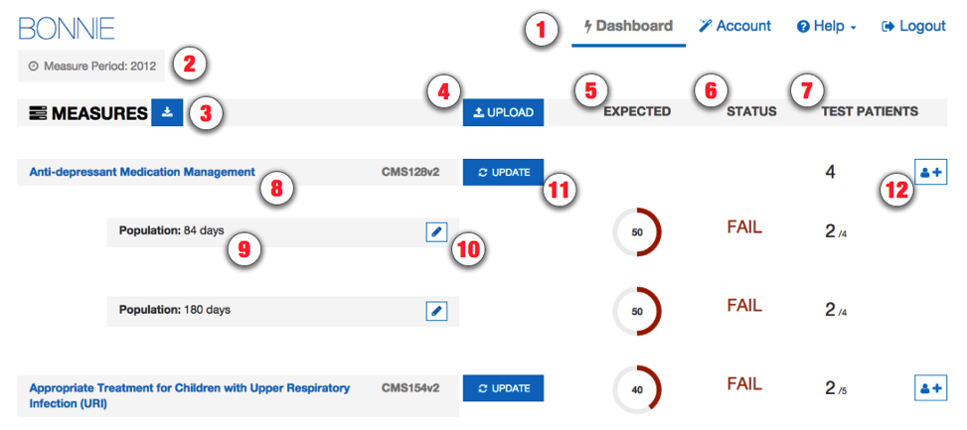

Figure 5. Measure Dashboard View

## Loading a New Measure

When a user logs into the system for the first time, there will be no measures associated with the account. The user’s first step is to load a measure into the account to begin testing the measure with the Bonnie application.

The steps for loading a new measure are:

1. Click the “Upload” button (item #4) on the Measure Dashboard, which opens the New Measure Dialog.
2. On the New Measure Dialog (Figure 6):
3. Choose a MAT export zip file.
4. Specify if the measure is eligible professional (EP) or eligible hospital (EH).
5. Specify if the measure is Patient-based or Episode of Care.
6. Click the “Load” button.

The action of clicking the “Load” button in the New Measure Dialog uploads the measure to the application for processing. If the measure loaded is episode of care or has multiple populations, the user is presented with the Finalize Measure Dialog (Figure 7). This dialog allows the user to specify the episode(s) of care for the measure and provide titles for subpopulations. Once the Finalize Measure fields have been filled out, the user clicks the “Done” button to finish loading the measure. Once measure loading is complete, the user is taken to the Measure Dashboard (Figure 5) with the new measure available. If the measure is not episode of care or does not have subpopulations, the user will not be presented with the Finalize Measure Dialog because no additional information is required to load the measure.

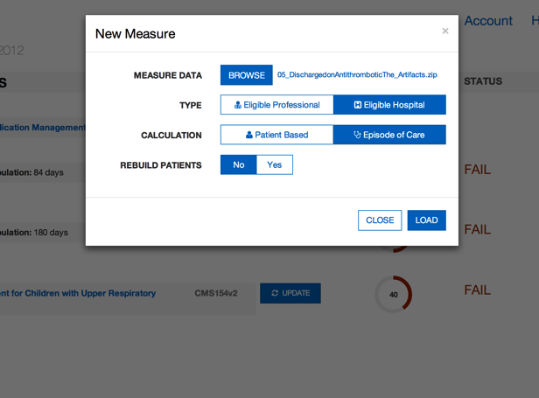

Figure 6. New Measure Dialog

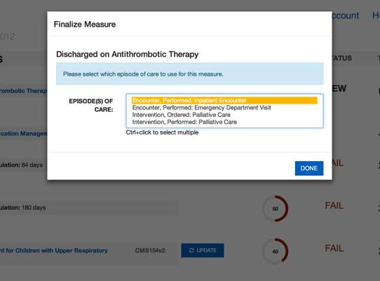

Figure 7. Finalize Measure Dialog

## Updating a Measure

Once the measure has been loaded, the testing process may identify issues with the measure. When issues are identified, the logic must be updated in the MAT to resolve these issues. Alternatively, the measure could be updated in the MAT as part of an annual update. Once a measure has been updated in the MAT, it may be necessary to update that measure in Bonnie for testing. To update a measure, follow these steps:

1. Click the “Update” button (#11) on the Measure Dashboard, which displays the “Update Measure” dialog (Figure 8).
2. Select a new MAT export zip with the updated measure definition.
3. Update the episode of care if it has changed.
4. Click the “Load” button to load the new version of the measure.

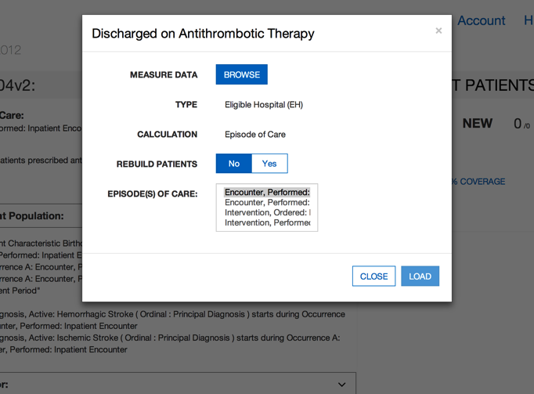

Figure 8. Updating Measure Dialog

## Creating Synthetic Test Records

Once a set of measures has been loaded into the Bonnie application, users can start building test patients for the measures. To build a test patient from the Measure Dashboard (Figure 5), click the “Add Patient” button (item #12 in Figure 5). This action opens the patient builder (see Figure 13). For more information, go to Section 5, *Building a Patient Test Record*.

After the user creates synthetic test patients for measures, the Measure Dashboard will display summary calculation results of the patients associated with each measure loaded by the user (Figure 5). As shown in Figure 5, UI elements #5, #6, and #7 on the Measure Dashboard provide the summary results for each measure. In the “Expected” column (item #5), the UI displays the percentage of patients associated with the measure whose calculated values meet the expectations set for the patient. The “Status” column (item #6) indicates the current state of the measure—whether it is passing, failing, or new. A measure is in the passing state if all associated patients are meeting expectations. If one or more patients are not meeting expectations, then the measure is in a failing state. Any measure that does not have patients associated with it is in the new state. Finally, the “Test Patients” column (#7) displays the number of passing patients over the total number of patients as a fraction. The measure view, as represented in Figure 9 in Section 4, shows more detailed results for a measure.

# Measure Results View

## Overview

As shown in Figure 9, the Measure View page displays the detailed information, associated patients, and calculation results for a single measure. The Measure View allows the user to add new patients to a measure, update a measure, and delete a measure. To access the Measure View, click on the “Measure Title” link (#8) on the Measure Dashboard, as shown in Figure 5.

The Measure View page presents the title and description of the measure along with the logic for the measure. A measure for measure complexity is shown as well. The page also lists the current set of test patients associated with the measure in the column on the right-hand side of the page. This column displays the summary calculation results for the patient test deck associated with the measure along with the list of patients and the individual calculation results for each. This page shows the results of calculation for a single patient along with an overlay of the calculation results on the measure logic.

The Measure View page employs the following UI elements (indicated by their item numbers in Figure 9):

1. Measure Title – Displays the title and description of the measure.
2. Measure Actions – Allows the user to delete or update a measure definition, or activate an alternate view of the measure logic.
3. Measure Complexity – Indicates how complex the measure is.
4. Measure Subpopulations or Stratifications – Allows access to different subpopulations or stratifications in the measure.
5. Measure Logic – Displays a representation of the logic for the measure.
6. Logic Highlighted With Coverage – Displays the logic for the measure highlighting which lines of the measure are covered by the test patients.
7. Patient Actions – Allows the user to export patient records and access the Patient Bank.
8. Percent Successful – Displays the percent of patients currently meeting expectations for the measure.
9. Patients Passing Count – Displays the current number of patients meeting expectations over the total number of patients in the test deck for the measure.
10. Test Coverage – Displays the percentage of the measure logic that has evaluated to true for the patient test deck. This measure provides a method for determining how much of the logic has been tested.
11. Add Patient Button – Allows the addition of a new patient to the test deck for this measure.
12. Failing Patient – An example of a patient that is not currently meeting expectations for the measure.
13. Passing Patient – An example of a patient that is meeting expectations.
14. Patient Name – Displays the name given to the patient.
15. Patient Status – Displays PASS or FAIL to indicate if the patient is meeting expectations.
16. Expand Patient Results Button – Allows display of the calculation details of a patient. This display will show the expected and actual values for the patient against the measure.

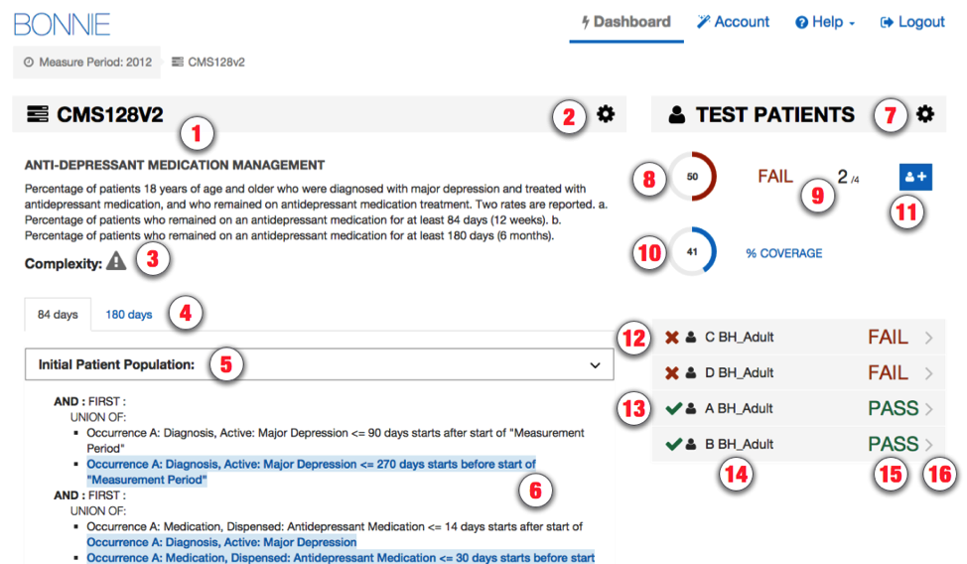

Figure 9. Measure View

## Measure Logic

The left-hand side of the Measure View contains the measure title, description, and a representation of the logic. The representation of the measure logic is similar to the human-readable display for the measure provided in the MAT measure exports. Some differences in the structure of the logic are a result of restructuring that is done while parsing the measure logic from the HQMF specification. The most notable difference is that relative timings applied to logical groups are distributed down into the statements of the logical group rather than displayed at the level of the grouping.

The measure logic section can be used to verify that the measure logic was properly loaded from the HQMF without the loss of any logical conditions. The logic can also be used to evaluate the nature of the calculation of a test patient against the logic (please refer to subsection 4.4, *Calculation Results*) and to visualize the test coverage of the measure logic.

## Creating a New Test Record

To create a new test record, begin by clicking the “Add Patient” button (item #11) in the Measure View (Figure 9). This action opens the Patient Builder (shown in Figure 13). Once a patient record has been created, the application returns the user to the Measure View where the user can evaluate the results of calculating the patient against the measure.

## Calculation Results

Once the user has constructed a test patient record, the user can calculate that patient against the logic of the measure in the Measure View (Figure 9). High-level results are calculated automatically when the Measure View is loaded. These high-level results appear under the test patients section on the right-hand side of the Measure View. These results include the percent of patients passing (item #8), the test coverage (item #10), individual statuses for each patient (items #12-16), and the passing patient count (item #9).

In addition to these high-level results, detailed results can be displayed for an individual patient by clicking the “Expand Patient Results” button (#16). This displays a table of expected and actual results for the patient covering each population listed in the measure and shows whether that population is currently meeting or failing expectations.

The Expanded Results View employs the following UI elements (as indicated by their item numbers in Figure 10):

1. Passing Population – A population for which the patient passes.
2. Failing Population – A population for which the patient fails.
3. Population Column – A list of the population types.
4. Expected Value – The user-defined expected value for the population.
5. Actual Value – The calculated value for that population.
6. Edit Patient Button – Allows editing of the selected patient.
7. Clone Patient Button – Allows cloning of the selected patient.
8. Delete Patient Button – Allows deleting of the selected patient.
9. Share Patient Button – Allows sharing the selected patient to the Patient Bank. If already shared, this will display as “Unshare” and will allow the patient to be retracted from the Patient Bank.

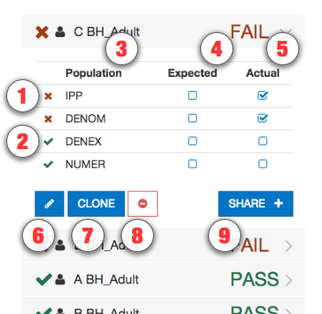

Figure 10. Expanded Results View

Clicking the “Expand Patient Results” button also displays the patient results calculated against each line of logic. This information is displayed in the measure logic section of the view by highlighting the lines of logic. As shown in Figures 11 and 12, a green highlight indicates a passing result for the logic calculation, while a pink highlight indicates a failing result over the applicable lines of text.

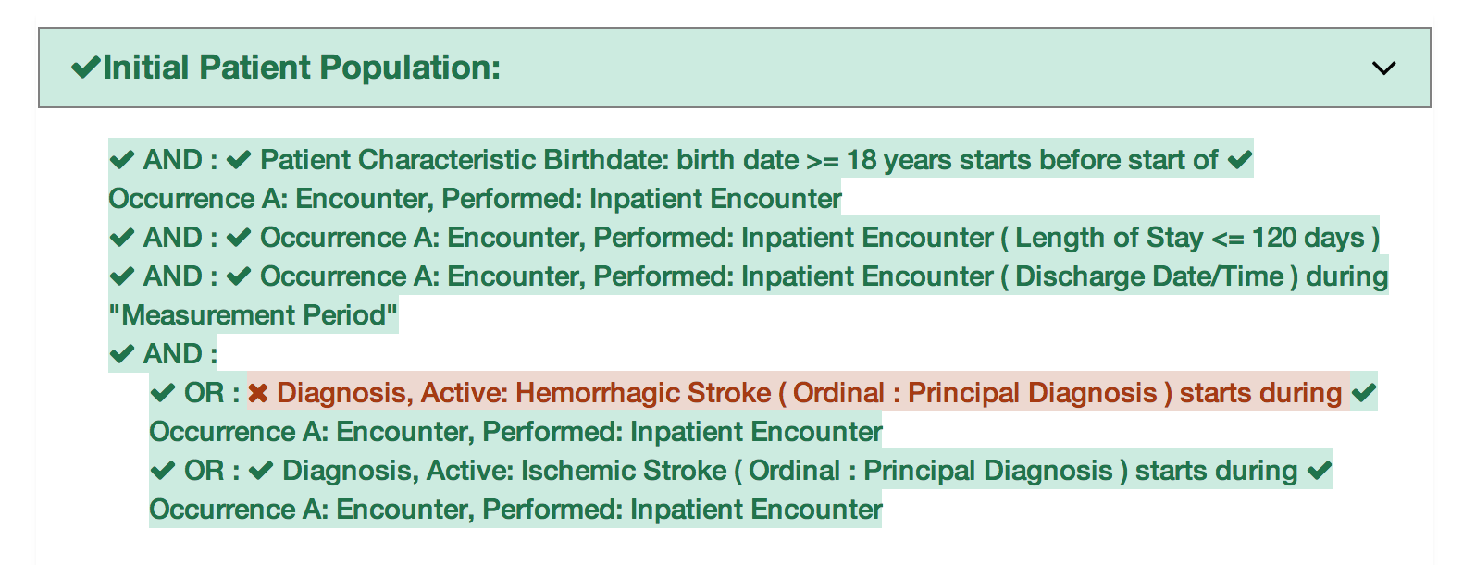

Figure 11. Logic Calculation Highlight – Passing Results

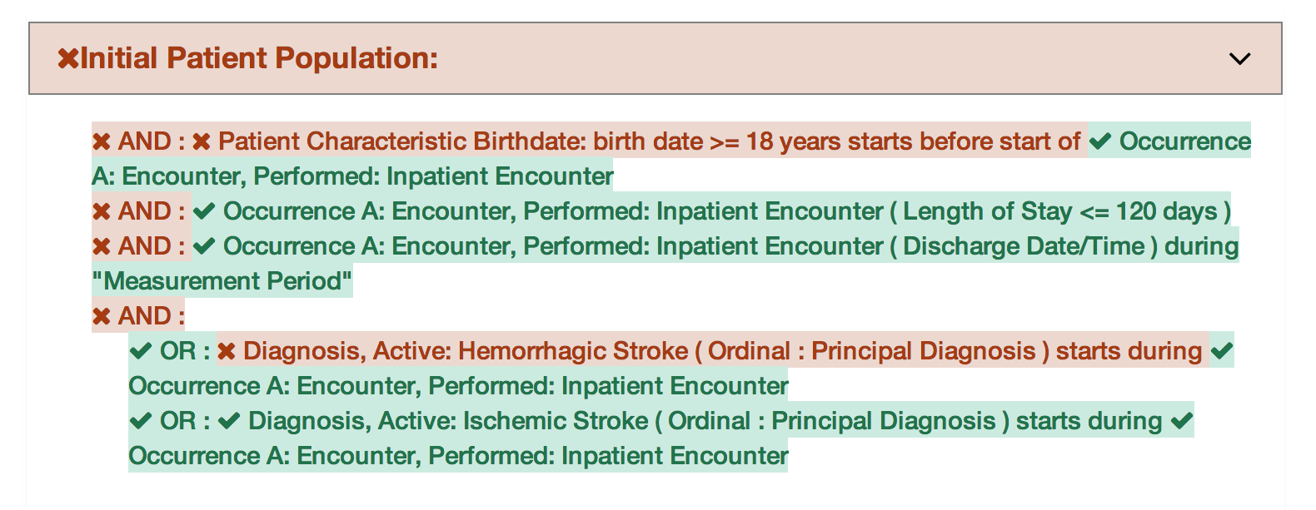

Figure 12. Logic Calculation Highlight – Failing Results

Figure 11 shows the results of a single patient calculated against the measure logic. The highlighting of the measure logic for calculation is intended to provide a clearer understanding of why a patient is calculating to a specific population. The highlighting of the logic text uses the following indications of status:

* **Logic evaluated to TRUE** – green highlighting along with a checkmark icon
* **Logic evaluated to FALSE** – pink highlighting along with an “X” icon
* **Unaligned Specific Occurrences** – pink highlighting along with a bold asterisk icon

The results of the calculation shown in Figure 11 are that the patient aligns with the logic of the initial patient population (IPP). The highlighting of the logic in Figure 11 indicates that every AND condition was evaluated to true and at least one condition from each OR was evaluated to true. Based on this calculation, the IPP evaluates to true for the patient.

In Figure 12, all the logical statements are highlighted in pink, indicating that all statements evaluate to false. Figure 12 also shows unaligned specific occurrences. This state indicates that the line of logic would evaluate to true if it were not for specific occurrences. Because all logical lines related to a specific occurrence must evaluate to true for any to evaluate to true, the line does not evaluate to true. Therefore, this third indication related to specific occurrences helps to identify which lines referencing that occurrence may cause the calculation to evaluate to false. The results calculated in Figure 12 indicate that the patient is not included in the IPP.

## Editing a Test Record

The user can edit a test patient from the Measure View (Figure 9) by clicking the “Edit” button. The user accesses the “Edit” button for a patient (item **#6** in Figure 10), accessible after expanding the patient result. Clicking the “Edit” button opens the Patient Builder (as shown in Figure 13) with the data populated for that patient. Once a patient record has been edited and saved, the application returns the user to the Measure View.

## Cloning a Test Record

The user can clone a test patient from the Measure View (Figure 9) by clicking the “Clone” button (item **#7** in Figure 10) to the immediate right of the “Edit” button. This action opens the Patient Builder (Figure 13) with the data populated for the patient being cloned. The difference between editing and cloning a patient is that the clone process creates a new patient based on an existing patient, while the edit process updates the data for an existing patient. Once a patient record has been cloned, edited, and saved, the application returns the user to the Measure View.

## Deleting a Test Record

The user can delete a test patient from the Measure View (Figure 9) by clicking the “Delete” icon (item **#8** in Figure 10) to the immediate right of the “Clone” button. Deleting a patient requires a two-step process for confirmation. Once a user deletes a patient record, the action cannot be undone. To delete a patient record, the user initially clicks the “Delete” button. A second “Delete” button is then displayed. The user must click the second “Delete” button to confirm the deletion of the patient.

## Sharing a Test Record

The user can share a test patient from the Measure View (Figure 9) by clicking the “Share” button (item **#9** in Figure 10) to the right. Sharing a patient allows that patient to be accessible to other users through the Patient Bank. If the patient is already shared, the user may use this button to stop sharing the patient. See Section 6 for more detail on the Patient Bank.

## Updating a Measure

The user can update a measure by clicking the “Update Measure” button, which is accessed by clicking the “Measure Actions” icon (**#2**). The “Update Measures” button displays the Update Measure Dialog (Figure 8), which allows the user to specify a new zip package for a measure exported from the MAT. Once the new measure package has been entered, the user clicks the “Load” button, which updates the measure definition and returns the user to the Measure View with the updated measure definition.

## Deleting a Measure

The user can delete a measure from the Measure View (Figure 9) by clicking the “Delete” icon for a measure. To access the “Delete” icon, the user clicks the “Measure Actions” icon (item **#2**). Once a user deletes a measure, the action cannot be undone. To delete a measure, the user initially clicks the “Delete” icon. A second “Delete” icon is then displayed. The user must click the second “Delete” icon to confirm the deletion of the measure. After the measure is deleted, the Measure Dashboard is displayed with the deleted measure no longer present.

# Building a Patient Test Record

## Overview

The Patient Builder view, as shown in Figure 13, allows the addition and editing of clinical data for a synthetic test patient record. The user accesses the Patient Builder view by clicking the “Add Patient” button (item #12) on the Measure Dashboard (Figure 8), or by clicking the “Add Patient,” ‘Edit,” or “Clone” buttons from the Measure View (Figure 9).

The Patient Builder view also provides fields to either add new data or edit existing data for a patient. The patient first and last name can be defined using the associated edit fields; characteristics such as gender, birthdate, race, and ethnicity can be set in the characteristics section; and Quality Data Model (QDM) elements can be added to the patient history section by dragging and dropping an individual element onto the patient history section.

In addition to defining the patient data, the Patient Builder view allows the user to set expectations on the patient using the “Expectations” section. Expectations represent how the user expects the patient being defined to calculate against the measure. The “Expectations” section will be different based on the type of measure for which the user is building the patient record. The “Expectations” section for patient-based measures provides a check box for users to select the appropriate expected populations (numerator, denominator, etc.) within which the patient will be included. The “Expectations” section for episode of care-based measures allows users to select the number of episodes of care that are expected to be included in each population using a number picker. Continuous variable measures allow users to define the expected value(s) the measure is expected to calculate for the patient.

In addition, the Patient Builder’s logic section displays the logic of the measure against which the patient test record is constructed. As data is entered, the application continuously calculates the patient against the measure logic, and the results are displayed against the measure using the logic highlighting. Subsection 4.4 provides additional information about the descriptions of the logic highlighting technique based on calculation results shown in Figures 11 and 12.

The Patient Builder View employs the following UI elements (as indicated by their item numbers in Figure 13):

1. Patient Name – Allows the entry of a first and last name for the patient record.
2. Patient Characteristics – Allows the definition of characteristics data for the patient.
3. Measure Information – Shows the description for the patient’s associated measure.
4. Expectations – Allows users to set the calculation expectation for each population of the measure.
5. Actions – Allows users to save or cancel a patient record.

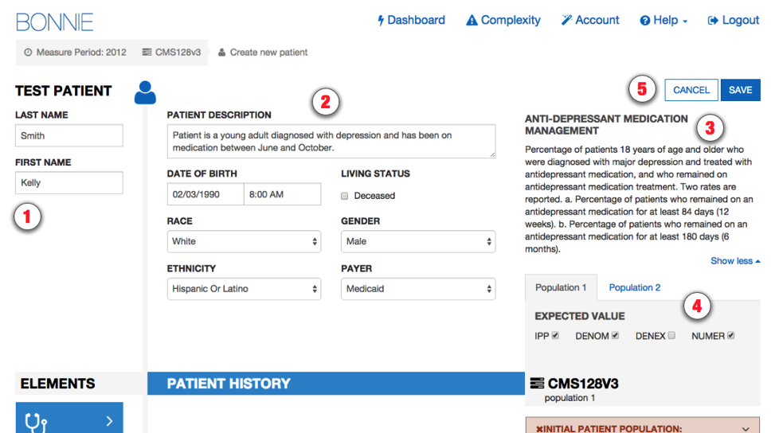

Figure 13. Patient Builder View

## Building a Synthetic Patient

The first step to building a synthetic patient record is defining the name of the patient. The patient’s first and last name can be set in the “Patient Name” section (item #1 in Figure 13). The user can then add patient notes and define patient characteristics in the “Patient Characteristics” section (item #2). Characteristics for the patient include data such as birthdate, race, ethnicity, gender, payer, and living status.

After defining the patient’s name, the user defines the expectations for how the patient will behave and be calculated against the measure. The user sets the expectations for the patient in the “Expectations” section (item #4). If the user expects the patient to align with the initial patient population logic, then the user should set that expectation in item #4. Expectations are used throughout the Bonnie application to determine if a patient is passing or failing against the measure.

If the expected results for the patient align with the actual results from calculating the patient against the measure logic, the patient passes. If the expected results do not match the actual calculated results, the patient fails. This system provides the capability to build patients and set expectations for those patients based on the intent of the measure. Once the measure is calculated, the passing state indicates that the measure logic aligns with the intent, while the failing state indicates that either the measure logic does not align with the intent or the synthetic patient was constructed improperly.

## Building the Patient History

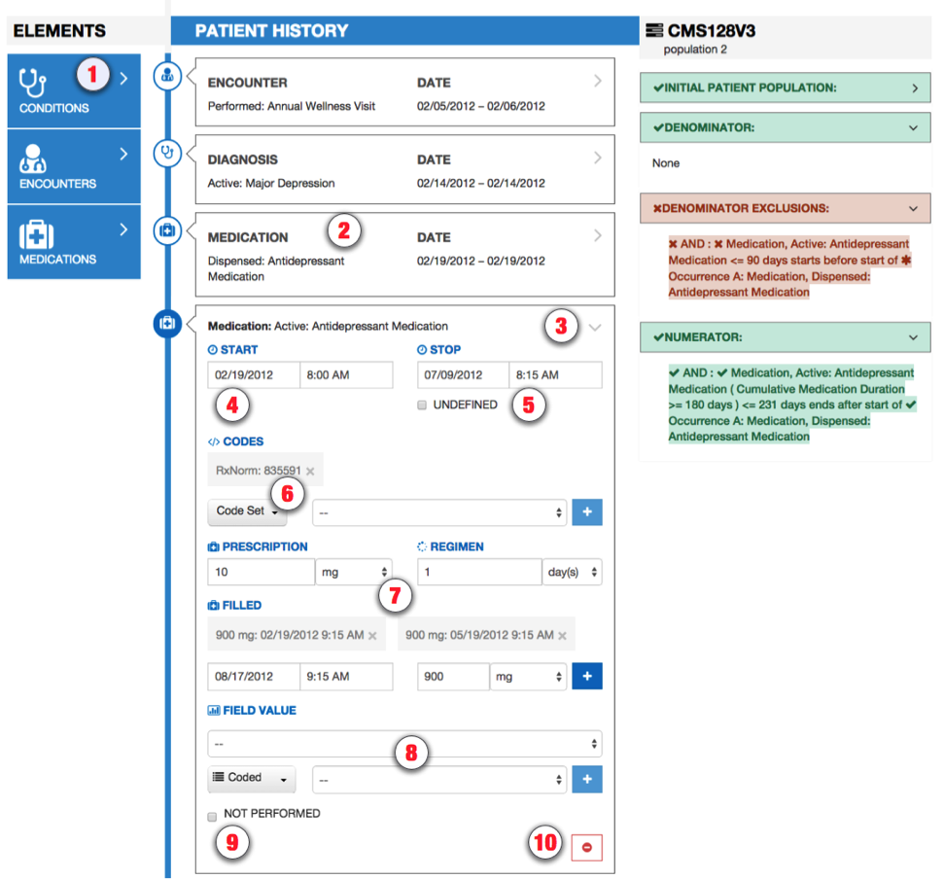

Figure 14. Building Patient History, including Edit Clinical Element View

The following UI elements are shown in Figure 14:

1. Elements Section – Contains QDM elements that the user can add to the patient history.
2. QDM Element – Shows a condensed summary of a QDM element.
3. Expand/Collapse Details – Allows hiding or expanding the details of an element.
4. Start Date/Time – Allows setting the start date/time for an element.
5. End Date/Time – Allows setting the end date/time for an element. The checkbox allows specifying that the end date/time is undefined (ongoing event).
6. Codes Section – Allows adding codes to the element. Note that Bonnie will automatically find an appropriate code and add it.
7. Medication or Value Section – Allows adding values to the element (i.e., laboratory result values). This element shows details for adding a medication, allowing the user to specify amount prescribed, regimen, amount filled, and the times the prescription was filled.
8. Fields Section – Allows adding fields to the element (i.e., ordinality).
9. Negation Section – Allows indicating that the element is not done with a reason.
10. Delete Button – Allows deleting an element from the patient history.

After the user defines the patient characteristics, the user builds a patient history from QDM elements extracted from the measure. The available elements from the measure are organized by category and listed in the “Elements” section (item #1). The user can click a category to expand the list of available elements. Expanding this list allows the user to click and drag an individual element onto the patient history (item #2).

Figure 14 depicts four events in the patient’s history—an encounter, a diagnosis, and two medications—based on data elements from the measure. When a QDM element is added to the patient history, it becomes an event in the patient’s history, which warrants a duration and associated fields. When an event is first created, it is given default start and end date/times and is associated with a code from each value set associated with the source QDM element. These defaults as well as additional data can be edited by expanding the event. Figure 14 shows an example of an expanded event from the patient history that can be edited. By clicking the expand/collapse details icon (item #3), the user can edit the details of the element.

Several fields in the Edit Clinical Element View can be edited for an event in the patient history using the controls shown in Figure 14. These fields include the start date/time of the event (items #4 and #5), codes (item #6), values (item #7), various fields (item #8), and negation rationale (item #9). The start and end date times can be set for an event by either typing into the text fields directly or by using the date/time pickers that are displayed when the field is selected. An undefined end time can be set for the event (used for active or ongoing events) by selecting the “Undefined” checkbox. Selecting the “Undefined” check box clears the end date/times, indicating that the event has not ended.

Values, fields, and negation rationale also can be set for an event. Values can be set by electing the type of the value (scalar or coded) and entering a scalar value or selecting a coded value from a drop-down listing of all the value sets associated with the measure. Fields such as ordinal, severity, discharge date/time, etc. can be added using the “Fields” section. Fields are added by selecting the type of the field (scalar, coded, or time) and entering a scalar value, selecting a value set, or entering a date.

Negation rationale can be defined for the event to indicate that the event was not done for a specific reason. Negation rationale is added by clicking the “Not Performed” checkbox in the negation section and selecting a value set representing the reason the event was not done.

Finally, events can be removed from the patient history by clicking the “Delete” icon (item #10). Deletion requires a two-step process. After initially pressing the “Delete” icon, the user is prompted to depress the “Delete” icon a second time to confirm the deletion.

### Representing a Cumulative Medication Duration

To represent a Cumulative Medication Duration (CMD), a medication is added to the patient history and the “Prescription,” “Regimen,” and “Filled” options are adjusted appropriately.

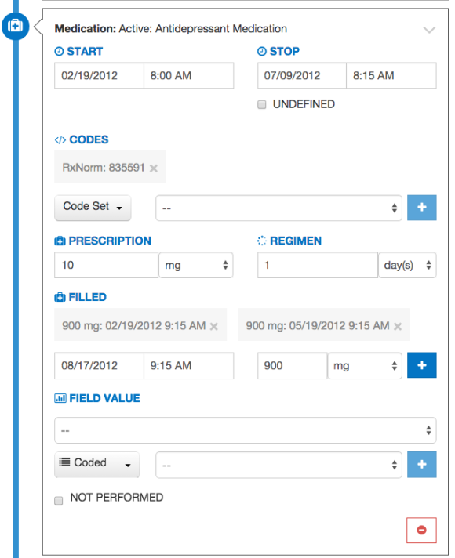

Figure 15. Editing a Medication

In the example shown in Figure 15, a prescription is specified as 10mg. This represents a single dosage of the medication. The regimen is set to 1 day(s), meaning that the single dosage is taken once per day.

The Filled section allows simulation of this prescription being filled. It takes a date, time, and amount of medication. In this example, 900mg is entered to represent a 90 day supply of this medication (based on a 10mg daily dose). Pressing the blue plus-sign button (+) will add this prescription amount.

These steps lead to a CMD of 90 days. Additional prescriptions can easily be added by pressing the plus-sign button again; once more will bring the total to 180 days, twice more to 270 days, and so on.

## Incremental Calculation

The final section of the Patient Builder View is the logic section. This section displays a representation of the logic for the measure against which the patient is constructed. The logic can be a reference to help describe the details of the data that should be added in building the synthetic patient.

The logic section continuously displays the results of calculating the patient against the measure by means of the logic highlighting described in Figures 11 and 12. Any modification made to a patient triggers a recalculation of the patient against the measure, which updates the results of the calculation displayed by the logic highlighting. Therefore, as the patient record is being constructed, the user can inspect the behavior of the logic relative to the patient.

When the user has completed constructing a synthetic patient, the user clicks the “Save” button in the Patient Builder View, which adds the patient to the test deck for the measure and returns the user to the Measure View. After the user creates the first patient, additional patients can be created from scratch or cloned from existing patients to extend the coverage of the test deck against the measure.

# Importing Patients from the Patient Bank

## Overview

As of Bonnie version 1.3, users can import test patients through the Patient Bank View. Through the Patient Bank, test patients can be shared between different user accounts and between different measures. Shared patients are accessible to anyone using Bonnie. Users can select patients from the Patient Bank for export or for cloning into their own measures. Patients imported in this manner will be copies of the original patient, so any edits made on the original patient will not affect a cloned patient and vice versa.

To use the Patient Bank, the user must first navigate to a measure. From the Measure View, the user can click the “Patient Actions” button (the gear icon on the upper right) and click the blue icon to access the Patient Bank.

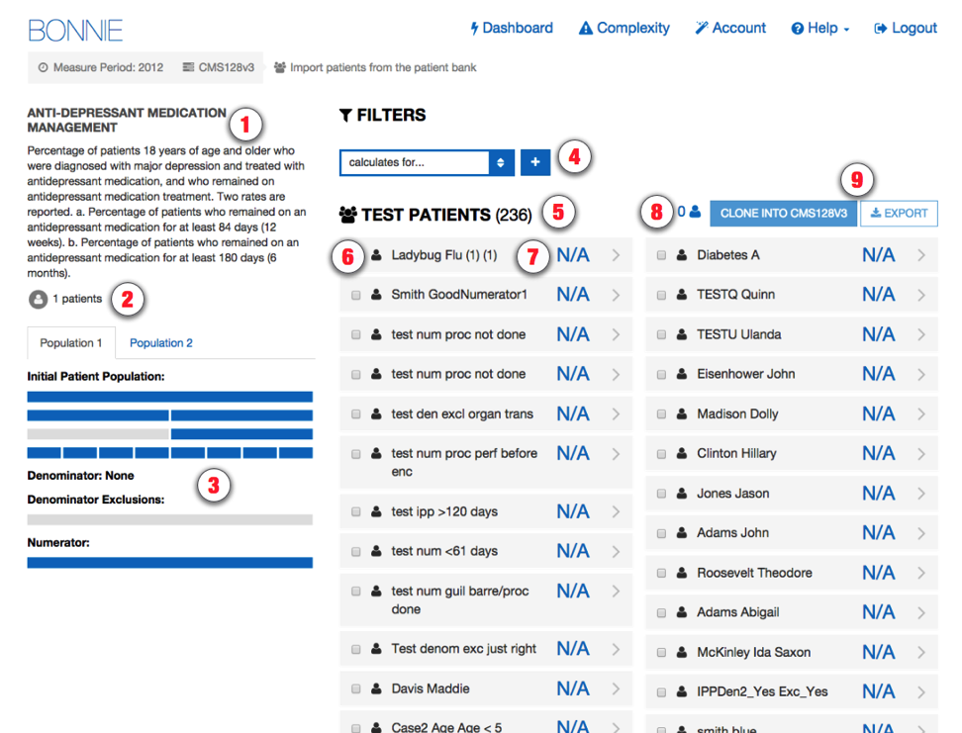

Figure 16. Patient Bank View

The Patient Bank shows all patients who have been shared across the Bonnie application. The Patient Bank View employs the following UI elements (as indicated by their item numbers in Figure 16):

1. Measure Information – Shows the name and description of the measure.
2. Measure Patient Count – Shows the number of patients in the measure.
3. Measure Logic – Shows the coverage of logic.
4. Filters – Allows filtering on the patient results.
5. Result Count – Shows the number of shared patients.
6. Patient Indicator – Indicates whether patient is already in your measure.
7. Patient Calculation Result – Indicates how the patient calculates against the measure.
8. Selected Patient Count – Shows the number of patients selected by the user.
9. Patient Bank Actions – Allows exporting or cloning of selected patients.

Note that the Patient Calculation Result (item #7) will display “N/A” rather than pass or fail if that patient was constructed for a different measure (i.e. this patient has no expectations set for this measure).

The Patient Indicator will highlight patients already in that measure with a grey enclosed icon. In the example shown below, the last patient already belongs to the user.

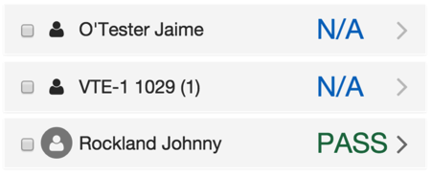

Figure 17. Patient Listing Example

## Filtering Patient Results

The Patient Bank includes powerful filtering capability to help the user find specific test patients. There is no limit to how many filters can be applied. However, the results returned only contain test patients satisfying **all** the filters applied. It is recommended to set all desired filters before selecting test patients. The user can filter the results by the following:

1. Population – Allows filtering results by whether the patient passes for a selected population for the currently displayed stratification.
2. Measure – Allows filtering results by measure. The user can enter all or part of a measure code (e.g. “CMS142v2” or “142” will both work).
3. Associated User Account – Allows filtering results by user. The user can enter all or part of an email address associated with a Bonnie user account.

Figure 18 shows the Patient Bank filtered by whether the patient passes for the measure’s numerator for the stratification named “Population 1.” This example has one result.

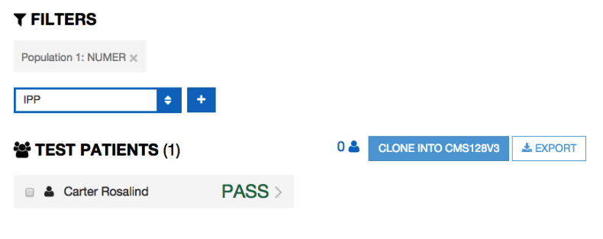

Figure 18. Example Filter Usage

## Using Test Patients

Each test patient result can be expanded to show further details on that patient. This shows the patient summary and the calculated results for that patient.

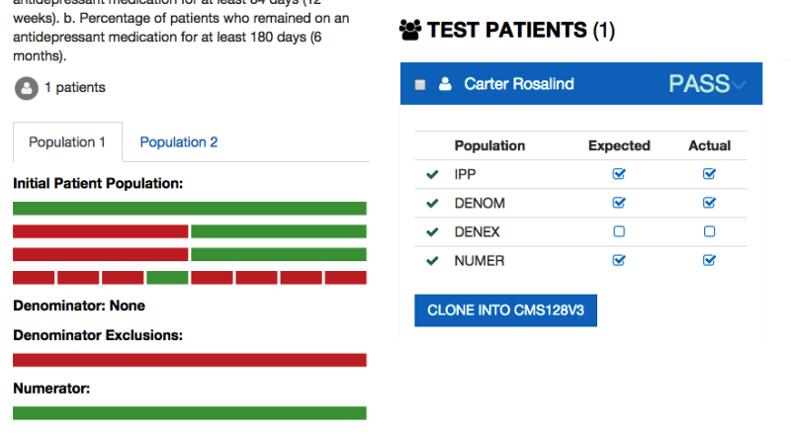

Figure 19. Patient Result Details

When the patient result is expanded, the measure logic view updates to show how the patient meets the data criteria. The patient has data criteria meeting the green lines of logic shown in the measure logic view.

The user can select one or more patients by clicking the checkbox associated with each patient.

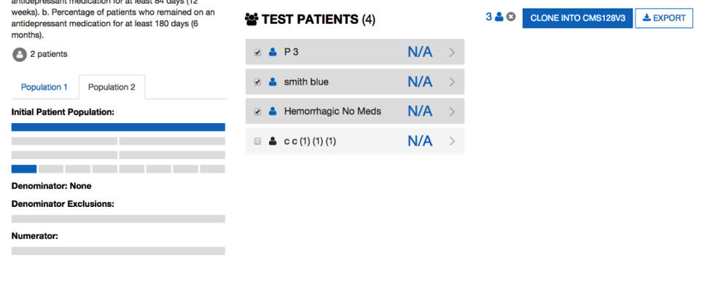

Figure 20. Selected Patients

Selecting patients will highlight those records with a darker background color and a blue icon. The selected patients will also be reflected in the measure logic view at right – the blue sections indicating the sections are measure logic covered by the set of selected patients. The user can see the number of patients selected and also unselect all patients at once by clicking the “x” icon.

Once patients have been selected, the user can either clone these patients into the measure or export these patients in QRDA and HTML formats.

# Additional Tools

Bonnie also features additional tools that may be activated on a per-account basis by sending an email to the Bonnie feedback list bonnie-feedback-list@lists.mitre.org.

## Complexity and Change Dashboard

The Complexity and Change Dashboard is available to explore how measures change between releases. Users who have this feature activated can access it from the “Complexity” link on the navigation bar. The initial page invites the user to select two sets of measures for comparison before proceeding.

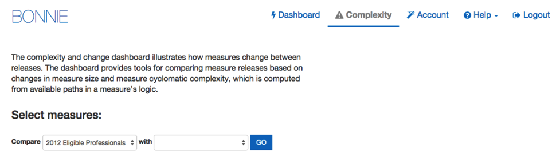

Figure 21. Selecting Sets of Measures to Compare

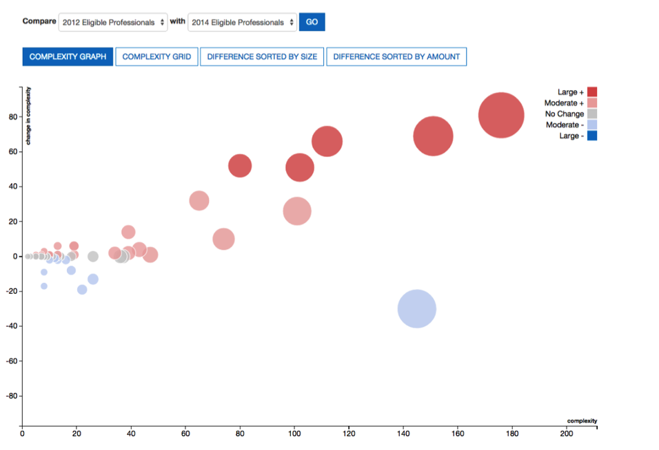

Figure 22. Complexity Graph

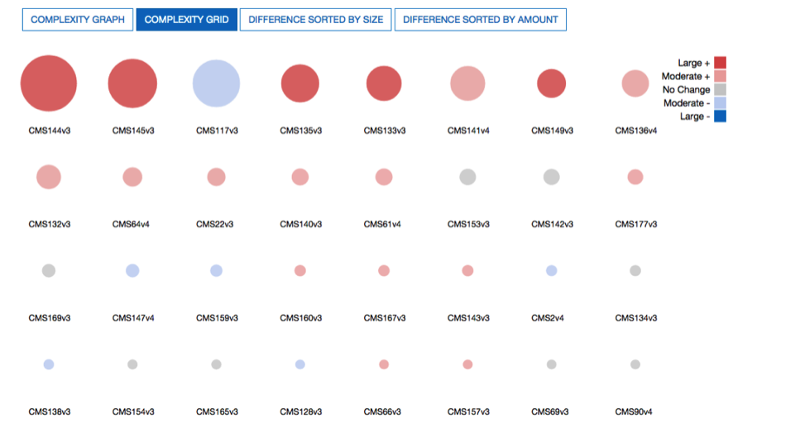

Figure 23. Complexity Grid

On either view, hovering over the circles will show a popup with more details on how that measure has changed. The measure below shows a change from a slightly complex denominator exclusion to a simple one.

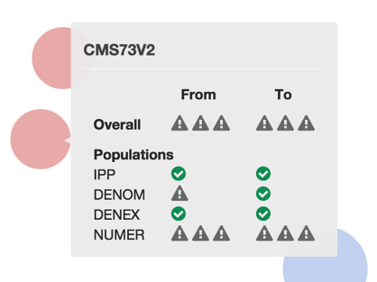

Figure 23. Measure Complexity Change Details

Alternatively, the changes in measures can be viewed more granularly by clicking “Difference Sorted by Size” or “Difference Sorted by Amount.” Each view illustrates a measure as a set of lines and highlights lines that have been added, removed, or unchanged between the two sets.

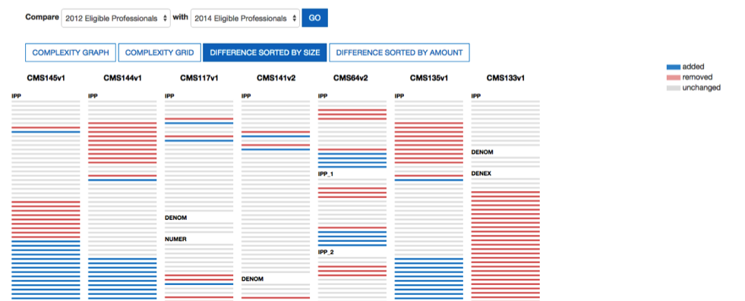

Figure 25. Measure Difference Sorted by Size

# Feedback and Support

An issue tracker and feedback email list are available to support the resolution of issues and to answer questions related to the Bonnie application. The Bonnie issue tracker is available on the ONC Jira system using the following URL:

<http://jira.oncprojectracking.org/browse/BONNIE>

The issue tracker should be used to report bugs encountered when using the Bonnie application, to ask questions, or to request new features. To add an issue, a login account must be created in the Jira system. Once an issue has been entered, the Bonnie team will review and prioritize it. Alternatively, questions can also be addressed to the Bonnie feedback list [bonnie-feedback-list@lists.mitre.org](mailto:bonnie-feedback-list@lists.mitre.org). The Bonnie feedback list email can be accessed using the “Contact” link in the main Bonnie navigation menu at the top of every page.

# Frequently Asked Questions

Does Bonnie replace Cypress or is it an alternative to Cypress for certification?

Bonnie is a testing tool for measure developers to test measures as they are being authored, while Cypress is the Meaningful Use certification tool. Bonnie cannot be used for Meaningful Use certification for vendors. Bonnie has been designed to provide insight into the details of how measure logic behaves. This makes it useful to vendors, measure developers, and others in the clinical quality measure space who would like to better understand the behavior of clinical quality measures. The Bonnie testing tool uses the same measure calculation engine as the Cypress tool. Therefore, Bonnie can be used to better understand the behavior of the measures when implementing a measure prior to certification.

Can I export patient records from Bonnie?

Bonnie allows test patients constructed using the tool to be exported in a human readable (HTML) format and in the QRDA Category 1 format.

Can I load patient records into Bonnie?

Currently Bonnie does not support loading patient records into the tool. If you would like to calculate clinical quality measures using existing patients, the popHealth tool may be a better solution.

Does Bonnie automatically generate patient records?

Currently Bonnie does not have the ability to automatically generate patient records based on the measure logic. The goal of Bonnie is to allow the construction of carefully considered patient scenarios. These synthetic patient records are intended to have an expected result based on the intent of the measure. Automatically generating patient records would generate patients that aligned with the measure logic as written, but they might not align with the intent of the measure if there are issues in the measure logic.

My patient does not match the logic of the Initial Population. Why is the patient passing?

A test in Bonnie is based on assigning an expected outcome to a synthetic patient record based on the intent of the measure. A patient can be constructed with the expectation that the patient calculated is to be included in the Initial Patient Population. If the patient actually calculates to the Initial Patient Population, then the test passes. If the patient does not calculate to the initial patient population, then the test fails. The patient’s alignment with the expectations needs to match exactly. For instance, if the expectation is set for only the Initial Patient Population, and the patient calculates to the Initial Patient Population and the Denominator, the test fails. Similarly, a patient can be constructed with the expectation that they do not align with any of the measure populations. In this case if the patient does not calculate into the initial patient population, the test will pass. If a patient is constructed that has the expectation set that they do not align with any of the measure populations and that patient calculates into the Initial Patient Population, that test will fail.

Can I use patients that I’ve built in one measure for another measure?

Bonnie allows patient records built for one measure to be copied to another measure. This transfer can be done only within the context of a single account. Patient records cannot currently be copied between accounts. Once a patient test record is copied from one measure to another, modifications to the patient record in one measure will not modify the copied patient record.

Where can I get help with Bonnie?

The Bonnie application has a Help menu in the header. Once you log into the application, you can use the help menu to send an email to the Bonnie feedback list asking a question directly; access the Bonnie issue tracker to enter a bug, ask a question, or request a feature; and access the user guide that provides step-by-step instructions on using the Bonnie tool.

What measure formats can I load into the Bonnie tool?

The Bonnie application can currently load Health Quality Measures Format (HQMF) release 1 and release 2. HQMF can either be loaded directly using an HQMF xml file or it can be loaded using a Measure Authoring Tool (MAT) export zip file containing an HQMF xml file. Bonnie can also load measures defined in the MAT SimpleXML format either directly using the XML file or through a MAT zip file export. Note that when loading a SimpleXML or HQMF file, you will need a National Library of Medicine (NLM) Value Set Authority Center (VSAC) account to download the value sets associated with the measure.

Do I have to be a measure developer to use the Bonnie tool?

You do not need to be a measure developer to use the Bonnie tool. Anyone can sign up for a Bonnie account using the register link on the login page.

Do I need to be a Measure Authoring Tool user to use the Bonnie tool?

Measures can be loaded into the Bonnie tool either by using a Measure Authoring Tool (MAT) zip file export or by directly loading the measure using HQMF that has been released to the CMS website. Loading measures using a MAT zip file export will require a MAT account to download the export zip. However, if you do not have a MAT account, you can get HQMF files for the released versions of the measures from the electronic Clinical Quality Measures (eCQM) Library page on the CMS website.

Can Bonnie be used to calculate the results for a large number of patient records?

Bonnie is not designed to handle calculating more than a few hundred patient records per measure. If you are interested in calculating clinical quality measures against a larger number of patient records, the popHealth tool may be a better solution.