Automatic Plant Irrigation Using PIC

The system’s main aim is to provide the amount of irrigation to agricultural fields by observing the moisture content of soil. The project minimizes the manual process if irrgating the field by switch the pump ON/OFF. The system works with the use of PIC microcontroller, which collects the input signals that measures moisture content of soil through sensing arrangement. On receving the signal, the PIC microcontroller produces an output that drives a relay and operates the water pump. The system is also built in with a LCD which is interfaced with the microcontroller for displaying the moisture content of soil and water pump status. This system helps in reducing the manual work and provides required irrigation to the agricultural feild.

Block Diagram :
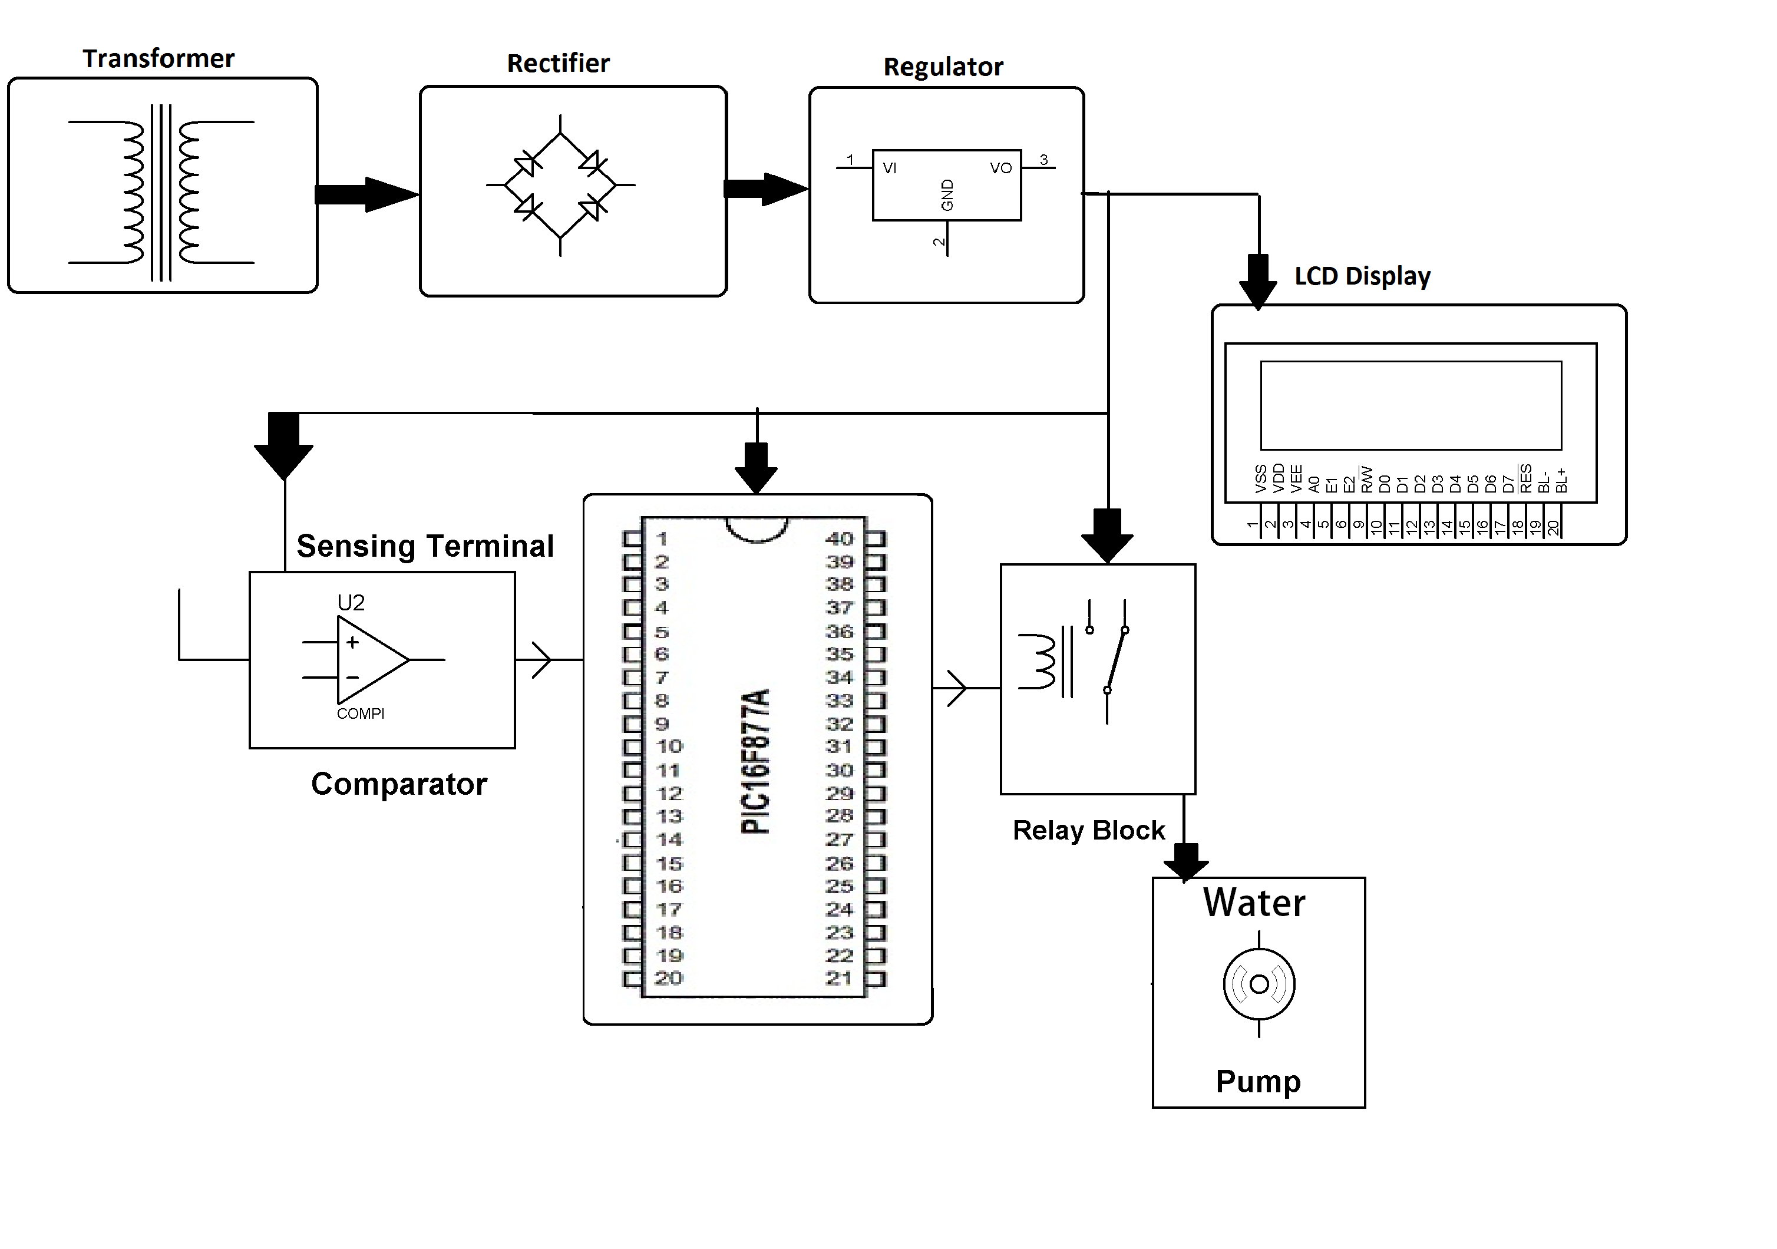

Hardware Specifications :
- PIC Microcontroller
- Diodes
- Op amp
- Crystal
- Water Pump
- LCD
- Relay
- LED
- Voltage Regulator
- Transistor

Software Specifications :
- MPLAB
- MC Programming Language: C

Reference
- http://ieeexplore.ieee.org/xpl/articleDetails.jsp?arnumber=7359336&queryText=automatic%20irrigation&newsearch=true

