**A**

**Project Report on**

**Fully Automated Irrigation System for Efficient use of Water and Electricity**

**Submitted**

**In partial fulfillment of the requirements for the degree of**

**Bachelor of Technology in**

**Electrical Engineering**

**Submitted by**

|  |  |
| --- | --- |
| **Name of Student** | **Roll No** |
| Shreyas Ranjit Patil | 1908057 |
| Aditya Arvind Desai | 1908058 |
| Aishwarya Ashok Desai | 2058003 |
| Devika Sachin Desai | 2058010 |

**Under the Guidance of**

**Prof.R.Metri.**



K.E. Society’s

Rajarambapu Institute of Technology, Rajaramnagar

**(An Autonomous Institute, Affiliated to Shivaji University, Kolhapur)**

**Department of Electrical Engineering**

**2022-2023**

**K.E. Society’s**

Rajarambapu Institute of Technology, Rajaramnagar

**(An Autonomous Institute, Affiliated to Shivaji University, Kolhapur)**

**Department of Electrical Engineering**

**CERTIFICATE**



This is to certify that the project entitled, **“Fully Automated Irrigation System for Efficient use of Water and Electricity”,**has been carried out and is submitted by **Mr.Aditya A. Desai(1908058),Mr.Shreyas R.Patil(1908057),Miss. Aishwarya ANagargoje(2058003) and Miss. Devika.S.Desai(2058010)** in the partial fulfillment for the award of the degree of Bachelor of Technology in Electrical Engineering, during the year 2022-23 under my supervision and guidance within the four walls of the institute and the same has not been submitted elsewhere for the award of any degree.

|  |  |
| --- | --- |
| Prof.R.Metri  **Project Guide** | **External Examiner** |
| Dr. V. N. Kalkhambkar  **HOD, Electrical** | Dr. S. S. Kulkarni  **Director, RIT** |

Date:

Place: R.I.T., Sakharale

**DECLARATION**

We declare that this report reflects our thoughts about the subject in our own words. We have sufficiently cited and referenced the original sources, referred or considered in this work. We have not misrepresented or fabricated or falsified any idea/data/fact/source in this submission. We understand that any violation of the above will be cause for disciplinary action by the institute.

|  |  |  |
| --- | --- | --- |
| **Roll No.** | **Name of Students** | **Signature** |
| 1908058 | Aditya Arvind Desai |  |
| 1908057 | Shreyas Ranjeet Patil |  |
| 2058003 | Aishwarya Ashok Desai |  |
| 2058010 | Devika Sachin Desai |  |

**ACKNOWLEDGEMENT**

At the outset, we think ourselves fortunate enough to have the pleasure of working under the supervision of Prof. R. Metri, Assistant Professor, Department of Electrical Engineering. He stood by our side for this work and his worthwhile guidance, support & reassurance throughout our project made our work possible. We would like to convey our deep regards and deep sense of thankfulness to him. We divulge our warm gratitude to faculties and supporting staff of the department of electrical engineering, and all our close friends and classmates to cite a few apparitions that helped us to overcome the labyrinth of hardships that come as the mark of vicissitude. We would like to extent our thanks to the head of electrical engineering department Dr. V N Kalkhambkar for his support throughout this work. We would like to sincerely acknowledge Director, RIT, Dr. Mrs. Sushma S. Kulkarni, for her support and encouragement. Finally, we express our self that working on this subject was throughout the pleasant learning understanding. We truly hope that this work with its assumption will reflect the best work put into it. It also has been a wonderful pleasure to relate to the Rajarambapu Institute of Technology, Islampur.

**ABSTRACT**

Our project is a fully automated irrigation system that highlights the optimum solution for the efficient use of water and electricity for agricultural purposes. There are some existing systems who come up with two solutions, one is timer-based and another one is moisture-based atomization. The timer-based system has demerits like being semi automated i.e., timer needs to be changed manually according to climate. Similarly, in moisture-based systems, reliability is the issue. So the main objectives of the paper are to overcome the demerits of the present systems by integrating both the systems, to develop a fully automated irrigation system, to manage the use of water, electricity, and to add a remote controlling system. The paper includes the integration of moisture and timer-based system which provides the optimum efficiency on the water use and the use of solenoidal valve and siphon technology decreases the use of electricity while our future idea to prepare a smartphone application gives us the advantage to continuous monitoring over the system and provides control over irrigation from anywhere.

**INDEX**

|  |  |  |  |
| --- | --- | --- | --- |
| **Chapters** | **Content** | | **Page No.** |
| 1 | 1.1 | Introduction | 10 |
|  | 1.2 | Research Motivation | 11 |
|  | 1.3 | Problem Statement | 12 |
|  | 1.4 | Objective of Project | 13 |
|  | 1.5 | Scope of Project | 13 |
|  | 1.6 | Organization of Report | 14 |
| 2 |  | Literature Review | 15 |
| 3 |  | Behaviour of System |  |
|  | 3.1 | Timer Based System | 17 |
|  | 3.2 | Moisture Based System | 18 |
| 4 |  | Description of System |  |
|  | 4.1 | Block Diagram | 20 |
|  | 4.2 | Flowchart | 21 |
|  | 4.3 | Program | 22 |
|  | 4.4 | Components |  |
|  | 4.5 | Circuit Diagram |  |
|  | 4.6 | Hardware Model |  |
| 5 |  | Results & Discussion |  |
|  | 5.1 | Hardware Results and Discussion |  |
| 6 |  | Conclusion and Future scope |  |
|  | 6.1 | Conclusion |  |
|  | 6.2 | Future scope |  |
|  |  | Appendix A |  |
|  |  | Appendix B |  |
|  |  | References |  |
|  |  |  |  |
|  |  |  |  |
|  |  |  |  |
|  |  |  |  |
|  |  |  |  |
|  |  |  |  |
|  |  |  |  |
|  |  |  |  |
|  |  |  |  |
|  |  |  |  |
|  |  |  |  |
|  |  |  |  |
|  |  |  |  |
|  |  |  |  |
|  |  |  |  |
|  |  |  |  |
|  |  |  |  |
|  |  |  |  |
|  |  |  |  |
|  |  |  |  |
|  |  |  |  |
|  |  |  |  |

**LIST OF FIGURES**

|  |  |  |
| --- | --- | --- |
| **Fig. No** | **Fig. Name** | **Page No.** |
| 3.1 | Control Unit | 17 |
| 3.2 | Control Centre | 17 |
| 3.3 | Open Field Area | 17 |
| 4.2 | Making a Test Bench | 19 |
| 4.1 | Block Diagram | 21 |
| 4.2 | Flowchart |  |
| 4.3 | Circuit Diagram |  |

**LIST OF TABLES**

|  |  |  |
| --- | --- | --- |
| **Table. No.** | **Table Name** | **Page No.** |
| 3.1 | Comparision of conventional system and our’s system | 43 |
|  |  |  |
|  |  |  |

**Chapter 1**

* 1. **Introduction**

Our project is a fully automated irrigation system that highlights the optimum solution for the efficient use of water and electricity for agricultural purposes. There are some existing systems who come up with two solutions, one is timer-based and another one is moisture-based atomization. The timer-based system has demerits like being semi-automated i.e., timer needs to be changed manually according to climate. Similarly, in moisture-based systems, reliability is the issue. So the main objectives of the paper are to overcome the demerits of the present systems by integrating both the systems, to develop a fully automated irrigation system, to manage the use of water, electricity, and to add a remote controlling system. The paper includes the integration of moisture and timer-based system which provides the optimum efficiency on the water use and the use of solenoidal valve and siphon technology decreases the use of electricity while our third idea to prepare a smartphone application gives us the advantage to continuous monitoring over the system and provides control over irrigation from anywhere.

**1.2 Research Motivation**

India’s ground water levels are critically low and present irrigation systems are poor in efficient water and energy management. So there is definite need of developing the efficient system for irrigation of water. Our project is a fully automated irrigation system that highlights the optimum solution for the efficient use of water and electricity for agricultural purposes. The existing systems come up with two solutions, one is timer-based and another one is moisture-based. The time-based system has demerits like being semiautomated i.e. timer needs to be changed manually according to climate. Similarly, in moisture-based systems, reliability is the issue. So our main objectives are to overcome the demerits of the present systems, to develop a fully automated irrigation system, to manage the use of water, electricity, and to add a remote controlling system. Our idea includes the integration of moisture and timer-based system which provides the optimum efficiency of water and the use of solenoidal valve and siphon technology decreases the use of electricity while our future idea is to prepare a smartphone application that gives us the advantage to continuous monitoring over the system and provides control over irrigation from anywhere.

## **Problem Statement**

India's ground water (GW) levels are critically low, owing to erratic monsoon rains and over extraction of water for irrigation, with agriculture accounting for 90% of India's G more than 30 million irrigation pumps. These irrigation systems are inefficient with poor water flow control, which over-extracts GW and over irrigation of fields. This wastes water and reduces crop yields. At the same time it wastes energy in pumping water and this leads to higher CO2 emissions. 10 millions of these pumps rely on diesel fuel, while the rest are powered by subsidized electricity which is coal-fired, using more than 18% of all electricity generated in India (Indian Bureau of Energy Efficiency). Agriculture sustains 50% of Indian households, and low GW levels threaten livelihoods and food security. Water scarcity is inextricably linked to extreme poverty and conflict and has a profound impact on the social welfare of people with an estimated 330 million people suffering acute water shortages. Improving the efficiency of the irrigation systems will reduce pressure on ground water and also cut energy consumption and carbon emissions. This has prompted the Indian Government to prioritize drought proofing and usage of precised irrigation systems.

## **Objective of project**

* To develop an fully automated irrigation system with integration of timer and moisture based system.
* To analyze the data by comparing it with the present system and modifying system for efficiency.
* Providing various watering scheduled program for particular crop.

## **Scope of project**

This project is an attempt to make the fully automated and efficient irrigation system.The systems early model is being implemented in Tulip Farms green houses. which is a new portable green house project. In addition to that we can easily insure that this system is capable of handling the load of open field systems with vast geographical area. Also the system is compactability makes it easy option for garden irrigation. Peeking into recent trends people are enjoying the organic lifestyle for that in many cities the peoples are growing their vegetables on their terrace called as balcony farming where with minimum use of electricity lots of human efforts can be reduced. If collected data is used to train an AI model then this could be revolution in irrigation sector for exactly suggesting the proper amount of water sourcing for particular crop.

## 

## **1.6 Organization of Report**

**Chapter 1** Gives the brief information about the institution of project including introduction, importance of the problem, problem statement, objective, and scope of the project.

**Chapter 2** Represents literature survey from different research papers. Also gives overview of different experiments done for simulating the project.

**Chapter 3** Talks about the behaviour of timer based system and moisture based system.

**Chapter 4** Contains the Description of system and detail information regarding block diagram and flow diagram and the circuit diagram and its components.

**Chapter 5** Contains the overall result of the project and hardware results.

**Chapter 6** Contains Conclusion of the project.

**Chapter 7** Contains References used for the project.

**Chapter 2**

**2.Literature Review**

For understanding the working of existing irrigation systems and for calculation of minimal amount of water requirement of particular plant many research paper were studied. Few of them are mentioned below

**Mohamed Ahmed Abdurrahman** (2015) Sensor Based Automatic Irrigation Management System: International Journal of Computer and Information Technology (ICIT) In the present review, an attempt has made to make an automatic irrigation system using PIC 16F877A, moisture sensor and induction valve. The sensors are used to measure the moisture level of an soil and control the valve according to the level of moisture.

**Bishnu Deo Kumar, Prachi Shrivasthay, Reetika Agrawal and Vanya Tiwari** (2017) Microcontroller based automatic plant irrigation system: International Research Journal of Engineering and Technology (IRJET):In the present review, an attempt has been made to provide Information about the automated irrigation system using microcontroller (ATMEGA 328). The efforts are made to provide continuous readings of the temperature of atmosphere along with humidity content of soil with an Automated control over irrigation based on ATMEGA 328 and GSM module.

**Raja. G. Abhiraj. R. Arunkrishnan, Febin Malik. Jesu Jorof Divin. J and Rajarathinum**

(2018) Smart Polyhouse Farming Using lot Environment: International Journal Of Trend in Scientific Research and Development IJTSRV)In this paper some essential sensors, Relay and Power supplies used in (polyhouse are discussed in brief. The sensors which have been discussed are Temperature, Humidity, Moisture and ultrasonic sensors. By implementing automation inside the polyhouse all things are monitored through mobile.

**R.Nageswara Rao,B.Sridhar** (2018)IOT Based Crop Filed Monitoring And Automation Irrigation System: second international conference on inventive system and control(ICISC)This system is used for controlling and monitoring of crop field and this research paper describe the block diagram of IOT based automatic crop field monitoring.

**G.K.Banerjee,Rahul Singhal** (2010)Microcontroller based polyhouse automation controller :International symposium on electronic system design.

**Chapter 3**

**3.Behaviour Of Existing system**

There are two systems available in the market timer based and moisture based. Both of them have their advantages and disadvantages those are discussed below.

**3.1 TIMER BASED SYSTEM :**

This system is based on time delay based control. This system can be applied for mega open fields and also for micro farms. The system is totally based on timer. We have to set ON time in the system. When the setted time arises motor turns on and after some pre setted delay motor goes off. This system does not incorporate any type of feedback. So is the soil is actually irrigated or not is unknown for the system. In addition to that this system is not fully automated we have to provide manual input to set the date daily.

For further understanding we have visited one automated irrigation system. Which comes under SUMAN AGRO IDUSTRIES, ITKARE. The system is provided by JAIN solutions. And it costed approximately 90 lack rupees to suman agro. Here they have implemented the timer based irrigation system for open fields. They have managed to automate the area of 80 acres. The irrigation system is used by both the water transmission system and also the nutrition transmission system. The Fig. 3.1 Shows the control unit which is used to control the timer. The Fig. 3.2 shows the control centre of the systems. The White tanks are being used for filtering purpose. While in blue tanks the injection of nutrition into water takes place. The Fig. 3.3 Shows the actual field on which dripper lines are laid.

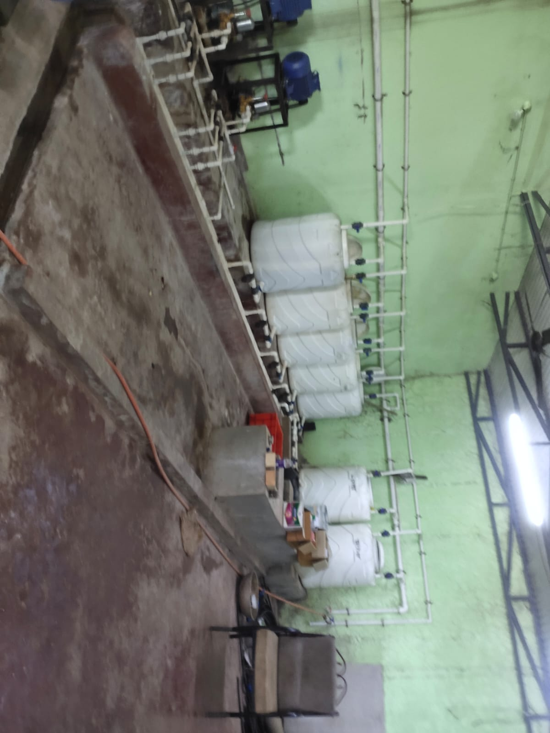

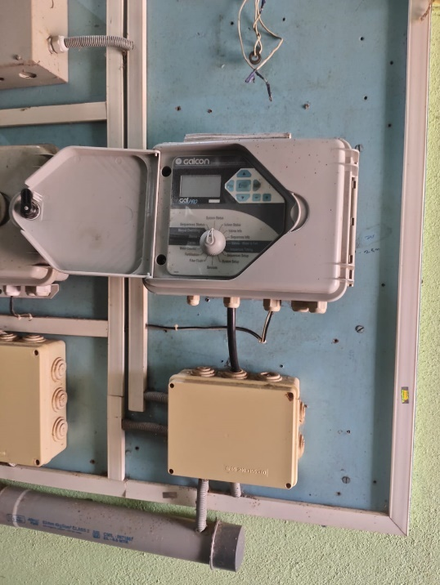

Fig. 3.1 Control Unit

Fig. 3.2 Control Centre

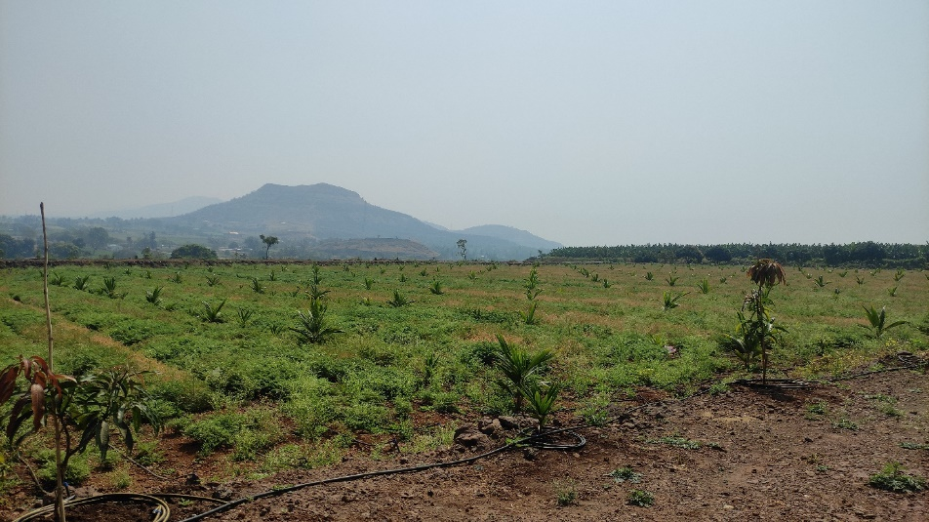

Fig. 3.3 The open field

After completing visit and analysing the data from various research paper we came across some of the de merits of the system. Like this system is not fully automated human efforts are still needed to set the timer and confirm that is the field is watered or not. Since no sensors are involved, The system is unable to collect data of the present weather and moisture conditions.

**3.2 MOISTURE BASED SYSTEM**

This system is mainly depending on input from moisture sensor. If moisture sensor detects lack of moisture in soil, then motor is turned on and water is directed to irrigate the field as soon as moisture sensor detects sufficient water then it gives signal to controller which turns off the motor.

Though this approach seems ideal but it is not that much practical. The system can be only implemented for small field area or green houses. If we tried to implement it in large open field then cost of sensors and efforts to maintain them are cancel out its advantages.

The disadvantage of both can be only overcome by integrating both of the systems which we are representing in this project.

**Chapter 4**

**DESCREPTION OF THE SYSTEM**

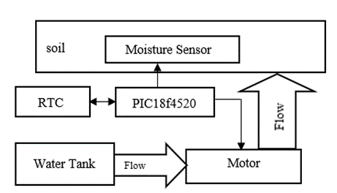**4.1 Block Diagram :**

Fig. 4.1 : Block Diagram Of the system

**CONTROLLER**

**4.1.1 Actual Working Of the System.**

The overall controlling of water is done by following way. The water is stored in upper tank and supplied to each rack independently. Then each rack has its own 12 V motor for individual flow control. Motor is actuated by relay while signal for each really is given by PIC 18f877A microcontroller.

The decision of keeping motor on and off is decided by two factors. One is by the schedule provided by the farmer and the moisture sensor. The main control is provided using schedule but if there is some extreme condition happens and moisture content in soil goes extremely low then moisture sensor can overwrite it and send signal to turn on the motor.

The schedule of watering for particular plant is planned such as it could yield maximum outcome in minimum use of water. To get real-time control over water DS3231 RTC (Real Time Clock) module is integrated with it. Which provides present time and date to the microcontroller and it is compared with planned schedule and when the real time matches with presetted time it gives signal to relay to turn on motor and motor is turned on and water is supplied to the crops. After pre-setted another signal is given to relay indicating turning off of the motor.

During summer due to extreme temperature or by any other means if the moisture content of soil decreases than pre-setted minimum value then it is addressed by the moisture sensor and given to microcontroller now moisture sensor gives immediate instruction to the relay to turn the motor and necessary changes are made in the schedule to keep system running in original state.

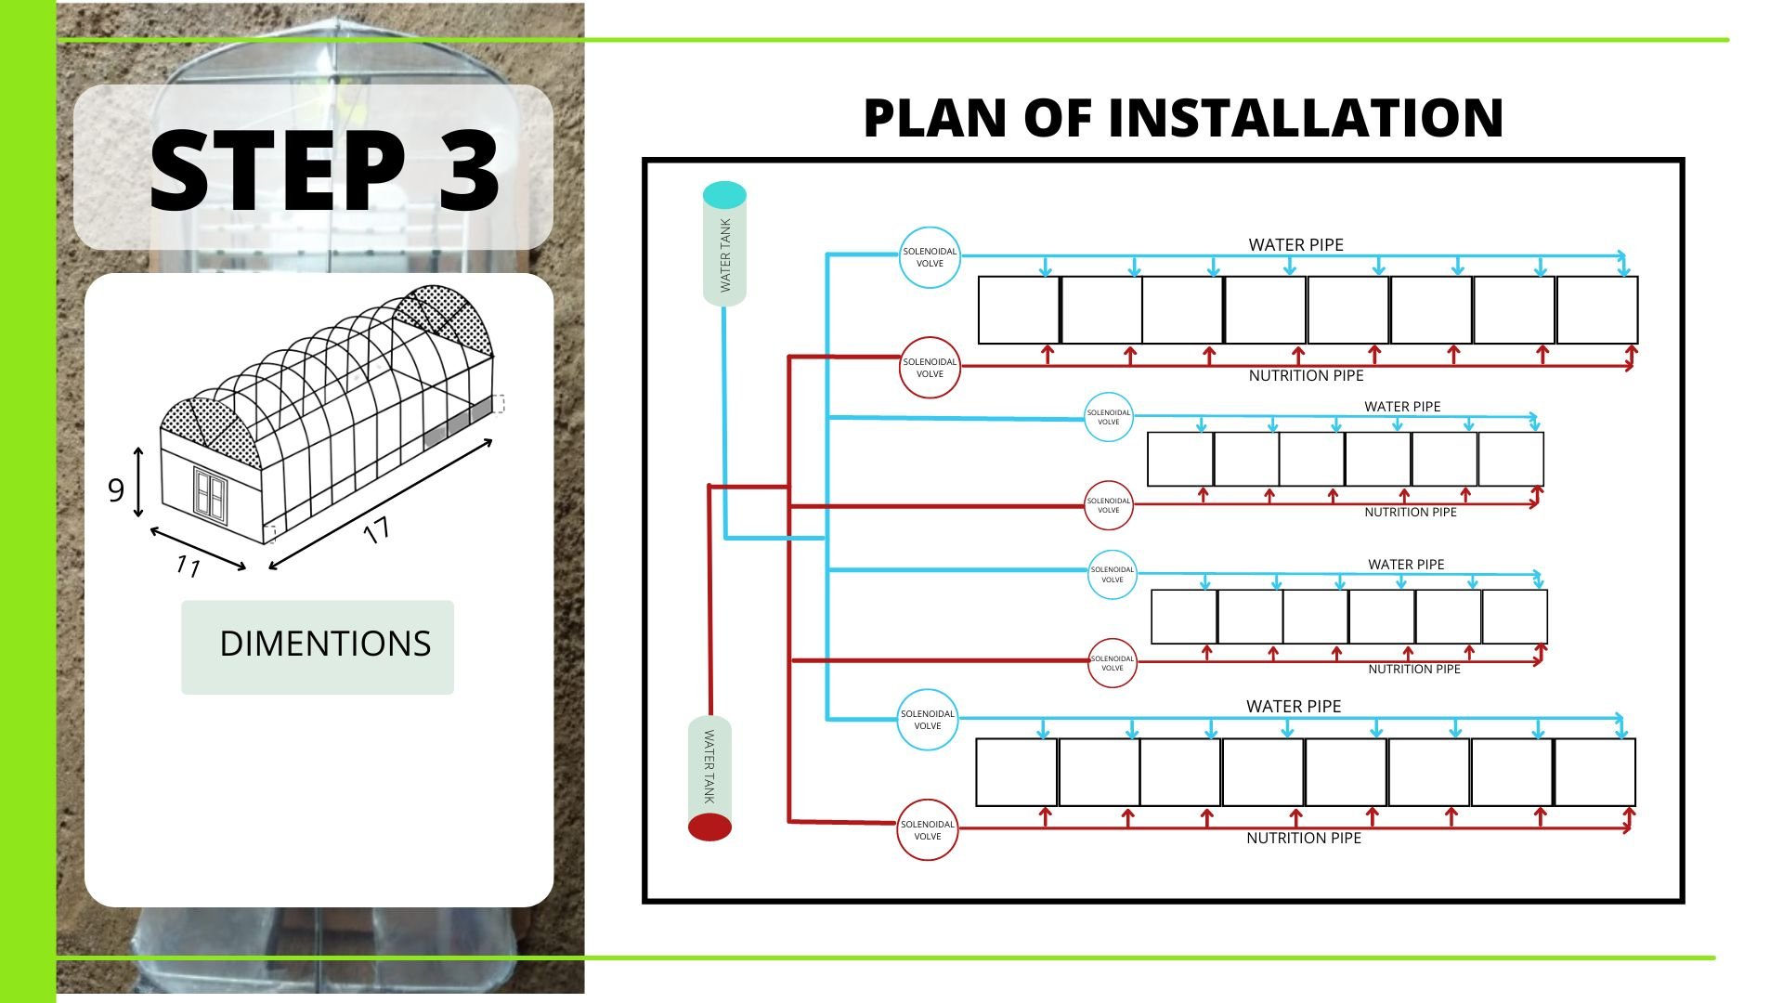**4.2 Plan Of Installation.**

|  |
| --- |
|  |
| Fig 4.2 : Making of test bench |

Fig 4.3 : Actual Plan Of Installation

|  |
| --- |
| Our project is sponsored project which is sponsored by external organization TULIP FARM.As per their requirement we have designed one greenhouse by using Transparent, tight, cheap, and flexible polyhouse and Ultraviolet plastic Sheet and iron pipes or GI pipes. the size of that greenhouse is 15ft*11ft*9ft.In that greenhouse 4 racks are mounted .Each rack contains 7 or 8 trays and.each rack has different types of vegetables.so as per their requirement ,every crop of each rack is controlled at different timing.so in this tank we have planned that, there are two tanks available in greenhouse..so one tank contains water and other tank contains nutritions.every rack has different pipeline of water and nutritions so every pipe have one solenoid valve and by using that solenoid valve.we supplied water and nutritions to each tray |

|  |
| --- |
| **4.1 Flow Chart** |
| Fig 4.2 Flowchart |
| To understand the working of the system we will take some dummy data for watering crops  **For 1st week:**  The microcontroller does write operation on the RTC module then the continuous time and date are transferred to the microcontroller and value of date and time are copied into Dip=Tip variables. Now if Dip (input date is less than 7 then the loop for week 1 got executed. now if input date and input time are matched with the set date and set time then the motor turned ON. After that proper delay it applicable to keep motor turned on for few minutes after that signal is provided so that motor turns OFF. Then Dset (set date) is increased by 2 days (Dset=Dset) And it again jump to weak condition check unless date is not move than 7 it stay in some loop. Now if the set date and set time are not equal to input date and input time then sufficient then again jumped to week check in condition if it is motor turn off. again Dset is changed to (Dset T1) and jumped weak check condition if date is grater than 7 and less than 15 it enter into second loop.  **For 2nd Week**  Now if Dip (input date is less than 15)then the loop for week 2 got executed. now if input date and input time are matched with the set date and set time then the motor turned ON. Then proper delay it applicable to keep motor turned on for few minute after that signal is provided so that motor turns OFF. Then Dset (set date)is increased by 3 days(Dset=Dset )And it again jump to weak condition check unless date is not move than 15 it stay in some loop. Now if the set date and set time are not equal to input date and input time then moisture comes into play.it checks the moisture level of soil. if sufficient then again jumped to week check in condition if it is insufficient. then it bypasses timer and turn on the motor. After delay motor turn off. again Dset is changed to (Dset T1) and jumped weak check condition if date is grater than 15 and less than 30 it enter into third loop.  **For 3RD week:**  Now if Dip (input date is less than 30)then the loop for week 3 got executed. now if input date and input time are matched with the set date and set time then the motor turned ON.Then proper delay it applicable to keep motor turned on for few minute after that signal is provided so that motor turns OFF. Then Dset (set date)is increased by 4 days(Dset=Dset t)And it again jump to weak condition check unless date is not move than 30 it stay in some loop. Now if the set date and set time are not equal to input date and input time then moisture comes into play.it checks the moisture level of soil. if sufficient then again jumped to week check in condition if it is insufficient. then it bypasses timer and turn on the motor.after delay motor turn off. again Dset is changed to (Dset T1) and jumped weak check condition if date is grater than 30 .it enter into first loop.   * 1. **Program**   #include "ACS712.h" /* ----- C Program for Arduino based Alarm Clock ---- */  #include <Wire.h>  #include<EEPROM.h>  #include <RTClib.h>  #include <LiquidCrystal.h>  LiquidCrystal lcd(7, 6, 5, 4, 3, 2);  RTC_DS3231 RTC;  int temp,inc,hours1,minut,add=11;  #define buzzer 13  #define relay1 12  #define relay2 11  #define relay3 10  #define mois1 A0  #define mois2 A1  #define mois3 A2  #define mois4 A3  int HOUR,MINUT,SECOND;  int h=0;  int m=0;  int d=0;  void setup()  {  Serial.begin(9600);  Wire.begin();  RTC.begin();  lcd.begin(16,2);  pinMode(buzzer, OUTPUT);  pinMode(relay1, OUTPUT);  pinMode(relay2, OUTPUT);  pinMode(relay3, OUTPUT);  pinMode(mois1, INPUT);  pinMode(mois2, INPUT);  pinMode(mois3, INPUT);  pinMode(mois4, INPUT);  lcd.setCursor(0,0);  lcd.print("Real Time Clock");  lcd.setCursor(0,1);  lcd.print("Circuit Digest ");  delay(2000);  // RTC.adjust(DateTime(F(_DATE),F(TIME_)));  // if(!RTC.isrunning())  //{  //RTC.adjust(DateTime(_DATE,TIME_));  // }  }    void loop()  {  checkmois();  int temp=0,val=1,temp4;  DateTime now = RTC.now();  lcd.clear();  lcd.setCursor(0,0);  lcd.print("Time:");  lcd.setCursor(6,0);  lcd.print(HOUR=now.hour(),DEC);  // Serial.print(HOUR=now.hour(),DEC);  Serial.print(HOUR);  lcd.print(":");  Serial.print(":");  lcd.print(MINUT=now.minute(),DEC);  // Serial.print(MINUT=now.minute(),DEC);  Serial.print(MINUT);  lcd.print(":");  Serial.print(":");  lcd.print(SECOND=now.second(),DEC);  Serial.print(SECOND=now.second(),DEC);  Serial.println(" ");    lcd.setCursor(0,1);  lcd.print("Date: ");  lcd.print(d=now.day(),DEC);  //Serial.println(now.day(),DEC);    Serial.println(d);  lcd.print("/");  lcd.print(now.month(),DEC);  lcd.print("/");  lcd.print(now.year(),DEC);  match();  delay(200);  }  /Function to set alarm time and feed time into Internal eeprom/  /* Function to chack medication time */  void match()  {  if((HOUR == 16) && (MINUT == 00) && (d == 1) )  {  motoron();  }  if((HOUR == 16) && (MINUT == 00) && (d == 3) )  {  motoron();  }  if((HOUR == 16) && (MINUT == 00) && (d == 5) )  {  motoron();  }  if((HOUR == 16) && (MINUT == 00) && (d == 7) )  {  motoron();  }  if((HOUR == 16) && (MINUT == 00) && (d == 10) )  {  motoron();  }  if((HOUR == 16) && (MINUT == 00) && (d == 11) )  {  motoron();  }  if((HOUR == 16) && (MINUT == 00) && (d == 13) )  {  motoron();  }  if((HOUR == 16) && (MINUT == 00) && (d == 14) )  {  motoron();  }  if((HOUR == 16) && (MINUT == 00) && (d == 16) )  {  motoron();  }  if((HOUR == 16) && (MINUT == 00) && (d == 17) )  {  motoron();  }  if((HOUR == 16) && (MINUT == 00) && (d == 20) )  {  motoron();  }  if((HOUR == 16) && (MINUT == 00) && (d == 21) )  {  motoron();  }  if((HOUR == 16) && (MINUT == 00) && (d == 24) )  {  motoron();  }  if((HOUR == 16) && (MINUT == 00) && (d == 25) )  {  motoron();  }  if((HOUR == 16) && (MINUT == 00) && (d == 28) )  {  motoron();  }  if((HOUR == 16) && (MINUT == 00) && (d == 30) )  {  motoron();  }  }  void motoron(){  Serial.print("alarm on");  beep();  }  /* function to buzzer indication */  void beep()  {  digitalWrite(buzzer,HIGH);  digitalWrite(relay1,HIGH);  digitalWrite(relay2,HIGH);  digitalWrite(relay3,HIGH);  // delay(60000);  checkmois();  delay(5000);  checkmois();  delay(5000);  checkmois();  delay(5000);  checkmois();  delay(5000);  checkmois();  delay(5000);  checkmois();  delay(5000);  checkmois();  delay(5000);  checkmois();  delay(5000);  checkmois();  delay(5000);  checkmois();  delay(5000);  checkmois();  delay(5000);  checkmois();  delay(5000);  digitalWrite(buzzer, LOW);  digitalWrite(relay1, LOW);  digitalWrite(relay2, LOW);  digitalWrite(relay3, LOW);  delay(500);  }  void checkmois(){  int key1= digitalRead(mois1);  int key2= digitalRead(mois2);  int key3= digitalRead(mois3);  int key4= digitalRead(mois4);  if (key1==LOW){    digitalWrite(relay1, LOW);  }  if (key2==LOW){    digitalWrite(relay2, LOW);  }  if (key3==LOW){    digitalWrite(relay3, LOW);  }  if (key4==LOW){    digitalWrite(buzzer, LOW);  }  } |

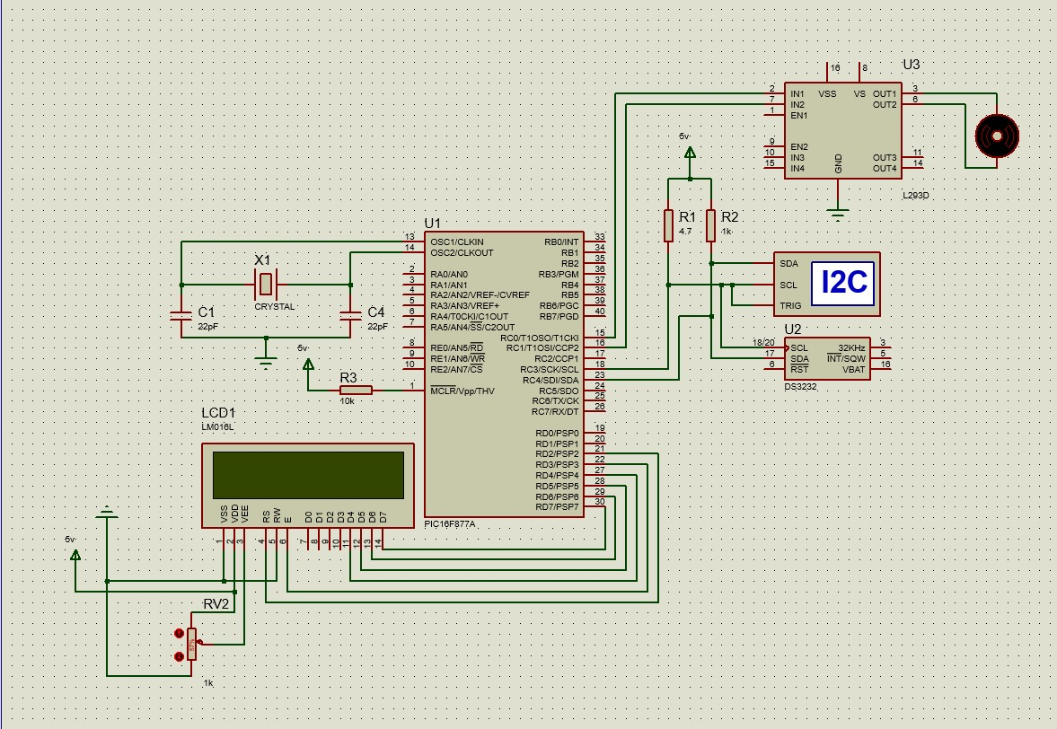**4.4 Simulation Model**

Fig 4.2 Proteus Simulation

The Fig 4.2 shows the proteus simulation of our system. The overall system is controlled by a PIC microcontroller. The DS3231 is the RTC module connected through an I2C protocol to the pin no. 18 and 23 of the microcontroller which provides the real time date and time to the microcontroller. The relay is connected between pins 15 and 16. Who controls the turning on and off of the motor view the signal given by microcontroller. The resister of 10K ohm is added to simulate the effect of the moisture sensor, While a crystall oscillator is used to give the clock pulse to the microcontroller. The 16*2 LCD Display is connected to microcontroller to show the date time and motor current state. Where pin no. 27 to 30 are connected to data pins D4 to D7 of LCD. And the Pin no. 21 and 22 are connected to Read/Write and enable pin to control flow of data and commands to the LCD from microcontroller

**4.5** **Components**

|  |
| --- |
| 1. PIC 18F(4520) |
|  |
| PIC18F4520 is a low-cost, low-power, high-speed 8-bit, fully-static Microcontroller unit that has 40 pins out of which 36 pins can be used as I/O pins. It has Power-on-Reset (POR) as well as the Extended Watchdog Timer (WDT) circuitry, which can be programmed for 4ms to 131s .PIC18F4520 also comes with 3 programmable external interrupts & 4 Interrupts-On-Change (IOC) pins, which are reliable features for interrupts related applications. Also, the system has a 13-channel 10-bit ADC converter module |

|  |
| --- |
| 2.LCD16x2 |
|  |
| The term LCD stands for liquid crystal display. It is one kind of electronic display module used in an extensive range of applications like various circuits & devices like mobile phones, calculators, computers, TV sets, etc. These displays are mainly preferred for multi-segment light-emitting diodes and seven segments. The main benefits of using this module are inexpensive; simply programmable, animations, and there are no limitations for displaying custom characters, special and even animations, etc.The operating voltage of this LCD is 4.7V-5.3V  It includes two rows where each row can produce 16-characters.  The utilization of current is 1mA with no backlight  Every character can be built with a 5×8 pixel box  The alphanumeric LCDs alphabets & numbers  Is display can work on two modes like 4-bit & 8-bit  These are obtainable in Blue & Green Backlight  It displays a few custom generated characters |
|  |
| 1. DS3231 RTC Module |
|  |
| RTC means Real Time Clock. RTC modules are simply TIME and DATE remembering systems which have battery setup which in the absence of external power keeps the module running. This keeps the TIME and DATE up to date. So we can have accurate TIME and DATE from RTC module whenever we want.RTC counts seconds, minutes, hours and year  Accuracy: +2ppm to -2ppm for 0ºC to +40ºC , +3.5ppm to -3.5ppm for -40ºC to +85ºC  Digital temperature sensor with ±3ºC accuracy, 2 Time-of-day alarms, Programmable square wave output, Register for Aging trim,400Khz I2C interface,DS3231 RTC MODULE Specifications,Operating voltage of DS3231 MODULE: 2.3V – 5.5V  Consumes 500nA on battery backup,Maximum voltage at SDA , SCL : VCC + 0.3V  Operating temperature: -45ºC to +80ºC |
| 1. 12V DC relay |
|  |
| 12V DC relay switches are the best solution for full voltage applications, as they allow a low current flow circuit to control a high current flow circuit, like a vehicle's horn, headlights, auxiliary lamps, fan motors, blower motors and countless pieces of equipment existing on vehicles today. |
|  |
| 5.5V DC PUMP MOTOR |
|  |
| Operating Voltage : 2.5 ~ 6V  Operating Current : 130 ~ 220mA  Flow Rate : 80 ~ 120 L/H  Maximum Lift : 40 ~ 110 mm  Outlet Outside Diameter: 7.5 mm  Outlet Inside Diameter: 5  This DC 3-6 V Mini Micro Submersible Water Pump is a low cost, small size Submersible Pump Motor which can be operated from a 2.5 ~ 6V power supply. It can take up to 120 liters per hour with a very low current consumption of 220mA. Just connect tube pipe to the motor outlet, submerge it in water and power it.Make sure that the water level is always higher than the motor. The dry run may damage the motor due to heating and it will also produce noise |
|  |
| 6.Soil Moiture Sensor |
|  |
| The moisture of the soil plays an essential role in the irrigation field as well as in gardens for plants. As nutrients in the soil provide the food to the plants for their growth. Supplying water to the plants is also essential to change the temperature of the plants. The temperature of the plant can be changed with water using the method like transpiration. And plant root systems are also developed better when rising within moist soil. Extreme soil moisture levels can guide to anaerobic situations that can encourage the plant’s growth as well as soil pathogens. This article discusses an overview of the soil moisture sensor, working and it’s applications. |
|  |
| 7.AVR (Atmega 328p) |
|  |
| The Atmel 8-bit AVR RISC-based microcontroller combines 32 KB ISP flash memory with read-while-write capabilities, 1 KB EEPROM, 2 KB SRAM, 23 general-purpose I/O lines, 32 general-purpose working registers, 3 flexible timer/counters with compare modes, internal and external interrupts, serial programmable USART, a byte-oriented 2-wire serial interface, SPI serial port, 6-channel 10-bit A/D converter (8 channels in TQFP and QFN/MLF packages), programmable watchdog timer with internal oscillator, and 5 software-selectable power-saving modes. The device operates between 1.8 and 5.5 volts. |
|  |
| 8.Connecting Wires |
|  |
| Jumper wires are simply wires that have connector pins at each end, allowing them to be used to connect two points to each other without soldering. Jumper wires are typically used with breadboards and other prototyping tools in order to make it easy to change a circuit as needed. Fairly simple. In fact, it doesn’t get much more basic than jumper wires. |
|  |
| 9.adapter |
|  |
| It allows high-power 5-Volt DC items to operate on 110 to 240 Volt AC power which makes it ideal for traveling also. |

**4.7 Hardware Model**

|  |
| --- |
|  |
| Fig 4.7 Hardware Model |

**Chapter 5**

**5.2 Hardware Results and Discussion**

**The power usage :**

Our system :

Electricity used by 1 microcontroller kit 1 Watt per hour

Electricity used by 12 Volt Motor : 60 Watt per hour

Electricity used by 12 Volt Motor: 60+1 = 61 W

For Green House Containing

6 Racks61*6 = 366 W per hour Maximum motor on for 30mins

then total electricity usage in a day : 183 watts

Total usage of the month 183*30 = 5490W

Total Units consumed : 5.490 Units

total running cost of the month : 5.36*5.490 = 29.42 rs

**Conventional System:**

Power consumption by motor : 746 watt per hour

373 watt in each day

Power consumption by motor for month : 373*30

For a month (units) : 373*30 = 11190Whr =11.19 units

cost of running:

223.5*5.36 = 59.97 rs per month

**Water Usage:**

For a Conventional System (half Hp motor)

1960/2 = 980*30 = 29400

1960 litre per hour ;

for a per day 30 mins of use = 1960/2 = 980 litre

for a month 980*30 = 29400 litre

our system

12V 110psi motor = avg 200 ltr per hour

for a per day 30 mins of use = 100 litre per day

for 6 motor 100*6=600 litr per day

600*30 = 18000 liter ;

**Human Efforts :**

In conventional system no matter what you have to put one person for monitoring and control of motor in our case these human are eliminated by incorporating automation for sake of convenience we have considered half hour of human efforts in entire month .

The following graph shows the entire difference in both systems in terms of electricity usage , water usage and human efforts. In all of these aspects our systems comes out as the best. In the case of electricity usage we save around 50 percent of money spend on electricity. The graph also shows the total water usage of the system which is comparatively lot lower than conventional system. We can easily save 40 percent of water by implementing our system. Looking towards human efforts column we can easily say our systems eliminates conventional systems in this case with saving around 90 percent of human efforts.

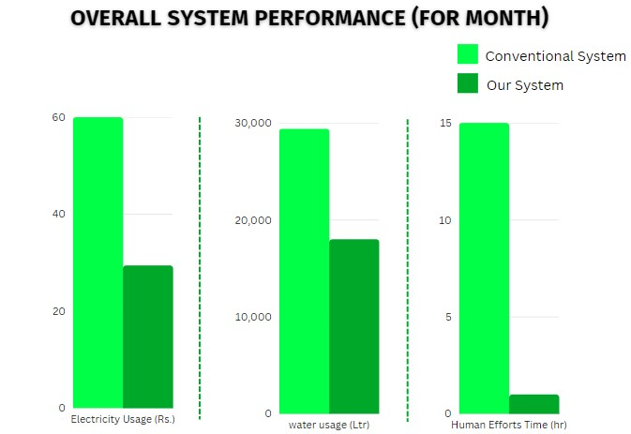

**Table 5.1:Comparision of conventional system and our’s system**

**Chapter 6**

**Conclusion and Future scope**

**6.1 Conclusion**

The ploy house /greenhouse parameter monitor and control system for desired conditions is implemented. The sensor devices available are integrated with Microcontroller board with stack-able slot for wireless or other modules is very useful. The setting needs series of observations and study inter dependency of various parameters, such as temperature, humidity and sun light intensity. Arduino board make it easy to install and maintain the system.

The system deployment in test poly house is studied implies need of poly house structures study, inside, outside environment study, crop needs etc. Simply controlling given parameters is not enough. The experimental results demonstrates that the growth of plant is increased by 20% in the control environment. A low cost embedded system is developed to measure and monitor polyhouse environment. The wireless model needs as DC supply can be given in the form of a battery bank easy to charge with solar system. There are limitation in terms of seasonal measurements and crop needs. The user's awareness of how to check system operation is a basic need to be fulfilled.

Based on the experiments there is a scope for sensor developments, which can be easy to replace and calibrate. The plug and self-install system models are a necessity.

**6.2 Future scope**

1.Artificial Intilligance and machine larning can be implemented to provide optimum watering schedule according to given condition.

2.Remote Monitoring and control can be achieved through smart phone application.

3.Scheduling part of the system can be used to automate the auto switch of the water pump in the fields.

**Chapter 7**

**References**

1. Mehamed Ahmed Abdurrahman (2015) Sensor Based Automatic Irrigation Management System : International Journal of Computer and Information Technology (IJCIT) , Vol. 04, Issue. 03, pp. 05-15
2. Bishnu Deo Kumar, Prachi Shrivasthav, Reetika Agrawal and Vanya Tiwari (2017), Microcontroller based automatic plant irrigation system : International Research Journal of Engineering and Technology (IRJET), Vol. 04, Issue. 05, pp.
3. Raja. G, Abhiraj. R, Arunkrishnan, Febin Malik, Jesu Jorof Divin. J and Rajarathinum (2018), Smart Polyhouse Farming Using Iot Enviroment: International Journal Of Trend in Scientific Reasearch and Development (IJTSRV) , Vol. 02, Issue. 03, pp. 03-18
4. R.Nageswara Rao,B.Sridhar(2018) IOT Based Crop Filed Monitoring And Automation Irrigation System: second international coferance on inventive system and control(ICISC)
5. G.K.Banerjee,Rahul singhal(2010)Microcontroller based polyhouse automation controller:International symposium on electronic system design
6. U N V P Rajendranath,Dr. V. Berlin Hency(2015) Implementation of a automatic irrigation system:IEEE Sponsored 2nd International Conference on Innovations in Information, Embedded and Communication systems.
7. Surenthar Munusamy; Safaa Najah Saud Al-Humairi; Muhammad Irsyad Abdullah(2021) Automatic Irrigation System: Design and Implementation: IEEE 11th IEEE Symposium on Computer Applications & Industrial Electronics (ISCAIE)
8. Ms Diana Josephine, Santhosh Gurunathan,vamsi krishna,Gokul Nath;Siva Ramasamy (2021) SMART IRRIGATION SYSTEM: International Conference on Internet of Everything, Microwave Engineering, Communication and Networks (IEMECON)
9. F. Rodrguez, J. L. Guzmn, Adaptive hierarchical control of greenhouse crop production, Int. J. Adap. Cont. Signal Process 22 (2008) 180–197.
10. N. Wang, N. Zang, Wireless sensors in agriculture industryrecent development and future perspective, Computers and Electronics in Agriculture 50 (2006) 1–14.
11. S. Shanmugantah, A. Ghobakhlou, P. Sallis, Sensor data acquisition for climate change modelling, WSEAS Transactions on Circuits and Systems 7 (2008) 942–958.
12. J. Burrell, T. Brooke, R. Beckwith, Vineyard computing: Sensor networks in agricultural production, Sensor and Actuator Network 7 (2004) 38–45.
13. R. Morais, M. Fernandes, S. M. et. al., A zigbee multipowered wireless acquisition device for remote sensing applications in precision viticulture, Computers and Electronics in Agriculture 62 (2008) 94–106.