**Overview of system:**

We have to automate the irrigation system .this is not the new idea .previously various attempts has been made. Few of them are moisture sensor based and few of timer based so, In moisture based system ,the water is controlled by moisture sensor also it senses the level of water in soil .

if level of the water is not sufficient then it gives signal to microcontroller to start motor microcontroller analyzer signal and gives signal and to relay to turn on the motor so that water is supplied to soil.

The timer is setted only once so that the water is supplied to the soil after equal interval.

For collecting more information about the existing system we have visited the suman agro industries itakare, after carefully analysing the system we come to know about following demerits of existing system

* semi-automated system.
* manual reset required.
* not much efficiency is achived.
* less relibility over sensors.
* lack of nutrition indication
* lack of remote control view app.
* not efficient for energy

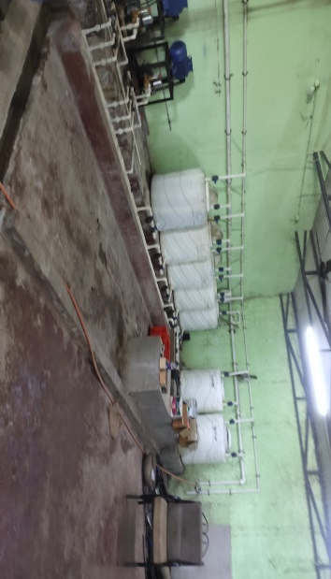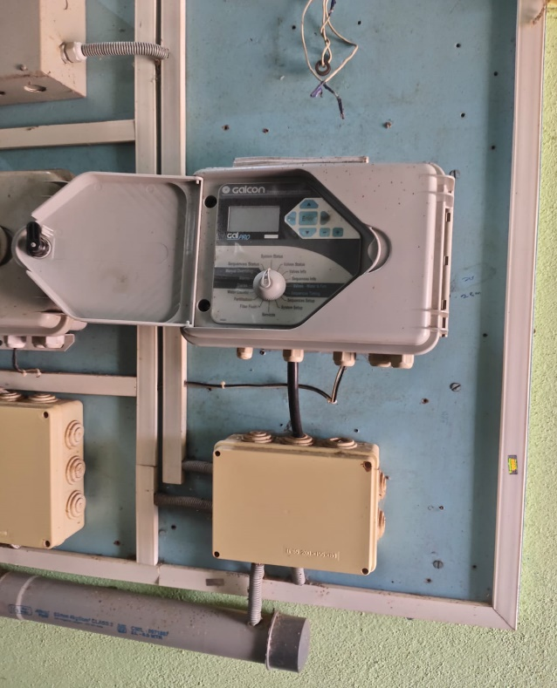

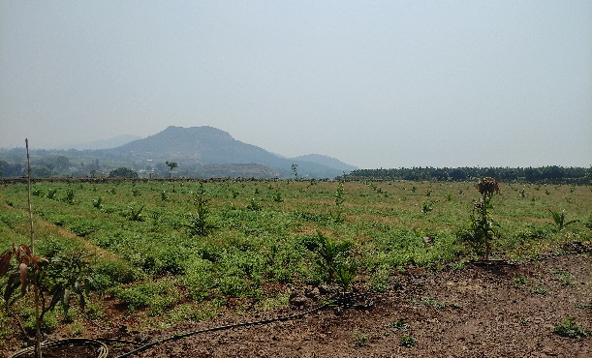

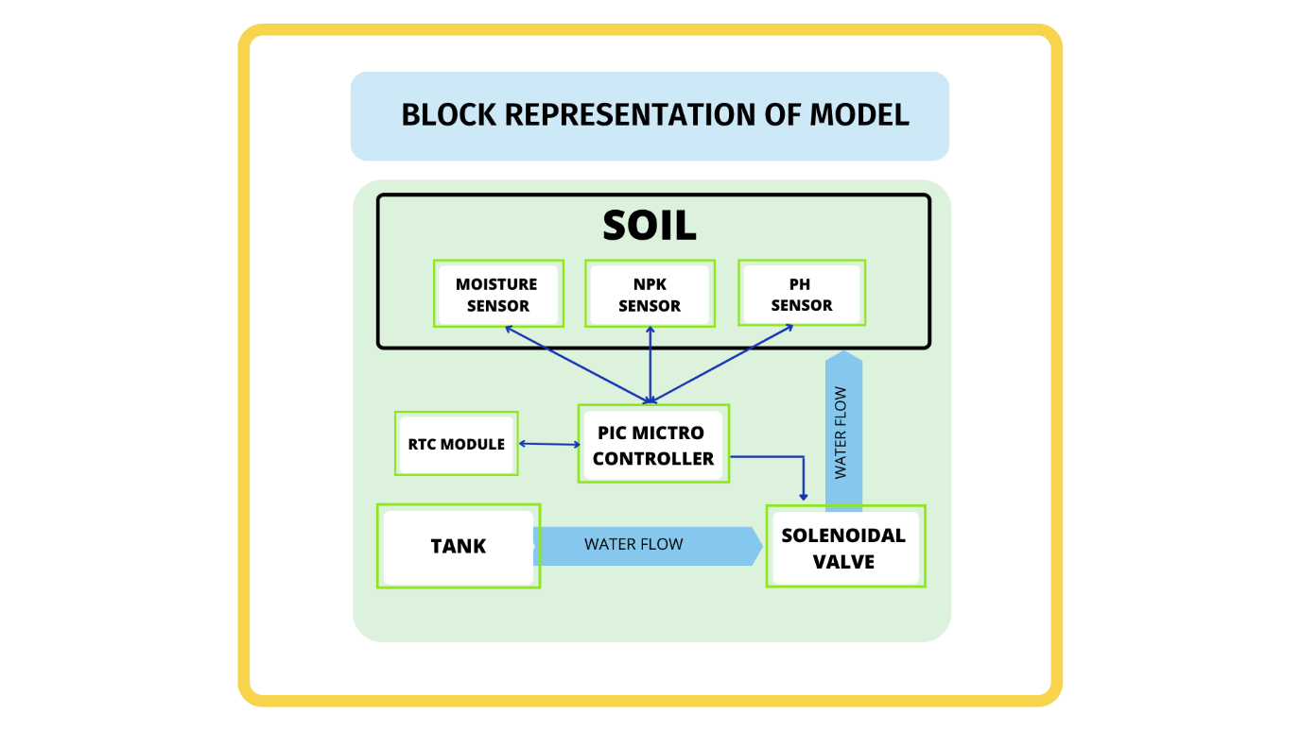But we have to make a combination of both i.e timer based and moisture based system.

Water should be given after equal interval but if need arises.at high temperature condition , the need of water of soil increases for that moisture sensor should provided to microcontroller to on motor.

and after processing motor should be on for given periods of timer .after that motor should go off.to overcome this difficulty we have come with following solution.

**Flowchart:**

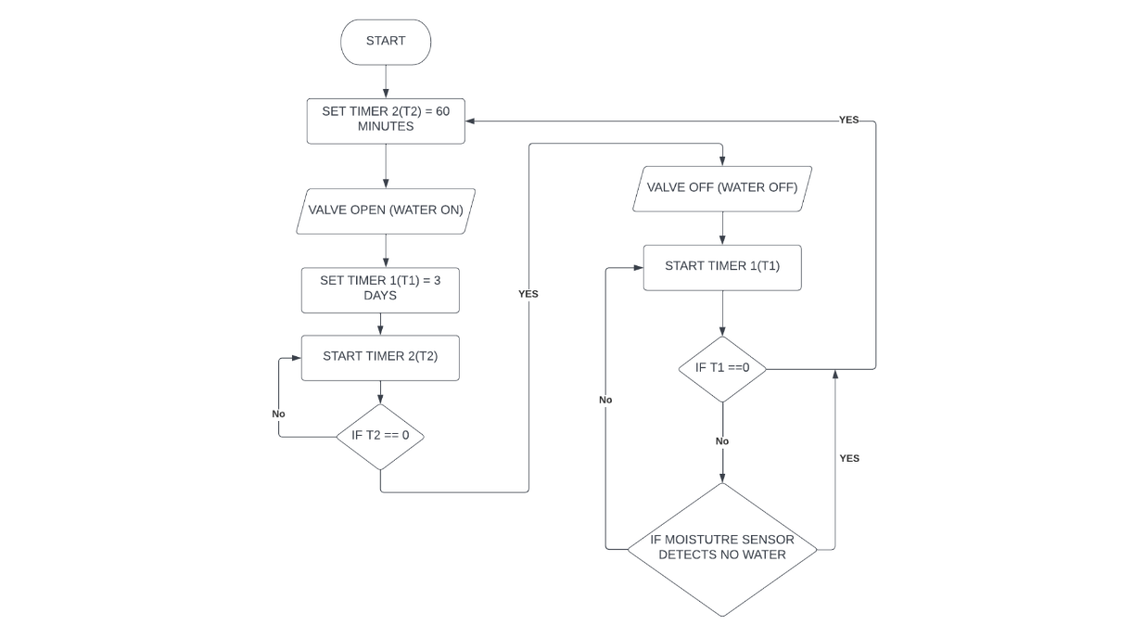

In this system we have planned there are 2 :

Timer 1=to keep motor off

Timer 2=to keep motor on

Firstly system start. and timer 2 and timer 1 get setted for 5 mins and 3 days respectively .At the starting of the system motor turn on and simultaneously timer 2 start as soon as timer 2 reaches zero motor turns off. Then timer 1 stared motor stay off until timer 1 reaches to zero as soon as timer 1 reaches to zero motor turned on again timer 2 start and cycle continues.to the interconnection moisture sensor and the timer we have provided addition input signal of to the microcontroller .when microcontroller receives a signal of water inefficiently then it turns on the motor . and again timer 2 start and cycle continues.

**BENEFITS:**

1)Integration of two system is achieved .

2)due to proper measurement of how much time should the motor kept on so that crop gets proper water so overall efficiency is increases

**DEMERITS:**

1. No real time control
2. If power supply gets off and on irregularly then whole cycle is disturbed.

To overcome this we need to give information about real time and date to microcontroller on which it processer and take decision. To do so we have integrated rtc module which requires i2c communication protocol. through which it gives real time day and date to the microcontroller. After discussion we come to know that the ds3231 is best for our project,

**HOW RTC WOKS?**

1)Basically RTC module has various registers who keeps data about day ,date ,month ,hour, second ,minute ,hour, respectively.

2)so firstly we have to manually insert current date and time into the respective registers of RTC. after that RTC automatically increases updates second ,minute

3)reading phase=

We have to give command to RTC to receives into about time and date from respectively register. this time and date are saved in various variables and updated time to time.

**What is I2C?**

I2C is a protocol which is used to connect various devices to microcontroller using only pins.

The RTC is connected to I2C which acts a communicators between RTC and microcontroller.

One taken as master and other taken as slave .master provide information to slave .first during time setting phase microcontroller acts as a master and RTC module act as a slave. Specific address is provided to make write operation on slave.

Now time and date are written on RTC and communication is modified so that RTC acts a master and microcontroller act as a slave.

Specific address is provided to make read operation on RTC ,now the date from registers is copied into variables of microcontroller

This information is in binary form so we have to converted into decimal format.

So we have wrote the function binary to decimal form. This values are then compared with the presented value of date and time if it matches then command is provided to turn on the motor.

Further we have developed the algorithm for one month irrigation plan for coriander.

Which is explained in further flowchart.

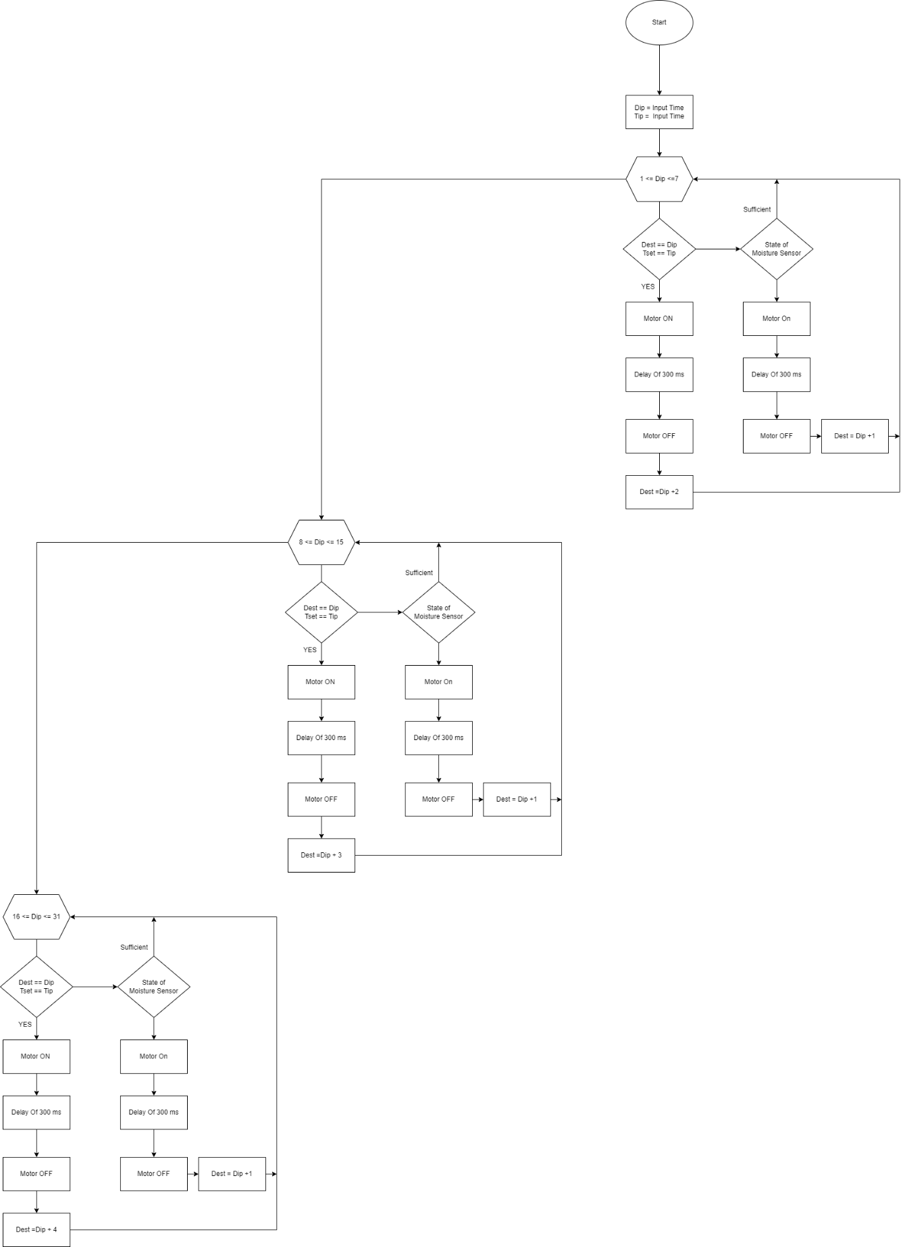**Flowchart:**

**EXPLANATION OF FLOWCHART:**

**For 1st week:**

The microcontroller does write operation on the RTC module now the continuous time and date are transferred to the microcontroller and value of date and time are copied into Dip=Tip variables **.**Now if Dip (input date is less than 7)then the loop for week 1 got executed. now if input date and input time are matched with the set date and set time then the motor turned ON.Then proper delay it applicable to keep motor turned on for few minute after that signal is provided so that motor turns OFF. Then Dset (set date)is increased by 2 days(Dset=Dset t)And it again jump to weak condition check unless date is not move than 7 it stay in some loop. Now if the set date and set time are not equal to input date and input time then moisture comes into play.it checks the moisture level of soil. if sufficient then again jumped to week check in condition if it is insufficient. then it bypasses timer and turn on the motor.after delay motor turn off. again Dset is changed to (Dset T1) and jumped weak check condition if date is grater than 7 and less than 15 it enter into second loop.

**For 2nd week:**

Now if Dip (input date is less than 15)then the loop for week 2 got executed. now if input date and input time are matched with the set date and set time then the motor turned ON.Then proper delay it applicable to keep motor turned on for few minute after that signal is provided so that motor turns OFF. Then Dset (set date)is increased by 3 days(Dset=Dset )And it again jump to weak condition check unless date is not move than 15 it stay in some loop. Now if the set date and set time are not equal to input date and input time then moisture comes into play.it checks the moisture level of soil. if sufficient then again jumped to week check in condition if it is insufficient. then it bypasses timer and turn on the motor.after delay motor turn off. again Dset is changed to (Dset T1) and jumped weak check condition if date is grater than 15 and less than 30 it enter into third loop.

**For 3RD week:**

Now if Dip (input date is less than 30)then the loop for week 3 got executed. now if input date and input time are matched with the set date and set time then the motor turned ON.Then proper delay it applicable to keep motor turned on for few minute after that signal is provided so that motor turns OFF. Then Dset (set date)is increased by 3 days(Dset=Dset t)And it again jump to weak condition check unless date is not move than 30 it stay in some loop. Now if the set date and set time are not equal to input date and input time then moisture comes into play.it checks the moisture level of soil. if sufficient then again jumped to week check in condition if it is insufficient. then it bypasses timer and turn on the motor.after delay motor turn off. again Dset is changed to (Dset T1) and jumped weak check condition if date is grater than 30 .it enter into first loop.