**Project Report On**

**Online Jobplacement System**

**By**

**Pagare Pooja Sanjay [07]**

**Sonawane Gayatri Anil [05]**

**Deore Bhagwati Chandrakant [36]**

**Under the Guided of**

**Dr. Amit Kasliwal**

**Submitted In Partial Fulfillment of**

**T.y.Bsc(Comp sci)**

**SAVITRIBAI PHULE PUNE UNIVERSITY**

**(2018-2019)**



**CERTIFICATE**

This is to certify that, the project entitled _______________________________________ submitted to Department of Computer Science, is a bonafide record of work done by ___________________________________________, Roll No. ____, Uni. Seat No. _______ under my supervision for the partial fulfillment of T. Y. B. Sc. (C. S.) in Lab Course III (CS-349) during academic year 2018-2019.

Project Incharge

D. J. Deore

Internal Examiner External Examiner

**Project Progress Report**

**Acknowledgment**

It gives as great

Pleasure and satisfaction in presenting this report an our project work as part of partial fulfillment for bachelor in computer science

Gratitude to several people, it would have been impossible for us to carry out the desire work we like to express our sincerely thank to our department teachers for their guidance throughout project. We would like to express our heartfelt thanks to our H.O.D.

Mr. D.J.Deore sir for their constant support and encouragement during these phase and forgive us valuable suggestion time to time. Last but not list we are to thankful to our family members and friends for their silent cooperation and passion, and all known and unknown person who helped us in this duration.

**Index**

1. Introduction

2. Working of Existing System

3 .Objective of Proposed System

4.1 Technical Feasibility

4.2 Economical Feasibility

4.3 Operational Feasibility

4.4 Social Feasibility

4.5 System Requirement

5. System Requirement

6. System Diagram

7. System Screen

8. Testing

9. Future Enhancement

10. Bibliography

**ONLINE JOB PLACEMENT**

**INTRODUCTION**

This project *Online Job Placement System* is an online website in which jobseekers can register themselves online and apply for job and attend the exam. Online job placement System provides online help to the users all over the world.

This project *Online Recruitment System* is an online website in which jobseekers can register themselves online and apply for job . Online Recruitment System provides online help to the users all over the world. Such sites also make it possible for recruiters and companies to post their staffing requirements and view profiles of interested candidates. Earlier recruitment was done manually and it was all at a time consuming work. Now it is all possible in a fraction of second. It is all done online without much time consuming. Today’s recruitment applications are designed to do a whole lot more than just reduce paperwork. They can make a significant contribution to a company’s marketing and sales activity. Recruitment websites and software make possible for managers to access information that is crucial to managing their staff, which they can use for promotion decisions, payroll considerations and succession planning.

Online Recruitment System enables the users to have the typical examination facilities and features at their disposal. It resolves typical issues of manual examination processes and activities into a controlled and closely monitored work flow in the architecture of the application. This multi-platform solution brings in by default, the basic intelligence and immense possibilities for further extension of the application as required by the user. The system makes it friendly to distribute, share and manage the examination entities with higher efficiency and easiness. The objective of these websites is to serve as a common meeting ground for jobseekers and employers, both locally and globally, where the candidates find their dream jobs and recruiters find the right candidate to fulfill their needs. These sites are specifically designed for those who seek the most demanding and challenging positions in their chosen field, with the most dynamic employers. Thousands of websites compete for your attention-each has its own unique interface, URL and peculiarities

**Existing System and Its Drawbacks:**

The earlier system is not computerized. All transactions in the system are done manually maintaining records. To make this laborious job simple the clients have to computerize the system. The management and all the departments that have been carrying out this job using manually makes the job more complicated and tedious most of the times. So, the best way is computerize computerization of the current environment. For example, in the earlier system placement officer has to collect student details for placements. Approving those student details takes lot of time. Placement officer and students have to consult each other directly if any information is needed. If any new company come for placements, placement officer and his staff has to search the student details and they have to find the eligible candidates for that particular company placement.

Here searching for eligible candidates takes lots of time. And sometimes some candidates’ details may be missed.

The existing system requires applicants to search through print and visual

Media for job opportunities. Applicants need to apply for jobs using conventional methods and appear for interview on a specified date at a specified location. . In the current manual system jobseekers had to send resumes and cover letters by mail, deliver them in person or fax them, and then wait for an interview request. Employers need to advertise the vacancies and sort all applicant details, conduct selection procedures and complete the formalities. The job application process took quite some time. This approach is tedious and requires much effort and resources. This process was equally frustrating for recruiters, as it often took some time to fill positions with qualified candidates. Online recruitment speeds up and makes the process much more efficient.

**Drawbacks of Existing System:**

It takes so much time for a placement officer to collect students’ details and

approving the details provided by them.

Poor communication between students and placement officer, so here intimating

about new placements is a hard task.

Students may not know about company details. Here also poor communication

provides a problem.

Candidate may not get required information if concerned TPO is not at the desk.

**Disadvantages:**

Non availability of data when required.

Resume sent manually, it is a waste of papers and consumes a lot of time

No database/system to keep track of resume of candidate

Difficulty to search for required job vacancy. It takes a long time for job

seeker.

Inviting applications through post takes a lot of time

**REQUIREMENTS ANALYSIS:**

Requirements analysis is the process of defining what the user requires from the

system and defining the requirements clearly and in an unambiguous state. The outcome of the requirement analysis is the software developing activities. Thus it deals with understanding the problem goals and constraints. This specification part mainly focuses on what had been found during analysis. A requirement is a relatively short and concise piece of information, expressed as a fact. It can be written as a sentence or can be expressed using some kind of diagram.

Requirements are divided into two major types functional and non-functional.

**Functional requirements:**

Following is a list of functionalities of the system. More functionality that you find appropriate can be added to this list. And, in places where the description of functionality is not adequate, you can make appropriate assumptions and proceed.

**Fact Finding**

Fact-finding is one of the important steps toward any system development. It is essential to gather all the information and facts about an existing system to ensure that all strengths and weakness are discovered. Thus when a new system is designed as many of the weaknesses as possible are eliminated, whilst retaining the strengths. There are five general techniques available; those used depend upon the particular circumstances!

· **Sampling of Existing Documents;**

· **Interview;**

· **Observation;**

· **Questionnaires;**

· **Research and Site Visits**

**01. Sampling of Existing Documents:** To follow this particular method of fact-finding, Analyst has to study well existing documentation, forms, and files of existing system. A good analyst gets fact first from existing documentation rather than from people.

**02. Interview:** This technique of fact-finding is most popular, productive for good analysts and most probably widely used. Interviews are a fact-finding technique where by the systems analysts collects information from individual fact to face.

Interviewing can be used to find-facts; verify facts; clarify facts; general enthusiasm etc.

**03. Observation:** Observation could be Formal or Informal. This is most effective when and analyst wants to obtain an understanding of a system. This technique used when analyst wants either participates in or watches a person perform activities to learn about the system.

**04. Questionnaires:** This is a special purpose document that allows the analyst to collect information and opinions from respondents. Questionnaires become useful when a little information is required from a number of people.

**05. Research and Site Visits:** Analyst has to research with data of the organisation. The data could be collect from the documents, files or from computer. Most organisations like to maintain their web site. Analyst can get data and information of their existing system from their web site.

**Hardware and Software Requirement:**

**Hardware Requirement:**

Processor : Pentium IV.

RAM : Minimum 1 GB or Greater.

Hard disk : 500 GB.

**Software Requirement:**

Software : WAMP OR XAMPP.

Software Code : Php, css & java Script

Database : Postgresql 9.3

Operation System : Windows 7 or Linux O.S.(Ubuntu 17.10)

**Feasibility Study:**

Feasibility study is carried out to test if the proposed system is feasible in terms of economy, technology, resource availability etc. As such, given unlimited resources and infinite time, all projects are feasible. Unfortunately, such results and time are not possible in real life situations. Hence it is both necessary and prudent to evaluate the feasibility of the project at the earliest possible time in order to avoid unnecessary wastage of time, effort and professional embarrassment over an ill-conceived system.

1. **Technical Feasibility** :-

The System of operation which was functioning earlier was totally manual, with no kind of automation or computerization. All the departments were maintaining separate registers for keeping various records. Due to expansion of schools more workspace and it appears a tedious task to maintain with specifying equipment and software that online shopping system project report will successfully support the tasks required. As a result the computerized system is technically feasible as it is efficient, less time consuming, can produce outputs faster, can input large amount of data in limited time scale and easier to use in operation

1. **Operational Feasibility** : -

The ultimate users i.e. the people who are supposed to use the system are trained for a period of one month so as to get familiar with the new system and its operation. They are taught about the new skills and the new technology and how the technology will be useful to them in their functioning. Operational feasibility is concerned with human, organizational and political aspects. General impression of these factors is gained from the corporate appraisal.

1. **Economical Feasibility :**

The computerized system is economically feasible in the sense the cost of the hardware and software and the cost to training of personnel of the company to operate the system and the installation cost is less than the cost of maintaining the registers. This online shopping system project may not be a big sum in the long run of the school business. Also the time taken for the entire process of formulation, checking, studying and installation of the project has been equal to one working month of the school. As a result, there has been no hesitation on pert of the management in adopting the new system.

**4) Social feasibility:-**

In this social feasibility the user can easily access our system means our system friendly to our uses or jobseeker .Add also increase their skill .These feasibility take few time of our jobseeker and we will follow their interviews. i.e. Timeless procedure to produce in system**.**

**2.6. INPUT AND OUTPUT**

The main inputs, outputs and major functions of the system are as follows

**INPUTS:**

•Customer enters his or her user id and password.

•Operators enter his or her user id and password.

•Admin enter his or her user id and password.

•User requests the product description.

•User requests the product search.

•User orders product.

•System requests shipping & billing address.

**OUTPUTS:**

•Customer receives personal and order details.

•Operator receives the personal details.

•Admin receives order details.

•Users receive requested product details.

Project Report

•Users receive orders.

•System processes orders.

**System Diagram-:**

**ER Diagram-:**

M

M

1

M

M

M

M

1

1

M

M

M

M

1

1

User

Was

Registration

See

Brow-ses

Online-job Placement

Has

eid

Jobseeker name

image

Price

job-id

Search

Jobseeker

Employer

ename

descripth

Maintains

Added-to

does

Payment

Admin

Resume

Gives

News

User-id

News_details

N-date

Seeee

**Class Diagram-:**

Admin Master

Adminid:int

Username:char varying[20]

Pass: :char varying[30]

Login()

Registration()

Logout()

Add_User()

Add_Jobs()

View_Company()

Jobseeker_Registration

jobseekerid: int

jobseeker_name:char varying[20] address:char varying[50]

email:char varying[20]

mobile: int

username:char varying[20]

pass: int

registration()

login()

delete()

View_Order()

Job_Master

jobid:int

c_name:char varying[20]

Qualification:int

Company_Add:charvarying[20]

Item_add()

delete()

View()

1

has

•

1

1

•

origin

•

1

•

1

Origin

Destination

has

Employer master

Employer_id:int

Employer_name:char varying[30]

Pass:int

Description:char varying[20]

Employer _add()

delete()

View_employer()

Company Master

company_id:int

jobseeker_id:int

company_name:char varying[40]

Requirment:int

Qualification:cahrvaring[20]

address:charvaring[20]

Company_add()

delete()

View_company ()

News_master

job_id:int

cid:int

emp_id:int

Status:char varying[30]

Description:char varying[20]

News_deatail()

delete()

View_News()

**Use case Diagram:-**

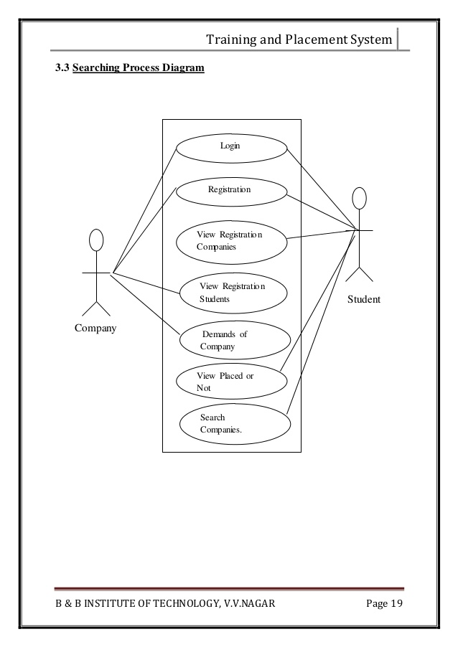

Activity Diagram

Login

Registration

Manage Jobseeker

Manage

User

Manage Jobs

Show Database

Logout

No

Yes

**Sequence Diagram**

Jobseeker

Employer

Company Details

Job Master

Database

**Login**

Add jobs () ( )

Insert company ( )

( )

Execute New Query ( )

( )

Execute Query ( )

( )

Show Result ( )

Return Response ( )

( )

Response to execute new Query ()

(

**Deployment Diagram :-**

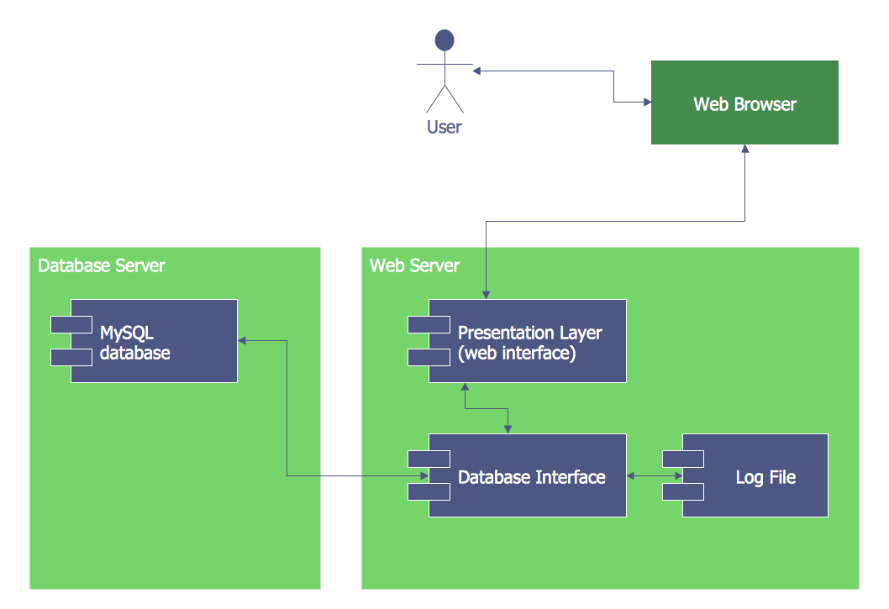

**Observation**

As I visited many shops for getting their invoice, I’ve observe their work style, activity well. I see most of their client system. But again for confidentially and software license they didn’t agree to show me their server system.

By observing shops I greatly understand the system of Point of Sales and all of my lacking knowledge about a POS become clear.

I watch their product cost in a sticker labelled in the products body, date validation in that label for date oriented product and non-date oriented products. By observing one shop I got the idea for fixing product rate in every product purchase invoice.

**Data Dictionary**

**1. Admin Master :-**

|  |  |  |  |
| --- | --- | --- | --- |
| Field Name | Data type | Size | Keys |
| id | integer | - | Primary key |
| Sname | Character varying | 20 | - |
| Address | Character varying | 20 | - |
| Qualification | Character varying | 20 | - |
| Email | Character varying | 20 | - |
| Password | Character varying | 20 | - |

**2. Application Master :-**

|  |  |  |  |
| --- | --- | --- | --- |
| Field name | Data type | Size | Keys |
| Applicationid | integer | - | Primary key |
| jobseekid | integer | - | Foreign Key |
| jobid | integer | - | Foreign Key |
| Status | Character varying | 30 | - |
| Description | Character varying | 200 | - |

**3. Employer Registration:-**

|  |  |  |  |
| --- | --- | --- | --- |
| Field name | Data type | Size | Keys |
| Employerid | integer | 11 | Primary key |
| Company name | Character varying | 20 | - |
| Contact person | Character varying | 20 | - |
| Saddress | Character varying | 100 | - |
| City | Character varying | 20 | - |
| Email | Character varying | 30 | - |
| Mobile | bigint | 20 | - |
| Area_work | Character varying | 40 | - |
| Status | Character varying | 10 | - |
| Username | Character varying | 20 | - |
| Jpassword | Character varying | 30 | - |
| Question | Character varying | 100 | - |
| Answer | Character varying | 50 | - |

**4. Feedback:-**

|  |  |  |  |
| --- | --- | --- | --- |
| Field name | Data type | Size | Keys |
| Feedbackid | integer | 11 | Primary key |
| Jobseekid | integer | 11 | Foreign Key |
| Feedbackdate | date | 11 | - |
| Feedback | Character varying | 200 | - |

**5. Job Master :-**

|  |  |  |  |
| --- | --- | --- | --- |
| Field name | Data type | Size | Keys |
| Company name | Character varying | 20 | - |
| Jobtitle | Character vaying | 50 | - |
| Vacancy | integer | 11 | - |
| Min  qualification | Character varying | 50 | - |
| Description | Character varying | 200 | - |
| Jobid | integer | 11 | Primary key |

**6. Jobseeker Education :-**

|  |  |  |  |
| --- | --- | --- | --- |
| Field name | Data type | Size | Keys |
| Eduid | integer | 11 | Primary key |
| Jobseekid | Character varying | 11 | - |
| Degree | Character varying | 20 | - |
| University | Character varying | 100 | - |
| Passingyear | Character varying | 10 | - |
| Percentage | Double precision | 11 | - |

**7. Jobseeker Registration :-**

|  |  |  |  |
| --- | --- | --- | --- |
| Field name | Data type | Size | Keys |
| Jobseekid | integer | Not null | Primary key |
| Jobseekname | Character varying | 20 | - |
| Address | Character varying | 100 | - |
| City | Character varying | 20 | - |
| Email | Character varying | 40 | - |
| Mobile | bigint | Not null | - |
| Qualification | Character varying | 20 | - |
| Gender | Character varying | 10 | - |
| Birthdate | Date | Not null | - |
| Resume | Character varying | Not null | - |
| Status | Character varying | 10 | - |
| Username | Character varying | 20 | - |
| Password | Character varying | Not null | - |
| Question | Character varying | Not null | - |
| Answer | Character varying | 50 | - |

**8. News Master:-**

|  |  |  |  |
| --- | --- | --- | --- |
| Field name | Data type | Size | Keys |
| Newsid | integer | - | Primary key |
| News | Character varying | - | - |
| Newsdate | Date | - | - |

**9. User Master:-**

|  |  |  |  |
| --- | --- | --- | --- |
| Field name | Data type | Size | Keys |
| Userid | integer | - | Primary key |
| Username | Character varying | 20 | - |
| Password | Character varying | 20 | - |

**10. Walkin Master:-**

|  |  |  |  |
| --- | --- | --- | --- |
| Field name | Data type | Size | Keys |
| Walkinid | integer | - | Primary key |
| Companyname | Character varying | 20 | - |
| Jobtitle | Character varying | 50 | - |
| Vacancy | integer | - | - |
| Minqualification | Character varying | 10 | - |
| Description | Character varying | 100 | - |
| Interviewdate | Date | - | - |
| Interviewtime | Date time without time zone | - | - |

**Home Page**

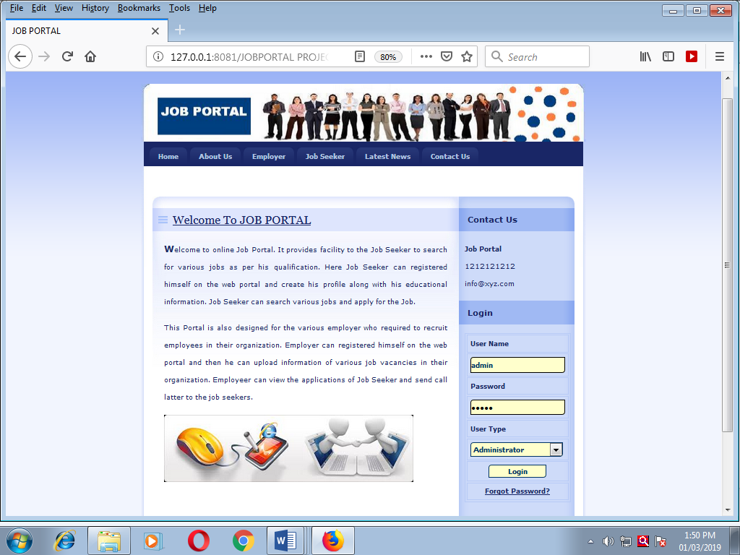

**Jobseeker Login**

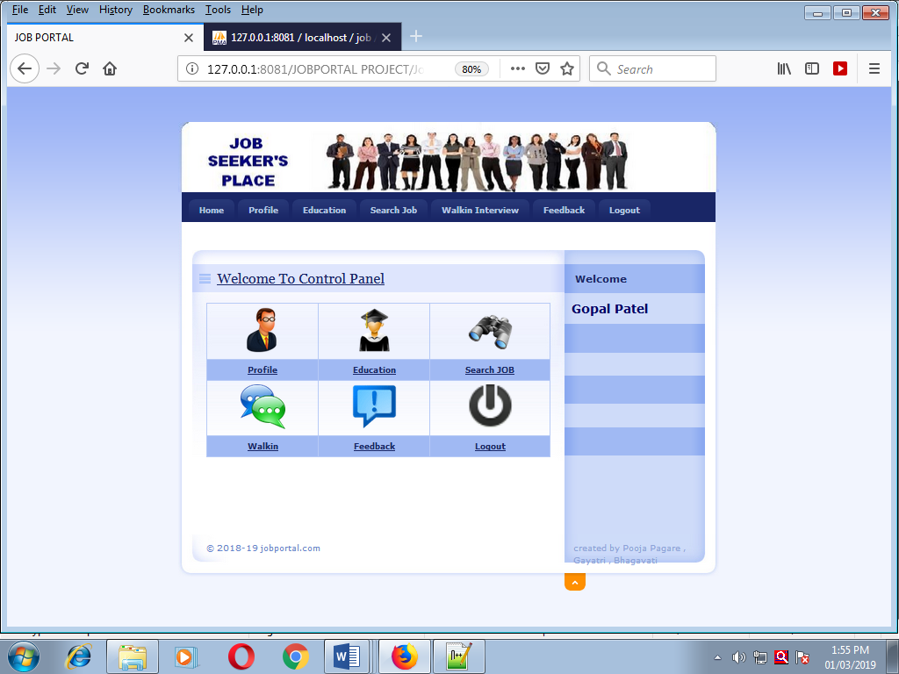

**Search Job-:**

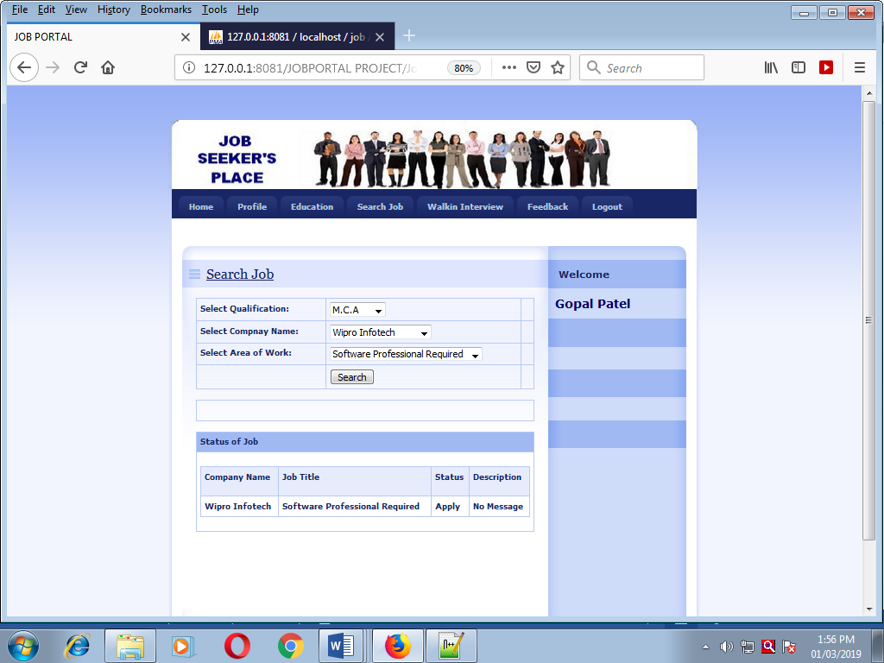

**Walk-in Interview-:**

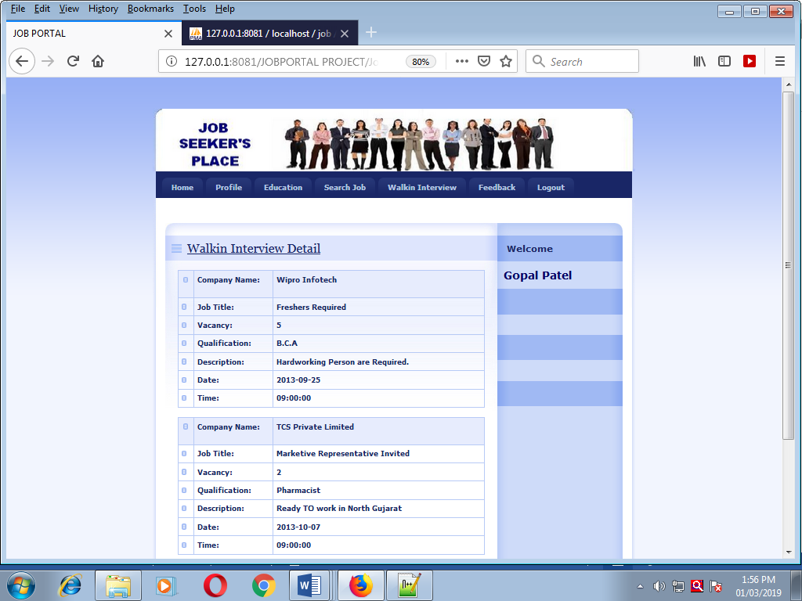

**Manage Jobs-:**

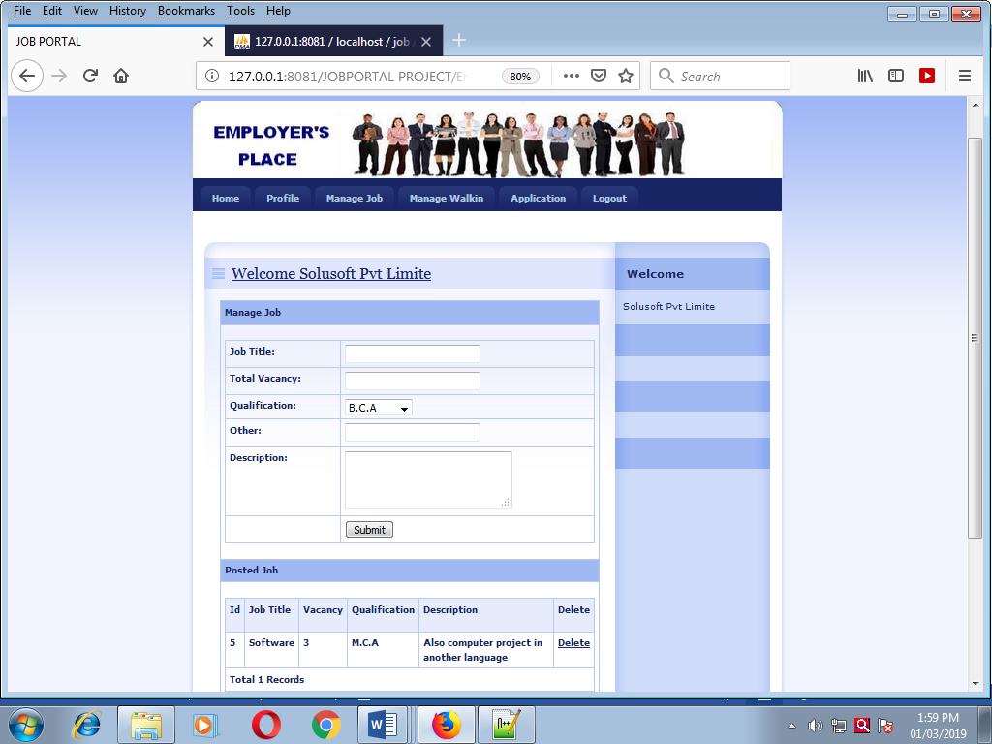

**Admin Page-:**

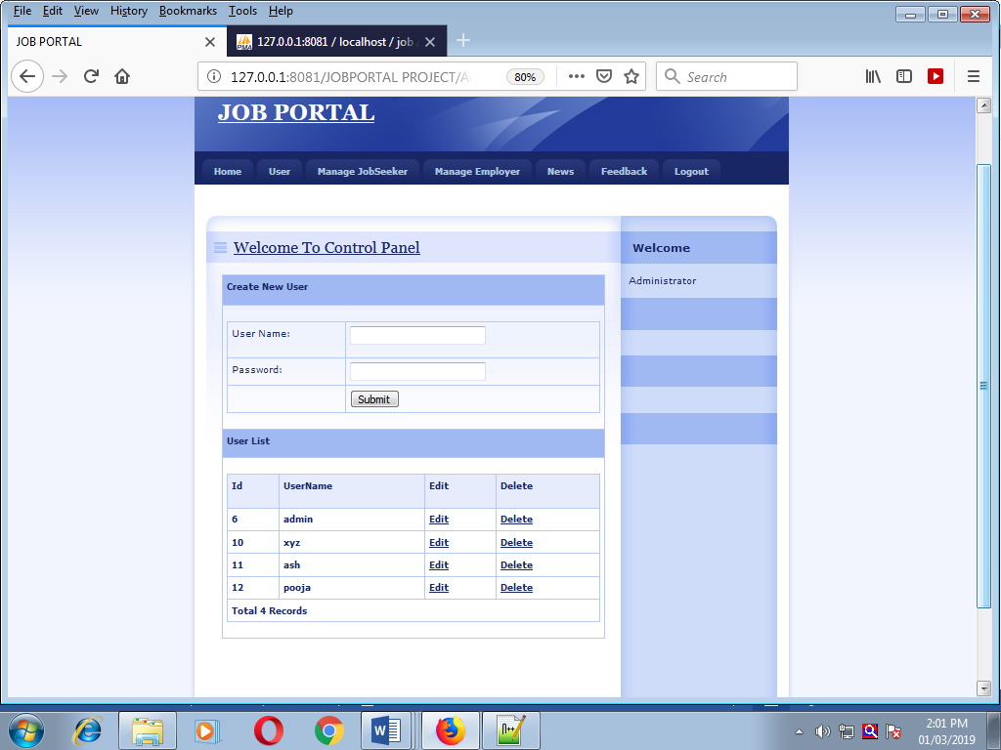

**Testing:-**

The process of executing a system with the intent of finding an error. Testing is defined as the process in which defects are identified, isolated, subjected for rectification and ensured that product is defect free in order to produce the quality product and hence customer satisfaction. Quality is defined as justification of the requirements. Defect is nothing but deviation from the requirements .Defect is nothing but bug. Testing --- The presence of bugs. Testing can demonstrate the presence of bugs, but not their absence. Debugging and Testing are not the same thing. Testing is a systematic attempt to break a program or the AUT. Debugging is the art or method of uncovering why the script /program did not execute properly.

1. **Black Box Testing –**

Is the testing process in which tester can perform testing on an application without having any internal structural knowledge of application. Usually Test Engineers are involved in the black box testing. In this testing we can give input and the system gives perfect output if input is right.

**2. White Box Testing –**

Is the testing process in which tester can perform testing on an application with having internal structural knowledge.

Usually The Developers are involved in white box testing.

**3. Alpha Testing –**

It is a type of user acceptance testing, which is conducted on an application when it is just before released to the customer.

**Future enhancement:-**

# 

* As the technology emerges, it is possible to upgrade the system and can be adaptable to desired environment.
* Because it is based on object oriented design, any future change can be easily adaptable.
* Base on future security issues can be improved using emerging technique.

1. **Bibliography:-**
3. **1.** Web database application by Hugh E.Williams
5. 2. Web application with postgresql by David Lane
7. 3. Web authoring tools by Al Stevens