**Hardware and Software Requirement:**

**Hardware Requirement:**

Processor : Pentium IV.

RAM : Minimum 1 GB or Greater.

Hard disk : 500 GB.

**Software Requirement:**

Software : WAMP OR XAMPP.

Software Code : Php, css & java Script

Database : Postgresql 9.3

Operation System : Windows 7 or Linux O.S.(Ubuntu 17.10)

1. **Economical Feasibility :**

The computerized system is economically feasible in the sense the cost of the hardware and software and the cost to training of personnel of the company to operate the system and the installation cost is less than the cost of maintaining the registers. This online shopping system project may not be a big sum in the long run of the school business. Also the time taken for the entire process of formulation, checking, studying and installation of the project has been equal to one working month of the school. As a result, there has been no hesitation on pert of the management in adopting the new system.

**4) Social feasibility:-**

In this social feasibility the user can easily access our system means our system friendly to our uses or jobseeker .Add also increase their skill .These feasibility take few time of our jobseeker and we will follow their interviews. i.e. Timeless procedure to produce in system**.**

**System Diagram-:**

**ER Diagram-:**

User

Was

Registration

See

Brow-ses

Online-job Placement

Has

eid

Jobseeker name

image

Price

job-id

Search

Jobseeker

Employer

ename

descripth

Maintains

Added-to

does

Payment

Admin

Resume

Gives

News

User-id

News_details

N-date

Seeee

M

1

M

M

M

M

1

M

M

1

1

M

M

1

M

**Class Diagram-:**

Admin Master

Adminid:int

Username:char varying[20]

Pass: :char varying[30]

Login()

Registration()

Logout()

Add_User()

Add_Jobs()

View_Company()

Jobseeker_Registration

jobseekerid: int

jobseeker_name:char varying[20] address:char varying[50]

email:char varying[20]

mobile: int

username:char varying[20]

pass: int

registration()

login()

delete()

View_Order()

Job_Master

jobid:int

c_name:char varying[20]

Qualification:int

Company_Add:charvarying[20]

Item_add()

delete()

View()

1

has

•

1

1

•

origin

•

1

•

1

Origin

Destination

has

Employer master

Employer_id:int

Employer_name:char varying[30]

Pass:int

Description:char varying[20]

Employer _add()

delete()

View_employer()

Company Master

company_id:int

jobseeker_id:int

company_name:char varying[40]

Requirment:int

Qualification:cahrvaring[20]

address:charvaring[20]

Company_add()

delete()

View_company ()

News_master

job_id:int

cid:int

emp_id:int

Status:char varying[30]

Description:char varying[20]

News_deatail()

delete()

View_News()

Activity Diagram

Login

Registration

Manage Jobseeker

Manage

User

Manage Jobs

Show Database

Logout

No

Yes

**Sequence Diagram**

Jobseeker

Employer

Company Details

Job Master

Database

**Login**

Add jobs () ( )

Insert company ( )

( )

Execute New Query ( )

( )

Execute Query ( )

( )

Show Result ( )

Return Response ( )

( )

Response to execute new Query ()

(

**Home Page**

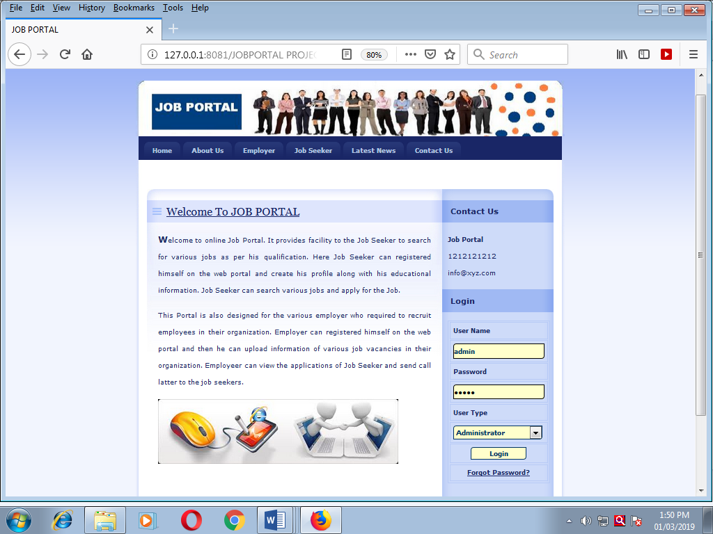

**Jobseeker Login**

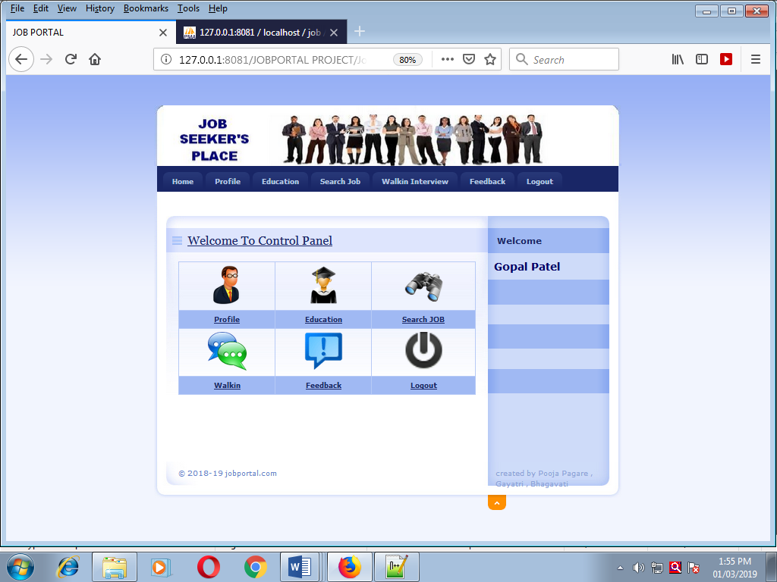

**Search Job-:**

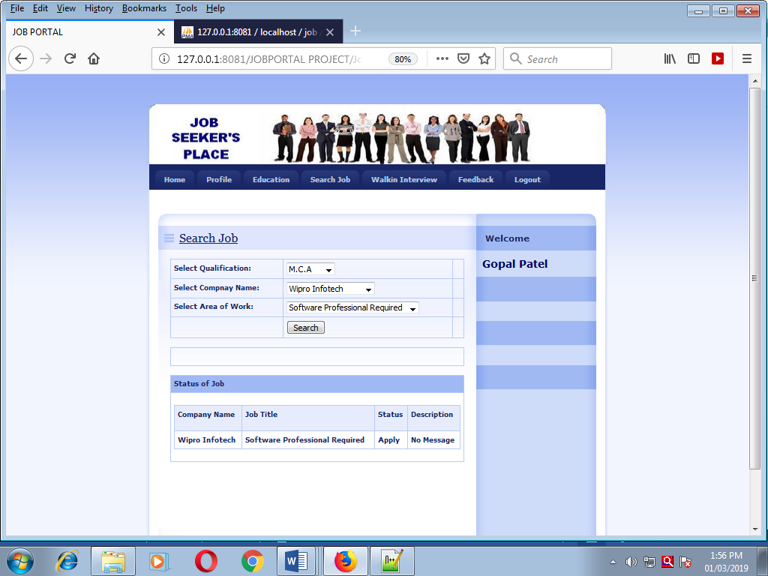

**Walk-in Interview-:**

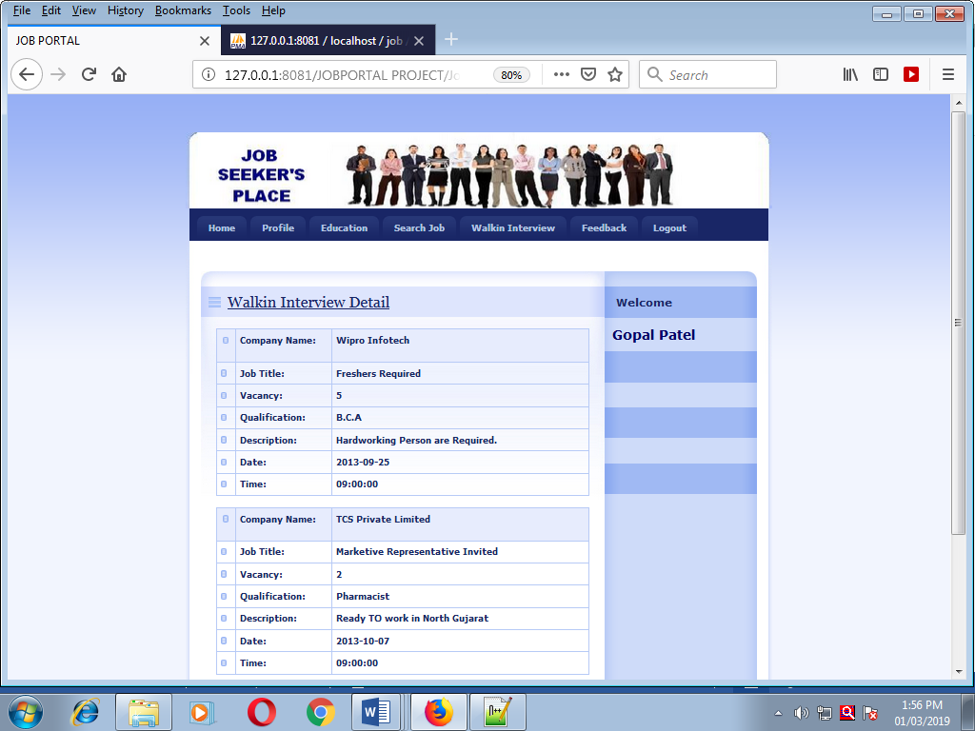

**Manage Jobs-:**

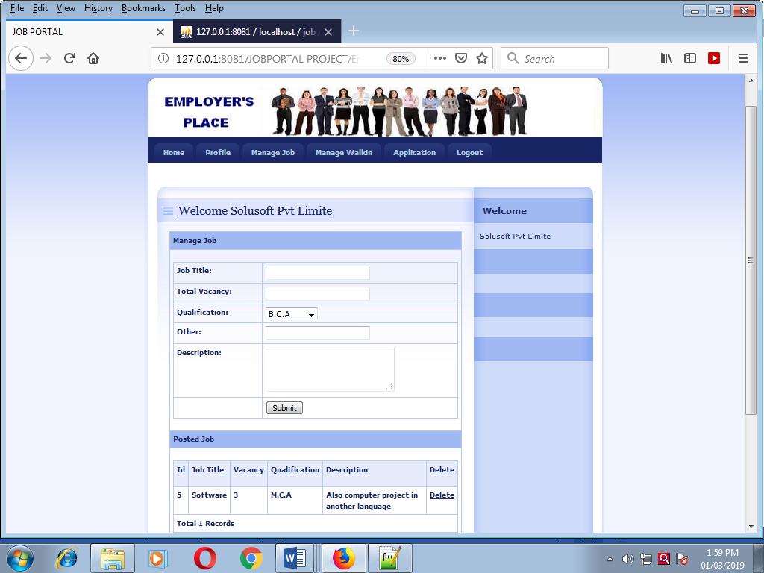

**Admin Page-:**

