

***BAHIR DAR INSTITUTE OF TECHNOLOGY***

***FACULTY OF COMPUTING***

***SOFTWARE ENGINEERING DEPARTMENT***

***SOFTWARE TOOLS AND PRACTICE***

***PROJECT ON HUMAN POPULATION CENSUS SYSTEM FOR ETHIOPIA***

***GROUP MEMEBERS: ID NUMBER:-***

***1. DEJEN ASCHALEW………………………………………………..……………………….1102467***

***2. MEBRHATU AWOKE……………….……………………………………………….......1102274***

***3. MINUYELET ENTEWEW………………………………………………………………….1101919***

***4. DESALEGN GETACHEW…………………………………………………………………..1102419***

***5. DANIEL GETANEH…………………………………………………………………………..1102203***

***6. DAGIMAWI AMARE……………………………………………………………………....1102462***

***ACKNOWLEDGEMENT***

First of all, we will give thanks for our GOD by wishing to help us the project completion. Second, we would want to say, “Thank you very much!” for our teacher Mrs. Mintesnote A. who is our Software tools and practice teacher because of giving the project which expand our knowledge and give us wide experience for future time.

***INTRODUCTION***

***Backgrounds of Population Census in Ethiopia***

Ethiopia, in its modern history conducted three national censuses. The first census was conducted back in 1984, during the Military Regime (Derg). Back then, the census only covered 81 percent of the population of the country and the total number of was said to be around 34.5 Million people.

Ethiopia has conducted its second and third population and housing census in 1994 and 2007 respectively. Basically, the current FDRE constitution dictates census to be conducted every ten (10) years. But following the 1994’s census, the EPRDF led-government decided to conduct the third census in 2007. This is because of the pre and post 2005’s general election crisis.

Yet, the 1984 census was much inclusive than the previous ways of counting population. The government, both the Imperial and the Military regime, have been using sample surveys to estimate the demographic surveys, where the first round was done in 1964/5 and continued until 1984. Over those 20 years, the country has conducted five surveys and using it as a source of demographic data. However, those surveys were not data and inclusive enough and most of the time didn’t include sedentary populations as well as those who live in rural areas.

The fourth census was held in April, 2019 with close to 200,000 experts, supervisors and enumerators. In addition to this, the proposed census was unique in many ways. Unfortunately, even if the government was in series of campaign and meetings all over the country as part of its preparation to conduct the census, some political groups were calling for extension of the upcoming census because of political crisis.

***Statement of the problem***

In an attempt to find facts and discover realistic problems and opportunities for improving the enumerating business process, the team gave and identified the following problems.

* The census system of the country is traditional that without technologies.
* The census method is tedious that requires a large budget and enormous amount of money as well as man power.
* There are drawback of shortage of transportation, to access data of each individual and forms.
* The data of each citizen were not collected for future use. Because the data collected in the past will use for the future census.
* Politically, there were crisis between states and central government because of counting one state more than the other.

***Objectives***

1. **General objectives:-**

The general objective of the project is to automate the placement and to count population and information services fairly, timely and successfully of the country.

1. **Specific objective:-**

To achieve the aforementioned general objective, the project will also address the following specific objectives

1. Identification and definition of the problem.

2. Business area analysis

2.1. Organizational profile: Relevant information about the organization, mission, locations, numbers and type of personnel, and relationships or interfaces with other organizations and entities, as they relate to the system task.

2.2. Business Functions: Processes, timing of critical processes and procedures by the users in the being automated or modified.

2.3. Component or system descriptions: Introduction to the component or system that is covered by the specification.

2.4. Deficiencies Portrays any problems experienced by the current process

3. Generation of requirement

3.1. Goals: a clear list of the expectations of a new system both in terms of what must be improved and what must be retained from the current processes.

3.2. Functional Requirement: requirements that deal with the fundamental processes of the system.

-Input and output requirements

-Data requirements

3.3. Non Functional Requirement: requirements that deal with the quality aspect of the system.

- Performance requirements

-System security requirements

-Backup and Recovery Requirements

-System and Communication Requirement

4. Object Oriented Analysis

To identify what will be build and clearly understand the problem domain of the system.

5. Object oriented design

Define how the system will be build and to clearly show the solution domain of the system.

1. **Scope and Limitation of the project**
2. **Scope:-**

Due to time, manpower, material and other constraints, the project is limited to automate;

* Placement section
* Family records and information section

1. **Limitation:-**

The project does not include;

* The system is only applicable for human being
* The system does not let accessed for other organization like political parties.

1. **Significance of the project**

This system is very useful to reduce many problems in different aspects like political, economic…etc.

For example:-

* Reduce the number of days placement activities
* Reduce resource wastage
* Needs few work force
* Faster decision making
* Reduce errors
* Creates satisfied workforce
* Supplies timely information for CSA

**Proposed System**

* Our System provides the searching based on status, priority, and operating system.
* It provides with user and professionals, which would be helpful in controlling the Enumeration system.
* It is provided with a fully authenticated system with password encryption. And has the facility for storing attachments for an enumeration.
* One can enumerate easily without going to enumeration station.
* The most advantage of this system is maintaining the citizen to enumerate easily.

**Functional requirements**

* Enumerator, Citizen, Supervisor and CSA shall be able to Login to thesystem.
* The system shall allow administrator to Add/ Edit new advisor, supervisor and enumerator.
* The system shall allow administrator to Add/ Edit priority to the Enumeration.
* The system shall allow administrator to add new projects to the system.
* The system shall allow administrator to add new modules to the existing projects.
* The system shall allow administrator to generate reports corresponding to the status of each enumeration i.e. is it under process, completed or pending?
* The system shall allow administrator to add new employee or update existing employee’s status in the system.
* The system shall allow administrator to assign the place/site to a particular employee.
* The system shall allow the CSA to view the information related to each site in the system.

**Non-Functional Requirements**

* The system shall be able to submit/search or any other activities done through the system in short time.
* The system shall allow the users to navigate between pages in short time.
* The system shall be able to generate error free report within a minimum minute.
* The system shall use Oracle database engine to run queries

**Software and Hardware Requirements**

Software Requirements

* A set of programs associated with the operation of a computer.
* Software is the part of the computer system which enables the user to interact with several physical hardware devices.
* The minimum software requirement specifications for developing this project are;
  + Eclipse
* Git-bash
* ArgoUML
* UML diagramed

## Hardware Requirement Specification

* The Collection of internal electronic circuits and external physical devices used in building a computer is called Hardware.
* The minimum hardware requirement specification for developing this project is as follows:
* Processor
* RAM
* Flash Disk
* Hard Disk

**Class diagram**

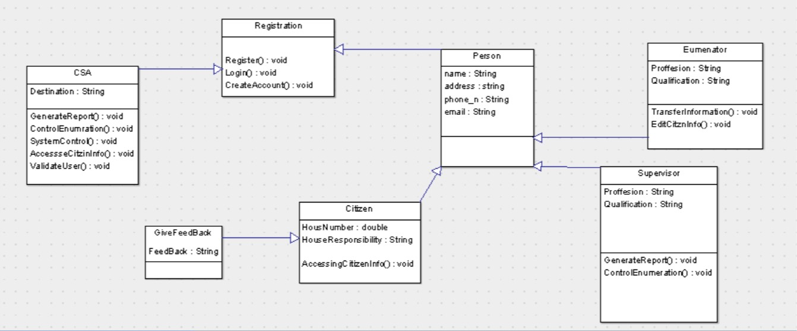**Use case diagram**



**Description of Use cases**

Name: Registration

Description: register a person as a user.

Pre-condition: the person is chosen as a user.

Post-condition: the user is registered as a user either an enumerator or a citizen or as a supervisor.

**Basic course of action A**

* + 1. Registration clerk wants to register new employee.
    2. The population census system shows the registration interface.
    3. The system registers the user.
    4. The use case ends.

**Alternative course of action-1:**

* 1. The user submit full name, ID, sex, address, date of birth, nationality, ethnic group, employment date, pension number, marital status.
  2. The user input job code, grade, the type of language the employee speak, read and write, education level, college and field of study and salary.
  3. The population census system the correctness of the entered information according to the business rule “BR2.1 validate user information”.
  4. The use case resumes at step-A.3.

**Alternative course-2: The entered information is incorrect**

* 1. The population census system determines the entered information is correct.
  2. The system informs the entered information is incorrect and prompts to re-enter the information.
  3. The use case resumes at step 1.3.

Name: transfer information

Description: transfer the information of enumerated person to the server.

Pre-condition: the enumerator must be registered at the system legally.

Post condition: the information of the enumerated persons (families) is transferred (uploaded) to the server.

**Basic course of action**

1. Transfer clerk wants to transfer information.
2. Transfer clerk submits personal information of enumerated person (families).
3. Population system verifies the validity of the entered information according to business rule “BR 3.validate the transferred data”.
4. The system transfer information.
5. The use case ends.

Alternative course of action-B: the entered information is incorrect.

B.3 the system determines the entered information is incorrect.

B.4 the system informs the entered information is incorrect and prompts to re-enter the information.

B.5 the use case resumes at step 2.

Name: login

Description: entered into the population census system

Pre-condition: the user must registered and create account

Post condition: The users can access to access the system.

**Basic course of action**

1. The user wants to login into the system.
2. The user enters his/her user name and password.
3. The system validates the entered user name and password according to the business rule.
4. The use case ends.

Alternative course of action-C: the entered user name and password is incorrect.

C.3. the system determines the entered information is incorrect.

C.4. the system informs the entered information is incorrect and prompts to re-enter the correct user name and password.

C.5. the use case resumes at step 2.

Name: Generate report

Description: generate the report specified.

Pre-condition: Supervisor must register and be legal for his power.

Post condition: report is generated.

**Basic course of action**

1. The supervisor wants to generate a report.
2. The supervisor enters to the system via “UC1. System login screen”.
3. The supervisor selects report generation from “main menu screen”.
4. The system display report generation screen.
5. The supervisor writes attributes to be generated from “UI11.Report generate screen”.
6. The supervisor satisfies the criteria that the attribute must hold.
7. The system generates the report
8. The use case ends.

The alternative course and other use case descriptions are much similar to the above ones. But adding these use case description add a lot of clutter without adding much useful information.

**USER story**

* As an Enumerator, I would like to submit citizen’s info in order to store their info in the server.
* As a supervisor, I would like to manage enumeration and project of the system.
* As Citizen, I would like to give appropriate information.
* As a CSA, I would like to manage overall the enumeration system.

Sequence Diagram

Login





**Figure 4.2 Sequence diagram for transfer**



# Activity Diagramming

Activity diagram is used to document the logic of a single operation/method, a single use case the flow of logic of a business process. It is equivalent to flowchart and data flow diagram from structured development (Ambler).







Registration class to be tested

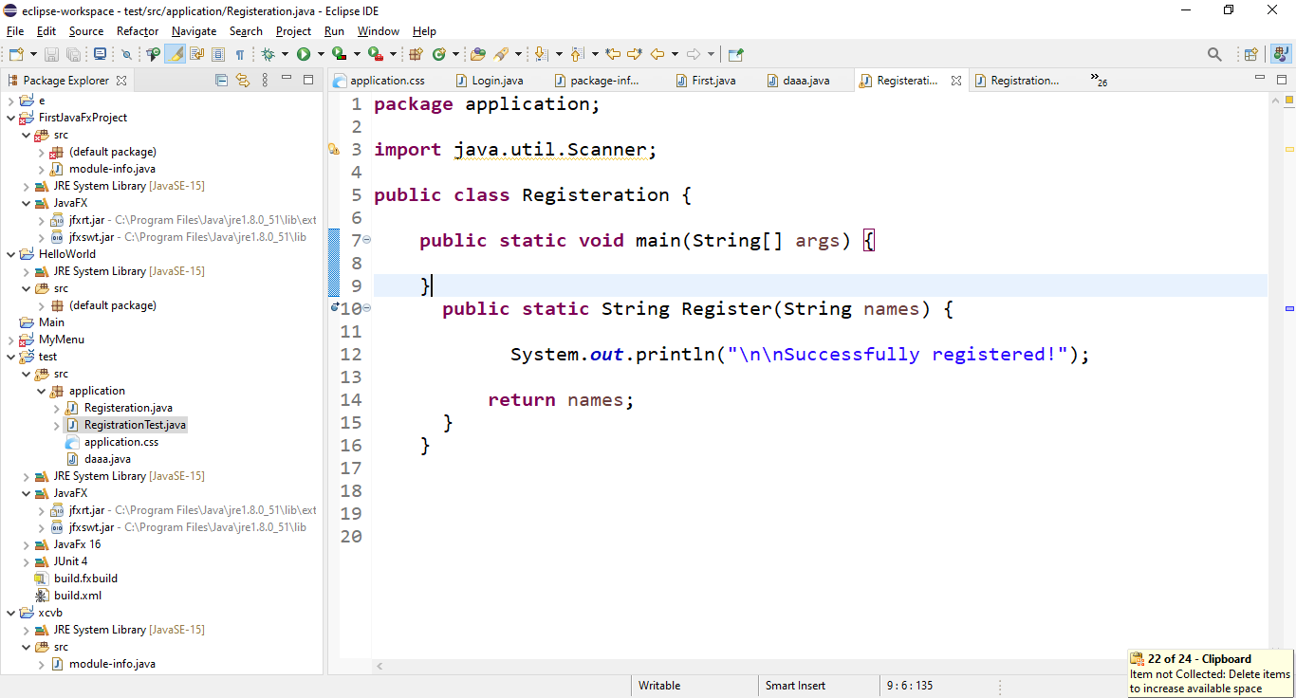

Test Case for the method Registration i.e. the method for which registers name

Test successfully.

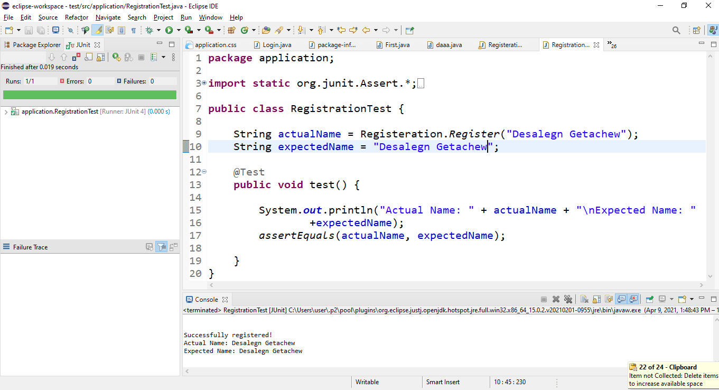

Test Case fail

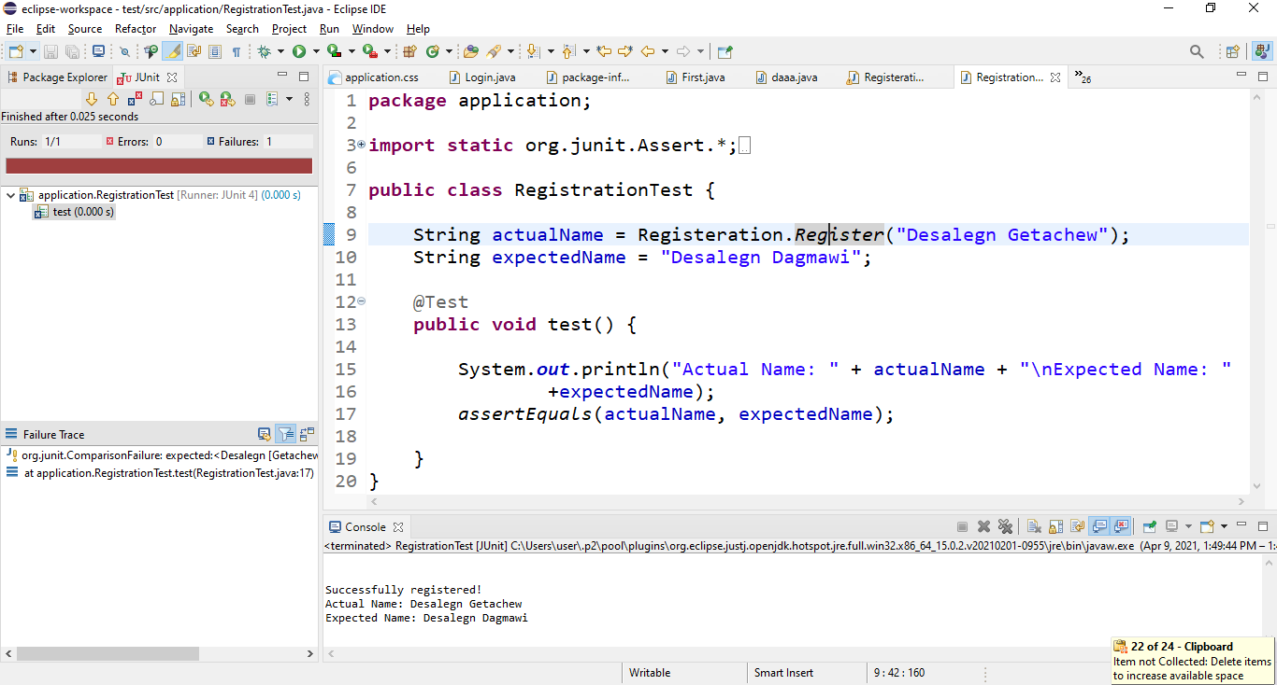

Git hub Pushing process

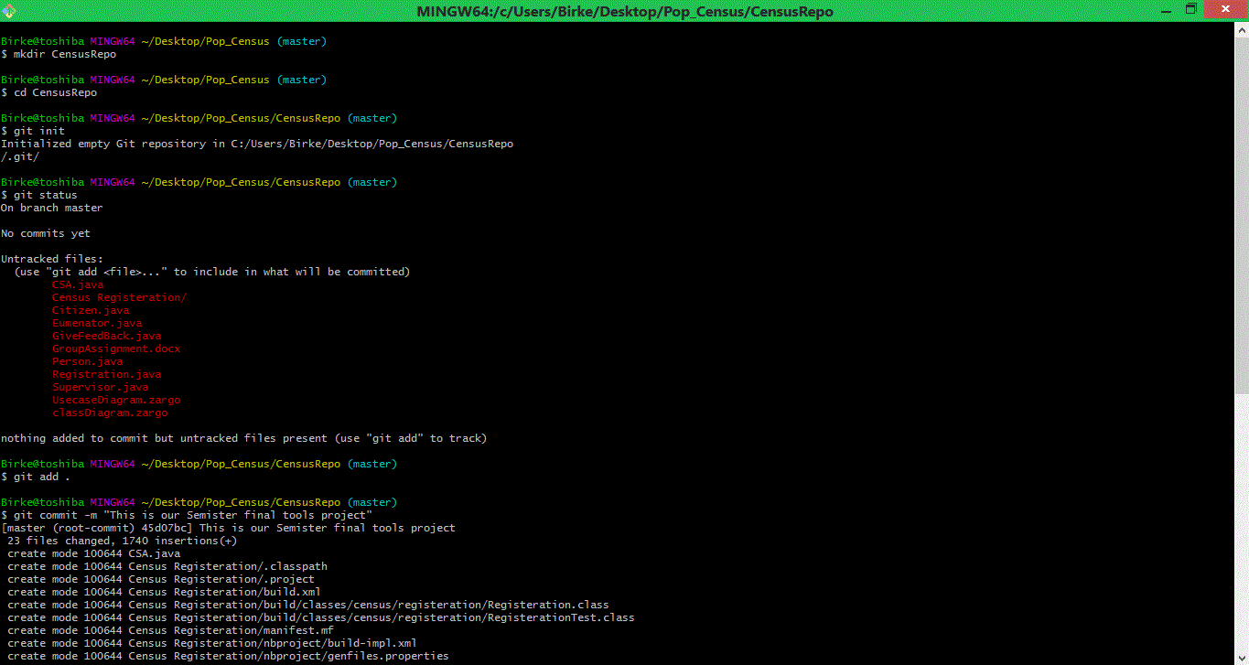

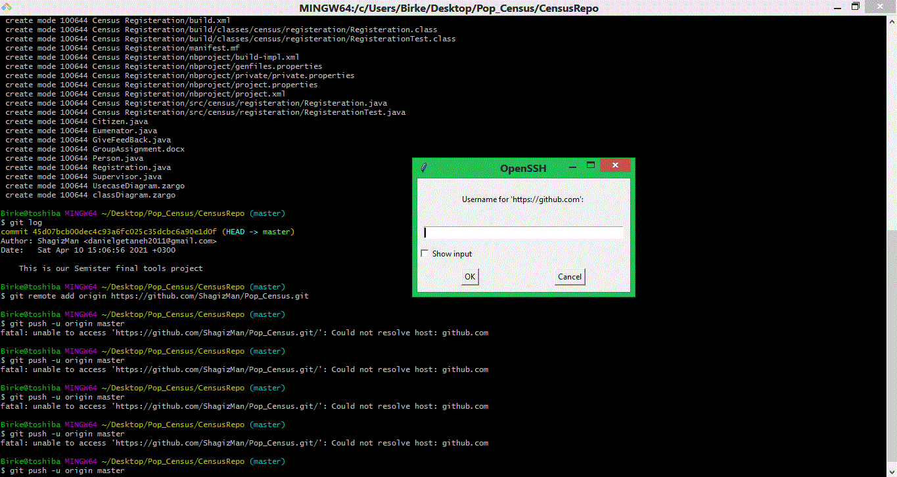

After this we enter our github user name and password.

