

# ADDIS ABABA SCIENCE AND TECHNOLOGY UNIVERSITY

## College of Engineering

## Department of Software Engineering

## SCD Project

**BY**

|  |  |
| --- | --- |
| **Name** | **ID** |
| Laelay Temesgen | 0746/13 |
| Kirubel Ateka | 0734/13 |
| Kirubel Dagnachew | 0735/13 |
| Natnael Endale | 1008/13 |
| Natnael Mulugeta | 1020/13 |
| Desalegn Sendek | 1553/13 |
| Mitiku Abebe | 0904/13 |

Submition Date: December, 2024

Submittes to Mr. Gzatie Desalegn

Table of Content

[Trello: What is Trello? 3](#_Toc185419381)

[Key Components: 4](#_Toc185419382)

[Boards 4](#_Toc185419383)

[Lists 4](#_Toc185419384)

[Cards 4](#_Toc185419385)

[For whom is Trello Designed? 4](#_Toc185419386)

[Why Use Trello? 4](#_Toc185419387)

[How to Use Trello Effectively 5](#_Toc185419388)

[1. Setting up Trello 5](#_Toc185419389)

[2. Organizing Your Board 6](#_Toc185419391)

[3. Creating and Managing Cards 7](#_Toc185419393)

[4. Collaboration and Communication 8](#_Toc185419394)

[5. Using Power-Ups 8](#_Toc185419395)

[6. Review and Adjust 8](#_Toc185419396)

[Best Practices for Using Trello 9](#_Toc185419397)

# Trello: What is Trello?

Trello is a cloud-based project management tool that uses a visual board and card system to help users organize tasks, projects, and workflows. It allows teams and individuals to plan, track, and manage their work in a flexible and intuitive manner. It is simple, flexible, and powerful. All it takes are boards, lists, and cards to get a clear view of who’s doing what and what needs to get done.

# Key Components:

* **Boards**: Represent projects or workflows.
* **Lists**: Columns within boards that categorize tasks (e.g., To Do, In Progress, Done).
* **Cards**: Individual tasks or items that contain details such as descriptions, due dates, attachments, and comments.

## Boards

Trello boards keep tasks organized and work moving forward. In a glance, see everything from “things to do” to “aww yeah, we did it!”

## Lists

The different stages of a task. Start as simple as To Do, Doing or Done—or build a workflow custom fit to your team’s needs. There’s no wrong way to Trello.

## Cards

Cards represent tasks and ideas and hold all the information to get the job done. As you make progress, move cards across lists to show their status.

# For whom is Trello Designed?

Trello is suitable for a wide range of users, including:

* **Teams**: Project teams in various industries (e.g., marketing, software development, design) can use Trello for collaboration and tracking progress.
* **Individuals**: Freelancers, students, and professionals can manage personal tasks, study plans, and projects.
* **Organizations**: Companies can utilize Trello for departmental projects, administrative tasks, and strategic planning.

# Why Use Trello?

Trello offers several advantages that make it a popular choice for task and project management:

1. **Visual Organization**: The card-based layout allows users to see the status of tasks at a glance, making it easy to track progress.
2. **Flexibility**: Users can customize boards, lists, and cards to fit their specific needs and workflows.
3. **Collaboration**: Real-time updates and team collaboration features enhance communication and coordination among team members.
4. **Integration**: Trello integrates with numerous other tools (like Slack, Google Drive, and Dropbox) to enhance functionality.
5. **Accessibility**: Available on multiple platforms (web, iOS, Android), Trello can be accessed from anywhere, facilitating remote work.
6. **User-Friendly**: The intuitive design requires minimal training, making it easy for users to get started quickly.

# How to Use Trello Effectively

### Setting up Trello

### temp_4.jpg

* **Create an Account**: Sign up for free on the Trello website or through a mobile app.

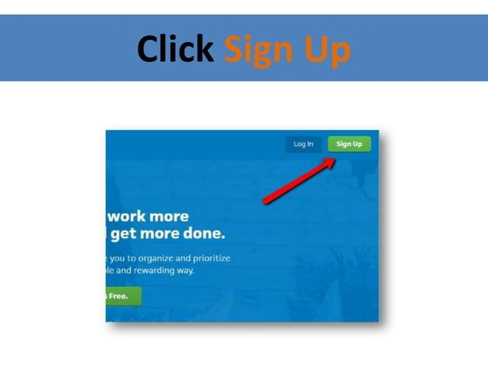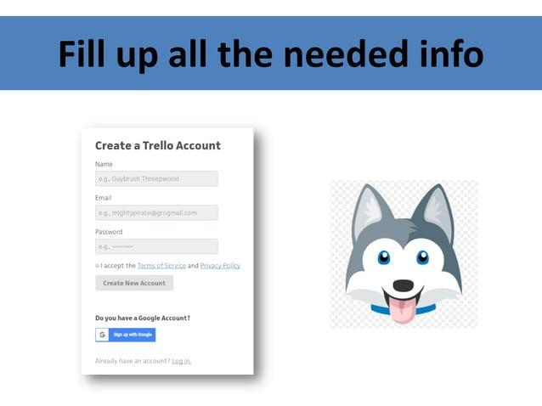

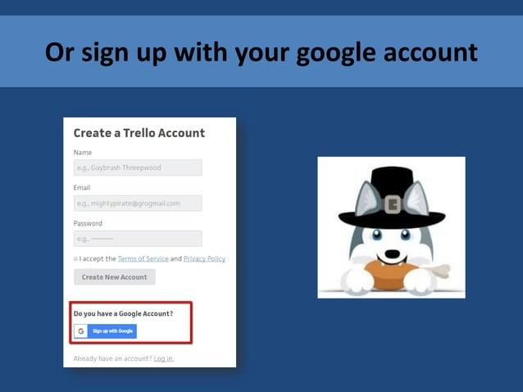

* **Create a Board**: Click “Create new board” to start. Choose a descriptive name and adjust settings (e.g., privacy).

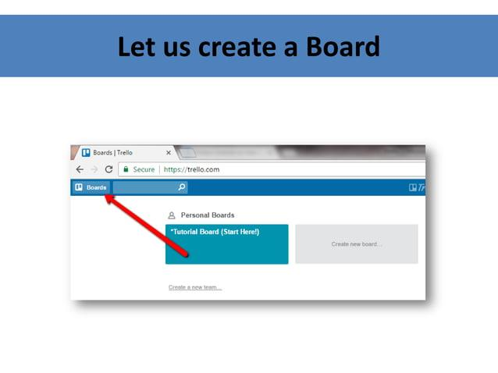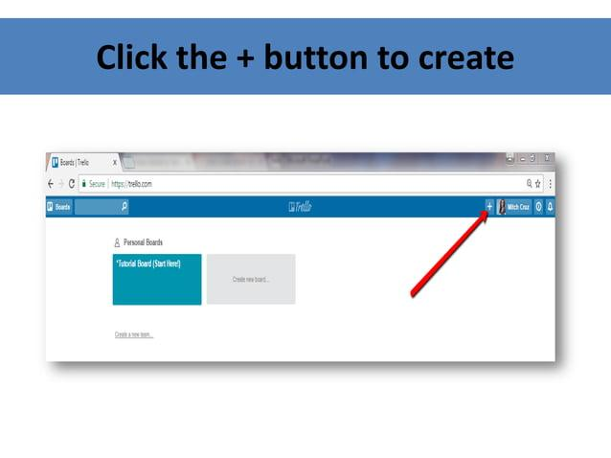

### Organizing Your Board

### temp_40.jpgtemp_41.jpg

* **Add Lists**: Organize your board with lists that reflect your workflow.

**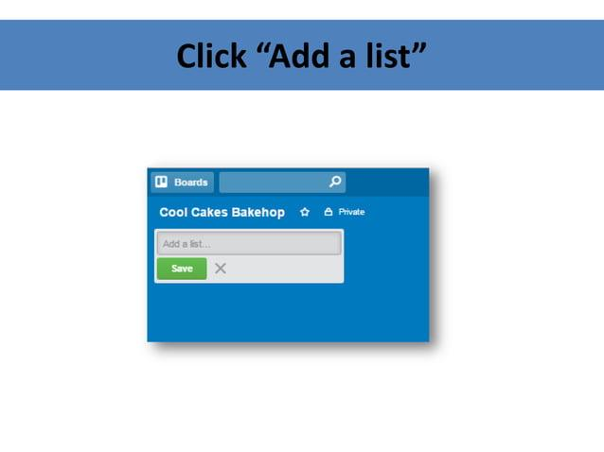**

Common examples are:

* + **To Do**: Tasks that need to be started.
  + **In Progress**: Tasks currently being worked on.
  + **Completed**: Finished tasks.

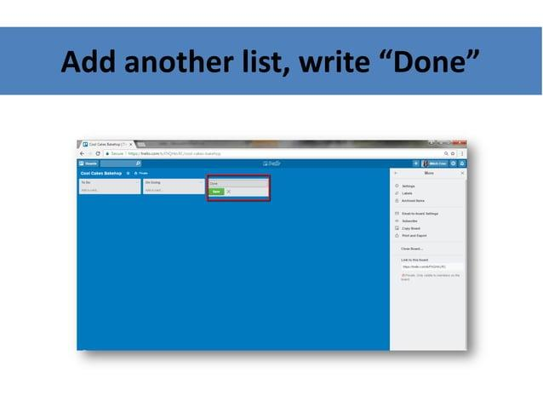

* **Customize Lists**: You can add more lists as needed, such as “Backlog” for future tasks or “Review” for tasks awaiting feedback.

### 3. Creating and Managing Cards

* **Add Cards**: Click on a list and select “Add a card” to create a new task. Include a clear title and description.

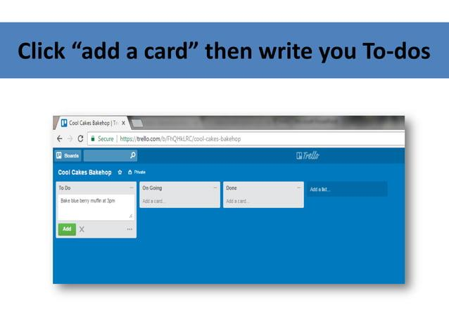

#### Detailing Cards:

* **Due Dates**: Assign deadlines to ensure timely completion.
* **Checklists**: Break tasks into smaller steps by adding checklists.
* **Attachments**: Upload files or link to external resources directly within the card.
* **Labels**: Use colored labels for categorization or to indicate priority.
* **Comments**: Collaborate with team members by discussing tasks in the comments section.

### 4. Collaboration and Communication

* **Invite Team Members**: Share your board with teammates by inviting them through email. Assign cards to specific members for accountability.
* **Notifications**: Enable notifications to stay updated on changes, comments, or card movements, ensuring everyone is informed.

### 5. Using Power-Ups

* **Enhance Functionality**: Explore Trello’s Power-Ups to integrate with other apps and tools. Examples include:
  + **Calendar**: View due dates in a calendar format.
  + **Automation (Butler)**: Set up automated actions like moving cards or sending reminders based on triggers.

### 6. Review and Adjust

* **Regular Check-Ins**: Schedule regular reviews of your boards to assess progress, re-prioritize tasks, and make adjustments as needed.
* **Archiving**: When tasks are completed, archive cards to keep your board tidy and focused on active tasks.

# Best Practices for Using Trello

* **Keep Boards Simple**: Avoid clutter by limiting the number of lists and cards. Use clear, concise titles and descriptions.
* **Stay Consistent**: Use consistent labeling and categorization to enhance organization.
* **Leverage Templates**: Use Trello’s templates for common projects to save time on setup.
* **Engage with Automation**: Utilize automation features to reduce manual tasks and streamline your workflow.

# Reference

[1] Trello, "How to Use Trello to Manage Your Projects," Trello Blog, <https://www.youtube.com/watch?v=zzwovrD0vM4>

[2] Atlassian. (n.d.). Create presentations from Trello boards. Atlassian Community. [https://community.atlassian.com/](https://www.google.com/url?sa=E&source=gmail&q=https://community.atlassian.com/)

[3] Trello. (n.d.). Trello Help Center. [https://help.trello.com/](https://www.google.com/url?sa=E&source=gmail&q=https://help.trello.com/)

[4] Project Management Institute. (n.d.). Trello Boards in Project Management. pmi.org. [https://www.pmi.org/](https://www.google.com/url?sa=E&source=gmail&q=https://www.pmi.org/)