

**Department of Computer Engineering**

**CSE5041 Database Design & Development  
Project Report**

**Warehouse Management System**

|  |  |  |
| --- | --- | --- |
|  | **ID** | **Name & Surname** |
| **Students :** | **1900002624** | **Arda Tekin** |
|  | **1900004483** | **Kemal Can Erdemir** |

**TABLE OF CONTENTS**

**1 INTRODUCTION** 4

1.1 PROJECT DESCRIPTION 4

**2 ENTITY RELATIONAL MODEL** 5

2.1 ENHANCED ER DIAGRAM 5

2.2 RELATIONAL SCHEMA & MAPPING 6

**3 NORMALIZATION** 7

3.1 FUNCTIONAL DEPENDENCIES 7

3.2 UNNORMALISED FORM 7

3.3 FIRST NORMAL FORM 7

3.4 SECOND NORMAL FORM 7

3.5 THIRD NORMAL FORM 7

**LIST OF FIGURES**

Figure 1: EER diagram of the Company Employee Administrative Database ............................... 5

Figure 2: Relational schema of the Company Employee Administrative Database with arrows indicating referential integrity....................................................................................................... 6

# INTRODUCTION

## PROJECT DESCRIPTION

Warehouse Management System Database stores information about the employees, customers, products and shipments. The following is the more detailed look at the database.

• The products are organized by sections and there properties(Flammability, Fragility etc.). Product’s location in warehouse, amount, type and properties are tracked in The database.

• Database holds the information about the changes in product’s amount, date of changes and notes about the product.

• We also have information about both employees and our customers in database. Customer’s information consists of address of the customer, phone number, email address and name of the customer so If customer wants to order another shipment from warehouse It can be done right away.

• Database also tracks shipments. It can track which customer ordered what with connections between Edit’s table and Customer’s table in the database. Shipment also tracks status and date of the shipment.

# ENTITY RELATIONAL MODEL

## ENHANCED ER DIAGRAM

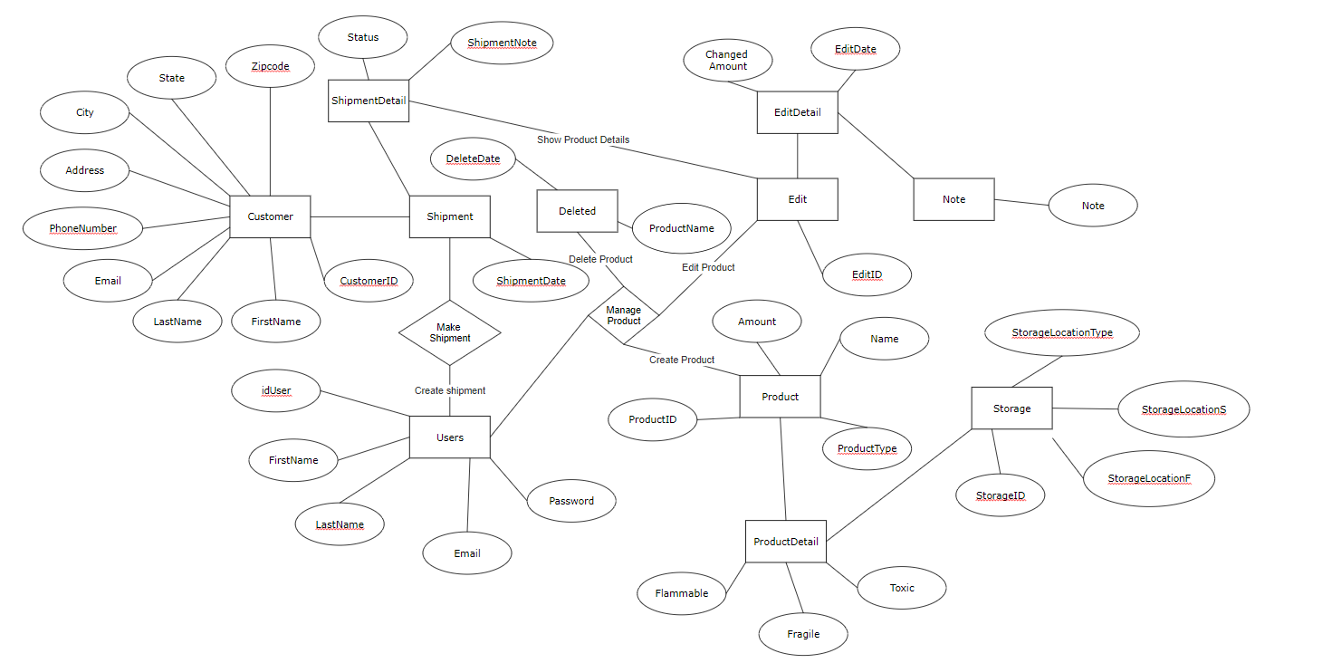

**Figure 1:** EER diagram of the Company Employee Administrative Database

## RELATIONAL SCHEMA & MAPPING

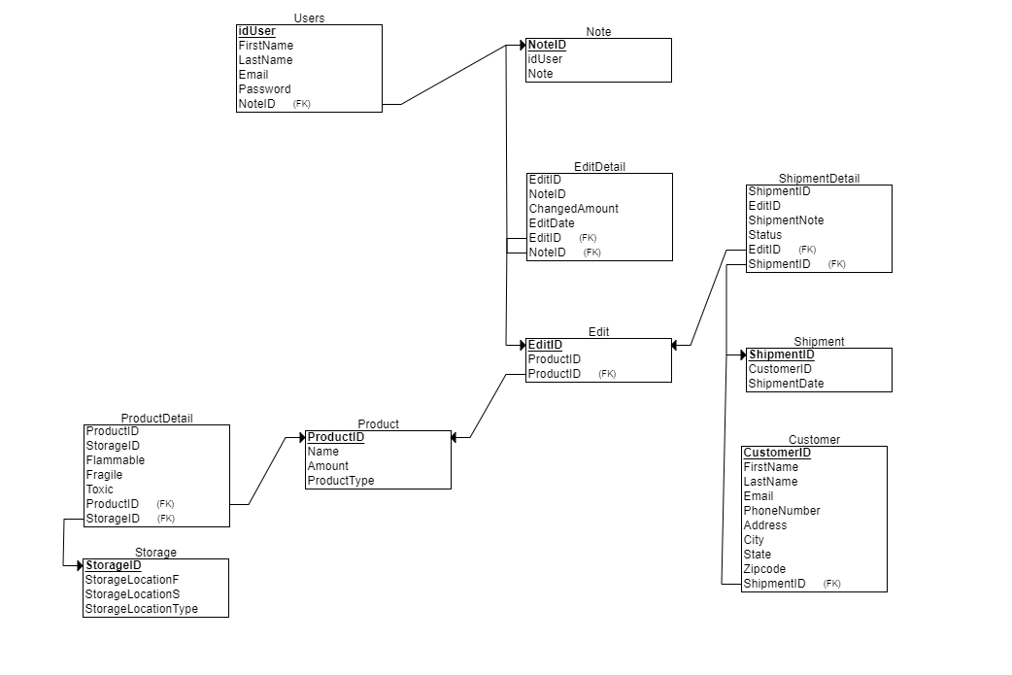

**Figure 2:** Relational schema of the Company Employee Administrative Database with arrows indicating referential integrity

# NORMALIZATION

## FUNCTIONAL DEPENDENCIES

F = {

FD1: idUser → FirstName, LastName, Email, Password

FD2: CustomerID → FirstName, LastName, Email, PhoneNumber, Address, City, State, Zipcode

FD3: ProductID→ Name, Amount, ProductType

FD4: EditID → ProductID

FD5: ShipmentID→ CustomerID, ShipmentDate

FD6: ShipmentID, EditID → ShipmentNote, Status

FD7: EditID, NoteID → ChangedAmount, EditDate

FD8: NoteID → idUser, Note

FD9: DeletedID → DeleteDate, ProductName

FD10: ProductID, StorageID → Flammable, Fragile, Toxic

FD11: StoageID → StorageLocationF, StorageLocationS, StorageLocationType

## UNNORMALISED FORM

Items(ID,Name,Note, Date, Amount)

## FIRST NORMAL FORM

User(ID, FirstName, LastName, Email, Password, PhoneNumber, Address, City, State, Zipcode)

Product(ID, Name, Amount, ProductType, StorageLocation, Status, Date, Note)

Edit(ID,Date,ChangedAmount, Note)

## SECOND NORMAL FORM

Users(idUser, FirstName, LastName, Email, Password)

Customer(CustomerID, FirstName, LastName, Email, PhoneNumber, Address, City, State, Zipcode)

Product(ID, Name, Amount, ProductType, StorageLocation, Status, Note)

Deleted(DeleteID, DeleteDate, ProductName)

Edit(EditID,Date,ChangedAmount, Note)

## THIRD NORMAL FORM

Users(idUser, FirstName, LastName, Email, Password)

Customer(CustomerID, FirstName, LastName, Email, PhoneNumber, Address, City, State, Zipcode)

Product(ProductID, Name, Amount, ProductType)

Storage(StorageID, StorageLocationF, StorageLocationS, StorageLocationType)  
Shipment(ShipmentID, ShipmentDate, Status, ShipmentNote)

Edit(EditID, Date, ChangedAmount)

Note(NoteID, Note)