Physics Assignment ScreenShots

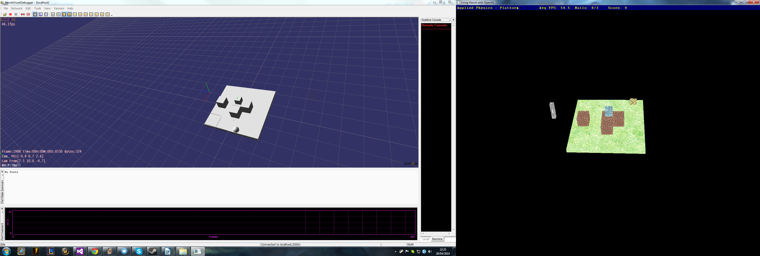
This shot shows the physics with the sphere tilting platform and 4 box objects in an array.

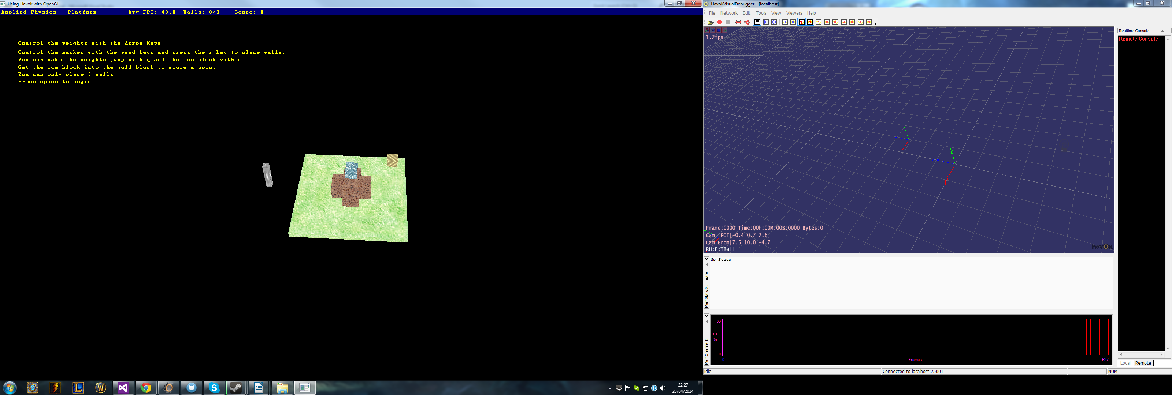
This is the base screen which shows some text to explain the game a little.

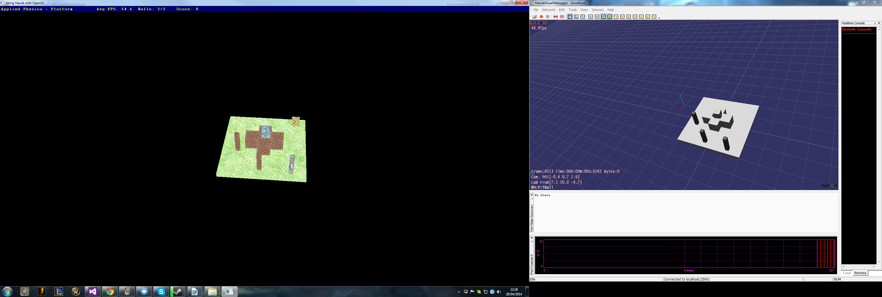
Here I have created 3 walls to show. These can be used for protecting the ice block from falling off, the ice block has a lower friction then the others. To show where the objects will be placed is a small marker, shown as the greyish wall in OpenGL.

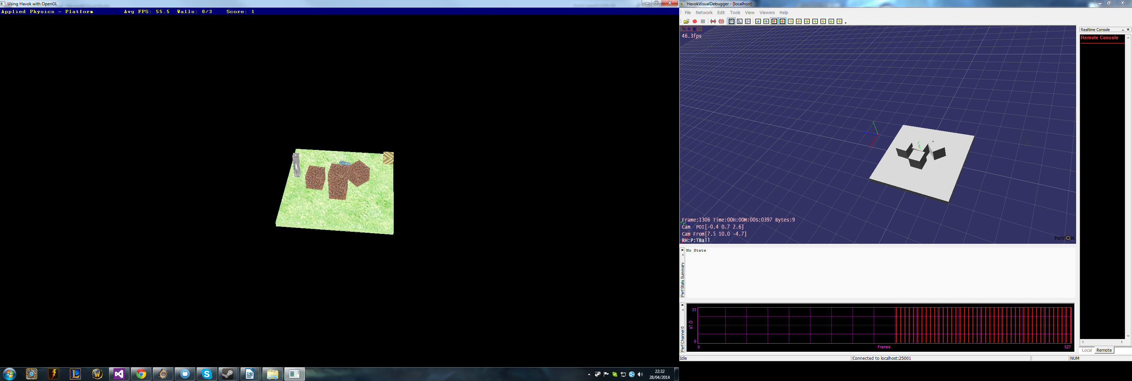
In this shot I have scored a point however this can be difficult without block falling off, points can be easier depending on how lucky you get with the spawning of the goal which is partly random.

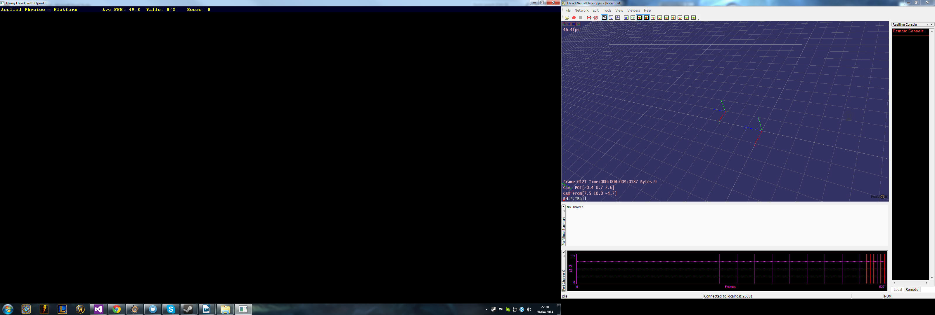

You can delete all objects by pressing ESC after you move through the text at the start.

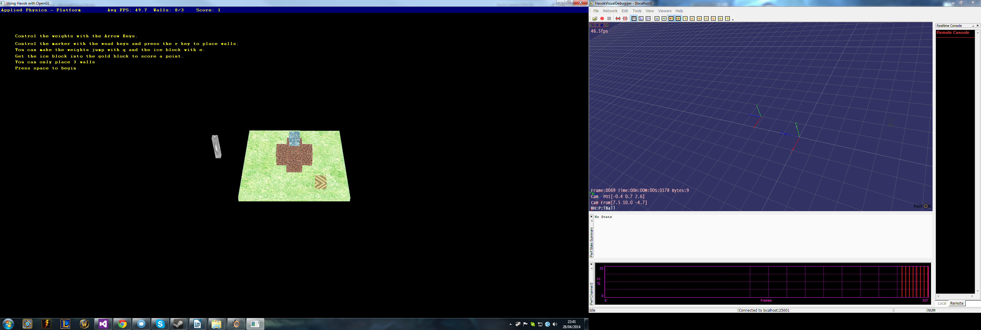
The objects can then be brought back with the U key and back to the beginning. It can be a little slow while reloading.

If I had some more time I would polish the mechanics a little more as at the moment the game is far too difficult. I would also add a way to lose such as falling from to great a height but when attempting this I ran into errors.

