Technical Design Document

Team: Gryffindor

Mascot: Lion

The Team name and Mascot comes from the harry Potter series of books written by J.K. Rowling. The houses represents a favorite amongst the fans of the book as many of the characters within the house are known to be selfless and frequently go out of their way to help others. Which represents our team very well. The mascot of the lion represents pridefulness as Gryffindors think they are the best and most noble of all the houses.

Danial Purselley- Captain

Danial Purselley is a 23-year-old Air Force IT Specialist who hails from the great state of Texas. Born and raised in the small town of Eustace where he graduated high school in 2017. That same autumn he joined the Air Force as a Knowledge Manager (KM). From 2017-2019 he was a KM apprentice at Offutt AFB in Omaha, NE until he deployed to Djibouti, Africa as a Command Team Executive Admin. In 2020 he returned to Omaha, NE as a KM supervisor, where he led a 4-man team developing and maintaining Offutt AFB’s SharePoint intranet, supporting 30+ organizations for 10,000+ personnel. In October 2021 he moved to Okinawa, Japan to fulfil a KM supervisor role and become an IT support specialist. During this time, he pursued education goals, gaining the CompTIA Security+ certificate and working towards his bachelor’s degree in Web Development. He has work experience as a system admin, network admin, cybersecurity specialist, SharePoint SCA, OSINT collector, project manager, IT supervisor and change manager.



Ferdinand Detres Jr

Ferdinand Detres is a native of Passaic, New Jersey. He Graduated from Easton Area High school in , Easton PA, before joining the military at the age of 17 in 2001. His first job in the military was an Automated Logistical Specialist which he did for four years at Ft. Hood, Texas and one of those years deployed to Iraq from 2004 - 2005. Shortly after returning from deployment, Detres re-classed into the Public Affairs field where he attended school in Fort Meade, Md. After graduating from the Defense Information School at Meade, he was assigned to the 1st Theater Sustainment Command, Fort. Bragg, N.C. He served another six years at Bragg before retiring in 2016 at Fort Sam Houston, San Antonio, Texas. Shortly after retiring he attended school at Codeup in San Antonio as a Full-Stack developer. After graduating Codeup, he went on to working as a federal civilian in Public Affairs providing content management support and development of Sharepoint sites for the Naval Medical Research Unit, San Antonio Texas and the U.S. Army Corps of Engineers, Omaha, Nebraska.

Website Goals

(paragraph approach)

The goal of the WhatABook site is to provide an easy-to-use interface for customers looking to purchase used books. Technical goals would be to enable users to have wishlist books that they can view, sort and filter through.

(bullet approach)

* Establish web presence
* Enable customers to have the same purchasing power as if they were in the store
* Browsing capabilities to see what books are available
* Wishlist feature to allow users to bookmark/save specific books
  + Wishlist filters
  + Wishlist sorting
  + Wishlist searching

Core Users

(paragraph approach)

The core audience of our website would be our store regulars, which consist of middle-aged users. A bonus would be to attract new younger customers that might be on the look-out for a good read.

(bullet approach)

* Retired Teachers
* Middle Age Bookworms
* College Students

# Personas

|  |  |  |  |
| --- | --- | --- | --- |
| Donna  Picture 6 | Age: 70  Occupation: Retired  Tech Level: Low | BIO  Donna is a retired teacher who loves reading books to her grandchildren | Needs  Donna needs a user friendly platform to view books that her grandkids might like |
| Kevin  Picture 7 | Age: 50  Occupation: Finance  Tech Level: Low | BIO  Kevin is in finance and loves to take his mind off work with a good read | Needs  Kevin needs a wishlist feature to add books for future reading |
| Travis  Picture 8 | Age: 22  Occupation: Student  Tech Level: Medium | BIO  Travis is a senior in college who enjoys reading in his free time | Needs  Travis needs the capability to filter out books by genre so he can explore new books |

Stories Per Persona

|  |  |
| --- | --- |
| WhataBook SCRUM Project |  |
| Milestone 1- Story Writing | Story Points |
|  |  |
| 1. As a Retired Teach |  |
| I need to ensure the application has text that is easy to read | ***1*** |
| So that I can easily read the names of the books to my grandkids |  |
| --------------------------------- |  |
| 2. As a Retired Teacher |  |
| I need to ensure the buttons on the screen are large | ***2*** |
| So that I can easily guide my mouse to the button |  |
| ——————————————- |  |
| As a Retired Teacher |  |
| I need to ensure the application has accessibility | ***610*** |
| So that I can use the reading function when my eyes are tired |  |
| ——————————————- |  |
| 4. As a Retired Teacher |  |
| I need to ensure the application is not very technical | ***3*** |
| So that I understand what I am doing on the screen |  |
| ——————————————- |  |
| 5. As a Retired Teacher |  |
| I need to ensure it works on a mobile device | ***377*** |
| So that my grandkids can help me find what I need |  |
| ——————————————- |  |
| 6. As a Finance Advisor |  |
| I need to ensure there is a wishlist | ***233*** |
| So that I can access the books I want later on |  |
| ——————————————- |  |
| 7. As a Finance Advisor |  |
| I need to ensure I can see my wishlist | ***144*** |
| So that I can see the books I have saved there |  |
| ——————————————- |  |
| 8. As a Finance Advisor |  |
| I need to be able to check books out | ***55*** |
| So that I am able to purchase them |  |
| ——————————————- |  |
| 9. As a Finance Advisor |  |
| I need to be able to see the price before purchasing | ***5*** |
| So that there are no surprises at checkout |  |
| ——————————————- |  |
| 10. As a Finance Advisor |  |
| I need to ensure the application is fast | ***89*** |
| So that I can fit it into my schedule when using it |  |
| ——————————————- |  |
| 11. As a college student |  |
| I need to make sure the books have isbn numbers | ***8*** |
| So that I can easily find the books I need for school |  |
| ——————————————- |  |
| 12. As a college student |  |
| I need to make sure there is a receipt | ***55*** |
| So that tI can show proof of purchase for taxes |  |
| ——————————————- |  |
| 13. As a college student |  |
| I need to ensure the information on the book is up to date | ***21*** |
| So that I am getting the version that is required |  |
| ——————————————- |  |
| 14. As a college student |  |
| I need to see how many are available | ***13*** |
| So that I am not buying something thats not in stock |  |
| ——————————————- |  |
| 15. As a college student |  |
| I need to see the picture of the cover | ***34*** |
| So I am not purchasing the wrong book |  |

WhatAbook Prototype

Landing Page



Search Pa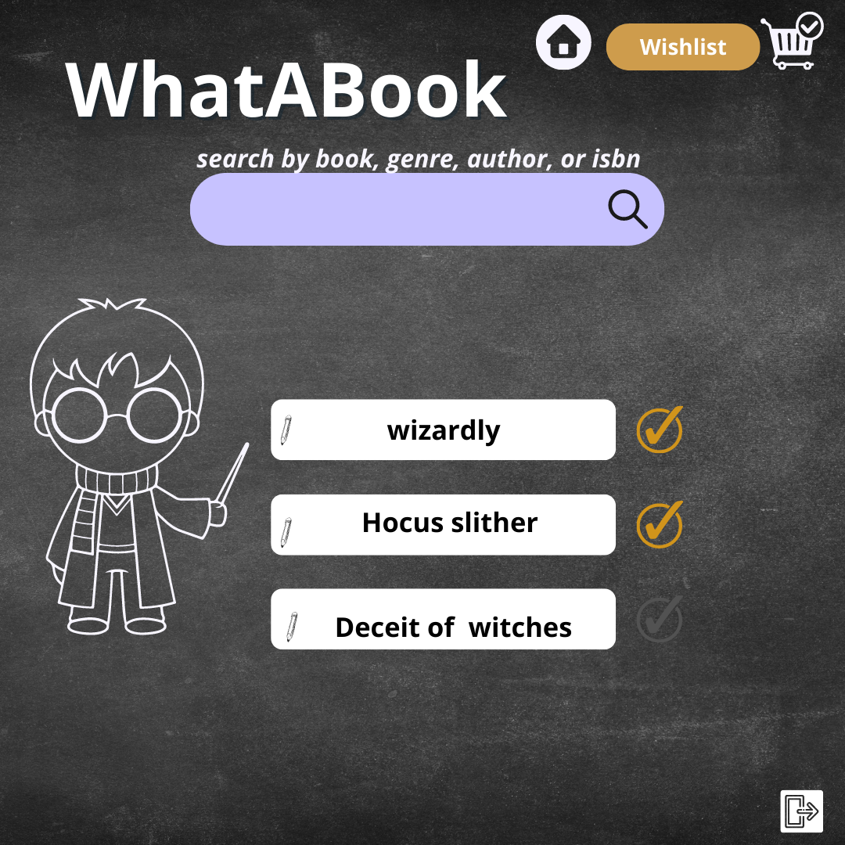ge

Wishlist

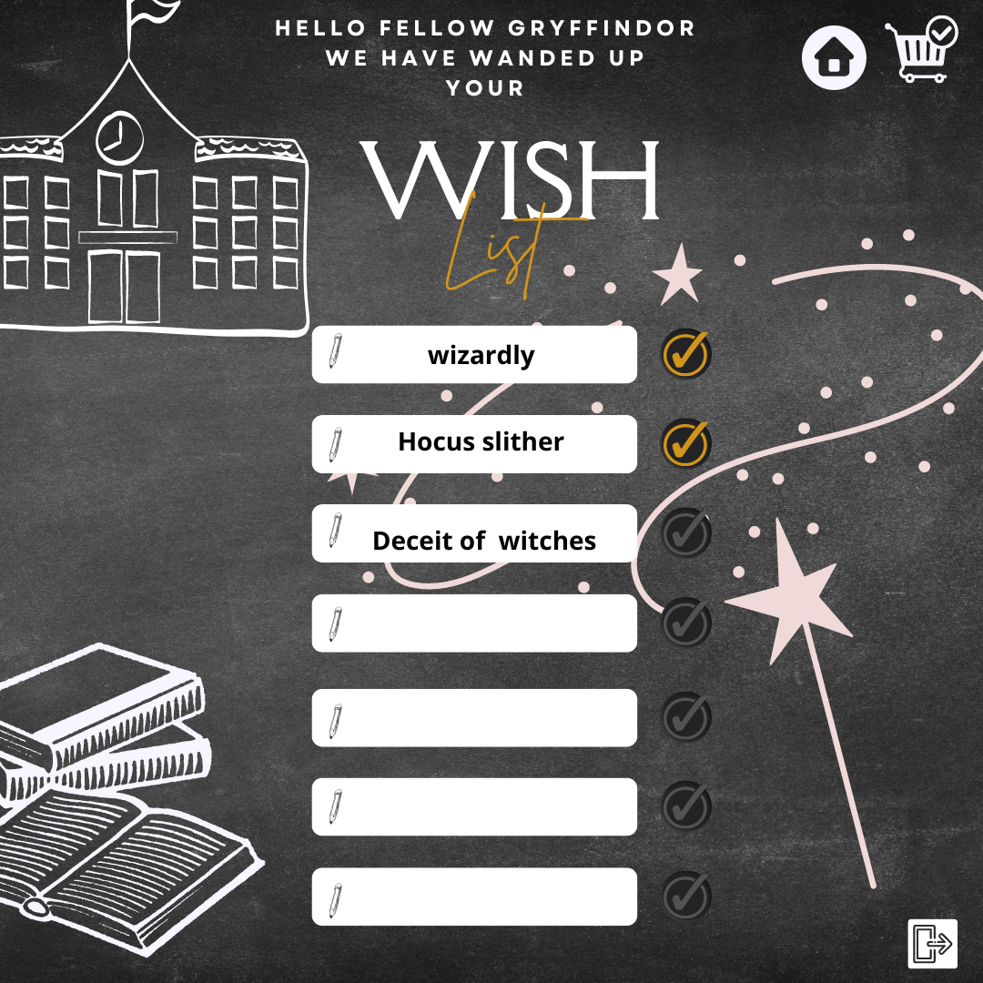

ORD/NoSQL

