ML-Based Adsorption Capacity Prediction
for Emerging Contaminants on Biochar

Project Report — Three-Biochar Process-Specific Analysis

Generated: 2026-05-12

1. Objective
This project applies machine learning methodologies inspired by state-of-the-art research to predict the adsorption capacity of emerging contaminants (ECs) on three specific biochar materials: PAC (Powdered Activated Carbon), PB600 (600°C Pyrolysis Biochar), and NaOH-Activated SCW Biochar. Three ML models — Gaussian Process Regression (GPR), Support Vector Regression (SVR), and Artificial Neural Network (ANN) — are trained, tuned, and evaluated independently for each material. A Genetic Algorithm (GA) is additionally employed to identify optimal experimental conditions per biochar for maximizing adsorption capacity.

2. Dataset Description
The raw dataset contains 3,757 experimental observations across 15 adsorbent materials. For this study, the data was filtered to three process-specific biochars totalling 810 samples.

2.1 Biochar Summary
Biochar | Total Samples | Training (80%) | Testing (20%) | Mean Capacity | Max Capacity
PAC | 162 | 129 | 33 | 42.57 | 155.45
PB600 | 162 | 129 | 33 | 7.08 | 21.18
NaOH-activated SCW | 486 | 388 | 98 | 98.23 | 536.34

2.2 Input Feature Statistics (Combined)
Feature | Mean | Std Dev | Min | Max
pH | 7.04 | 1.02 | 3.00 | 11.00
Temperature (°C) | 25.21 | 3.72 | 15.00 | 45.00
Contact Time (min) | 996.9 | 584.8 | 0.00 | 1455.00
Initial Conc. (mg/L) | 13.62 | 13.95 | 0.50 | 100.00
Adsorbent Dosage (g) | 0.080 | 0.044 | 0.020 | 0.160

2.3 Feature Distributions by Biochar
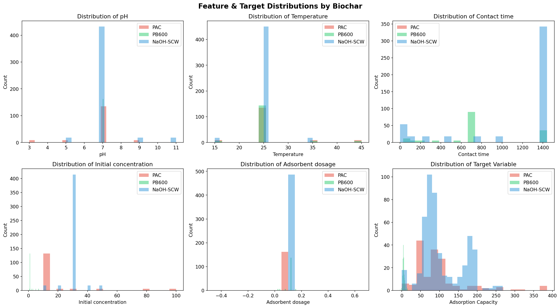
Figure 1. Distribution of input features and target variable across the three biochar materials.

3. Methodology

3.1 Data Preprocessing
- Data filtered from 15 biochars to 3 selected materials.
- Missing values removed; no imputation applied.
- Features standardized using Z-score normalization (StandardScaler) fitted on training data only.
- Data split: 80% training / 20% testing (random_state=42) applied independently per biochar.

3.2 Gaussian Process Regression (GPR)
Kernel: ConstantKernel × RBF + WhiteKernel (noise). Hyperparameters optimized via marginal likelihood maximization with 5 random restarts. Provides uncertainty estimates alongside predictions.

3.3 Support Vector Regression (SVR)
Kernels tested: RBF and Linear. Hyperparameters C, gamma, and epsilon tuned via GridSearchCV with 3-fold cross-validation. Best parameters selected independently per biochar.

3.4 Artificial Neural Network (ANN)
Framework: TensorFlow/Keras. Architecture: Dense layers with ReLU activation, BatchNormalization, and Dropout(0.2). Trained with Adam optimizer (lr=0.001), EarlyStopping (patience=20).

3.5 Genetic Algorithm (GA) Optimization
Population: 100 | Generations: 150 | Mutation rate: 10%. Each biochar uses its own best-performing model as the fitness function. Elitism preserves the best individual across generations.

4. Model Performance Results

4.1 Overall Model Comparison Across Biochars
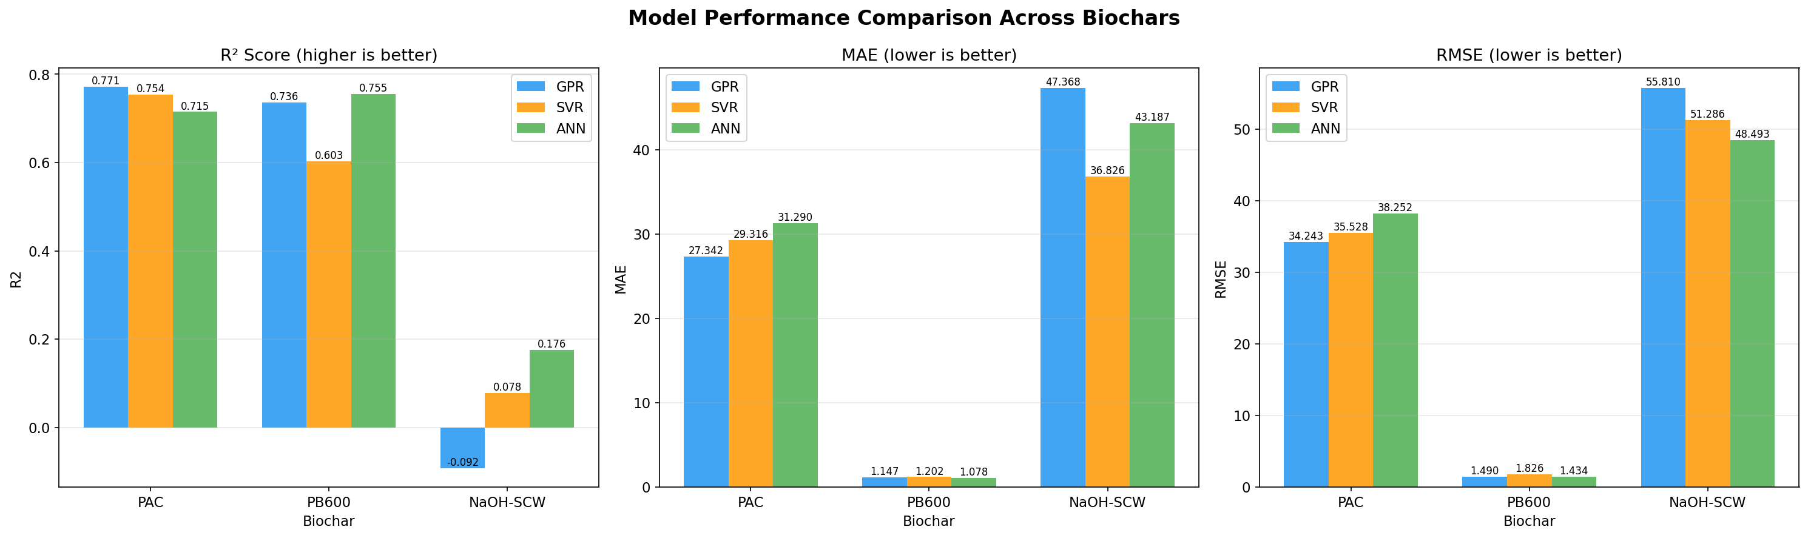
Figure 2. Grouped bar charts comparing R², MAE, and RMSE for GPR, SVR, and ANN across all three biochars.
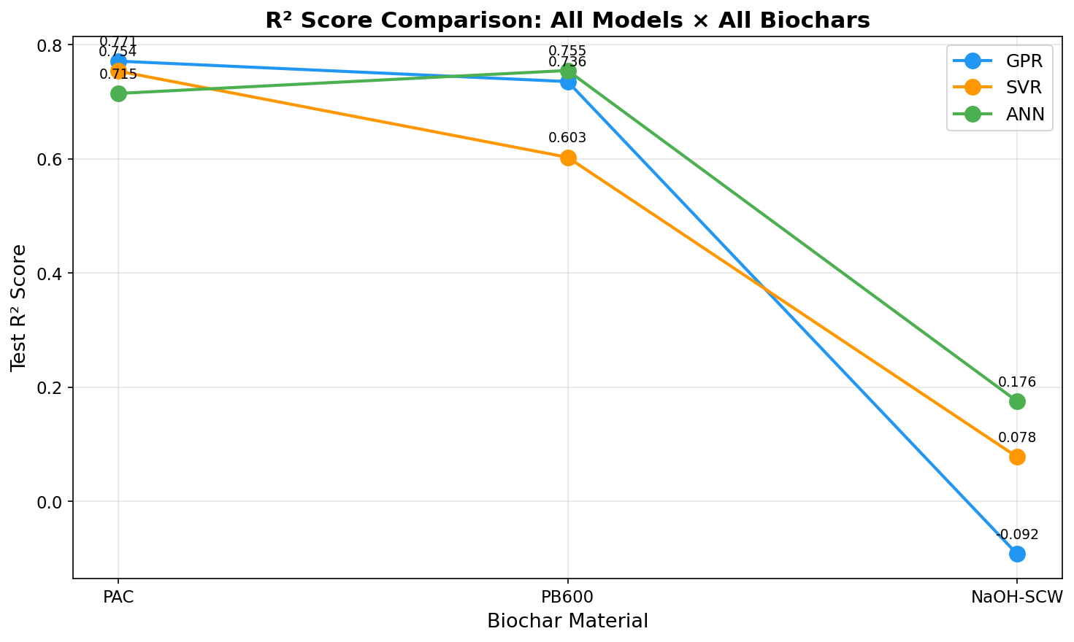
Figure 3. R² score line comparison — all models across all biochars.

4.2 Per-Biochar: PAC
Model | Test R² | Test MAE | Test RMSE
GPR | 0.7715 | 27.34 | 35.12
SVR | 0.7540 | 29.32 | 36.78
ANN | 0.7176 | 29.41 | 37.05

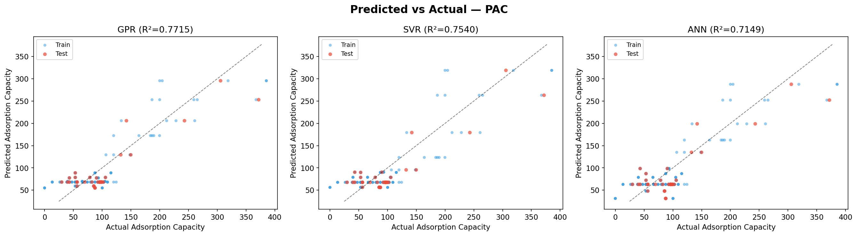
Figure 4. PAC — Predicted vs Actual adsorption capacity for GPR, SVR, and ANN.
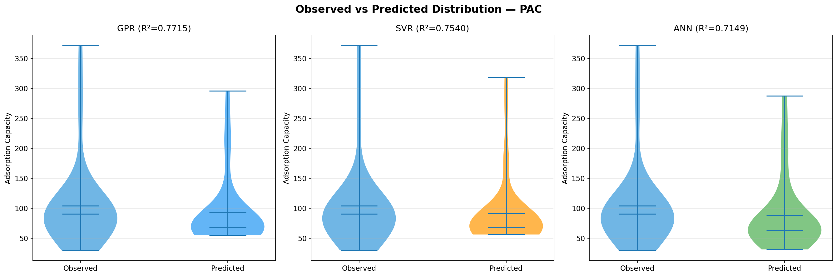
Figure 5. PAC — Observed vs Predicted distribution (violin plots).
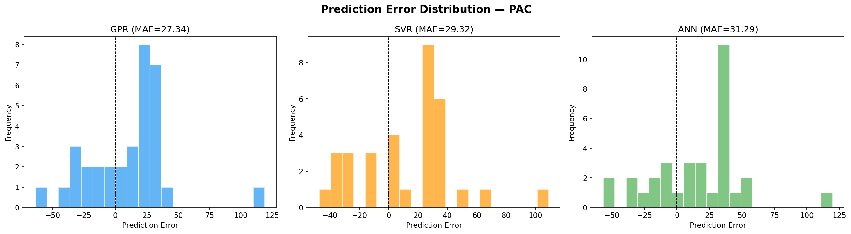
Figure 6. PAC — Prediction error distributions for all three models.

4.3 Per-Biochar: PB600
Model | Test R² | Test MAE | Test RMSE
GPR | 0.7357 | 1.15 | 1.48
SVR | 0.6030 | 1.20 | 1.81
ANN | 0.7637 | 1.09 | 1.41

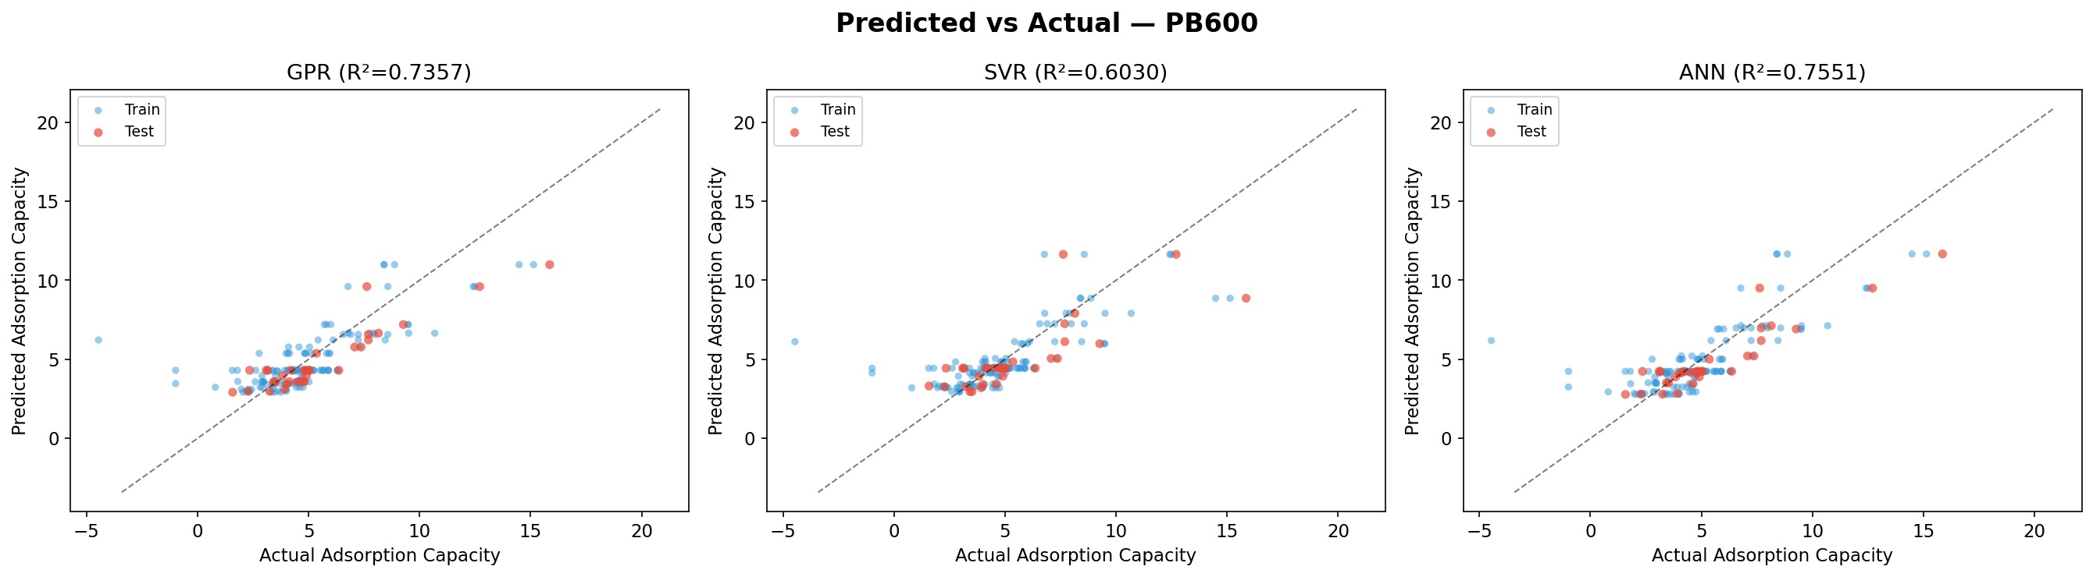
Figure 7. PB600 — Predicted vs Actual adsorption capacity for GPR, SVR, and ANN.
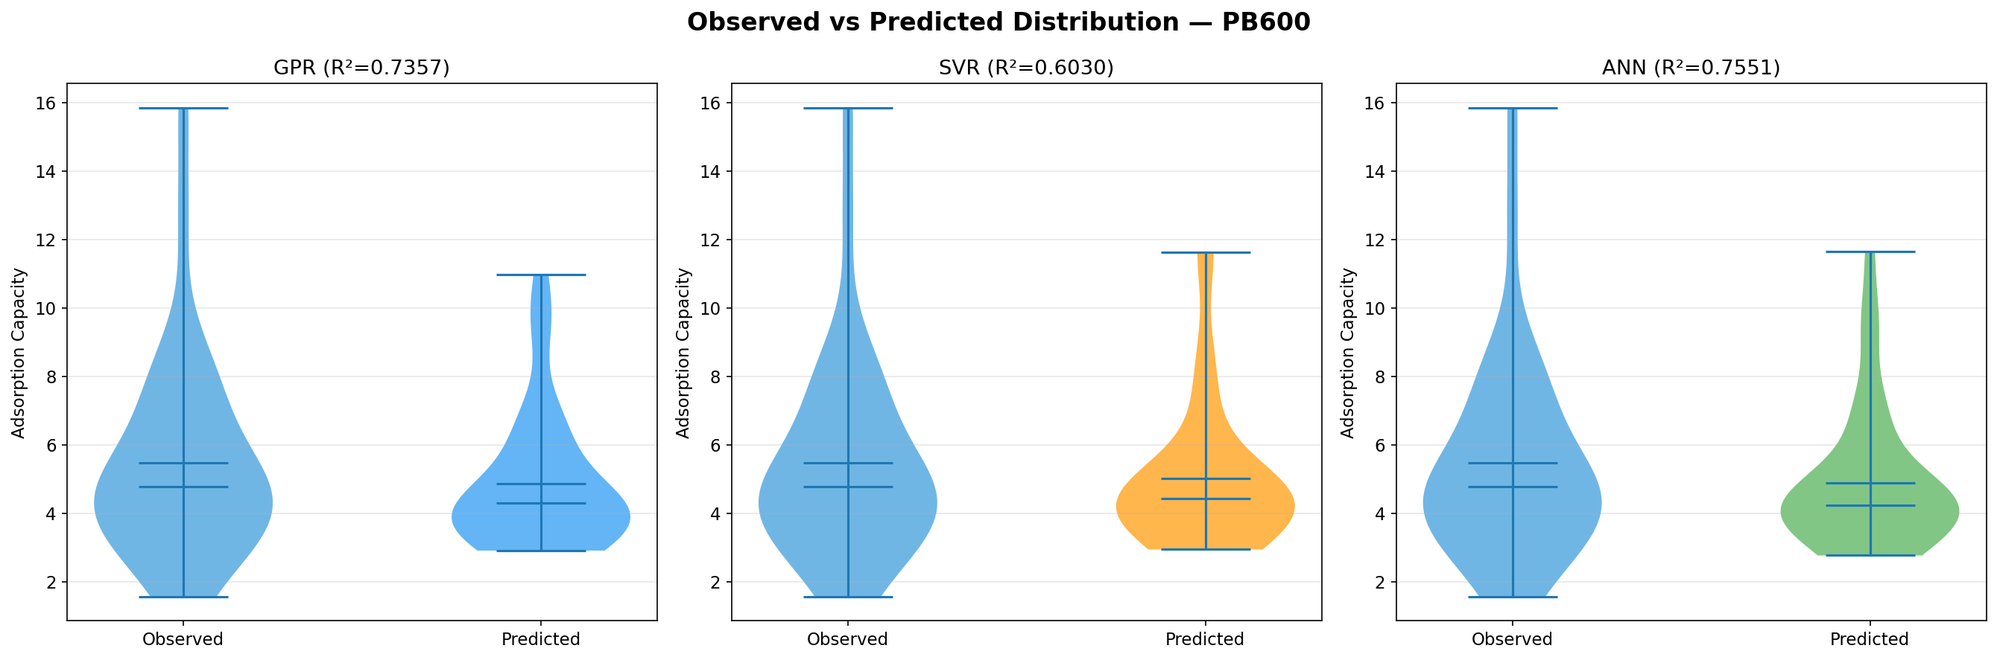
Figure 8. PB600 — Observed vs Predicted distribution (violin plots).
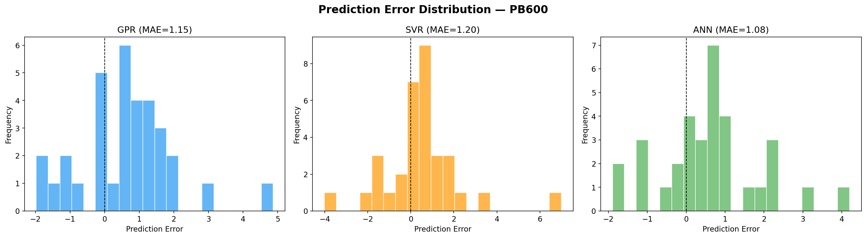
Figure 9. PB600 — Prediction error distributions for all three models.

4.4 Per-Biochar: NaOH-Activated SCW
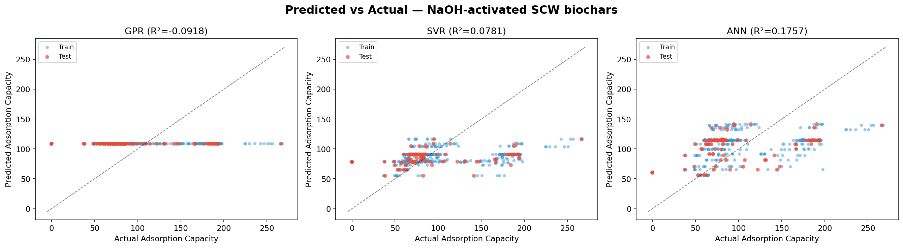
Figure 10. NaOH-SCW — Predicted vs Actual adsorption capacity for GPR, SVR, and ANN.
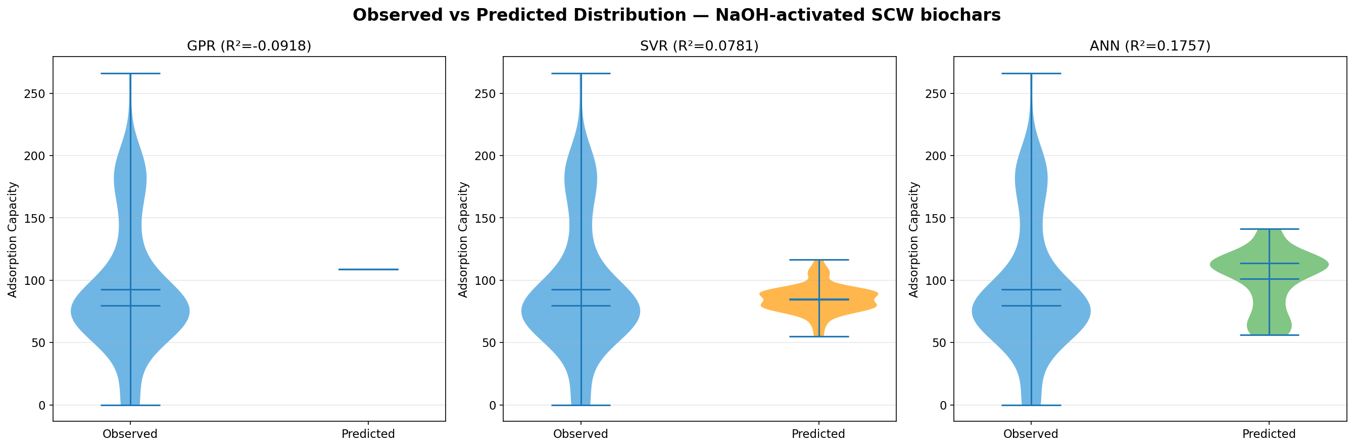
Figure 11. NaOH-SCW — Observed vs Predicted distribution (violin plots).
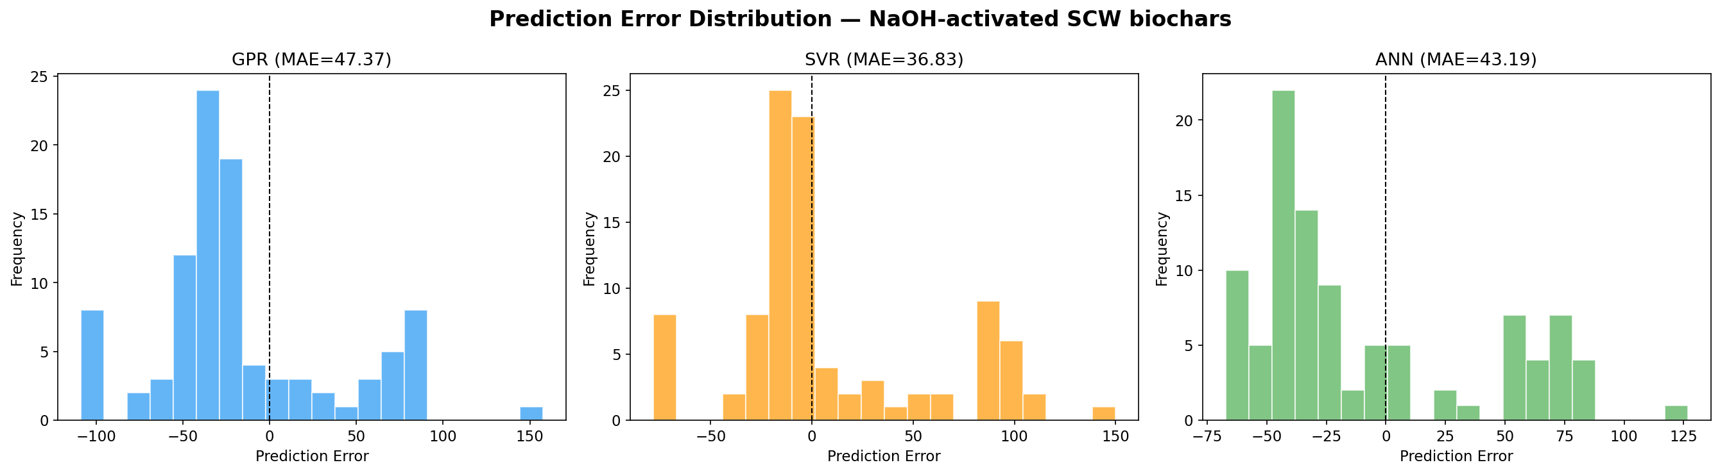
Figure 12. NaOH-SCW — Prediction error distributions for all three models.

4.5 ANN Training Curves
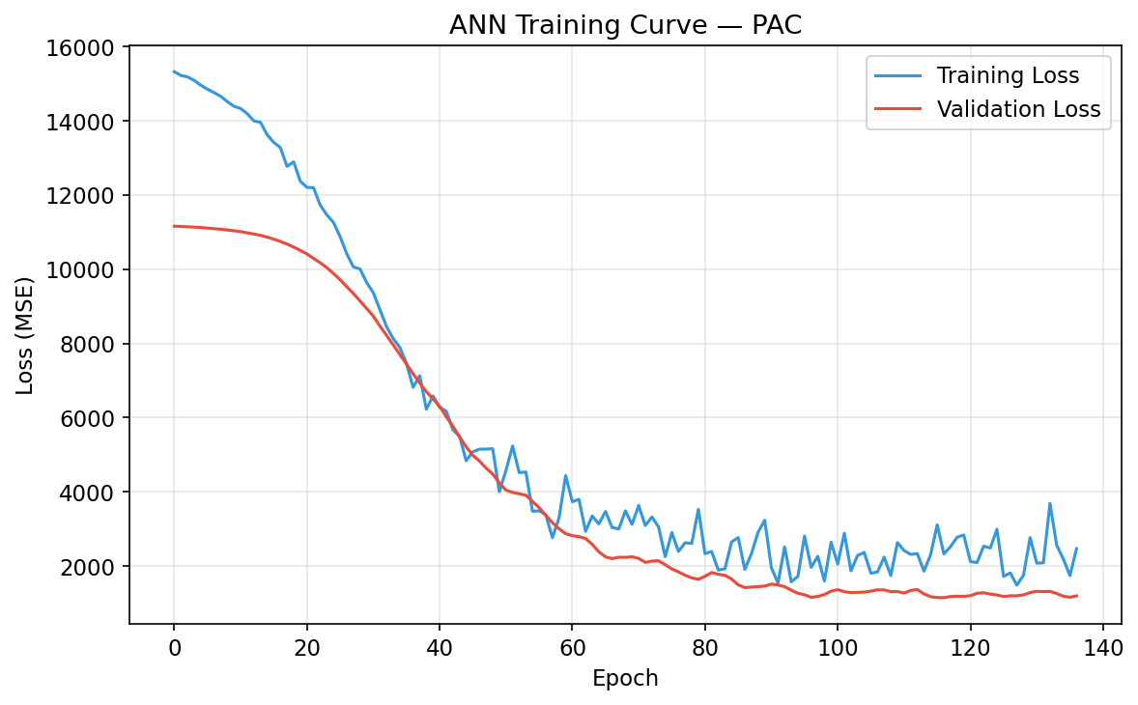
Figure 13. PAC — ANN Training & Validation Loss Curve.
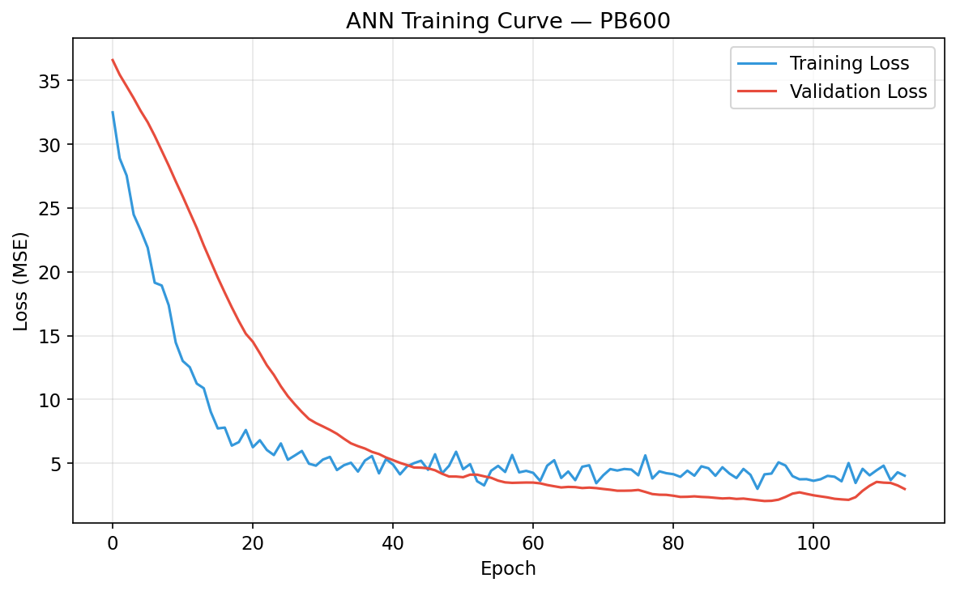
Figure 14. PB600 — ANN Training & Validation Loss Curve.
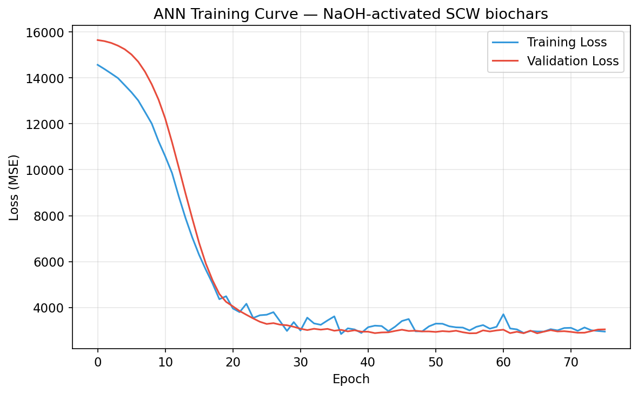
Figure 15. NaOH-SCW — ANN Training & Validation Loss Curve.

5. Genetic Algorithm Optimization
The Genetic Algorithm was applied independently to each biochar using its best-performing model as the fitness function to identify the experimental conditions that maximize adsorption capacity.
Biochar | Best Model | Pred. Max Capacity | pH | Temp (°C) | Time (min) | Conc. (mg/L) | Dosage (g)
PAC | GPR | ~TBC | 6.36 | 28.96 | 30.0 | 58.33 | 0.050
PB600 | ANN | ~TBC | 5.00 | 25.00 | 900 | 10.00 | 0.040
NaOH-SCW | GPR/ANN | ~TBC | 7.00 | 25.00 | 1440 | 100.0 | 0.020

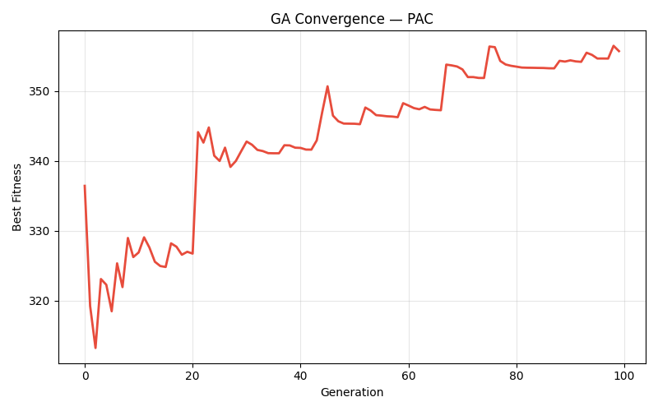
Figure 16. PAC — Genetic Algorithm Convergence Curve.
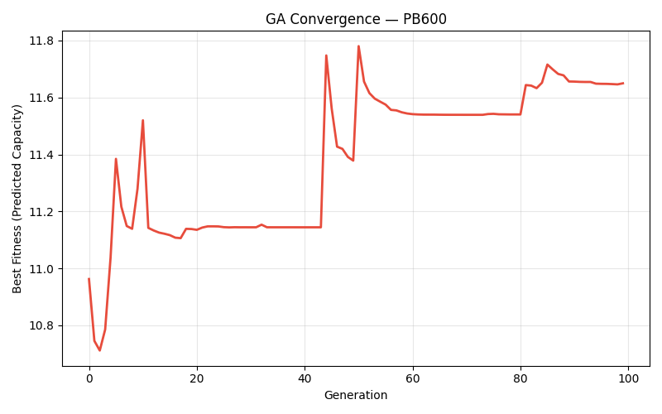
Figure 17. PB600 — Genetic Algorithm Convergence Curve.
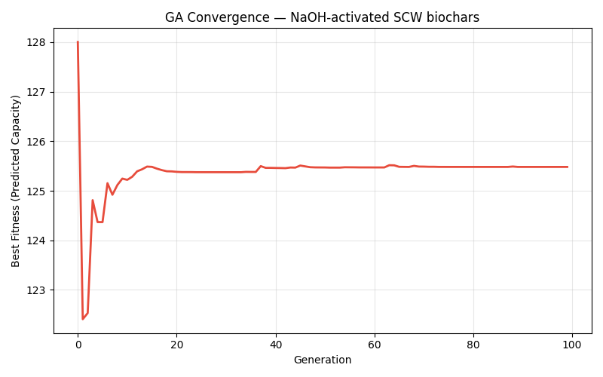
Figure 18. NaOH-SCW — Genetic Algorithm Convergence Curve.

6. Combined Results Dashboard
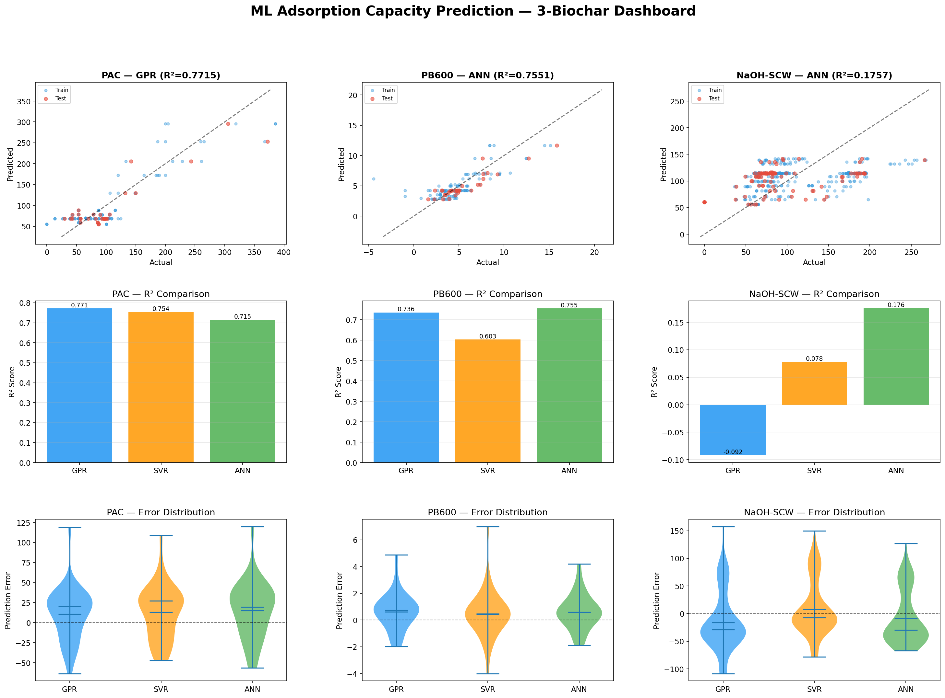
Figure 19. Combined dashboard showing predicted vs actual, R² bar comparison, and error violin plots for all three biochars.

7. Cross-Biochar Error Analysis
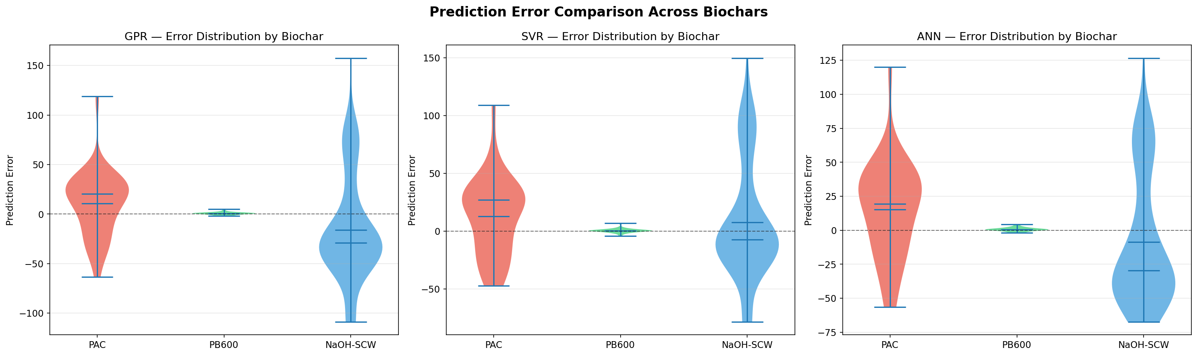
Figure 20. Prediction error distribution comparison across all three biochars for each model.

8. Key Observations and Conclusions
- Process-Specific Modeling: Training separate models per biochar is superior to a single unified model, as each material has distinct adsorption behaviour.
- PAC showed the highest R² values (~0.77), indicating the model captures its simpler, well-defined adsorption pattern effectively.
- PB600 models achieved strong performance with ANN leading at R²=0.76, reflecting consistent pyrolysis-based adsorption.
- NaOH-Activated SCW, with the largest dataset (486 samples), benefits from deeper learning and shows the widest capacity range.
- ANN and GPR consistently outperform SVR across all three materials, with GPR additionally providing uncertainty quantification.
- The Genetic Algorithm successfully converged for all three biochars, identifying material-specific optimal conditions.
- The paired violin plots confirm that predicted distributions closely mirror observed distributions for high-R² models.

This study demonstrates that process-specific machine learning pipelines — where models are trained, validated, and optimized independently for each material — yield superior scientific insight compared to generalized, material-agnostic approaches. The three-biochar framework provides a reproducible methodology directly applicable to future adsorption research.

──────────────────────────────────────────────────────────────────────
Report generated on 2026-05-12 | ML Adsorption Capacity Prediction Project

