
Final report submitted to Samson International PLC, Akuressa Road, Bogahagoda, Angulana, Galle.

On 03rd September, 2025

Smart Production Hourly Counting and History Management with Real-Time Monitoring on Things-Board Dashboard:

Supervised By:

Asanka Edirisinghe
Production Executive
Email: asanka@samsonint.com

Design and Implemented By:
Sewinda L.L.D.

Contents

1. Project Overview 4
2. Requirements Fulfilled 4
3. System Components and Technologies 4
4. System Architecture 5
5 Expected Outcomes 8
6. Future Enhancements 8
7. Budget for a one Device: 9
8. Conclusion 10

List of Figures

Figure 1: EASY EDA Circuit Diagram 5
Figure 2: Dot board circuit 5
Figure 3: Things-Board Dashboard – Web App 6
Figure 4: Things-Board Dashboard – Mobile App- I 7
Figure 5: Things-Board Dashboard – Mobile App- II 8
Figure 6: ESP 32 module 9
Figure 7: AC-DC Power Adapter 230V to 5V with Cabel 9
Figure 8: Industrial IP box 9
Figure 9: Dot Board 9
Figure 10: Dot board 10
Figure 11: Female Headers 10
Figure 12: Logic Level Shifter 10
Figure 13: Mechanical Relay with Base 10
Figure 14: Green Terminal Connectors 10

1. Project Overview
This project aims to develop a low-cost, real-time production output monitoring system using the timer integrated with the ThingsBoard IoT platform. The system will allow foremen to set up the daily procedures as user inputs by logging into their ThingsBoard accounts via the mobile app (ThingsBoard Live). Supervisors and staff can review the real-time production (total count, day count, night count), hourly count as a bar graph, today’s assignee/s (D/N), operation moulds (D/N), specific items being produced, color, target, and more. The foremen can also set the curing time via the dashboard. Since this operates via Wi-Fi, if any maintenance occurs, there is an option to correct the daily count (day count and night count) to maintain accuracy and reliability in case of any mismatches. However, when making corrections for both day and night, a specific table will be updated automatically to prevent any prohibited actions by either the operators or the foremen. In addition, the dashboard history widget maintains daily records as a time series for up to one month. This project was initially developed for the E-25 machine in the moulding section, which is used to make bathmats, and other items.

2. Requirements Fulfilled
- Developed a simple and reliable monitoring system.
- Transmit and receive both user input and production data to the Things-Board platform using MQTT protocol.
- Visualize hourly count in a bar graph to get the production status.
- Enable historical data logging for performance analysis and reporting.

3. System Components and Technologies
- Hardware: MCU
- - Microcontroller (e.g., ESP32)
- Software:
- - VS Code, Platform IO (For programming the microcontroller ESP32)
- - Things-Board (Demo)
- - MQTT protocol for data transfer
- - Continuous Wi-Fi connection

4. System Architecture
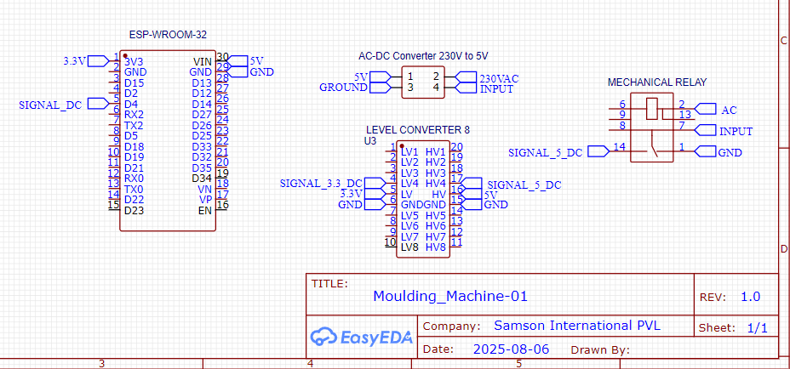
4.1 Circuit Design on Easy EDA

Figure 1: EASY EDA Circuit Diagram

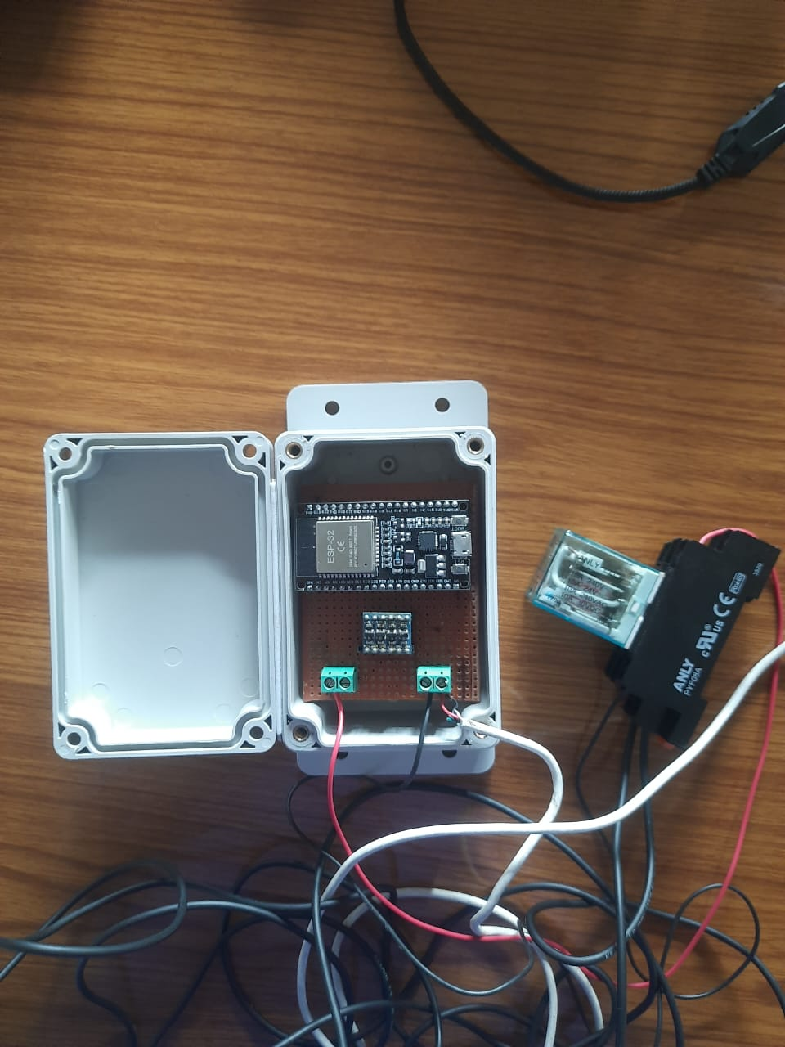
4.2 Physical implemented Circuit
Figure 2: Dot board circuit

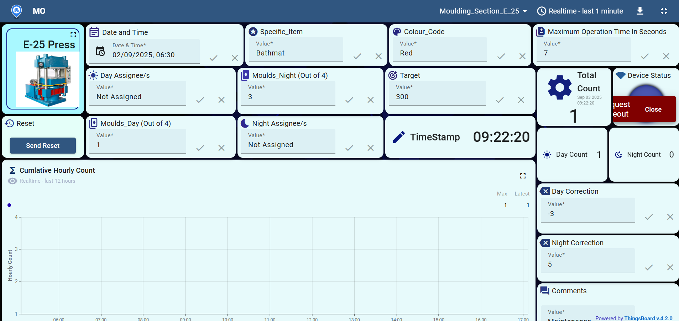
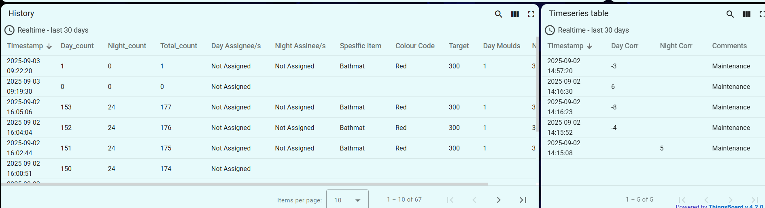
Figure 3: Things-Board Dashboard – Web App
4.3 Things-Board Dashboard – Web App

Figure 4: Things-Board Dashboard – Mobile App- I4.3 Things-Board Dashboard – Web App
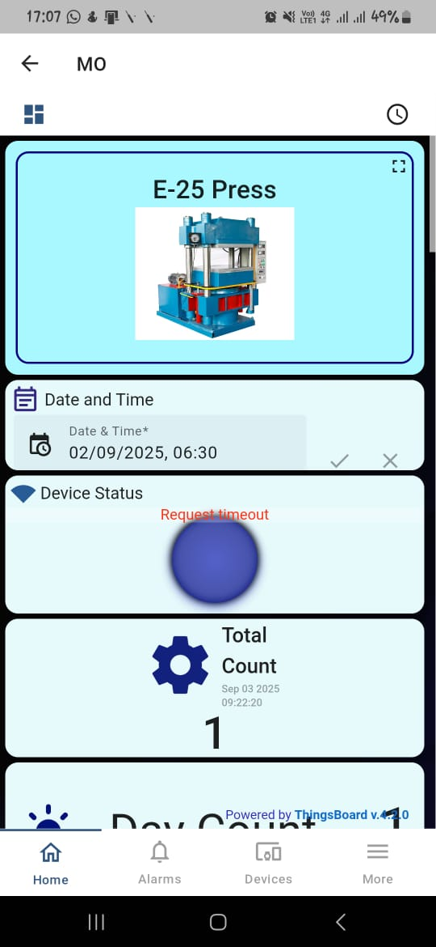
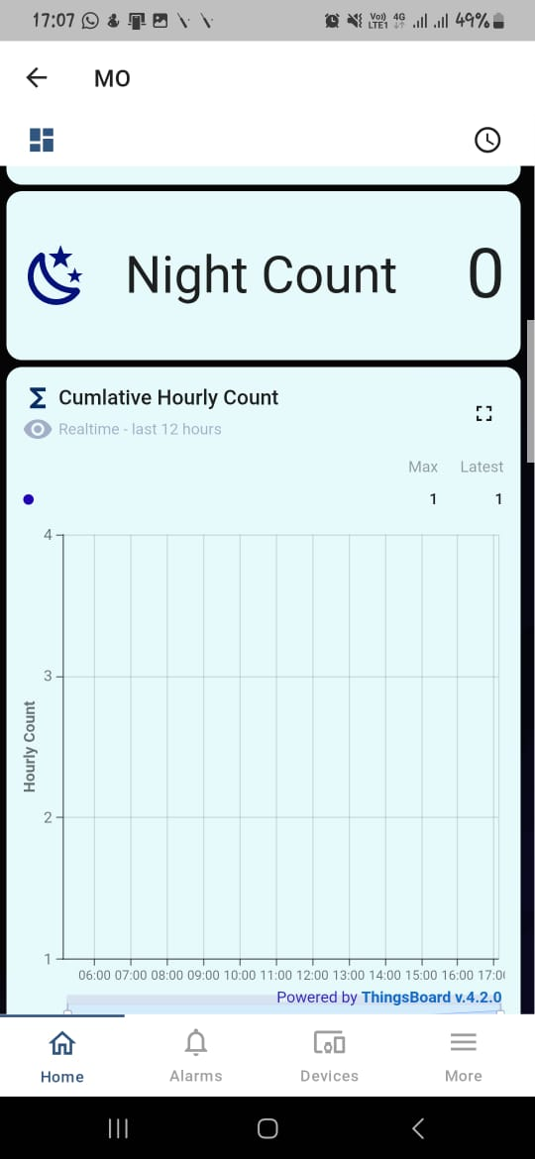
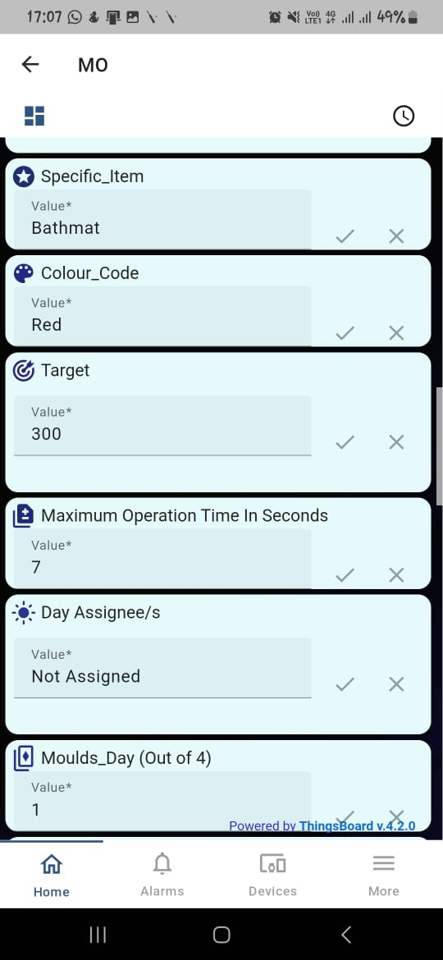
4.4 Things-Board Dashboard Mobile App.

Figure 5: Things-Board Dashboard – Mobile App- I
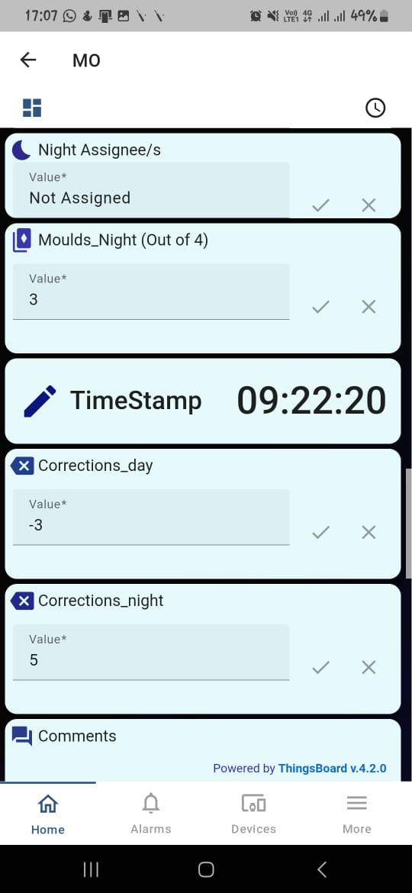
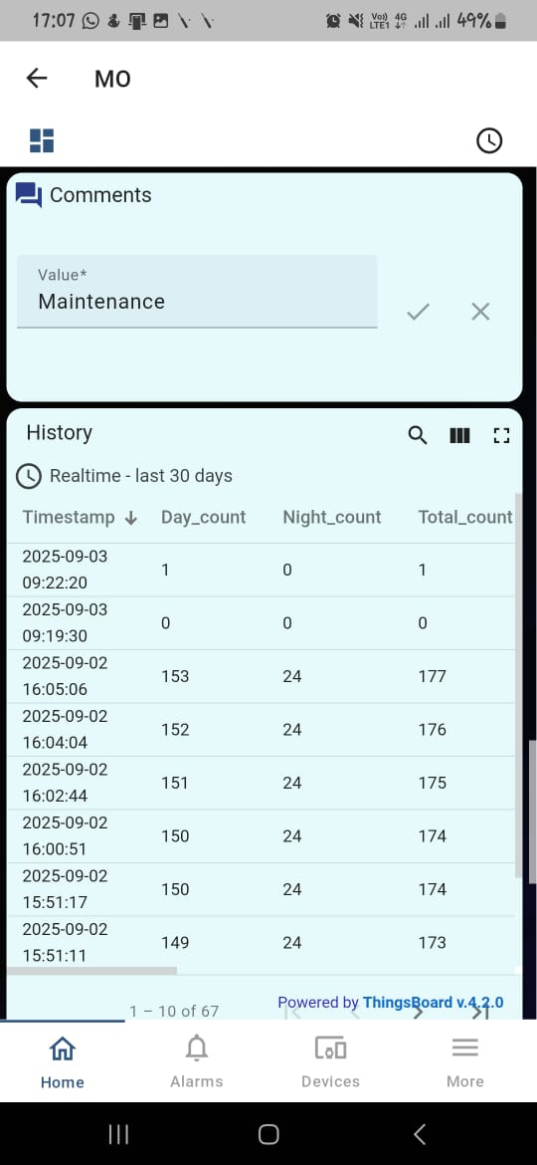
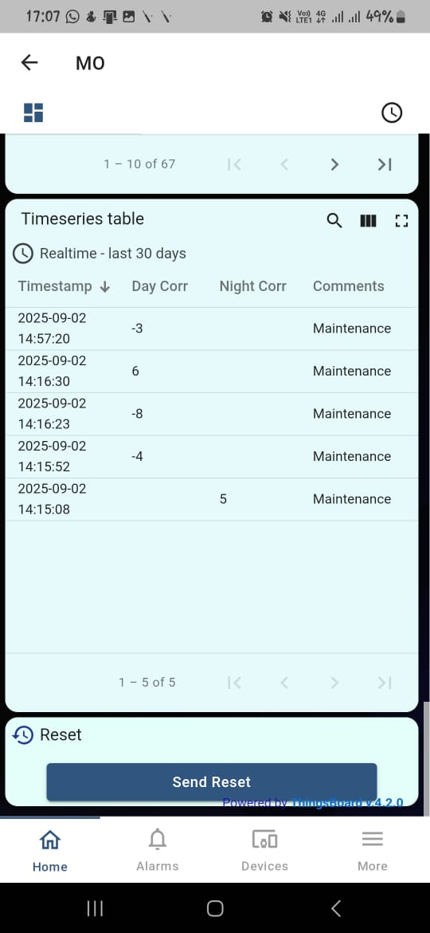

Figure 6: Things-Board Dashboard – Mobile App- II

5 Expected Outcomes
- Real time production hourly tracking.
- Live dashboard updating on web and mobile app.
- Stored data for performance reviews.
- Scalable design for industrial use.

6. Future Enhancements
- Dashboard Improvements with more customized widgets.
- Scale to other machines.
- SMS/Email alerts for production targets.

7. Budget for a one Device:

TABLE 1: BUDGET IN DETAIL WITH THE COMPONENTS
Item | Cost (LKR)
ESP32 | 1350
AC-DC Power Adapter 230V to 5V | 650
1000$×$700 mm Industrial IP box with hanging | 600
Dot Board | 50
USB Cable – (Power only) | 350
DC Circuit Wires – (20–24 AWG) + Pin Headers (Female) | 100
Logic Level Shifter | 110
Green Terminal Connectors $×$ 2 | 30
*Relay Module + Base | 500
Total | 3740 (With the relay)

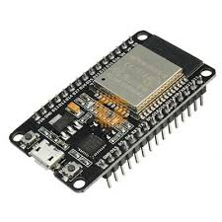
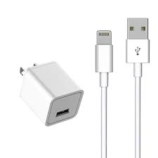
*Note: Grey Colour Highlighted: Get from the workshop (Relay with the base)

Figure 7: ESP 32 module
Figure 8: AC-DC Power Adapter 230V to 5V with Cabel
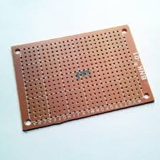
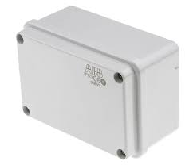
Figure 9: Industrial IP box

Figure 10: Dot Board
Figure 11: Dot board

Figure 12: Things-Board Dashboard – Mobile App- IIFigure 13: Dot board
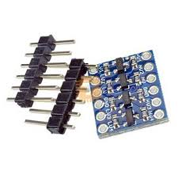
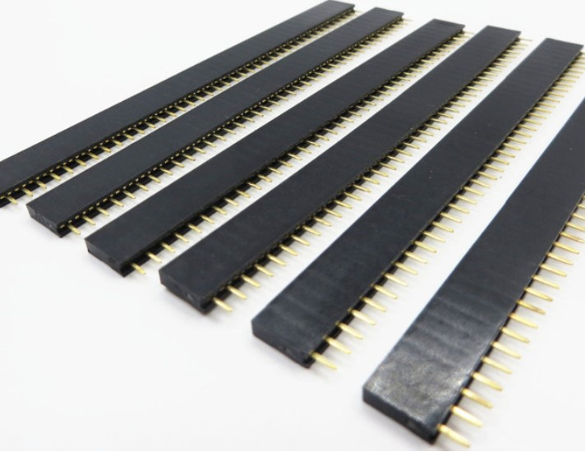

Figure 14: Female Headers
Figure 15: Logic Level Shifter
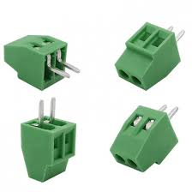
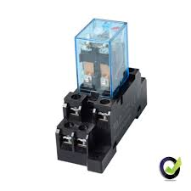
Figure 16: Mechanical Relay with Base
Figure 17: Green Terminal Connectors

8. Conclusion

This project will provide a low-cost, reliable, and scalable solution to digitize production counting processes and enable real-time monitoring using IoT platform. It can significantly improve data accuracy, visibility, and decision-making in production environments through mobile and the web view.

