Raspberry Pi with Qt

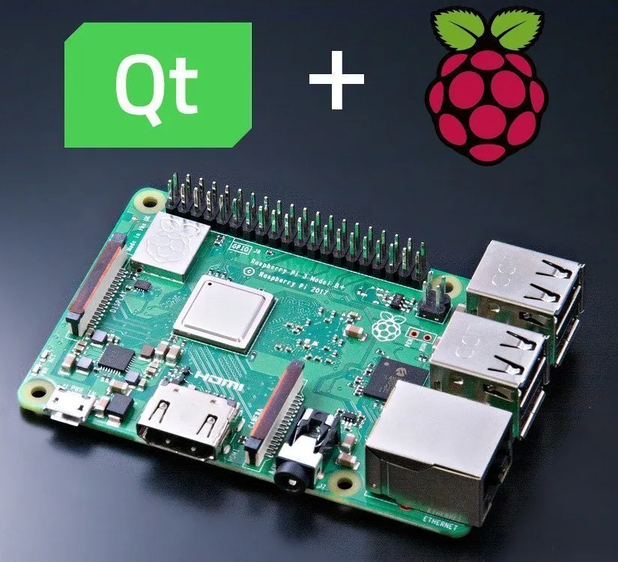

Table of Contents
Introduction 3
What is Cross-Compilation 3
What are the prerequisite before follow this documentation 3
Steps for configure Raspberry Pi 4
Install Following Things 4
Make Following Directory 5
Steps for configure host machine 5
First update and upgrade your host machine 5
Test your Raspberry Pi connection 5
Go to root 5
Install following things 5
Install GCC with Ubuntu via Toolchain PPA 5
Configure the priority of each version 6
Create new Directory and give permission to that 6
Get Linaro toolchain 6
Add above path to .bashrc 6
Download Qt 7
Create sysroot directory 7
Open terminal in current directory and run follow step one by one 7
Get sysroot-relativelinks.py 7
Check again sync all file with raspberry pi 7
Create qt5build directory 8
Compile All things 8
Make it 8
Install Qt Creator 8
Configure Qt Creator 8
Create New Kit 8
Add Raspberry Pi Device 11
Finish 11
Reference 11

Raspberry-PI with Qt 5.14.2

Introduction
Creating applications with Qt for Raspberry Pi is a rewarding and fun experience that allows you to unleash your creativity and innovation. Qt is a cross-platform framework that enables you to develop graphical user interfaces (GUIs) and applications that run on various hardware and operating systems. Raspberry Pi is a low-cost, credit-card-sized computer that can run Linux and other operating systems, and can be used for a variety of projects, such as robotics, gaming, smart home, and education. In this documentation, you will learn how to set up your development environment, how to create a cross compiler for Raspberry Pi, how to design and build GUIs with Qt Creator, and how to deploy and run your applications on Raspberry Pi. By the end of this documentation, you will have the skills and knowledge to create your own amazing applications with Qt for Raspberry Pi.

What is Cross-Compilation
Cross compilation in Qt for Raspberry Pi is a process of building Qt applications on a host machine (such as a PC) and then transferring them to a target device (such as a Raspberry Pi) for execution. This way, you can take advantage of the faster CPU and RAM of the host machine, and avoid the long compilation time and limited resources of the Raspberry Pi. Cross compilation also allows you to use Qt Creator, a powerful IDE for Qt development, on your host machine, and debug your applications remotely on the Raspberry Pi. To cross-compile Qt for Raspberry Pi, you need to have a cross-compiler toolchain, a sysroot directory that contains the target device's file system, and a CMake toolchain file that specifies the configuration options for Qt.

What are the prerequisite before follow this documentation
- Raspberry-Pi (This documentation is tested for Raspberry-Pi 2 model B. You should need to install raspbian OS to raspberry Pi. Next you need to install RealVNC server to connect Raspberry Pi to your host computer. Next you need to turn on ssh connection in Raspberry Pi.
- Host Machine (This documentation is tested for Ubuntu version is 22.04 – Ubuntu-22.04-desktop-amd64. After install Ubuntu you need to install RealVNC client to your machine. Turn on ssh connection in your host machine)
- Ethernet cable ( for connect Raspberry Pi and Host machine )
- Power cable ( for give power supple to Raspberry Pi )

Note :- After you connect your Raspberry Pi to Host machine via Ethernet you have to change your Raspberry Pi Ip Address. Host machine IP and Raspberry Pi IP should be same network
Follow this video URL :- Watch

Steps for configure Raspberry Pi
sudo vi /etc/apt/sources.list
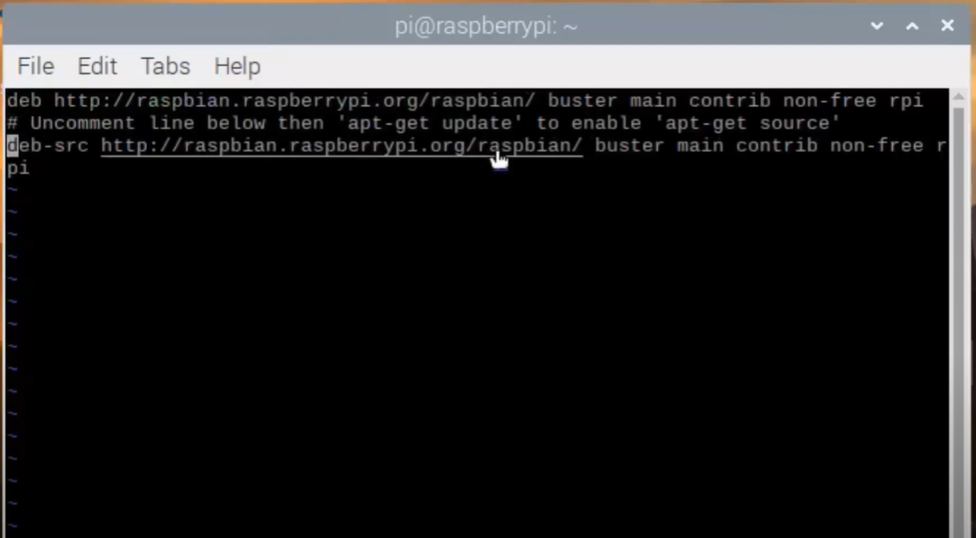Figure 1: Uncomment Last Line
sudo apt update
sudo apt full-upgrade
sudo reboot
sudo rpi-update
sudo reboot

Install Following Things
sudo apt-get build-dep qt5-qmake
sudo apt-get build-dep libqt5webengine-data
sudo apt-get install libboost1.58-all-dev libudev-dev libinput-dev libts-dev libmtdev-dev libjpeg-dev libfontconfig1-dev
sudo apt-get install libssl-dev libdbus-1-dev libglib2.0-dev libxkbcommon-dev libegl1-mesa-dev libgbm-dev libgles2-mesa-dev mesa-common-dev
sudo apt-get install libasound2-dev libpulse-dev gstreamer1.0-omx libgstreamer1.0-dev libgstreamer-plugins- base1.0-dev gstreamer1.0-alsa
sudo apt-get install libvpx-dev libsrtp0-dev libsnappy-dev libnss3-dev
sudo apt-get install "^libxcb.*"
sudo apt-get install flex bison libxslt-dev ruby gperf libbz2-dev libcups2-dev libatkmm-1.6-dev libxi6 libxcomposite1
sudo apt-get install libfreetype6-dev libicu-dev libsqlite3-dev libxslt1- dev libavcodec-dev libavformat-dev libswscale-dev
sudo apt-get install libgstreamer0.10-dev gstreamer-tools libraspberrypi-dev libx11-dev libglib2.0-dev
sudo apt-get install freetds-dev libsqlite0-dev libpq-dev libiodbc2-dev firebird-dev libjpeg9-dev libgst-dev libxext-dev libxcb1 libxcb1-dev libx11-xcb1
sudo apt-get install libx11-xcb-dev libxcb-keysyms1 libxcb-keysyms1-dev libxcb-image0 libxcb-image0-dev libxcb-shm0 libxcb-shm0-dev libxcb-icccm4 libxcb-icccm4-dev
sudo apt-get install libxcb-sync1 libxcb-sync-dev libxcb-render-util0 libxcb-render-util0-dev libxcb-xfixes0- dev libxrender-dev libxcb-shape0-dev libxcb-randr0-dev
sudo apt-get install libxcb-glx0-dev libxi-dev libdrm-dev libssl-dev libxcb-xinerama0 libxcb-xinerama0-dev
sudo apt-get install libatspi-dev libssl-dev libxcursor-dev libxcomposite-dev libxdamage-dev libfontconfig1- dev
sudo apt-get install libxss-dev libxtst-dev libpci-dev libcap-dev libsrtp0-dev libxrandr-dev libnss3-dev libdirectfb-dev libaudio-dev

Make Following Directory
sudo mkdir /usr/local/qt5pi
sudo chown <username>:<username> /usr/local/qt5pi

Steps for configure host machine

First update and upgrade your host machine
sudo apt-get update
sudo apt-get upgrade

Test your Raspberry Pi connection
ping <ip address of raspberry>

Go to root
sudo bash

Install following things
apt-get install gcc git bison python gperf pkg-config
apt install make
apt install libclang-dev
apt install build-essential

Note :- build-essential install gcc and g++ latest compilers. But this tutorial work with only gcc – 9 and g++ -9. for that we have to install gcc previous compilers.

Install GCC with Ubuntu via Toolchain PPA

sudo add-apt-repository ppa:ubuntu-toolchain-r/ppa -y
sudo apt update
sudo apt install gcc-9 g++-9 gcc-10 g++-10 gcc-11 g++-11 g++-12 gcc-12 g++-13 gcc-13

Configure the priority of each version

sudo update-alternatives --install /usr/bin/gcc gcc /usr/bin/gcc-12 40 -- slave /usr/bin/g++ g++ /usr/bin/g++-13 --slave /usr/bin/gcov gcov /usr/bin/gcov-13

sudo update-alternatives --install /usr/bin/gcc gcc /usr/bin/gcc-13 90 -- slave /usr/bin/g++ g++ /usr/bin/g++-12 --slave /usr/bin/gcov gcov /usr/bin/gcov-12

sudo update-alternatives --install /usr/bin/gcc gcc /usr/bin/gcc-11 80 -- slave /usr/bin/g++ g++ /usr/bin/g++-11 --slave /usr/bin/gcov gcov /usr/bin/gcov-11

sudo update-alternatives --install /usr/bin/gcc gcc /usr/bin/gcc-10 60 -- slave /usr/bin/g++ g++ /usr/bin/g++-10 --slave /usr/bin/gcov gcov /usr/bin/gcov-10

sudo update-alternatives --install /usr/bin/gcc gcc /usr/bin/gcc-9 100 -- slave /usr/bin/g++ g++ /usr/bin/g++-9 -- slave /usr/bin/gcov gcov /usr/bin/gcov-9

Create new Directory and give permission to that
mkdir /opt/qt5pi
chown <username>:<username> /opt/qt5pi
cd /opt/qt5pi/

Get Linaro toolchain
Wget https://releases.linaro.org/components/toolchain/binaries/latest-7/ arm-linux-gnueabihf/gcc- linaro-7.5.0-2019.12-x86_64_arm-linux- gnueabihf.tar.xz

tar xf gcc-linaro-7.5.0-2019.12-x86_64_arm-linux- gnueabihf.tar.xz

export PATH=$PATH:/opt/qt5pi/gcc-linaro-7.5.0-2019.12- x86_64_arm- linux-gnueabihf/bin

Add above path to .bashrc
nano ~/.bashrc
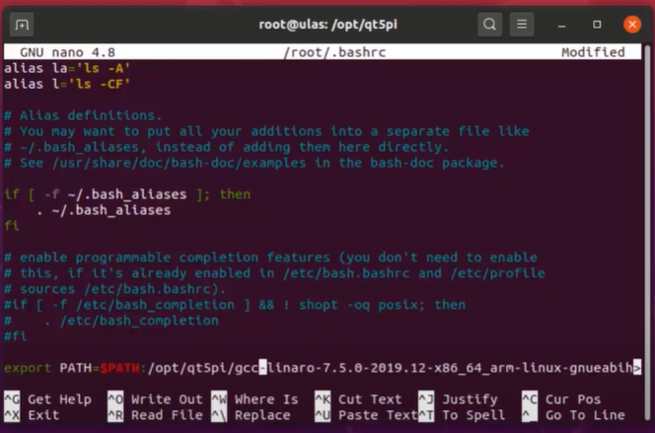Figure 2: Add path to .bashrc

Download Qt
wget https://download.qt.io/official_releases/qt/5.15/5.15.2/single/qt-everywhere-src-5.15.2.tar.xz
tar xf qt-everywhere-src-5.15.2.tar.xz

Create sysroot directory
mkdir sysroot
chown <username>:<username> sysroot

Open terminal in current directory and run follow step one by one
rsync -avz --rsync-path="sudo rsync" <username>@<rasp-IP>:/usr/include sysroot/usr
rsync -avz --rsync-path="sudo rsync" <username>@<rasp-IP>:/lib sysroot
rsync -avz --rsync-path="sudo rsync" <username>@<rasp-IP>:/usr/lib sysroot/usr
rsync -avz --rsync-path="sudo rsync" <username>@<rasp-IP>:/opt/vc sysroot/opt
ls sysroot/usr/lib/arm-linux-gnueabihf/libEGL.so.1.1.0
mv sysroot/usr/lib/arm-linux-gnueabihf/libEGL.so.1.1.0 sysroot/usr/lib/arm-linux- gnueabihf/libEGL.so.1.1.0_backup
ln -s sysroot/opt/vc/lib/libEGL.so sysroot/usr/lib/arm-linux-gnueabihf/libEGL.so.1.1.0
mv sysroot/usr/lib/arm-linux-gnueabihf/libGLESv2.so.2.1.0 sysroot/usr/lib/arm-linux-gnueabihf/ libGLESv2.so.2.1.0_backup
ln -s sysroot/opt/vc/lib/libGLESv2.so sysroot/usr/lib/arm-linux-gnueabihf/libGLESv2.so.2.1.0
mv sysroot/usr/lib/arm-linux-gnueabihf/libGLESv2.so.2.1.0 sysroot/usr/lib/arm-linux-gnueabihf/ libGLESv2.so.2.1.0_backup
ls sysroot/usr/lib/arm-linux-gnueabihf/libGLESv2.so.2.1.0
ln -s sysroot/opt/vc/lib/libGLESv2.so sysroot/usr/lib/arm-linux-gnueabihf/libGLESv2.so.2.1.0
ln -s sysroot/opt/vc/lib/libEGL.so sysroot/opt/vc/lib/libEGL.so.1
ln -s sysroot/opt/vc/lib/libGLESv2.so sysroot/opt/vc/lib/libGLESv2.so.2

Get sysroot-relativelinks.py
wget https://raw.githubusercontent.com/riscv/riscv-poky/master/scripts/sysroot-relativelinks.py
chmod +x sysroot-relativelinks.py
./sysroot-relativelinks.py sysroot

Check again sync all file with raspberry pi

rsync -avz --rsync-path="sudo rsync" <username>@<rasp-IP>:/lib sysroot
rsync -avz --rsync-path="sudo rsync" <username>@<rasp-IP>:/usr/include sysroot/usr
rsync -avz --rsync-path="sudo rsync" <username>@<rasp-IP>:/usr/lib sysroot/usr
rsync -avz --rsync-path="sudo rsync" <username>@<rasp-IP>:/opt/vc sysroot/opt/
./sysroot-relativelinks.py sysroot

Create qt5build directory
mkdir qt5build
cd qt5build/

Compile All things

../qt-everywhere-src-5.15.2/configure -opengl es2 -device linux-rasp-pi2-g++ - device-option CROSS_COMPILE=/opt/qt5pi/gcc-linaro-7.5.0-2019.12-x86_64_arm-linux- gnueabihf/bin/arm-linux-gnueabihf- -sysroot /opt/qt5pi/sysroot -prefix /usr/local/qt5pi -opensource -confirm-license -skip qtscript -skip qtwayland -skip qtdatavis3d -nomake examples -make libs -pkg-config -no-use-gold-linker -v

Note :- Check again above command paths according to your host machine. Stay one or two hour for complete this task

Make it
make -j8
make install
cd /opt/qt5pi/
rsync -avz --rsync-path="sudo rsync" sysroot/usr/local/qt5pi <username>@<rasp-IP>:/usr/local

Note:- Now cross-compiler is ready. After that you have to install Qt creator

Install Qt Creator
Download Qt creator online installer and install it. Use qt 5.xx.xx version. Because in this we use qt5.

Configure Qt Creator

Create New Kit
Note:- See follow screenshots and use that paths for your configurations
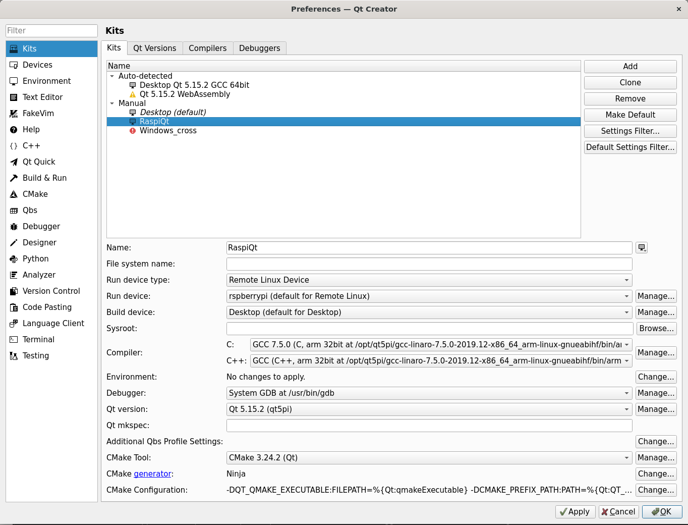Figure 3: Kit Configuration
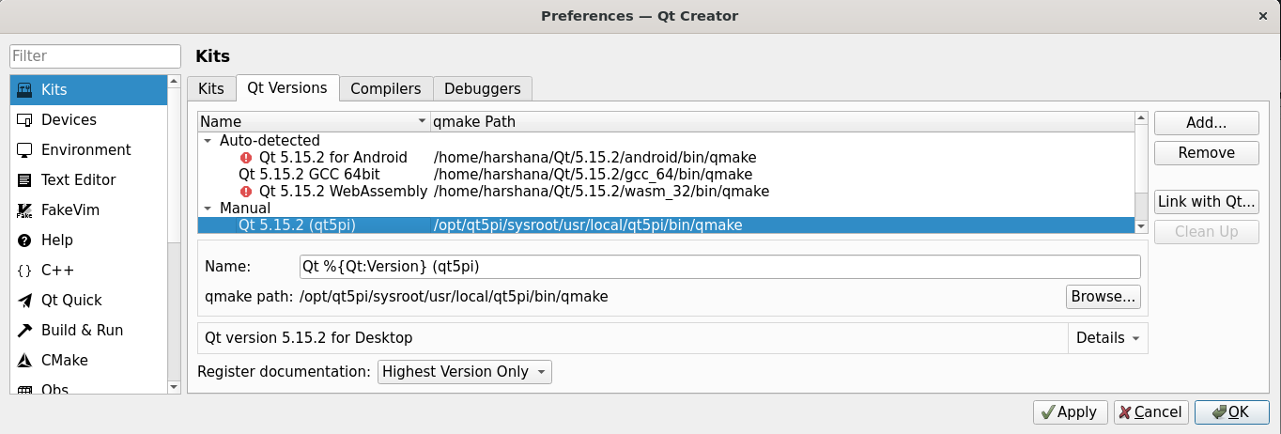Figure 4: Qt Version Configuration

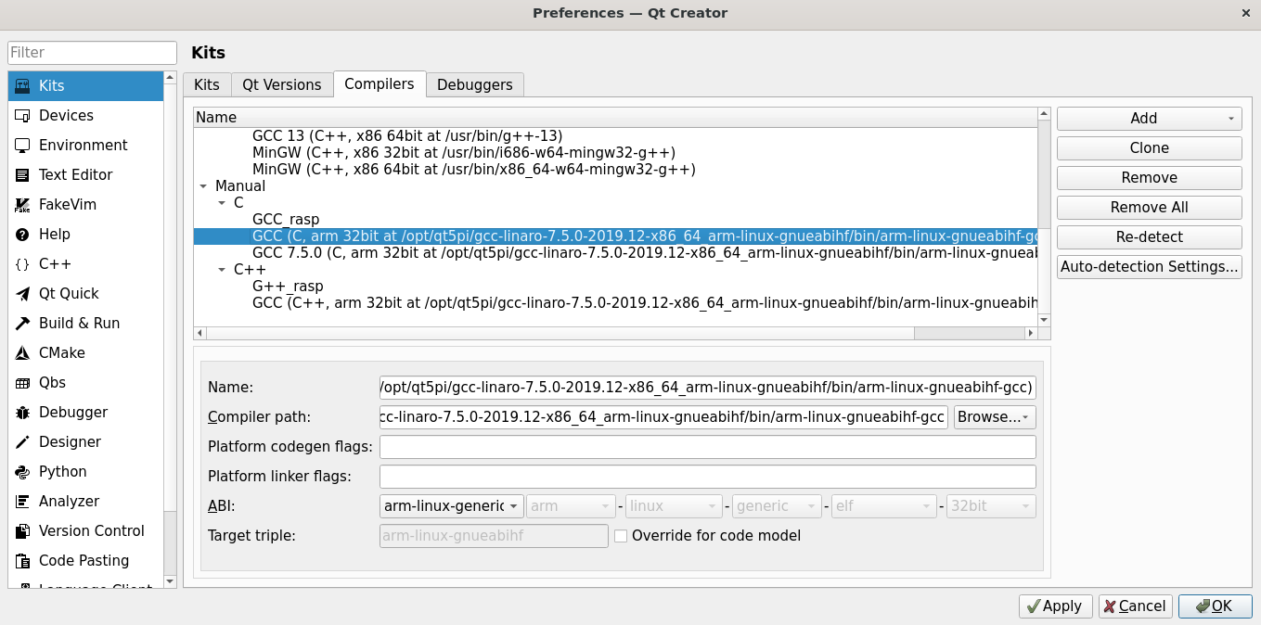Figure 5: Add GCC Compiler - Linaro Toolchain

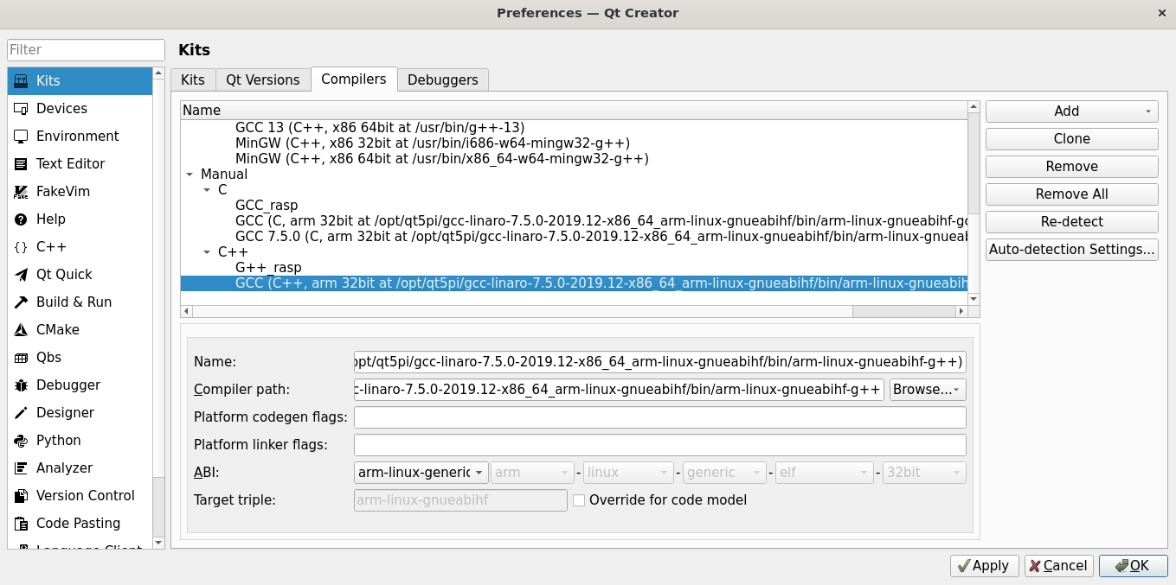Figure 6: Add G++ Compiler - Linaro Toolchain

Add Raspberry Pi Device
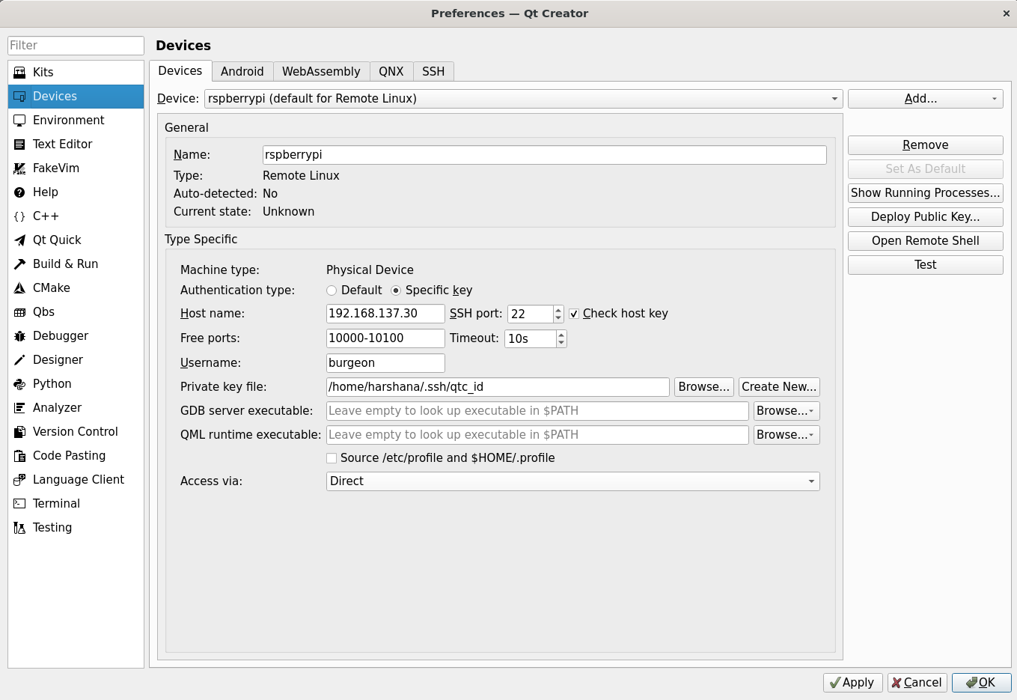
Note :- This step is necessary one. In this step you have to create private key file when you are going to add the device. Otherwise you will have errors when you are going to compile Qt applications

Finish
Now all configurations are complete. Now you can create application for raspberry pi. When you are going to create new project choose newly created kit. Then create project.
After build your project you can copy that build folder to raspberry pi. Then you can execute that application on raspberry pi

Reference
Tutorial Video -> Video
All Commands -> All Commands
Linaro toolchain path -> Toolchain

