Toad game By Deshawn Battle is a text-based game where you can select three characters, who comes with their own sets of advantages to help you get through the Mighty Toad!

**Thief**

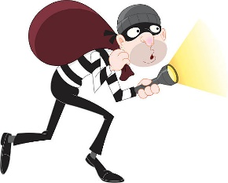

Just like any thief his mission success is mostly Luck! And hardly any skill. The thief can either be great, stronger than the knight more caring than the Mage, or the thief can be weak and poor in health.

Mage

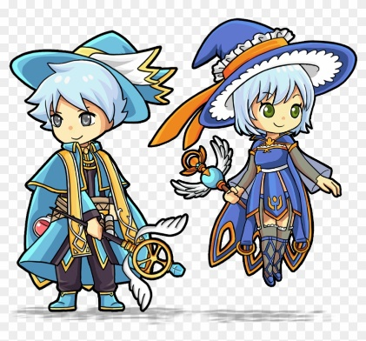

The Mage is a useful character because you may run into a Toad every step of the way, Mages are born with more health than anyone without the luck of a thief, with more health come slightly less Strength.

Knight

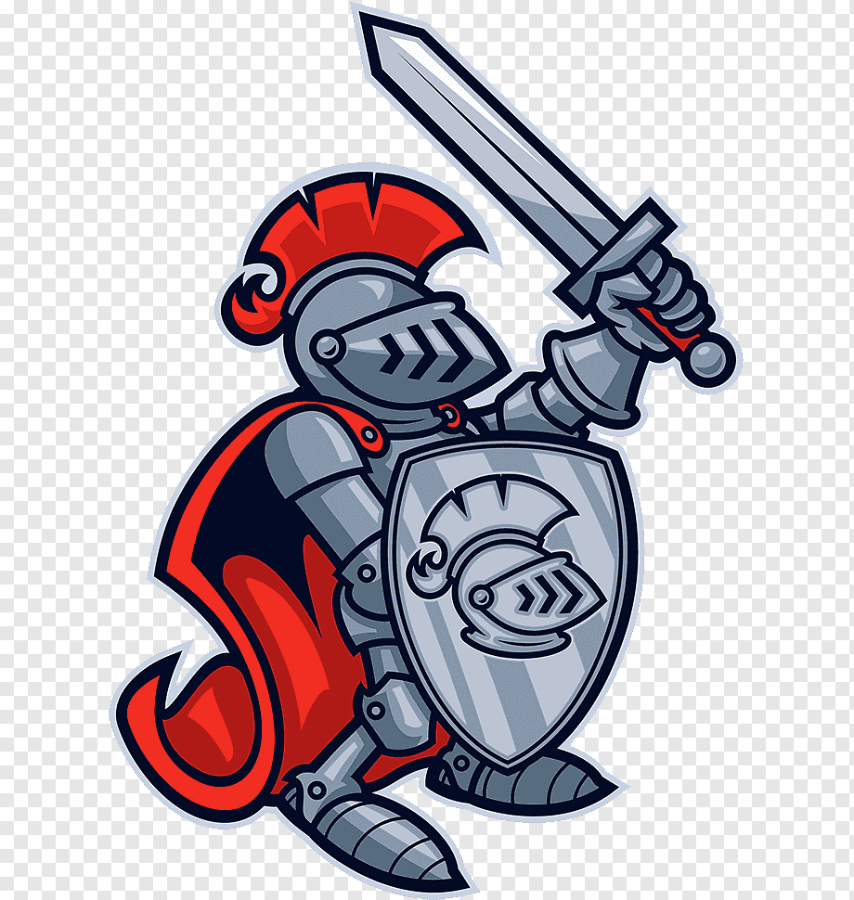

The knight, a brave soul who doesn’t back down from anyone or anything! He’s most prideful in his strength. He’s equipped with more strength than anyone else without the luck of a thief