1. **Home Page**

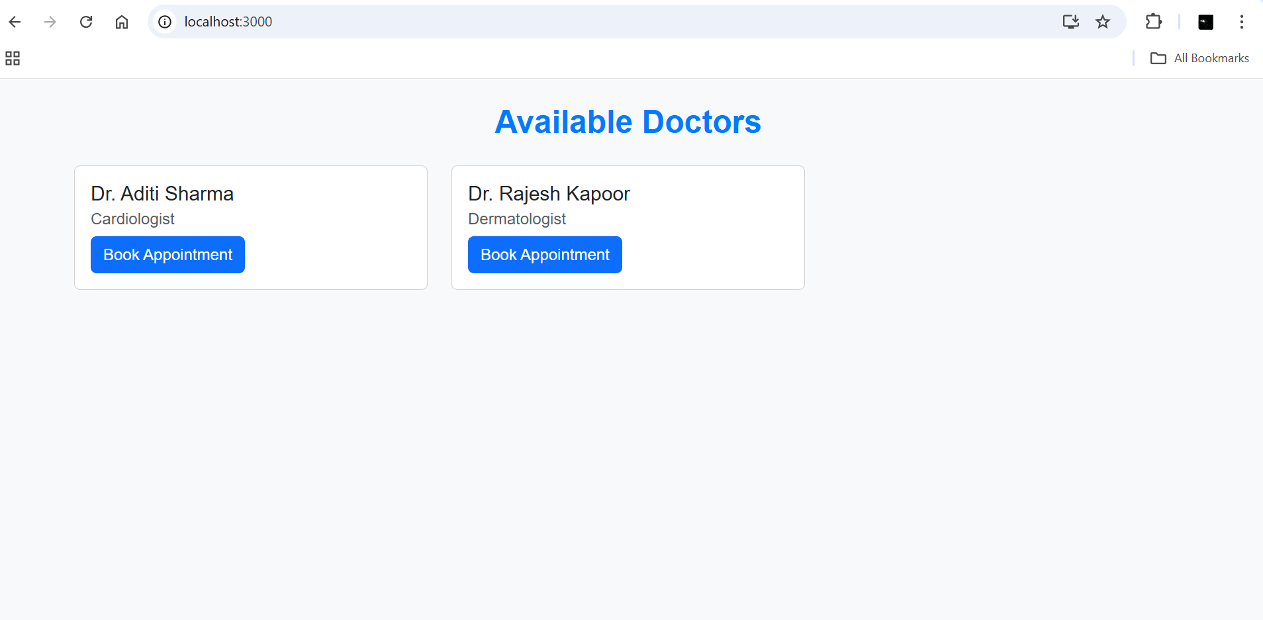

1. **A screenshot of a computer

   AI-generated content may be incorrect.Booking Form**
2. **A screenshot of a computer

   AI-generated content may be incorrect.Confirmation Page:**