**Coding Activity: E-Commerce Cart System (React & NodeJS)**

**Folder Structure :**   
Manikanth-Deshidi-MileStoneExam1-Wipro-NGA.net-FSD-React/

├── backend/

│ ├── package.json

│ └── server.js

└── client/

├── package.json

├── public/

│ └── index.html

└── src/

├── index.js

├── index.css

├── App_mani.js

├── context/

│ └── CartContext_mani.js

└── components/

├── Header_mani.js

├── ProductList_mani.js

├── Cart_mani.js

├── Checkout_mani.js

└── Confirmation_mani.js

**Image 1:**

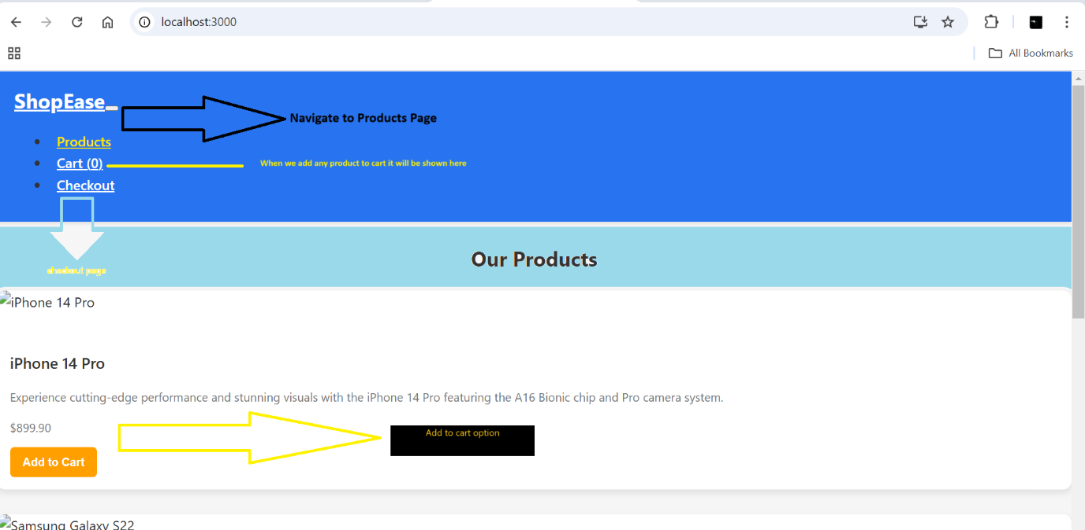

Image 2:

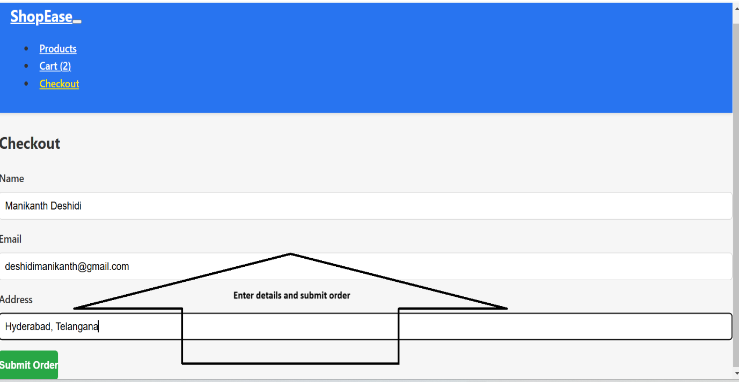Image 3:

Image 4:

