# **CS385 Computer Vision**

# **Lab-7: Hough Transform/Harris Corner and DOG**

# **100 points**

**Task :**

(1)First task is to experiment with Hough transform based line and circle extraction using cv2 routines . Summarize the results of these experiments as well as your conclusions. Use relevant images with sufficient lines /circles. **(20 Points)**

(2) For this second part assignment you will implement Harris Corner detection algorithm. You can use basic linear algebra operations provided by numpy in Python. Your main function should take as input a grayscale image and the corner detection parameters. The output of your function should be a binary image with the results of edge detection. Compare your implementation with built in routines in opencv. **(60 points)**

(3) A well known method of edge detection is the Difference of Gaussians (DoG). The method consists of subtracting two Gaussians, where a kernel has a standard deviation smaller than the previous one. The convolution between the subtraction of kernels and the input image results in the edge detection of this image. Create DOG pyramid for 2 images at different scale(as shown). Summarize the results of these experiments as well as your conclusions.

**(20 points)**

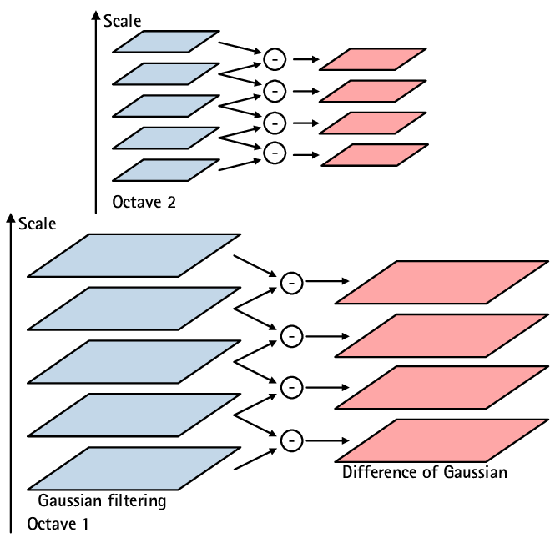

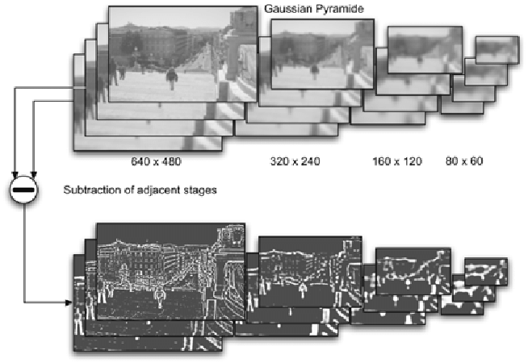

**Submission:**

Demonstrate your work . Also submit as a single file the code and results.

<https://u.pcloud.com/#page=puplink&code=QQGkZaJgn3VLH1SpuT4x22UhnEQH5c2tV>