# **CS385 Computer Vision**

# **Lab-9: Visualising High-Dimensional data**

# **100 points**

**Task :**

1. Perform a 2D visualization of MNIST dataset (<http://yann.lecun.com/exdb/mnist/>.) using PCA and [**t-SNE (t-distributed stochastic neighbor embedding)**](https://en.wikipedia.org/wiki/T-distributed_stochastic_neighbor_embedding) **(25 Points)**

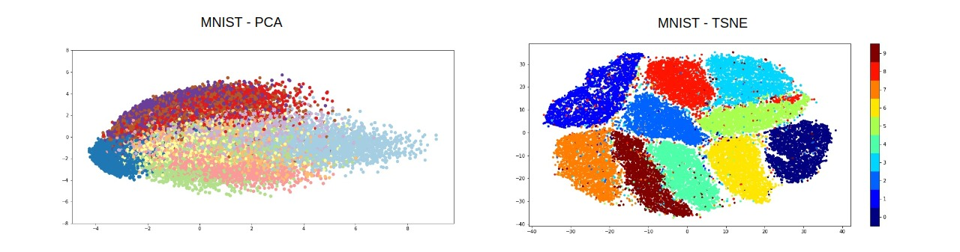

(2) Repeat (1) using fashion_mnist (<https://huggingface.co/datasets/fashion_mnist>) and AI21b dataset (lab 8) **(25 points)**

# **(3) N**on-linear feature reduction: **Use LLE(**Locally Linear Embedding), Laplacian Eigenmaps and isomap embedding **(** non-linear feature reduction methods) to perform a 2D visualization for A121b and face_data. [**https://cs.nyu.edu/~roweis/lle/algorithm.html**](https://cs.nyu.edu/~roweis/lle/algorithm.html)

( use mat = scipy.io.loadmat('face_data.mat') to extract the data from the matlab file)

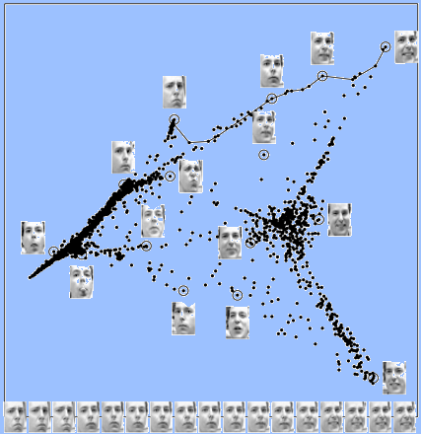

**(50 points)**

**Submission: submit before 11th March Monday 11 PM.**

<https://u.pcloud.com/#page=puplink&code=iuvkZCkJkzsn9BWhWPA2sgF7xHYNcykTy>