USER INTERFACE AND DESIGN
GOOD DESIGN:


POINTS ABOUT GOOD DESIGN:
- Clarity: The interface should communicate information clearly. Labels, icons, and actions must be easy to understand.
- Consistency: Use consistent colors, typography, and layouts across the application to reduce cognitive load.
- Feedback: Provide immediate and meaningful feedback for user actions (e.g., button clicks, form submissions).
BAD DESIGN:
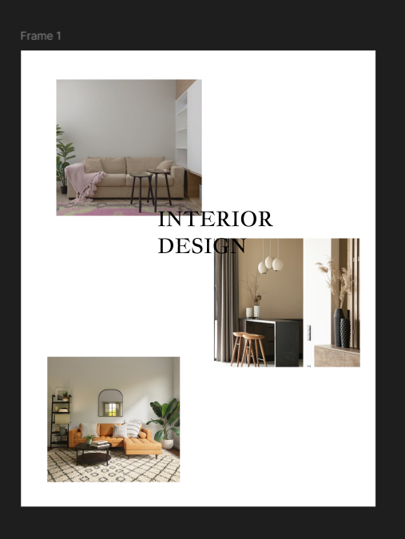

POINTS ABOUT BAD DESIGN:
- Cluttered Layouts: Too many elements crammed together, making it hard to focus or navigate.
- Inconsistent Design: Different fonts, colors, or button styles across screens confuse users.
- Poor Navigation: Hidden menus, unclear paths, or too many clicks to reach important features.

