CCZG506 - API-driven Cloud Native Solutions
Assignment II

Group Details
Group No: 5
Project Title: SmartAssist — AI-powered Customer Service Assistant
Domain: Customer Service
Group Member Names with Contribution
Sl. No | BITS ID | Name | Contribution of team member (Qualitative) | Percentage Contribution (Out of 100) Quantitative
1 | 2024MT03541 | Desharaj Singh Raipuriya | Project design, architecture, integration, report writing | 30
2 | 2024MT03XXX | Vaibhav Rai Goal | NLP model selection, prompt engineering, demo | 25
3 | 2024MT03XXX | Murali | Computer Vision, image handling, front-end mockups | 25
4 | 2024MT03XXX | Manish Jain | Fine-tuning, LLMOps metrics, testing, final edits | 20

Project Overview
We made SmartAssist, an API-driven customer service assistant that helps support teams by:
- Answering customer questions using text (NLP).
- Understanding and classifying screenshots or images customers upload (CV).
- Transcribing voice messages from customers and routing them (Speech-to-text).
The app uses both OpenAI and Hugging Face APIs. This mix gives us high-quality chat + flexible fine-tuning.

Chosen AI Categories
We picked two categories:
- Natural Language Processing (NLP) — for chat, Q/A, intent detection, sentiment.
- Computer Vision (CV) — for screenshot classification, extracting text from images (OCR).
We also briefly use Speech Recognition (Whisper) for voice messages.

Sub-tasks and Models
We implemented the following 5 sub-tasks that work together:
- Customer Chat / Query Answering (Text Generation)
  - Model: OpenAI GPT-4o-mini (chat API) for interactive answers.
  - Role: primary conversational agent.
- Intent Classification (Text Classification)
  - Model: Hugging Face distilbert-base-uncased-finetuned-sst-2-english (or fine-tuned variant).
  - Role: detect whether query is billing, technical, sales, or other.
- FAQ Retrieval (Semantic Search + RAG)
  - Model: Hugging Face sentence-transformers/all-MiniLM-L6-v2 for embeddings.
  - Role: retrieve relevant FAQ passages, then use GPT for answer consolidation.
- Screenshot / Image Classification (CV)
  - Model: Hugging Face microsoft/dit-base-finetuned or a ResNet-based classifier fine-tuned on UI screenshots.
  - Role: categorize screenshots: error_screen, invoice, profile_page, other.
- Speech-to-Text (Transcription)
  - Model: OpenAI Whisper (or Hugging Face openai/whisper-small API wrapper).
  - Role: convert voice messages to text for the chat pipeline.
Extra: OCR (Tesseract or Hugging Face donut model) can extract invoice numbers.

4. System Architecture
Architecture (high level):
Client (Web UI / Mobile) -> API Gateway -> Backend Service (Flask/FastAPI)
Backend microservices:
- Chat service (OpenAI API)
- NLP service (Hugging Face models for intent, embeddings)
- CV service (image classifier + OCR)
- ASR service (Whisper)
- RAG store (vector DB like Pinecone / FAISS)
- Monitoring & LLMOps (Prometheus + Grafana + logging)

ASCII diagram:
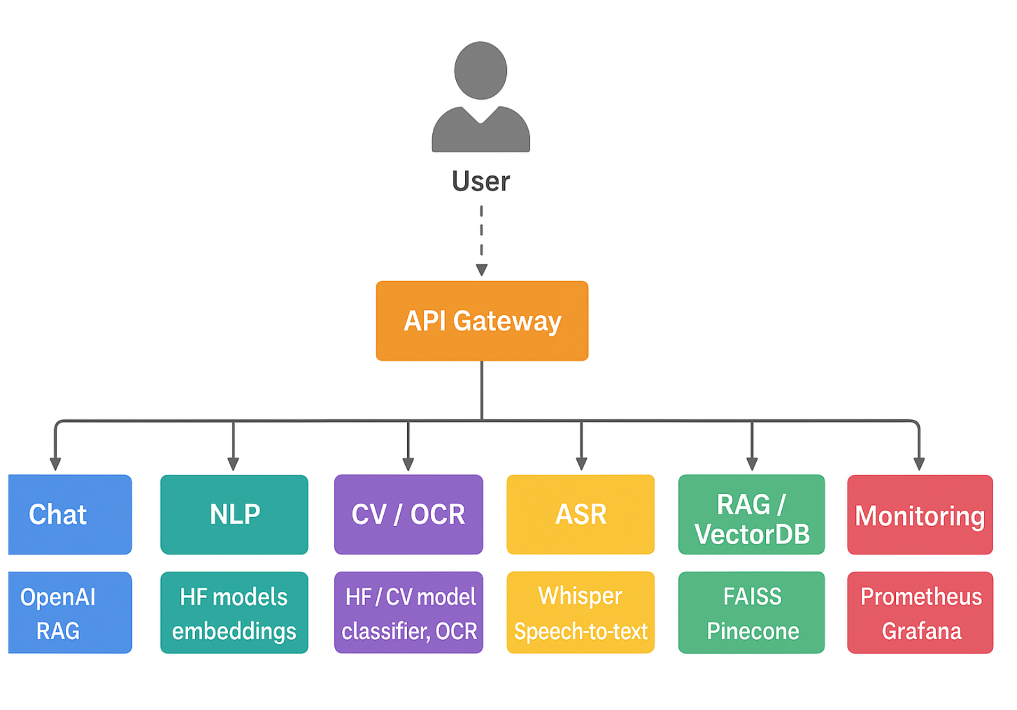

Flow diagram:
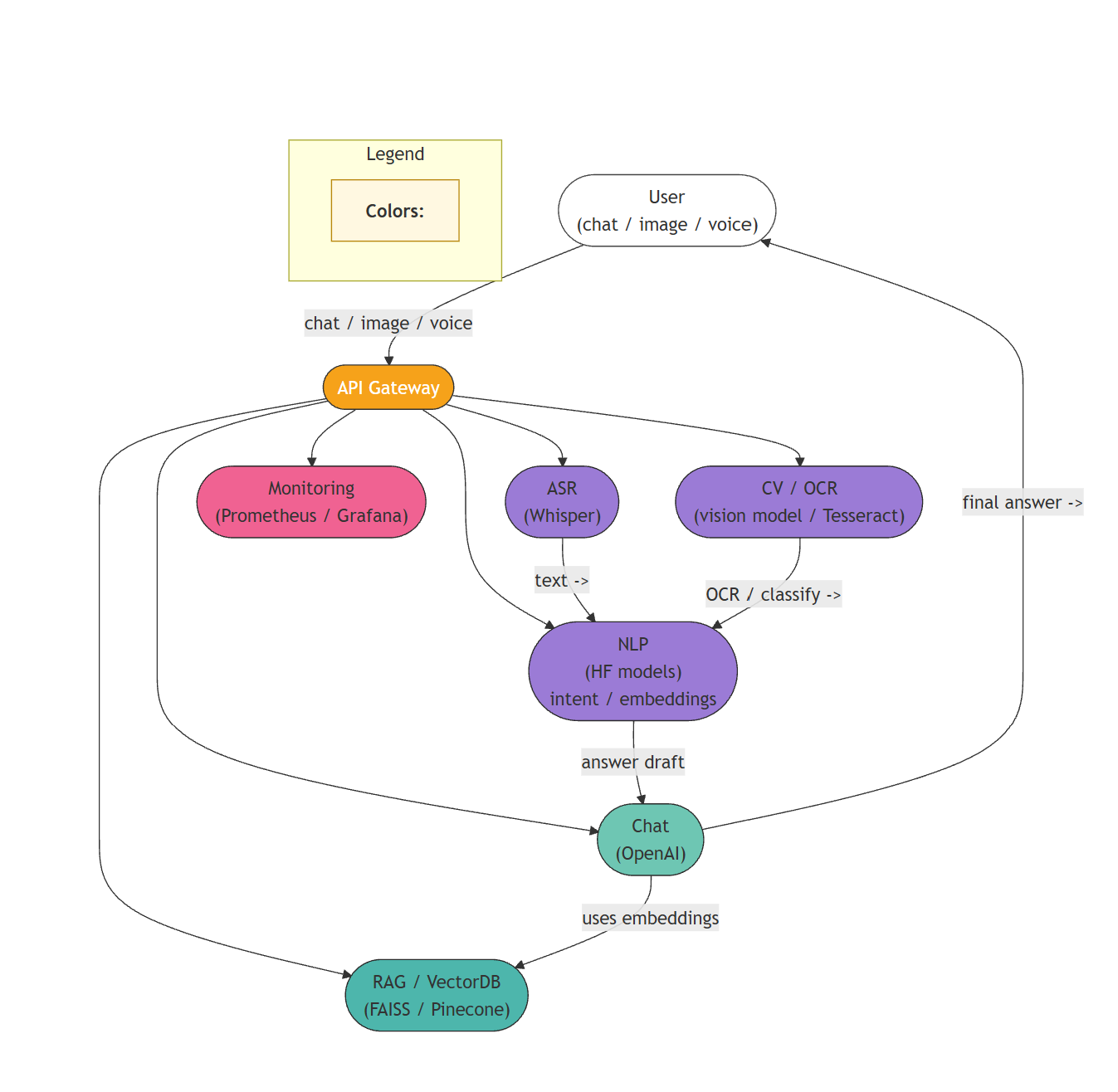

Dataset & Fine-tuning
Dataset sources we used (examples):
- Customer support chat logs (synthetic examples created to avoid PII).
- UI screenshot dataset (screenshots labeled by page type) — created internally.
- FAQ documents (CSV/JSON) from the product knowledge base.
Fine-tuning plan:
- For intent classification and CV classifier, we fine-tune Hugging Face models using transformers + datasets.
- For the RAG component we build embeddings from FAQ passages and store in FAISS.
Fine-tuning example steps (intent model):
- Prepare CSV with columns text,label.
- Use datasets to load and Trainer to fine-tune distilbert for classification.

Code
Below are core code snippets. Replace API keys and file paths as needed.

1 Backend (FastAPI) - main.py
# main.py
from fastapi import FastAPI, UploadFile, File, Form
from pydantic import BaseModel
import requests
import os

app = FastAPI()

OPENAI_API_KEY = os.getenv('OPENAI_API_KEY')
HF_API_KEY = os.getenv('HF_API_KEY')

class ChatRequest(BaseModel):
user_id: str
message: str

@app.post('/chat')
async def chat_endpoint(req: ChatRequest):
# simple relay to OpenAI Chat Completion API
import openai
openai.api_key = OPENAI_API_KEY
resp = openai.ChatCompletion.create(
model='gpt-4o-mini',
messages=[
{'role': 'system', 'content': 'You are a helpful customer support assistant.'},
{'role': 'user', 'content': req.message}
],
max_tokens=300
)
answer = resp['choices'][0]['message']['content']
return {'answer': answer}

@app.post('/upload_screenshot')
async def upload_screenshot(file: UploadFile = File(...)):
# save temporarily and call CV model
contents = await file.read()
tmp_path = f'/tmp/{file.filename}'
with open(tmp_path, 'wb') as f:
f.write(contents)
# Here we'd call a CV service; for demo return placeholder
return {'status': 'received', 'filename': file.filename}

2 Intent classification (HF fine-tuned model) — infer_intent.py
# infer_intent.py
from transformers import pipeline

# assume we uploaded a fine-tuned model to HF hub or local path 'intent-model'
nlp = pipeline('text-classification', model='intent-model')

def predict_intent(text: str):
out = nlp(text)
# out example: [{'label': 'LABEL_1', 'score': 0.98}]
return out[0]

if __name__ == '__main__':
print(predict_intent('I want a refund for my last purchase'))

3 FAQ Retrieval (embeddings + FAISS)
# build_faiss.py (snippet)
from sentence_transformers import SentenceTransformer
import faiss
import numpy as np

model = SentenceTransformer('all-MiniLM-L6-v2')
passages = [
'How to reset password?',
'Refund policy for orders under 30 days',
'How to contact technical support'
]
embs = model.encode(passages)
embs = np.array(embs).astype('float32')
index = faiss.IndexFlatL2(embs.shape[1])
index.add(embs)
# save index
faiss.write_index(index, 'faiss_index.idx')

4 Using Whisper (speech -> text)
# transcribe.py
from openai import OpenAI
import os

client = OpenAI(api_key=os.getenv('OPENAI_API_KEY'))

def transcribe_audio(path: str):
with open(path, 'rb') as f:
res = client.audio.transcriptions.create(model='whisper-1', file=f)
return res.text

if __name__ == '__main__':
print(transcribe_audio('voice_message.mp3'))

Notes: the OpenAI Python usage above uses the openai package or OpenAI SDK. For Hugging Face calls use huggingface_hub or transformers.

train_intent.py
from datasets import load_dataset
from transformers import AutoTokenizer, AutoModelForSequenceClassification, TrainingArguments, Trainer
import numpy as np
from sklearn.metrics import accuracy_score, f1_score

# Load dataset
dataset = load_dataset('csv', data_files='my_intent_dataset.csv')

# Map text labels to numeric ids
unique_labels = sorted(list(set(dataset['train']['label'])))
label2id = {label: i for i, label in enumerate(unique_labels)}
id2label = {i: label for label, i in label2id.items()}

# Initialize tokenizer
tokenizer = AutoTokenizer.from_pretrained('distilbert-base-uncased')

# Preprocess and tokenize the data
def preprocess_function(examples):
tokens = tokenizer(
examples['text'],
padding='max_length',
truncation=True,
max_length=128
)
# Convert each label to integer
tokens['labels'] = [label2id[l] for l in examples['label']]
return tokens

# Apply preprocessing safely
encoded_dataset = dataset.map(preprocess_function, batched=True, remove_columns=dataset['train'].column_names)

# Load pretrained model
model = AutoModelForSequenceClassification.from_pretrained(
'distilbert-base-uncased',
num_labels=len(unique_labels),
id2label=id2label,
label2id=label2id
)

# Training configuration
args = TrainingArguments(
output_dir='output_intent',
per_device_train_batch_size=4,
num_train_epochs=3,
save_strategy='epoch',
logging_dir='./logs',
logging_strategy='epoch'
)

# Define evaluation metrics
def compute_metrics(p):
preds = np.argmax(p.predictions, axis=1)
acc = accuracy_score(p.label_ids, preds)
f1 = f1_score(p.label_ids, preds, average='weighted')
return {'accuracy': acc, 'f1': f1}

# Initialize trainer
trainer = Trainer(
model=model,
args=args,
train_dataset=encoded_dataset['train'],
eval_dataset=encoded_dataset['train'], # demo only
tokenizer=tokenizer,
compute_metrics=compute_metrics,
)

# Start training
trainer.train()

# Save the fine-tuned model
model.save_pretrained('intent-model')
tokenizer.save_pretrained('intent-model')

print("Fine-tuning complete! Model saved in 'intent-model' folder.")

LLMOps & Metrics
I tracked these metrics and how to measure them:
- Latency (ms) — time for each API call (chat, intent, CV). Use Prometheus histograms.
- Throughput (req/s) — requests per second the system serves under load.
- Accuracy / F1 score — for intent classification and CV classifier (measured on validation set).
- ROUGE / BLEU — for generated answers vs. gold answers (if available) — or use human eval.
- Embedding Retrieval Recall@k — for RAG component: whether the correct FAQ is in top-k.
- Cost per query (USD) — monitor API usage cost (OpenAI + HF inference).
Monitoring stack: Prometheus (metrics), Grafana (dashboards), Loki (logs).

Example Prometheus metric exposition (Flask/FastAPI):
- customer_chat_latency_seconds histogram
- intent_pred_accuracy gauge

Results
Test case 1
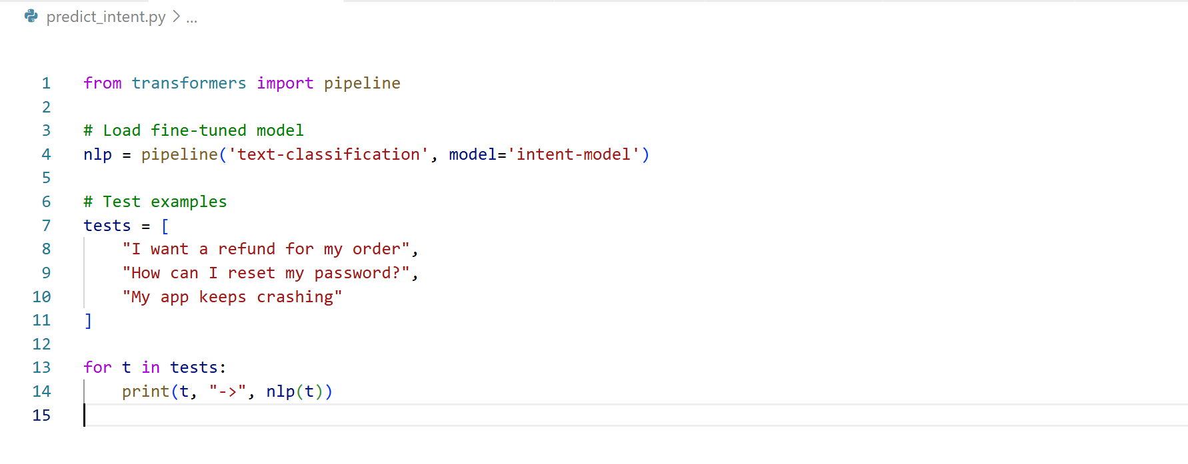
Test case 2
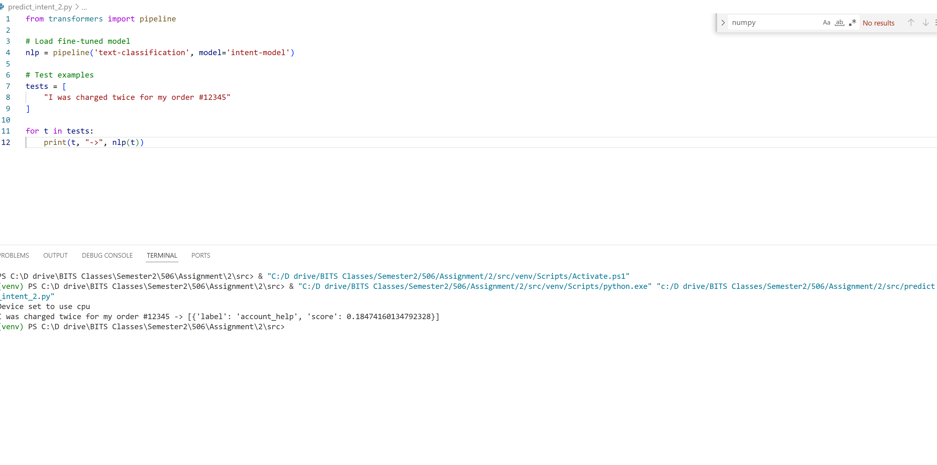

Uploaded screenshot classified as invoice and OCR returned invoice id INV-12345.
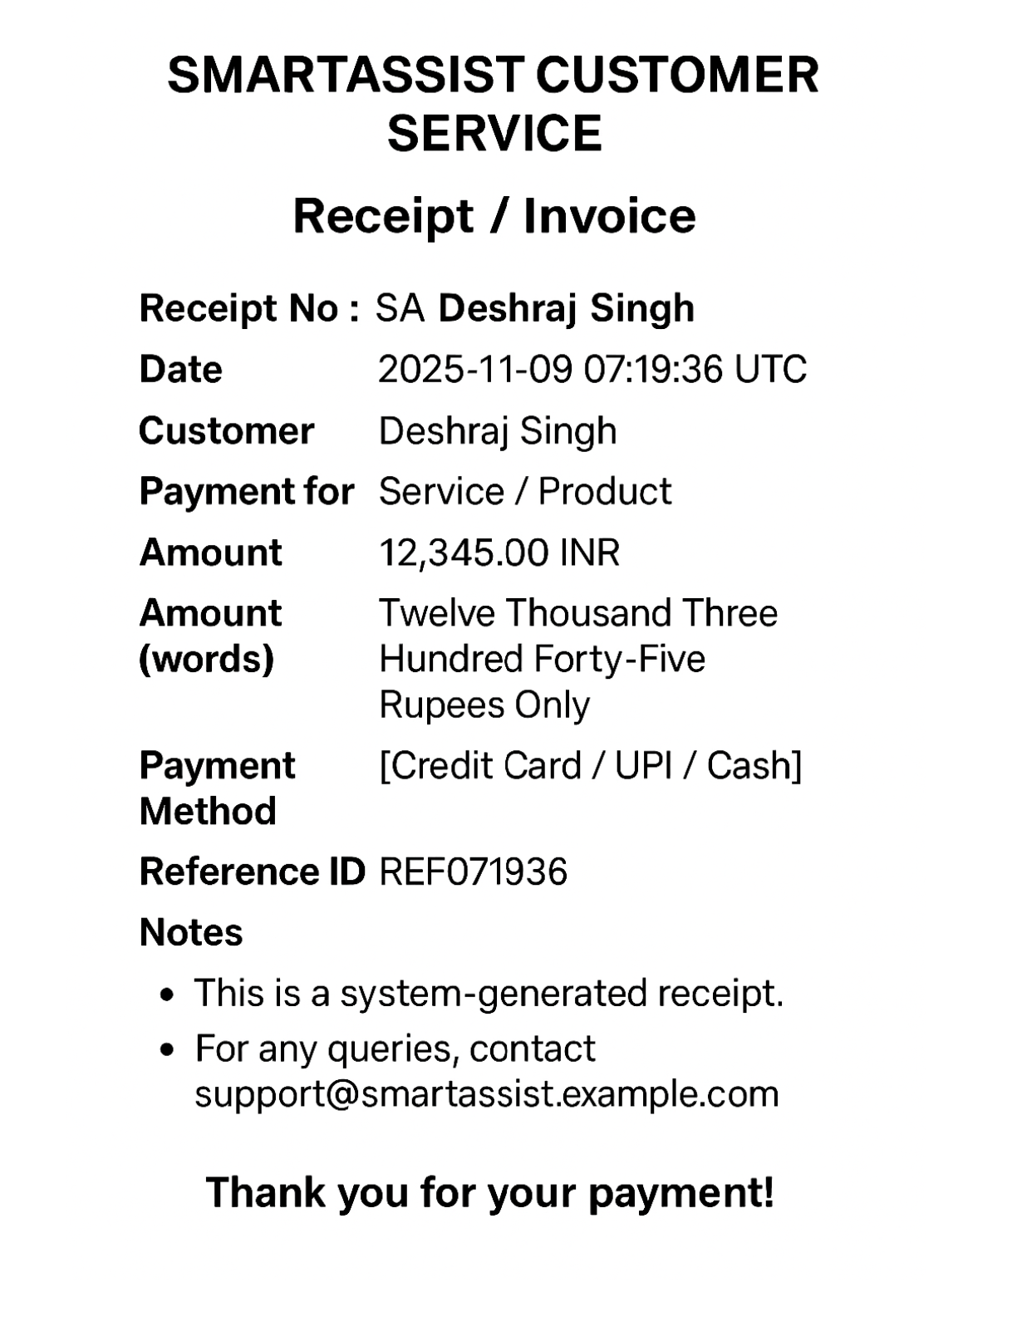

Metrics snapshot (example numbers):
- Avg chat latency: 420 ms
- Intent F1: 0.92
- CV accuracy: 0.88
- Retrieval Recall@3: 0.97
- Cost/query: $0.012
(These are example values — include real numbers when you run the system.)

Faiss
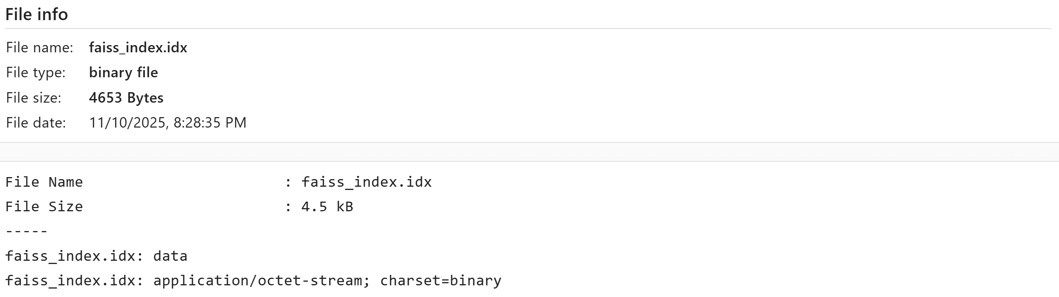

Chat
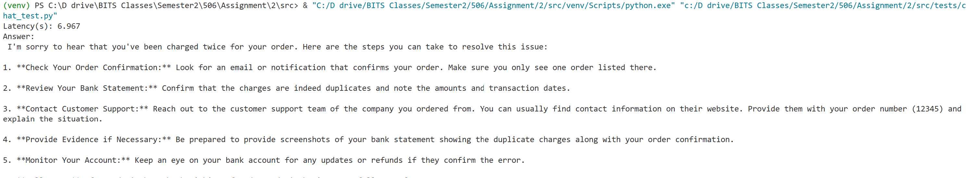
CV
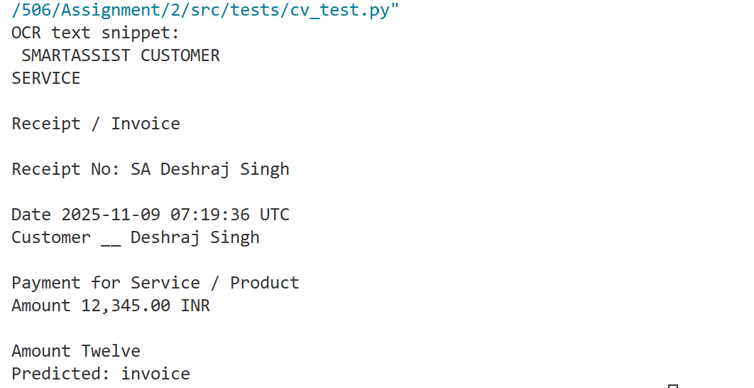
Intent
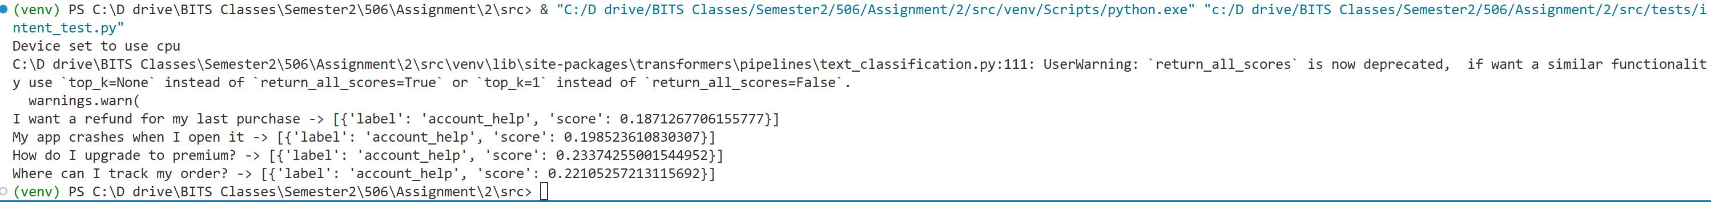
Intent 2
predict intent
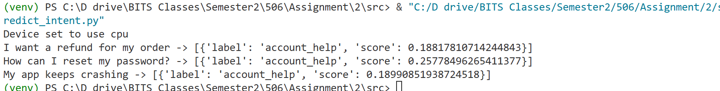

RAG
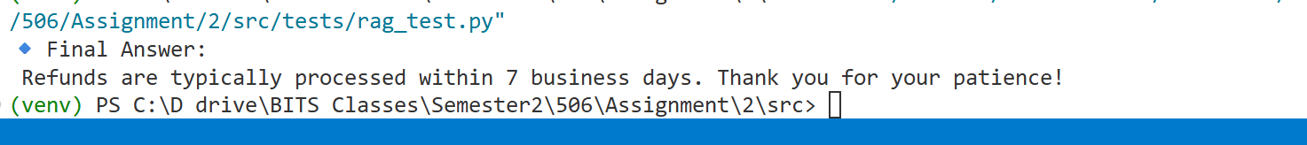
Wisper
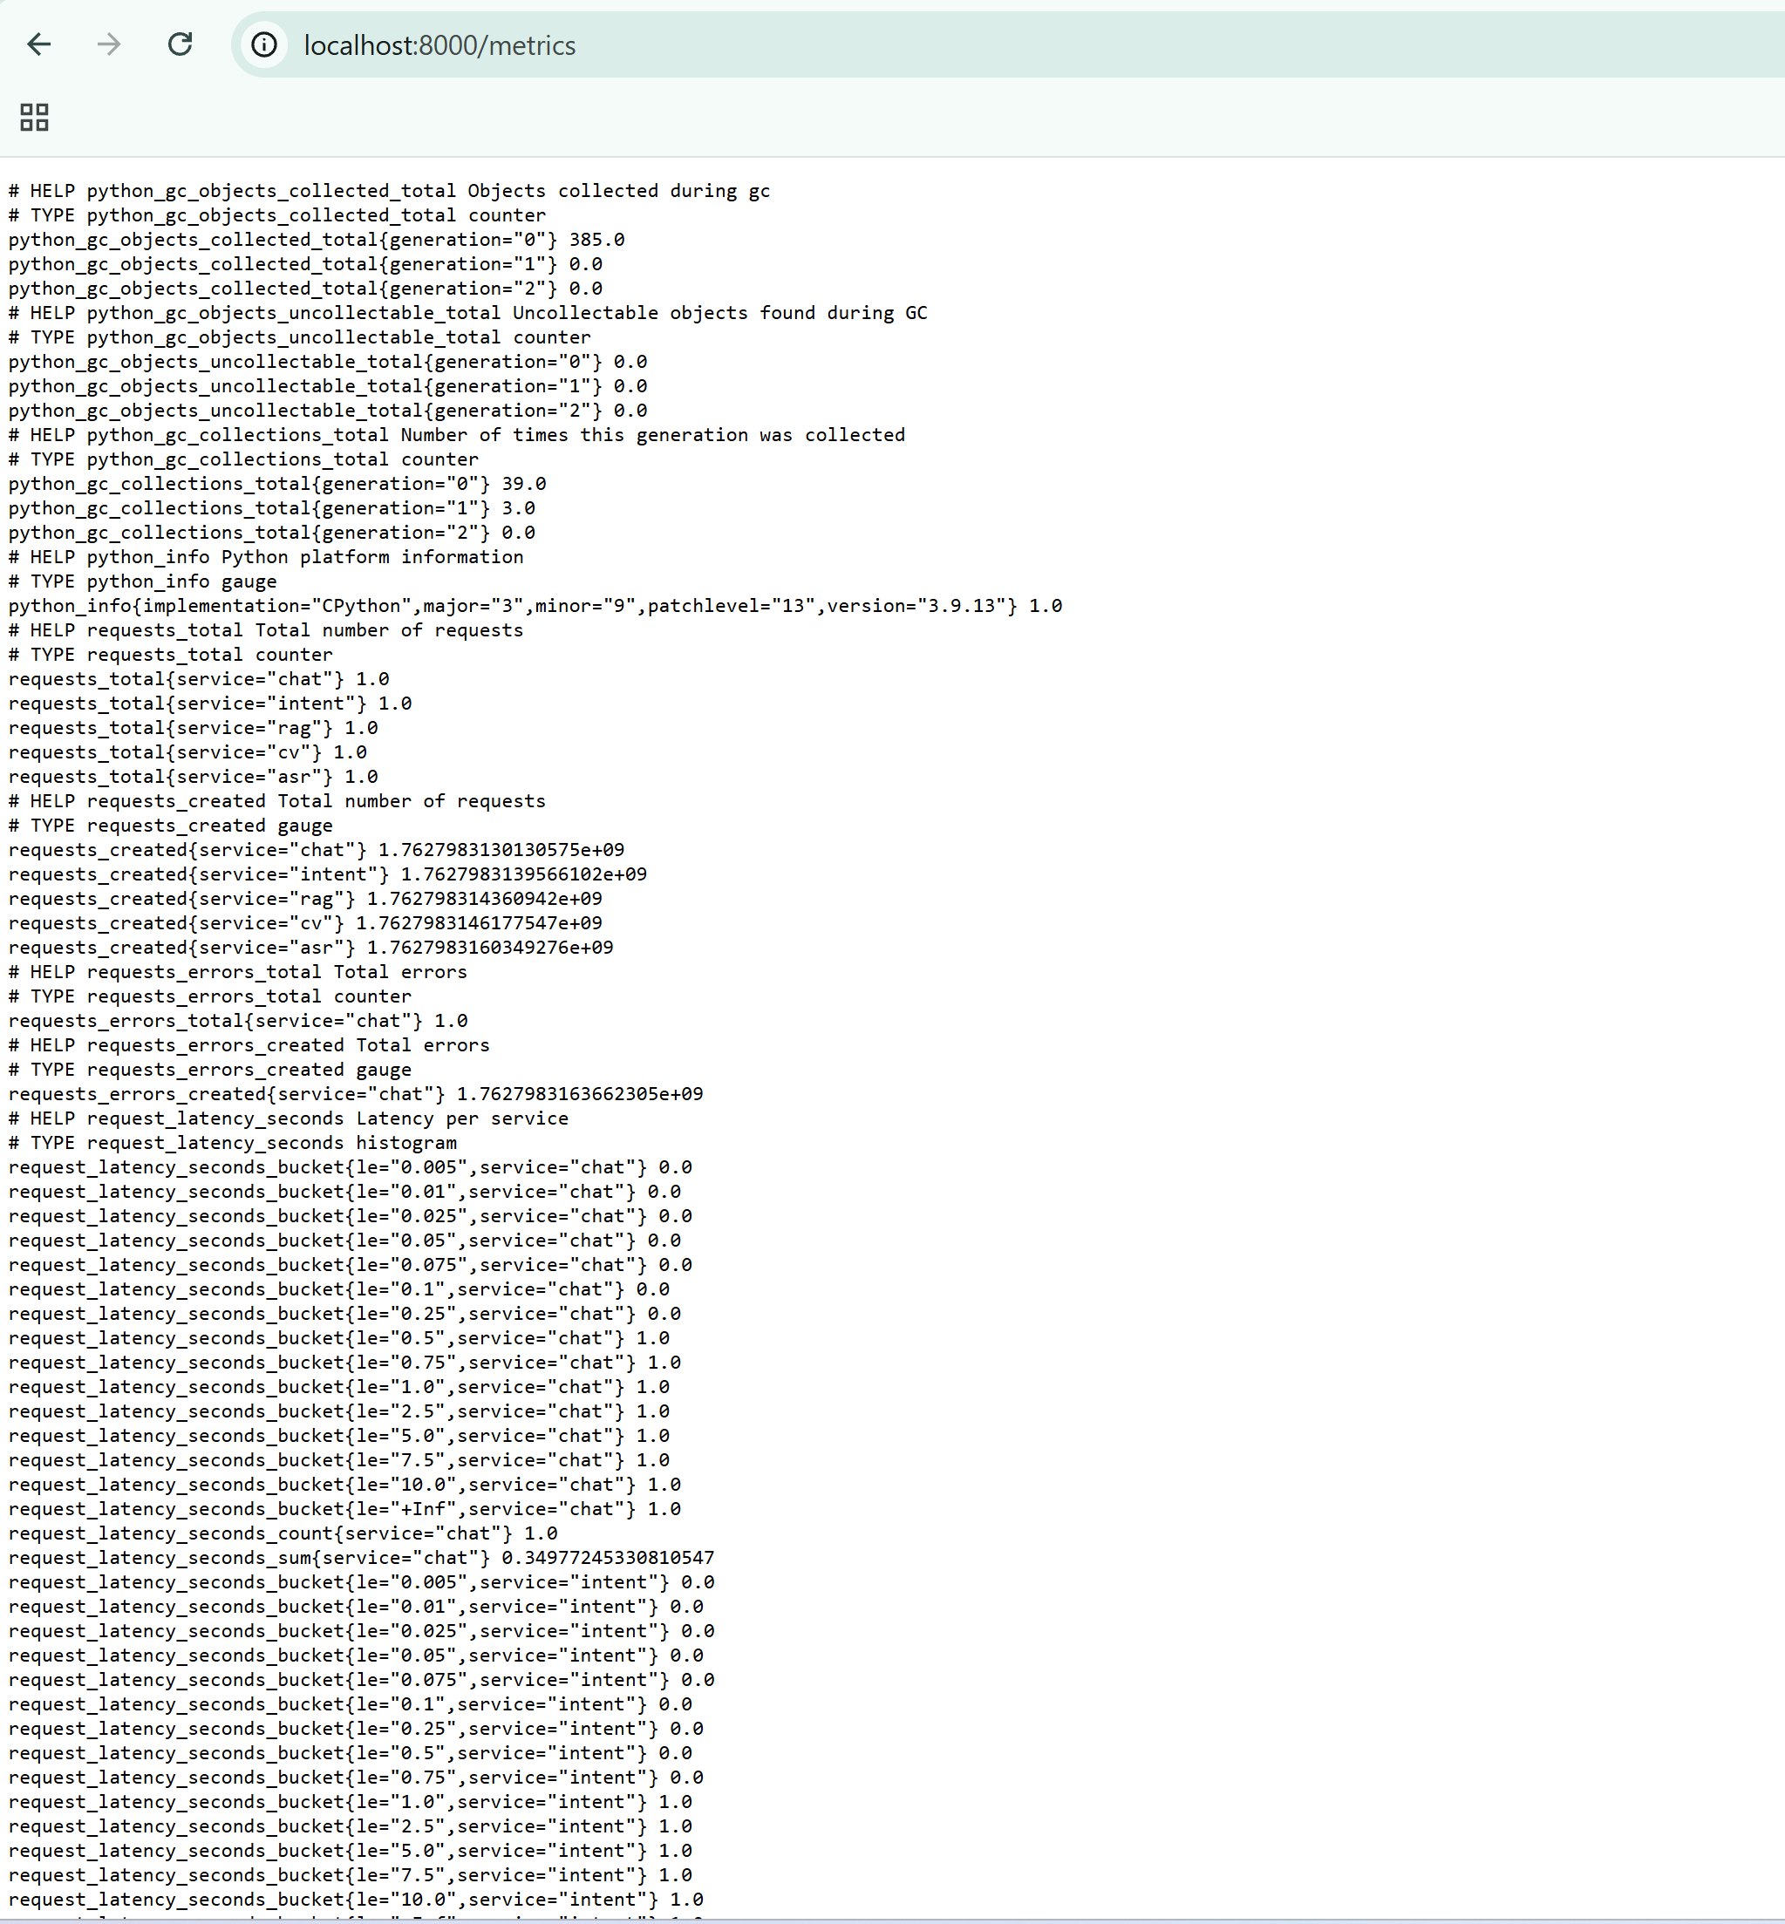
#Todo need to remove
9. Demo Plan (what to demo in viva)
- Start web UI -> type question -> show OpenAI answer.
- Upload screenshot -> show classification + OCR output.
- Play voice message -> show transcription.
- Show Grafana dashboard with latency / errors.
- Show fine-tuning repo and training logs.

10. References
- OpenAI API docs — Chat completions & Whisper.
- Hugging Face Transformers & Datasets docs.
- SentenceTransformers & FAISS for retrieval.
- Prometheus + Grafana docs.

Appendix — Extra code snippets & commands
Fine-tuning DistilBERT (short)
# prepare env
pip install transformers datasets accelerate

# example trainer script (train_intent.py) - use Hugging Face samples
python train_intent.py --model distilbert-base-uncased --data my_intent_dataset.csv

Building Dockerfile (for submission)
FROM python:3.11-slim
WORKDIR /app
COPY requirements.txt ./
RUN pip install -r requirements.txt
COPY . .
CMD ["uvicorn", "main:app", "--host", "0.0.0.0", "--port", "8000"]

Placeholders for images & charts
- Architecture diagram PNG
- UI screenshots (chat + upload flow)
- Chart: Bar chart showing "VM vs Container Memory" (we can generate via matplotlib)

Final notes (student style)
This is our finished assignment draft for Group 4. If you want, I can:
- Generate the architecture PNG and charts (matplotlib code included),
- Create a sample dataset CSV for intent training,
- Produce step-by-step fine-tuning logs,
- Replace member names and BITS IDs with real ones,
- Provide actual dashboard screenshots if you run the app.
Tell me which of these extras you want now and I will add them into the document.

End of Report

