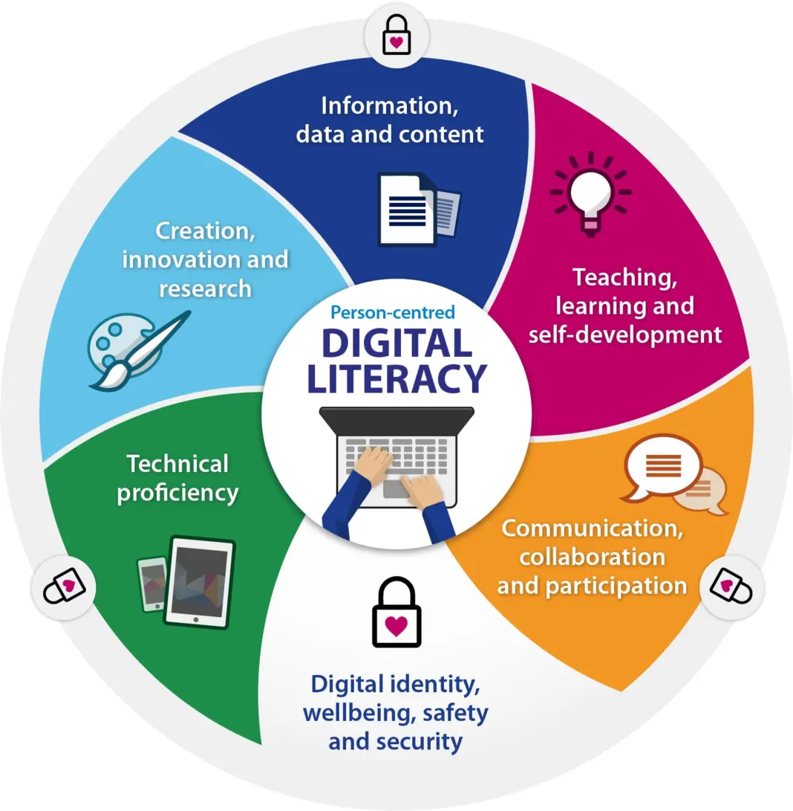

Course Code: CSE0001
Course Title: Digital Literacy
Name: Deshwan T.D
Registration Number: 25BOE10077
Branch: BIO-ENGINEERING
Year: First Year
Date: 28-03-2026

Introduction
In the modern era of having connected programs, digital literacy has become a very crucial skill that a student must acquire to be able to excel in his academic and professional worlds. This project has been carried out as part of a role of a Student Digital Ambassador with the purpose of understanding and promoting good and responsible use of digital tools. Through this project, I looked at a number of aspects related to the topic of digital literacy, covering online presence, charitable communication, collaboration platforms, the use of cyberspace, and cyber safety. For each task, there was a practical exposure to real-world tools and scenarios that gave me a very good foundation in traversing the digital ecosystem in a responsible and fluent manner.

Task 1: Digital Literacy in the Context of awareness, infographic
For this task I developed an infographic using an incredibly popular design tool, Canva, that is known to be simple and very flexible in terms of creativity. The infographic targets some of the aspects of digital literacy that include safe internet practices, good digital tools for students to use, and having a professional presence online. The visual design was organized to be informative but interesting with icons, minimal text and clean design that would increase readability.
One of the most interesting parts of this task was having to translate complex ideas into some simple visual format. However, making the aesthetics and the information density to balance was a bit difficult. This task helped me to understand how visual communication plays an important role to spread the awareness in an effective way.

Task 2: Digital Portfolio of Student

In this task, I created and updated the profiles in websites like GitHub, LinkedIn, Hacker Rank, etc. GitHub was used for displaying my projects and creating a profile README and Linked-in was helpful in creating a professional identity of myself with my academic details. Hacker Rank was accessed for practice of code and skill development.
Each and every platform has a different kind of purpose: GitHub is a project repository, LinkedIn is a professional networking website, and Hacker Rank is a skill building platform. For the next four years I intend to regularly be updating these profiles with my projects, certifications, and accomplishments. This will help me to build a strong digital presence which can lead to supporting internships and career opportunities.

Task 3: Coding & Collaboration Platform

For the coding practice part, I have used Hacker Rank and solved a basic level challenge that allowed me to grasp basic problem-solving techniques. This experience helped me feel more confident about coding and was an introduction to both structured problems solving.
For Project/Collaboration: By creating a Google Form with four questions and one question worded as a Digital Literacy Awareness Quiz, I was able to create a set of questions for students to complete. The form had multiple-choice and short-answer questions and responses were automatically recorded into a linked Google Sheet of responses. This task illustrated to me how digital tools can be used for the purpose of data collection and collaboration. These platforms will help me in academic fields extremely as it will help me in a better way for coding and also manage the data and make team work efficient.

Task 4: E-mail Etiquette & Email Communication

This task consisted of the creation of 2 professional emails, as well as a social media etiquette checklist. Through this, I learned the importance of being clear, using the right tone and structure when communicating with others in the workplace.
One of the problems faced in digital communication is misusing tone or lack of clarity, which may cause problems in understanding for instance, an email asking for extension that is not well written lacks structure and may leave a bad impression on the other person. This can be avoided by having a subject line that is clear and chock full of respectful tone and format.
Overall, the communication theme in this task was that it was important to communicate effectively not only in terms of information, but respectfully and professionally.

Task 5: Cybercrime Awareness

While researching on the topic of cybercrime I decided to focus my research on phishing attacks as this is one of the more common forms of fraud on the internet. I learned how attackers trick the users about revealing sensitive information through fake emails or websites.
What surprised me most is how convincing these types of attacks can be making even informed users vulnerable. As a result, I plan to develop some safer habits such as verifying the link before clicking on it and turning on two-factor authentication. This task made us note the importance of awareness and proactive steps on how to stay safe online and this applies to students because they use digital platforms on a regular basis.

Conclusion
This project gave one a full understanding of what digital literacy is and why it is important in today's life. From developing a professional digital identity, to being familiar with cybersecurity threats, each task helped in the process of developing crucial digital skills. It has given me more belief in enabling me to use online platforms responsibly and effectively. As a Digital Ambassador, I feel like I am now better equipped to help teach my peers to be safe, and professional in their use of the digital world.

