DesiZoom
Visual Reference — Page Screenshots
Captured live from https://desizoomnew.vercel.app — July 18, 2026
Companion to DesiZoom-Guide.docx

Home Page
Landing page with the festival countdown strip, hero search, Desi Radio sidebar (8 stations with play buttons), category tiles and city chips. Nav shows the GPS city pill (Little Elm, TX with green dot), Messages and Admin links.
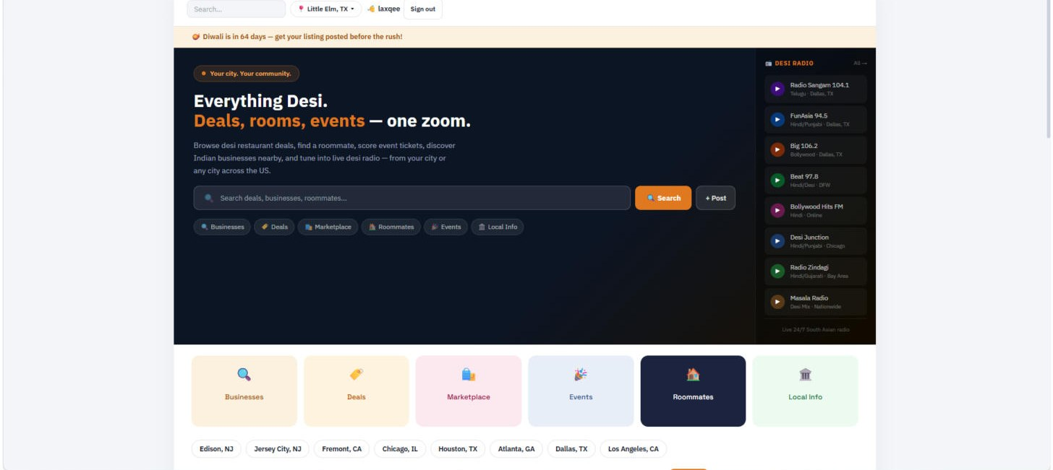

Deals Page
"Near You" section pulls real Indian restaurants near the user via Google Places (Special9, De Vibe, Kuppanna shown for Little Elm) with ratings, addresses and Google Maps buttons. Quick filter chips: Indian Restaurants, Grocery Stores, Sweet Shops, Desi Fast Food. Community deals appear below.
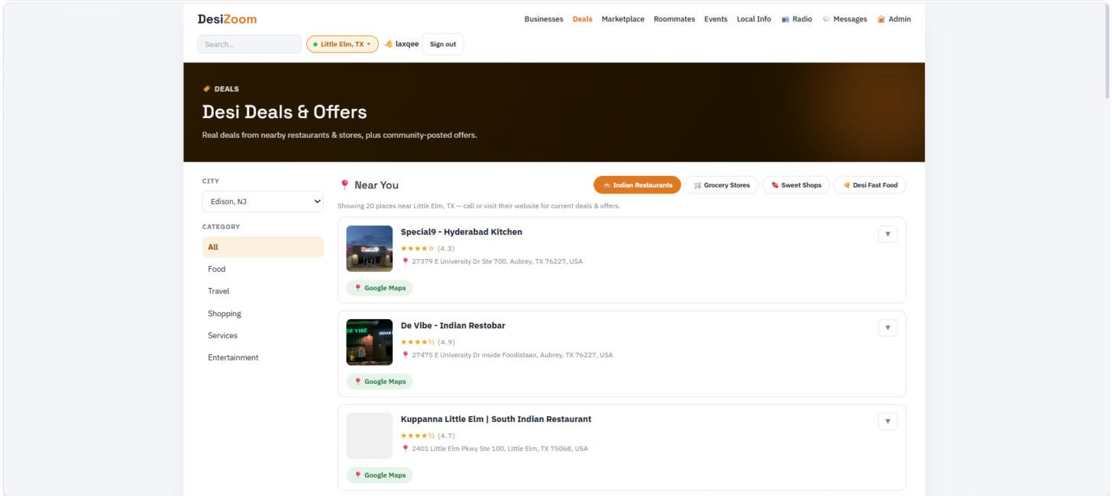

Marketplace
Listing grid with photos (Biryani sale shows an uploaded photo), category badges, Buy buttons for priced items, "Your listing" for own posts, and the "Want to sell? Connect your bank account" Stripe onboarding link. Category chips across the top; + List an item button.
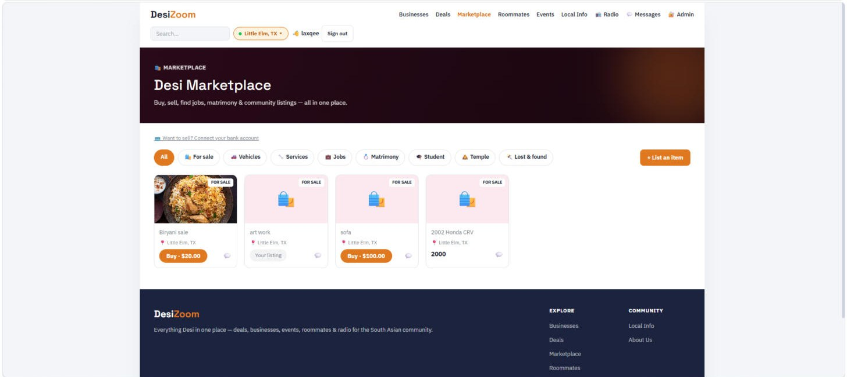

Listing Detail Page
Every post has its own shareable URL (/listing/id). Shows title, price, city, posted date, seller identity (name + member since), description, Share and Copy link buttons. Owners see the "Boost this listing — $2.99 for 7 days" panel; buyers see Buy and Message buttons.
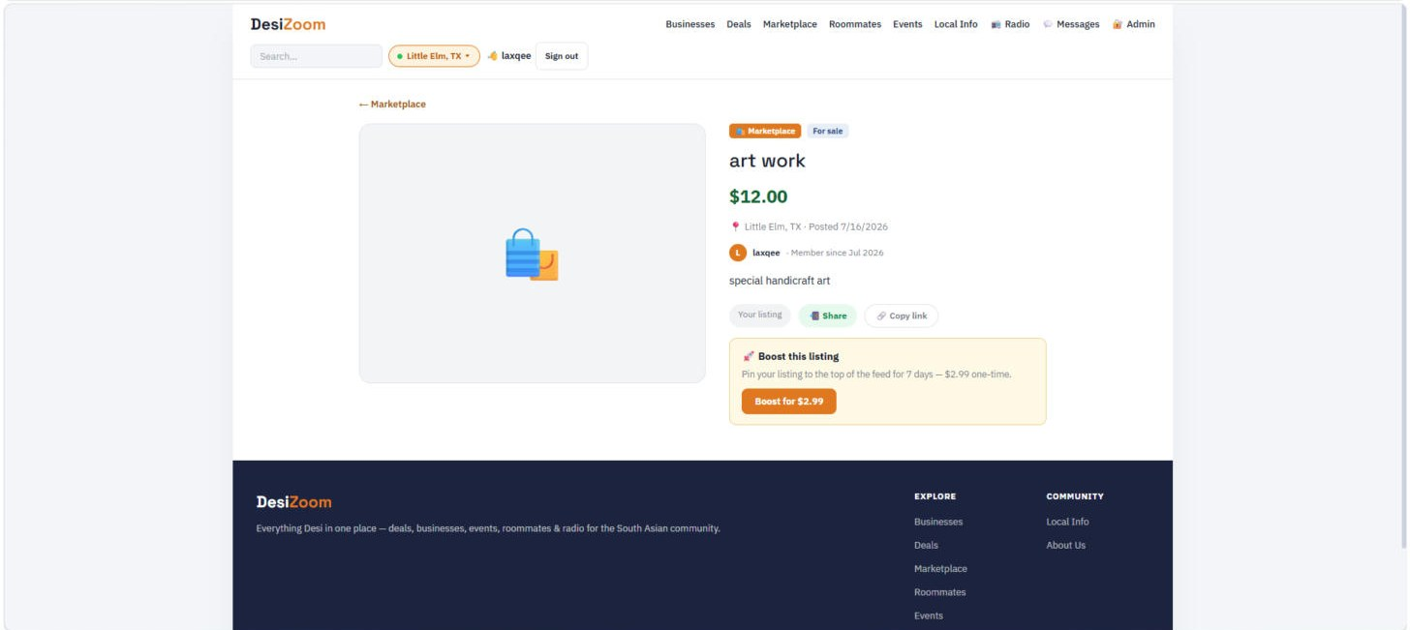

Messages (Chat)
Buyer–seller conversations. Left panel lists conversations with the listing and your role; right panel is the live chat with a message input. Messages update in realtime via Supabase.
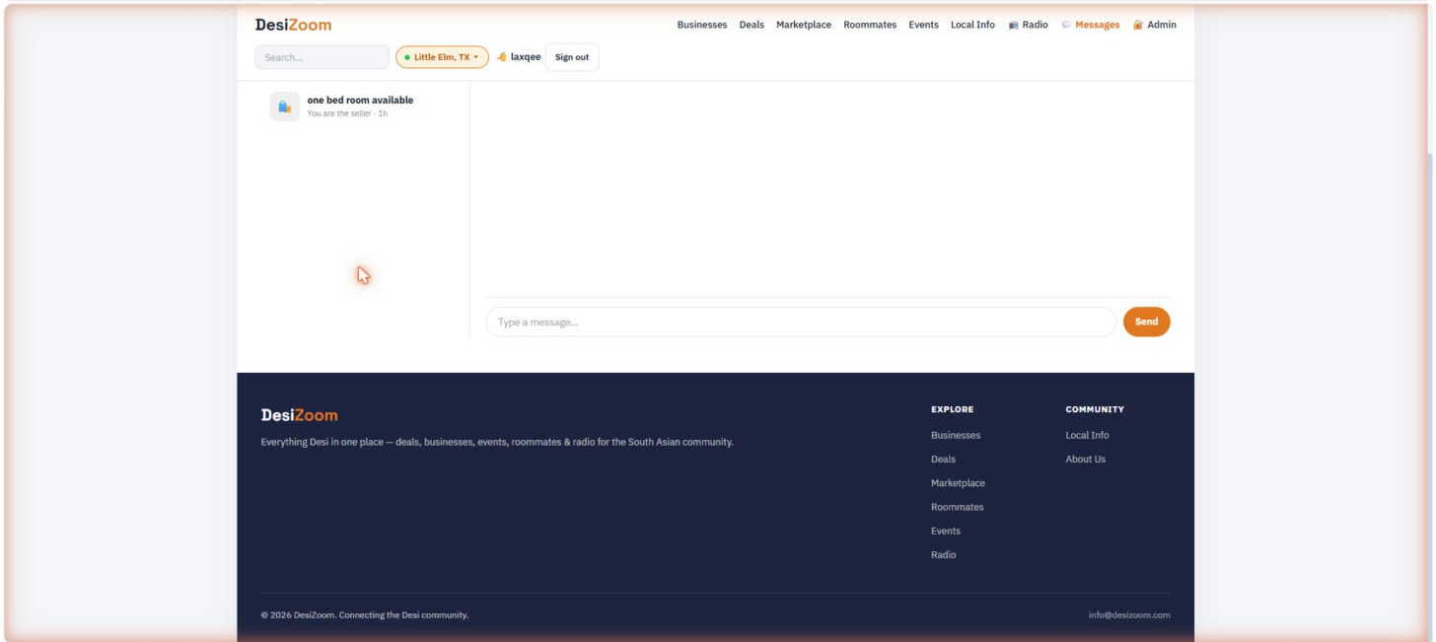

Events Page
Community events for the selected city with date badges. + Add Event opens the post form. (The "Happening Near You" Ticketmaster section appears here once the API key is added.)
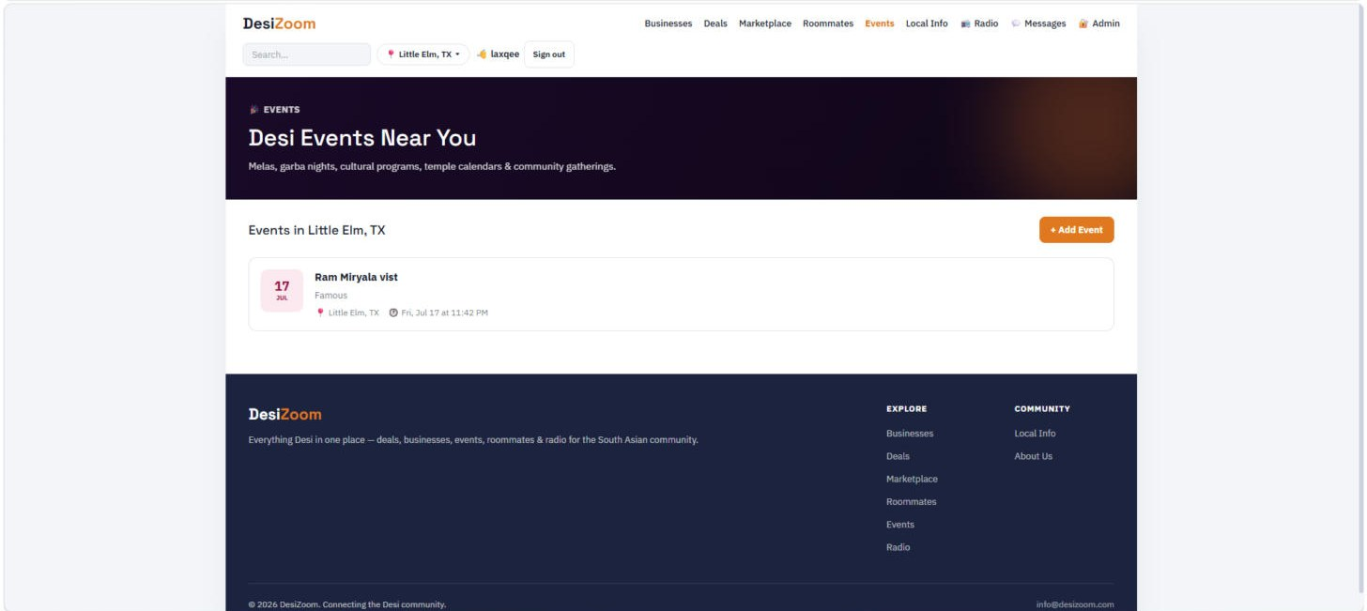

Local Info Page
City-specific directory with filter chips: Utilities, Emergency, Government, Trash & Recycling, City Info. Content is managed by admins in the local_info table; empty state prompts to add entries via the Admin dashboard.
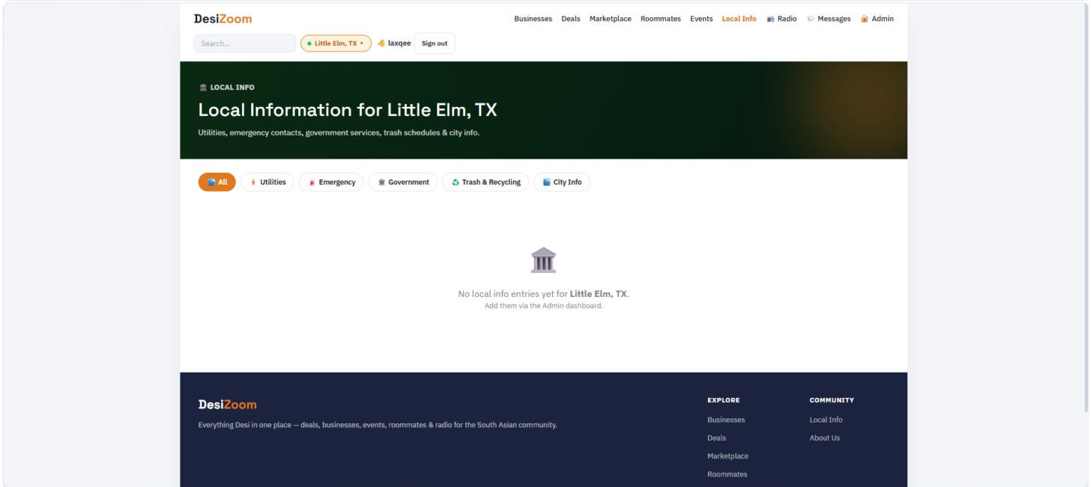

Radio Page
All 8 live South Asian stations — DFW FM stations (Radio Sangam 104.1 Telugu, FunAsia 94.5, Big 106.2 Bollywood, Beat 97.8) and national online streams (Bollywood Hits FM, Desi Junction, Radio Zindagi, Masala Radio). Click any station to stream in the browser.
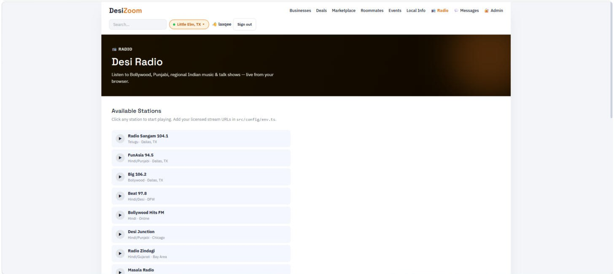

Admin — Overview Tab
Stats cards (3 users, 14 posts) plus the Revenue section: commission earned all-time and 30 days, sales volume, completed sales, and the Recent Transactions table showing your cut per sale. Tabs: Overview, Posts (14), Reports, Users (3).
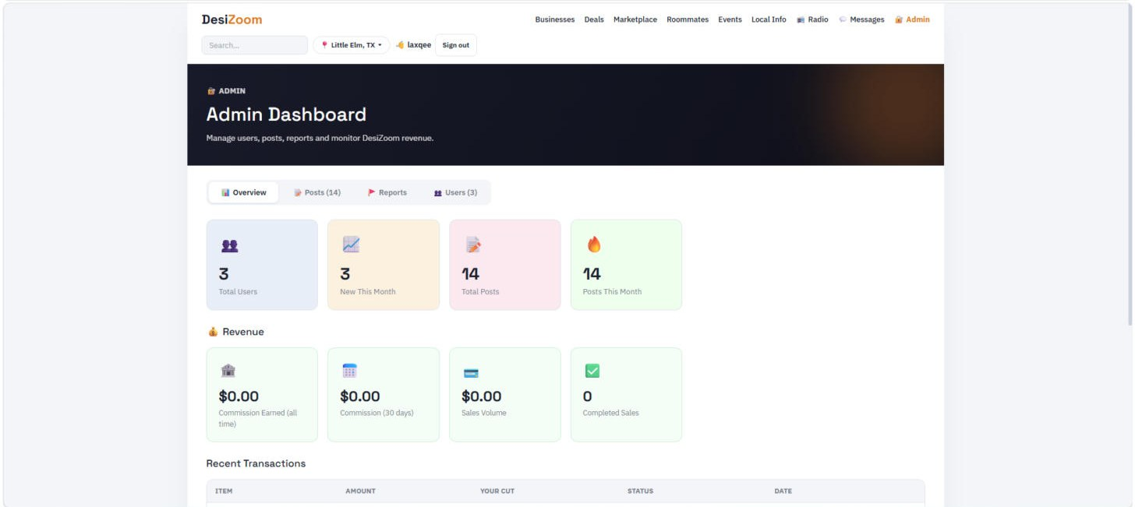

Admin — Posts Moderation
All posts with type, city, status and created date. Per-row actions: Hide (soft-remove), Sponsor (pin with SPONSORED badge — for businesses paying for placement), Delete (permanent). Filter box at top.
