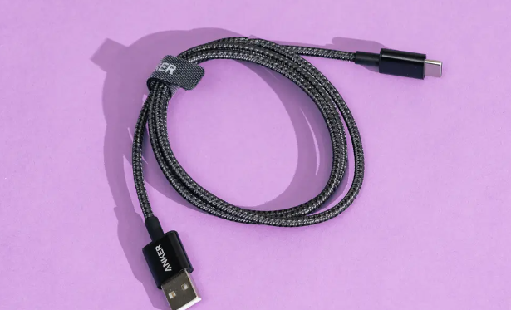

3.0 USB to Type C Data Cable

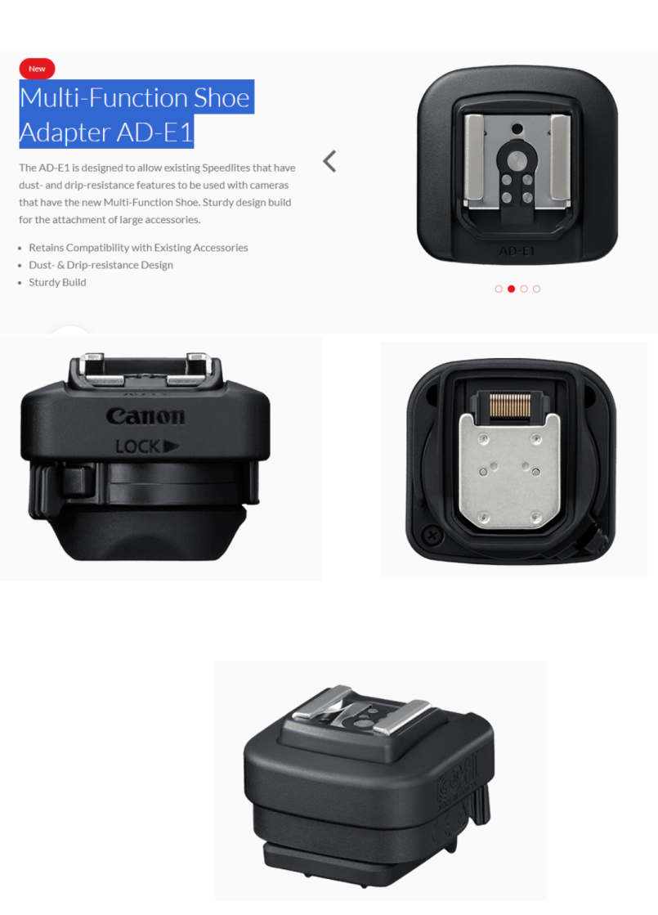

Multi-Function Shoe Adapter AD-E1 for Canon R50 Camera to Connect Flash Light