**Retraining Built Environment Retrofitting Problem Solving Skills with Augmented Reality Instructions**

**UCF STUDY00002145: Investigating the Impacts of a BIM-Augmented Reality System on Retrofitting Installation**

**Step by Step Instructions**

**(FOR THIS STUDY, THERE ARE NO LIVE ELECTRICAL WIRES)**

The following instructions will guide you through a standard indoor electrical smart eco-friendly outlet installation.

You are to install the new outlet on the lower right side of the wall, approximately 12-24 inches from the ground and 5-10 inches from the right edge. You’ll install the new junction box by mounting it directly onto the right side of a vertical stud hidden within the wall. The electric wire has already been connected to the circuit breaker and installed within the wall for you.

1. When instructed, locate, point, and verbally identify the tools that you will be using for this task to the experiment facilitator:
   1. Electric drill  
      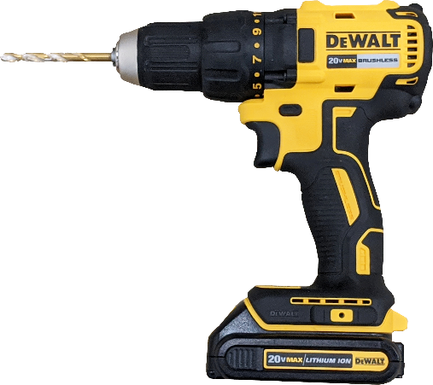
   2. Jab saw for drywall  
       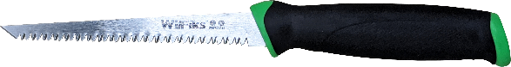
   3. Hand-held Phillips screwdriver  
      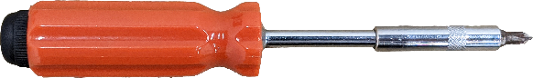
   4. Blue painter’s tape  
      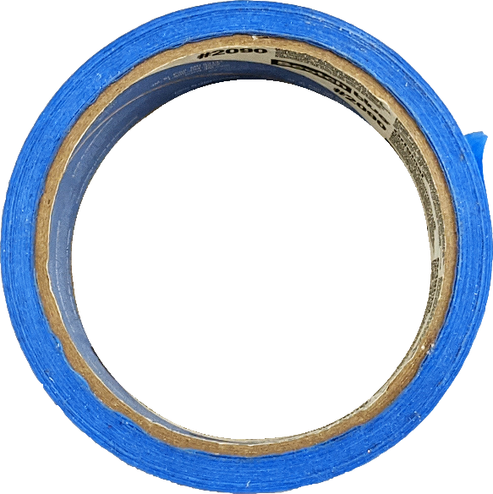
   5. Safety Gloves  
      
   6. Stud finder (if non-AR)  
      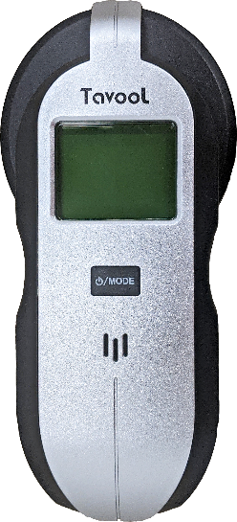
2. When instructed, locate, point, and verbally identify the materials that you will be using for this task to the experiment facilitator:
   1. Outlet and Single gang junction box

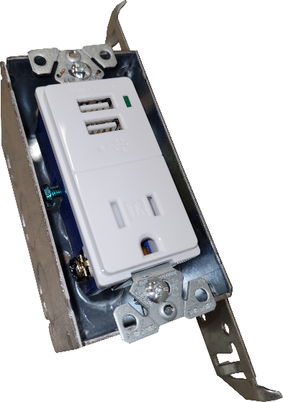

* 1. Mounting screws  
     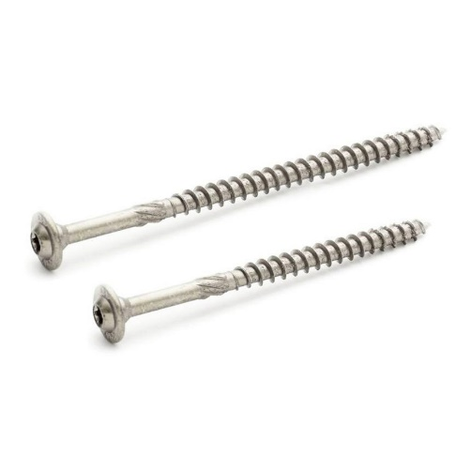
  2. Main service panel (Located right of the wall structure)  
     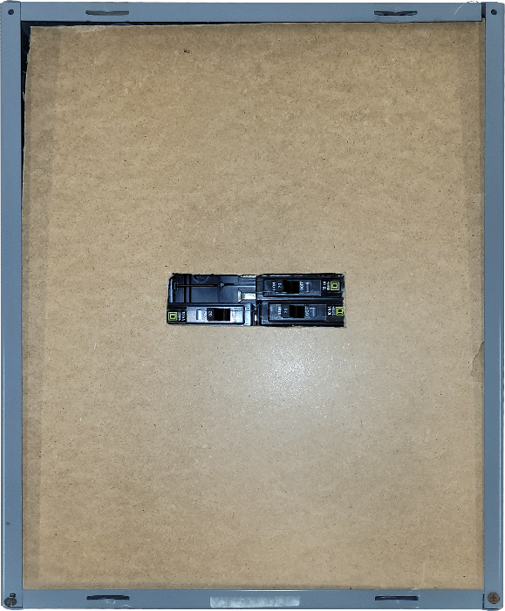

1. Locate the main service panel (also known as the breaker box or fuse box). The panel is usually located in a utility area of a building, such as a basement, or a utility closet. In this experiment, the breaker box is located to the right of the experimental apparatus and is not connected to live electrical power. Shut off the power to the circuit that will be powering the new outlet, this is done by turning off the marked switch (Tape and writing indicate the switch).
2. On the wall, use the Stud Finder to locate the vertical installation stud and the horizontal location on the wall you will be installing the outlet.
   1. Set the Stud Finder to stud mode using the button on the front of the device.  
      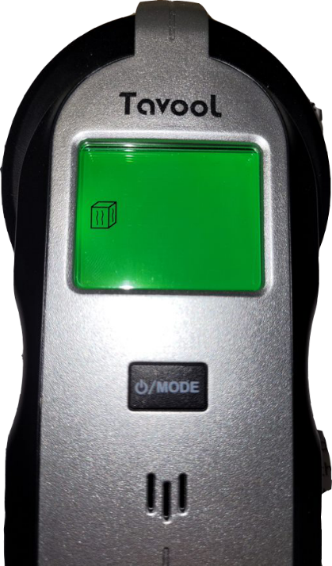
   2. Firm press the device against the wall and press the calibrate button on the side of it.
   3. Slowly drag the device along the front of the wall to locate the studs. The stud finder will indicate when the edge or center of a stud is lined up with the middle of the device.
   4. With three (3) pieces of blue tape, mark the candidate stud vertically. The pieces of tape should be spaced to cover as much of the height of the wall as possible.

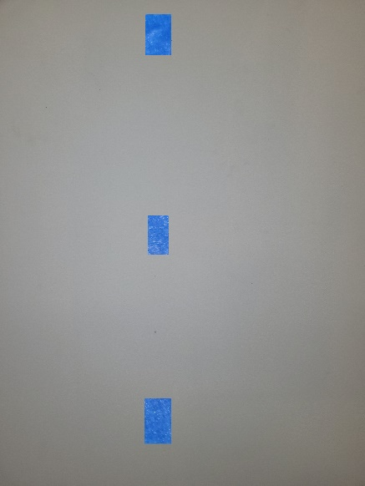

* 1. With a pencil, mark the height you want to install the junction box with a short horizontal line at its center point and with a vertical line where you believe the right edge of the vertical stud is located. NOTE: The junction box should be 12-24 inches above the base of the drywall and above the pipes.  
     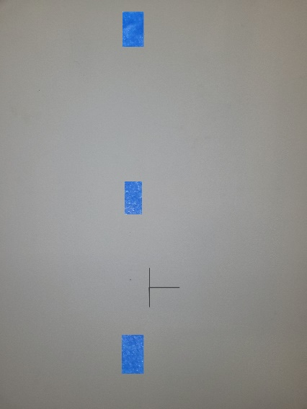

1. Identify the corners of the section of drywall you will remove by marking them with four (4) dots with a pencil. The leftmost dots should be aligned with the vertical line drawn in the previous step. This will be your starting point to make a cut with the jab saw. The outlet and junction box should be able to fit within the cut-out area and space must be left for the drill to attach the junction box to the right side of the vertical stud later during installation.
2. Draw lines with a pencil and ruler connecting those four (4) dots to guide your cuts.
3. Put on the safety gloves and drill holes on each of the four (4) drawn dots.
4. Put on the safety gloves and use the jab drywall saw to cut along the lines and remove the section of drywall.
5. Identify the wire that runs down the inside of the wall and notify the study administrator you found it.
6. Using the pencil, mark on the side of the vertical stud (inside the wall) the points where the junction box will be mounted. The holes on the side of the junction box can be used as a guide. Only two points are necessary, one for the top and one for the bottom.
7. Put on the safety gloves. Do NOT drill yet, but determine if there is enough space cut out of the wall so that drilling into the marked points with the electric drill is possible. If there is not enough space, use the jab saw to increase the cutout space as little as possible. Once you have determined that there is enough space for the drill, inform the study administrator.