**Personal Portfolio Website**

The project in question aims to create an online portfolio in website format, listing various skills, projects, teaching, work experience, and contact information. Continue onwards with the document to fully understand the details with the project’s purpose and conception.

Table of Contents

Technologies Used 1

Key Features 1

Home/About Me Section 1

Projects Section 2

Contact Section 2

Project Steps: 2

Visual Display 3

Author 3

# Technologies Used

- HTML/CSS/JavaScript: Structuring content, styling, and adding interactivity.

- Responsive Design: Ensuring accessibility and adaptability across devices using Bootstrap.

-Email Submissions: Successfully acquiring data sent by users by use of third-party FORM SUBMIT EMAIL LINK BETA.

-Hosting: Availability of access through the internet via third party Webhost000.

# Key Features

## Home/About Me Section

You will be met with a card detailing the owner’s appearance and information about him below consisting of:

1. Introduction
   1. A welcoming section introducing the website owner.
   2. Brief information about their background, such as their role, expertise, and passions.
   3. A concise summary of what visitors can expect from the website.
2. Skills and Knowledge:
   1. A brief straightforward explanation of the owner's skills and areas of expertise.
   2. Highlights of specific interests, hobbies, or specialized knowledge relevant to their field.
3. Interests:
   1. A paragraph outlining the owner's professional mission, goals, or objectives.
   2. Emphasis on personal values, work ethic, or aspirations related to their career path.
4. Links:
   1. Links will be made available for you via images to further inform on the purpose of the project or about the owner himself.

## Projects Section

1. Project Showcase:
   1. A grid or list showcasing various projects the owner has worked on.
   2. Each project card includes:
      1. Title and brief description providing context and purpose.
      2. Images illustrating the project's appearance or functionality.
      3. Links to project itself to view for viewing pleasure.

## Contact Section

1. Contact Form:
   1. An interactive contact form allowing visitors to send direct messages or inquiries.
   2. Fields for name, email, subject, and message, ensuring ease of communication.
2. Email and Social Links:
   1. Displayed prominently, providing visitors with alternative methods to connect.
   2. Links to professional social media profiles (LinkedIn, GitHub, etc.) for networking opportunities.

# Project Steps:

* Planning Your Content:
  + Outline the sections and content I want to include in your portfolio mentally.
  + Consider what I wanted this project be like and envisioning the final product
* Design:
  + Use of research platforms such as YouTube, Google for creative ideas for a simple and clean design for your portfolio.
  + Design the layout, color scheme, and overall visual aesthetics of the website.
* Set Up Your Development Environment:
  + Visual Studio Code and set up of server-side storage for contact form.
  + Preset up of external sources (images, webhost account).
* Build the Structure:
  + Creatin the basic structure of my HTML file.
  + Divide your portfolio into pages (Home, Projects, Contact.).
  + Use HTML for content structuring and CSS and Bootstrap for styling the elements.
* Add Interactivity:
  + Use JavaScript to add interactivity to your portfolio.
  + Implement features like smooth scrolling, transform transitions, animations, and hover effects to enhance user experience.
* Make it Responsive:
  + Ensuring that my portfolio is responsive and looks good on different devices and screen sizes.
  + Use of media queries in CSS to adjust the layout based on screen size and ensure accessibility for smaller devices.
* Contact Form and Backend:
  + Implemented a contact form using HTML for the frontend.
  + Connecting the form to either an email service or a backend (trying to use JavaScript, PHP, webhost, FORM SUBMIT) to handle form submissions.
* Documentation:
  + Creating the comprehensive documentation for your project, a README file:
  + Title and description of the project at the top.
  + Instructions for setting up and running the project locally.
  + Add in Dependencies and technologies used.
  + Have a link to live demos or hosted versions.
  + Screenshots showcasing the project design view.

# Visual Display

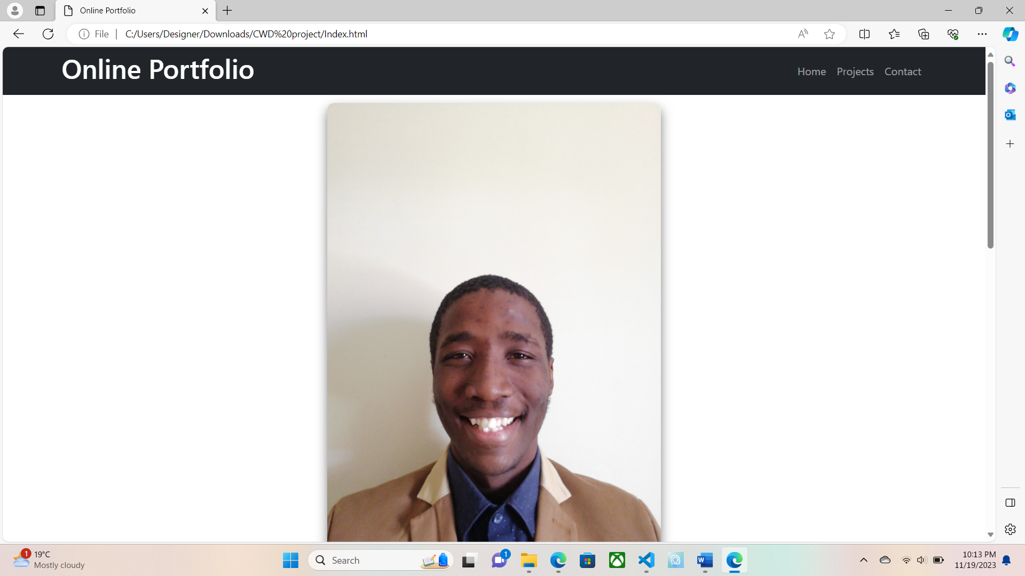

# Author

H, Faltein |Student ID: 20230474

*\*This project is created under the attendance of CTU Training Solutions \**

Create a README.pdf with:

- Project title and description.

- Setup and local run instructions.

- Dependencies and technologies used.

- Links to live demos/hosted versions.

- Screenshots or GIFs showcasing the project.