TRIPWISE – A PERSONALIZED TRAVEL PLANNING APPLICATION
A PROJECT REPORT
Submitted by
[STUDENT NAME IN CAPITALS]
([REGISTER NUMBER])
in partial fulfilment of the End Semester Examination for the course
CB23F35 –
LOW-CODE APPLICATION DEVELOPMENT USING ZOHO CREATOR
in
[BACHELOR OF ENGINEERING / BACHELOR OF TECHNOLOGY]
[DEPARTMENT / BRANCH NAME]

RAJALAKSHMI ENGINEERING COLLEGE
(An Autonomous Institution, Affiliated to Anna University, Chennai)
Rajalakshmi Nagar, Thandalam, Tamil Nadu – 602 105
[MONTH YEAR]

RAJALAKSHMI ENGINEERING COLLEGE
(An Autonomous Institution, Affiliated to Anna University, Chennai)
BONAFIDE CERTIFICATE
Certified that this project report titled “TripWise – A Personalized Travel Planning Application” is the bonafide work of [STUDENT NAME] ([REGISTER NUMBER]), who carried out the individual project work on the Zoho Creator low-code platform for the course CB23F35 – Low-Code Application Development using Zoho Creator, during the academic year [2026–2027], Semester [V], under my supervision.
SIGNATURE  [Name of the HoD]  HEAD OF THE DEPARTMENT  Department of [Department Name]  Rajalakshmi Engineering College  Thandalam – 602 105 | SIGNATURE  [Name of the Course Faculty]  COURSE FACULTY  [Designation]  Department of [Department Name]  Rajalakshmi Engineering College

Submitted for the End Semester Examination (Individual Project) held on [DD Month YYYY].
INTERNAL EXAMINER | EXTERNAL EXAMINER

DECLARATION
I, [STUDENT NAME] ([REGISTER NUMBER]), hereby declare that the project report titled “TripWise – A Personalized Travel Planning Application”, submitted for the End Semester Examination of the course CB23F35 – Low-Code Application Development using Zoho Creator, is a record of original work carried out by me individually. The Zoho Creator application described in this report — including its data model, forms, reports, pages, Deluge scripts, workflows and integrations — was designed and developed by me.
I further declare that this work has not been submitted, in part or in full, for the award of any other degree or course credit. Every template, sample application, AI-assisted feature (such as Zia or the AI application builder), code snippet or external resource used in this work has been duly acknowledged in the report.
Place: [Chennai] SIGNATURE OF THE STUDENT
Date: [DD Month YYYY] [STUDENT NAME]
[REGISTER NUMBER]

ACKNOWLEDGEMENT
I express my sincere gratitude to our Chairman [Name], Chairperson [Name] and Vice-Chairman [Name] for providing the infrastructure and facilities that made this work possible.
I am grateful to our Principal, [Name], Rajalakshmi Engineering College, for the constant encouragement extended to students to take up industry-relevant learning.
I thank [Name], Head of the Department, Department of [Department Name], for the guidance and support provided throughout the course.
I owe my sincere thanks to my course faculty, [Name], [Designation], for the valuable guidance, reviews and feedback that shaped this application and report.
I also acknowledge [Zoho Corporation / Zoho Creator Education Programme] for providing access to the Zoho Creator platform and learning resources, and I thank my family and friends for their unwavering support.

[STUDENT NAME]

ABSTRACT
Planning a trip is a multi-step decision problem for an individual traveler. Budget, trip duration, personal interests and the choice between domestic and international travel must be reconciled across many websites, blogs and spreadsheets. In the absence of a single tool, travelers compare destination costs by hand, draft itineraries in notes applications and lose their photographs and impressions once the trip is over. This manual and scattered process is slow, error-prone and offers no assurance that a chosen destination actually fits the available budget.
TripWise is a travel planning application developed on the Zoho Creator low-code platform to address this problem. A traveler enters a name, departure city, total budget in INR, trip duration, travel type, interests and preferred region. A rule-based recommendation engine implemented in Deluge scripts filters the destination database by region, interest alignment, duration compatibility and budget, ranks the results by the number of matching interests and explains every recommendation. A budget planner computes transportation, accommodation, food and activity costs and the remaining budget; an itinerary generator distributes stored activities into morning, afternoon and evening slots for each day; and travelers can save favourite destinations and record travel memories with photographs, highlights and ratings. Administrators maintain the destination and activity data, and a dashboard page gives both roles quick access to every feature. Zoho Creator suits this application because forms, reports, pages and workflows are assembled visually, hosting and security are built in, and custom logic is confined to short Deluge scripts. No external APIs are used.
The application was validated through test cases mapped to each functional requirement and published to the production environment of Zoho Creator. In a single guided flow a traveler now obtains a budget-checked, ranked and explained list of destinations, a detailed cost breakdown and a ready-to-edit day-by-day itinerary, replacing several manual research and calculation steps. [Add measured results here, for example the number of test cases passed and the number of manual steps eliminated.]
Keywords: [Low-Code Development; ZohoLow-Code Development; Zoho Creator; Deluge Scripting; Travel Planning; Recommendation Engine; Budget Planner

PROJECT AT A GLANCE
Attribute | Details
Project Title | TripWise – A Personalized Travel Planning Application
Application Domain | Travel and Tourism
Student Name & Register No. | [Name] – [Register Number]
Zoho Creator Edition | [Education / Free / Standard / Professional]
Application Name (Link Name) | [App_Name]
Published / Live URL | [https://creatorapp.zoho.in/…]
Demo Credentials (per role) | [Admin: … | Role 2: … | Role 3: …]
Number of Forms / Subforms | [ ] / [ ]
Number of Reports (by type) | [List: ] [Kanban: ] [Calendar: ] [Pivot/Chart: ] [Others: ]
Number of Pages / Dashboards | [ ]
Number of Workflows | [Form: ] [Schedule: ] [Approval: ] [Blueprint: ] [Batch: ]
Deluge Functions / Custom Actions | [ ]
Integrations | None – stand-alone application using stored destination data and rule-based logic
Roles & Profiles Defined | Traveler, Administrator
Environments Used | [Development → Stage → Production]
Date of Production Deployment | [DD Month YYYY]

TABLE OF CONTENTS
Formatting Standards (Anna University Convention) 1
Working with the Template 1
ABSTRACT iv
PROJECT AT A GLANCE v
LIST OF TABLES ix
LIST OF FIGURES x
LIST OF ABBREVIATIONS xi
INTRODUCTION 1
1.1 Background 1
1.2 Problem Statement 1
1.3 Objectives 1
1.4 Scope of the Project 1
1.5 Justification for a Low-Code Approach 2
1.6 Organisation of the Report 2
LITERATURE SURVEY AND SYSTEM STUDY 3
2.1 Study of the Existing System 3
2.2 Limitations of the Existing System 3
2.3 Low-Code versus Traditional Development 3
2.4 Literature Survey 4
2.5 Emerging Trends in Low-Code Development 4
2.6 Proposed System 4
REQUIREMENT ANALYSIS 5
3.1 Stakeholders and User Roles 5
3.2 Functional Requirements 5
3.3 Non-Functional Requirements 5
3.4 Hardware and Software Requirements 6
3.5 Use Case Model 6
SYSTEM DESIGN 8
4.1 System Architecture 8
4.2 Data Model 8
4.3 Form Design 9
4.4 Process and Workflow Design 9
4.5 User Interface and Navigation Design 10
4.6 Access Control Design 10
IMPLEMENTATION 11
5.1 Application Setup 11
5.2 Forms and Data Capture 11
5.3 Reports 12
5.4 Pages and Dashboards 13
5.5 Deluge Scripting 13
5.6 Workflows and Automation 14
5.7 Integrations 15
5.8 User Management and Role-Based Access 16
5.9 AI and Analytics Features 16
5.10 Pro-Code Extension 17
5.11 Mobile and Portal Access 17
TESTING AND DEBUGGING 18
6.1 Testing Strategy 18
6.2 Test Cases 18
6.3 Debugging Deluge Scripts 18
6.4 Defect Log 19
6.5 User Acceptance Testing 19
DEPLOYMENT, SECURITY AND GOVERNANCE 20
7.1 Environments and Deployment Strategy 20
7.2 Performance Optimisation 20
7.3 Security Features 21
7.4 Governance and Administration 21
RESULTS AND DISCUSSION 22
8.1 Application Output 22
8.2 Achievement of Objectives 23
8.3 Comparison with the Existing System 23
8.4 Limitations of the Low-Code Approach 23
8.5 Reflection on the No-Code → Low-Code → Pro-Code Spectrum 23
CONCLUSION AND FUTURE ENHANCEMENTS 24
9.1 Conclusion 24
9.2 Future Enhancements 24
9.3 Learning Outcomes and Career Relevance 24
REFERENCES 25
APPENDIX A – ZOHO CREATOR FEATURE COVERAGE CHECKLIST 26
APPENDIX B – COURSE OUTCOME MAPPING 28
APPENDIX C – COMPLETE DELUGE SOURCE CODE 29
APPENDIX D – USER MANUAL 30
D.1 Accessing the Application 30
D.2 Instructions for [Role 1] 30
D.3 Instructions for [Role 2] 30
APPENDIX E – EVALUATION RUBRIC 31
APPENDIX F – VIVA-VOCE RECORD SHEET 33

LIST OF TABLES
Table 2.1: Comparison of Low-Code and Traditional Development for the Proposed Application 3
Table 2.2: Summary of Literature Survey 4
Table 3.1: Stakeholders and User Roles 5
Table 3.2: Functional Requirements 5
Table 3.3: Non-Functional Requirements 5
Table 3.4: Hardware and Software Requirements 6
Table 3.5: Use Case Description – [Use Case Name] 6
Table 4.1: Entities and Relationships 9
Table 4.2: Field Specification – [Form Name] Form 9
Table 4.3: Role–Permission Matrix 10
Table 5.1: Reports Implemented 12
Table 5.2: Deluge Scripts Implemented 13
Table 5.3: Workflows Implemented 14
Table 5.4: Integrations Implemented 15
Table 6.1: Test Cases 18
Table 6.2: Defect Log 19
Table 6.3: User Acceptance Feedback 19
Table 7.1: Deployment Checklist 20
Table 7.2: Performance Optimisation Results 20
Table 7.3: Security Controls Implemented 21
Table 8.1: Mapping of Objectives to Outcomes 23
Table 8.2: Existing System versus Proposed Application 23
Table A.1: Feature Coverage Checklist 26
Table B.1: Mapping of Course Outcomes to Report Chapters 28
Table E.1: Evaluation Rubric for the Individual Project 31
Table E.2: Performance Level Descriptors 32
Table F.1: Viva-Voce Questions and Responses 33
Table F.2: Marks Summary 33

LIST OF FIGURES
Figure 2.1: [As-Is Process Flow of the Existing System] 3
Figure 3.1: [Use Case Diagram of the Application] 6
Figure 4.1: [System Architecture of the Application] 8
Figure 4.2: [Entity–Relationship Diagram] 8
Figure 4.3: Workflow / Process Flow for [Process Name] 10
Figure 4.4: Navigation Structure and Wireframe of [Page Name] 10
Figure 5.1: [Application Home and Navigation Sections] 11
Figure 5.2: [Form Name] Form in the Form Builder 11
Figure 5.3: [Form Name] Form in Live Mode 12
Figure 5.4: [Report Name] Report 12
Figure 5.5: [Dashboard Page Name] 13
Figure 5.6: [Workflow / Blueprint] Configuration 15
Figure 5.7: [Connection Setup and Postman / Response Output] 16
Figure 5.8: [Roles and Permission Profiles Configuration] 16
Figure 5.9: [AI / Analytics Feature in Use] 17
Figure 5.10: [Application on Mobile / Customer Portal] 17
Figure 6.1: [Deluge Debug Output / Log] 19
Figure 7.1: [Environments / Publish to Production] 20
Figure 7.2: [Audit Trail / Administration Settings] 21
Figure 8.1: Scenario Step 1 – [Description] 22
Figure 8.2: Scenario Step 2 – [Description] 22
Figure 8.3: Scenario Step 3 – [Description] 22

LIST OF ABBREVIATIONS
Abbreviation | Expansion
API | Application Programming Interface
CRUD | Create, Read, Update, Delete
DS | Deluge Script
ER | Entity–Relationship
FR | Functional Requirement
INR | Indian Rupee
LCAP | Low-Code Application Platform
NFR | Non-Functional Requirement
RBAC | Role-Based Access Control
REST | Representational State Transfer
SDLC | Software Development Life Cycle
TC | Test Case
UAT | User Acceptance Testing
UC | Use Case
UI | User Interface
Zia | Zoho's AI assistant

CHAPTER 1

INTRODUCTION

1.1 Background
Tourism is one of the fastest-growing consumer service sectors, and a growing share of travelers now plan trips independently instead of buying fixed packages. TripWise is a commercial travel planning application designed for such individual travelers, whether they travel solo, as a couple, with family or with friends. It targets users who think in terms of a total budget in INR, a limited number of days and a few interests, and who want to know where they can go rather than how to book a specific service.
Today the planning process is largely manual. A traveler reads travel blogs and websites, notes approximate costs for transport, stay, food and activities, checks by hand whether the total fits the budget and then writes a day-wise plan in a notes application. After the trip, photographs and impressions remain scattered across the phone gallery and messaging applications. TripWise brings destination discovery, cost estimation, itinerary preparation, favourites and travel memories into one application, with an administrator maintaining the underlying destination data.

1.2 Problem Statement
Individual travelers face an overwhelming number of travel choices, but no single tool lets them match destinations to their budget, trip duration, interests and region, estimate the total cost reliably and convert the chosen destination into a day-by-day plan. The problem is to provide a self-contained application that performs this matching and planning automatically and also lets travelers keep what they like and what they experienced.
- Destination research is repeated for every trip because information is spread over many sources with no common structure.
- Cost estimates are calculated manually and are easily wrong, so a destination may turn out to be beyond the budget only late in the planning.
- Itineraries are prepared by hand and have to be rewritten whenever the number of days or the destination changes.
- Saved shortlists, photographs and trip highlights are kept in unrelated places and are difficult to find later.

1.3 Objectives
- To design a normalised data model and forms for destinations, activities, travel preferences, budget plans, itineraries, favourites and travel memories.
- To automate destination matching, budget calculation, itinerary generation and duplicate prevention using Deluge scripting and workflows.
- To provide a dashboard and role-based reports for travelers and administrators with summary statistics and quick actions.
- To build the complete solution with native Zoho Creator capabilities only, without external integrations, so that stored destination data remains the single source of truth.
- To deploy the application securely to a production environment with role-based access and governance controls.

1.4 Scope of the Project
In scope: a destination database with cost breakdown, multi-interest tagging and Domestic/International classification; capture of traveler preferences with validation; a rule-based recommendation engine with explanations; a budget planner; a day-by-day itinerary generator with Morning, Afternoon and Evening slots; a favourites list; a travel memory journal; and a dashboard. Two user roles are supported: Traveler and Administrator. The application is delivered as a web application on Zoho Creator.
Out of scope: live flight, hotel or activity prices, currency conversion, online booking and payments, and any external travel API. Costs are estimates stored by the administrator, and recommendations follow explicit rules rather than machine-learning models.

1.5 Justification for a Low-Code Approach
The application is dominated by forms, lookups, filtered reports and a few calculation rules, which is exactly the kind of workload for which low-code platforms are designed [1]. Zoho Creator provides form and report builders, a page builder for the dashboard, built-in cloud hosting, role-based access control and the Deluge scripting language for custom logic [2], [3]. This allowed the whole of TripWise to be assembled visually, with code limited to short scripts for validation, matching and calculation. The resulting application can be maintained by a citizen developer: a new destination, interest or activity is added through a form, not through a code change. Analyst reports also identify such platforms as a mainstream route to faster application delivery at lower cost [5].

1.6 Organisation of the Report
Chapter 2 reviews the existing system and related low-code literature. Chapter 3 presents the requirement analysis. Chapter 4 describes the system design. Chapter 5 details the implementation on Zoho Creator. Chapter 6 covers testing and debugging. Chapter 7 discusses deployment, performance optimisation, security and governance. Chapter 8 presents results and discussion, and Chapter 9 concludes the report with future enhancements.
CHAPTER 2

LITERATURE SURVEY AND SYSTEM STUDY

2.1 Study of the Existing System
In the existing, largely manual process a traveler first decides to take a trip and then browses travel blogs and websites to find candidate places. Approximate costs for transport, accommodation, food and activities are noted in a spreadsheet or notepad and the traveler checks by hand whether the total fits the budget and the number of days. If it does not, the search is repeated. The chosen destination is then turned into an itinerary written by hand, and photographs and memories of the trip end up scattered across different applications (Figure 2.1).

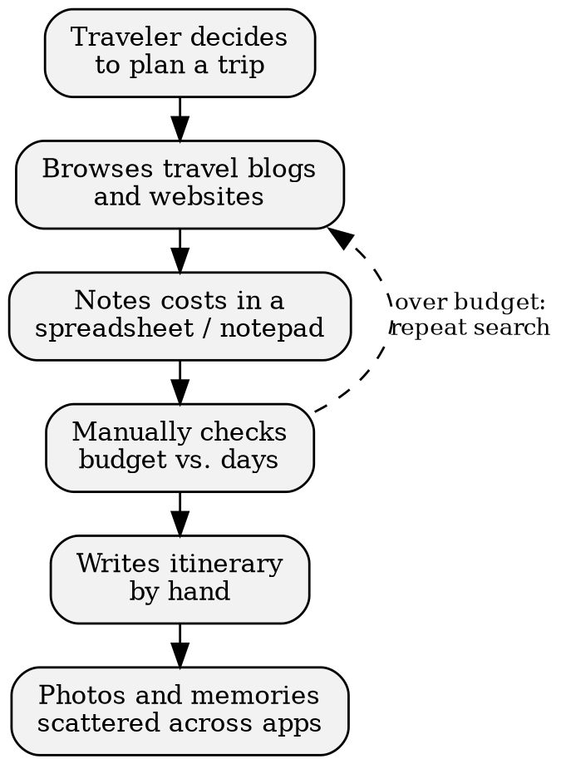
Figure 2.1: As-Is Process Flow of the Existing Travel Planning Process

2.2 Limitations of the Existing System
- Information is scattered and unstructured, so comparing destinations is slow and inconsistent.
- Budget and duration checks are done by hand, which leads to calculation errors and repeated searching.
- There is no automatic link between a preferred interest, a destination and a day-wise activity plan.
- There is no explanation of why a destination suits a traveler, so decisions rest on guesswork or on generic lists.
- Itineraries, favourites and travel memories are stored in unrelated tools, with no single record of a traveler's plans and experiences.

2.3 Low-Code versus Traditional Development
Table 2.1: Comparison of Low-Code and Traditional Development for the Proposed Application
Criterion | Traditional (Pro-Code) Development | Low-Code on Zoho Creator
Development time | [e.g., 8–10 weeks – confirm your own estimate] | [e.g., 2–3 weeks – confirm your own actual effort]
Skills required | Back-end and front-end programming, database design and API development in an SDLC with separate roles | Form and report configuration plus basic Deluge scripting; one developer can build and maintain the application
Hosting & infrastructure | Servers, database, deployment pipeline and monitoring must be set up and maintained | Hosted on the Zoho cloud; no separate infrastructure to manage
Mobile application | Separate mobile code base or a responsive redesign | Application is available through Zoho Creator's mobile access without extra development
Security & access control | Authentication, authorisation and data protection have to be coded and tested | Built-in roles, profiles, permissions and HTTPS hosting configured through settings
Maintenance & change | Each new field or screen needs code changes, testing and redeployment | New fields, interests or reports are added visually and published in minutes
Customisation limits | Unlimited flexibility, including complex algorithms and any third-party library | Limited to platform components and Deluge; complex or heavy computation is awkward
Cost | High initial development and ongoing infrastructure and maintenance cost | Subscription based; very low development and hosting cost for an application of this size

2.4 Literature Survey
Table 2.2: Summary of Literature Survey
S.No. | Author(s) / Source & Year | Title / Product | Key Findings | Relevance to this Project
1 | W. Rosam and O. Kalnichevski, 2021 [1] | Low-Code Development: A Practical Guide | Explains low-code concepts, benefits, governance and typical use cases for rapidly building business applications. | Justifies the low-code approach for a forms-and-rules application such as TripWise.
2 | Zoho Corporation, Zoho Creator Help [2] | Zoho Creator Help Documentation | Describes forms, reports, pages, workflows, roles and deployment on Zoho Creator. | Primary reference for the components used to build every module.
3 | Zoho Corporation, Deluge Reference [3] | Deluge Script Reference Guide | Documents Deluge syntax, data types, fetch and insert tasks, and form events. | Basis for the validation, matching, budget and duplicate-check scripts.
4 | Zoho Corporation, Learning Centre [4] | Zoho Creator Learning Centre | Provides guided tutorials and sample applications for building and deploying Creator apps. | Guided the design of the dashboard, reports and the deployment steps.
5 | Gartner, Inc. [5] | Magic Quadrant for Enterprise Low-Code Application Platforms | Evaluates low-code platforms and highlights adoption by citizen developers and fusion teams. | Supports the choice of a low-code platform and the discussion of trends.

2.5 Emerging Trends in Low-Code Development
Several trends in low-code development influenced TripWise. AI-assisted app building and assistants such as Zia point towards personalised, predictive recommendations; TripWise deliberately starts with transparent rule-based matching so that each recommendation can be explained, and keeps the data model ready for later machine-learning extensions. Citizen development encourages designs that a non-programmer can maintain, which is why destinations, interests and activities are data records rather than code. Hyper-automation led to automating the full chain from preference capture to recommendations, budget and itinerary instead of automating single steps. Composable design shaped the modules (destinations, budget, itinerary, favourites, memories), which share data through lookups and can be extended independently.

2.6 Proposed System
The proposed system is the TripWise application on Zoho Creator. It replaces scattered research with a central destination database and replaces manual comparison with a rule-based engine that filters by region, interests, duration and budget and explains each result. It overcomes the limitations in Section 2.2 as follows: structured destination records remove scattered information; automated cost calculation and budget validation remove manual arithmetic; stored activities generate itineraries automatically; and favourites and travel memories keep a traveler's shortlists and experiences in one place with every record linked to the user.
CHAPTER 3

REQUIREMENT ANALYSIS

3.1 Stakeholders and User Roles
Table 3.1: Stakeholders and User Roles
Role | Description | Key Responsibilities in the Application
Traveler | An individual who plans trips with the application, travelling solo, as a couple, with family or with friends. | Enter preferences, view recommendations, plan budgets, generate and edit itineraries, save favourites, record travel memories.
Administrator | The person who maintains the destination database and sample data. | Add, edit, delete and view destinations and activities; oversee user data.

3.2 Functional Requirements
Table 3.2: Functional Requirements
FR ID | Requirement | Role(s) | Priority
FR-01 | The system shall allow the Administrator to add, edit, delete and view destination records with costs, activities and best travel seasons. | Admin | High
FR-02 | The system shall tag each destination with multiple interests (Nature, Adventure, Beaches, Culture, Food, Shopping, Sightseeing) and classify it as Domestic or International. | Admin | High
FR-03 | The system shall store transportation, accommodation, food and activity costs per day for every destination. | Admin | High
FR-04 | The system shall capture traveler name, departure city, total budget in INR, duration, travel type (Solo, Family, Friends, Couple), interests and preferred region. | Traveler | High
FR-05 | The system shall reject a travel preference whose budget or duration is not a positive number. | Traveler | High
FR-06 | The system shall match destinations with the preferred region (Domestic, International or Any). | Traveler | High
FR-07 | The system shall match user interests with destination interests and prioritise destinations with more matches. | Traveler | High
FR-08 | The system shall check that the destination's recommended duration is compatible with the available days. | Traveler | High
FR-09 | The system shall calculate the estimated total cost and recommend only destinations within the budget. | Traveler | High
FR-10 | The system shall display an explanation for every recommendation and a helpful message when no destination matches. | Traveler | Medium
FR-11 | The system shall calculate transportation, accommodation, food and activity costs, the estimated total and the remaining budget. | Traveler | High
FR-12 | The system shall generate a day-by-day itinerary for the selected number of days with Morning, Afternoon and Evening slots and activity costs. | Traveler | High
FR-13 | The system shall let the traveler view and edit the itinerary and shall not create duplicate records when it is regenerated. | Traveler | Medium
FR-14 | The system shall let the traveler save, view and remove favourite destinations with the saved date and without duplicates for the same user and destination. | Traveler | Medium
FR-15 | The system shall let the traveler create and view travel memories with destination, dates, title, experience, photographs, highlights and rating. | Traveler | Medium
FR-16 | The system shall display a dashboard with a welcome message, quick action buttons, summary statistics and recently added destinations. | Traveler, Admin | Medium

3.3 Non-Functional Requirements
Table 3.3: Non-Functional Requirements
NFR ID | Category | Requirement
NFR-01 | Performance | Recommendation results and reports shall load within 5 seconds for up to 100 destination records.
NFR-02 | Security | Travelers shall access only their own preferences, favourites, itineraries and memories; only the Administrator shall modify destinations and activities.
NFR-03 | Usability | The application shall be usable in a web browser and shall have a clean, travel-themed interface with quick action buttons.
NFR-04 | Availability | The application shall run on the Zoho Creator cloud without separate infrastructure.
NFR-05 | Maintainability | Destinations, interests and activities shall be maintainable as data without code changes.
NFR-06 | Auditability | All record changes shall be traceable through the audit trail.

3.4 Hardware and Software Requirements
Table 3.4: Hardware and Software Requirements
Category | Specification
Platform | Zoho Creator [Education / Professional] Edition
Scripting language | Deluge (Data Enriched Language for the Universal Grid Environment)
Browser | Google Chrome / Microsoft Edge / Mozilla Firefox (latest version)
API testing tool | Postman
Other Zoho services | None used
Mobile | Zoho Creator mobile access (Android / iOS), optional
Client hardware | Intel Core i3/i5 or above, 8 GB RAM, internet connection

3.5 Use Case Model

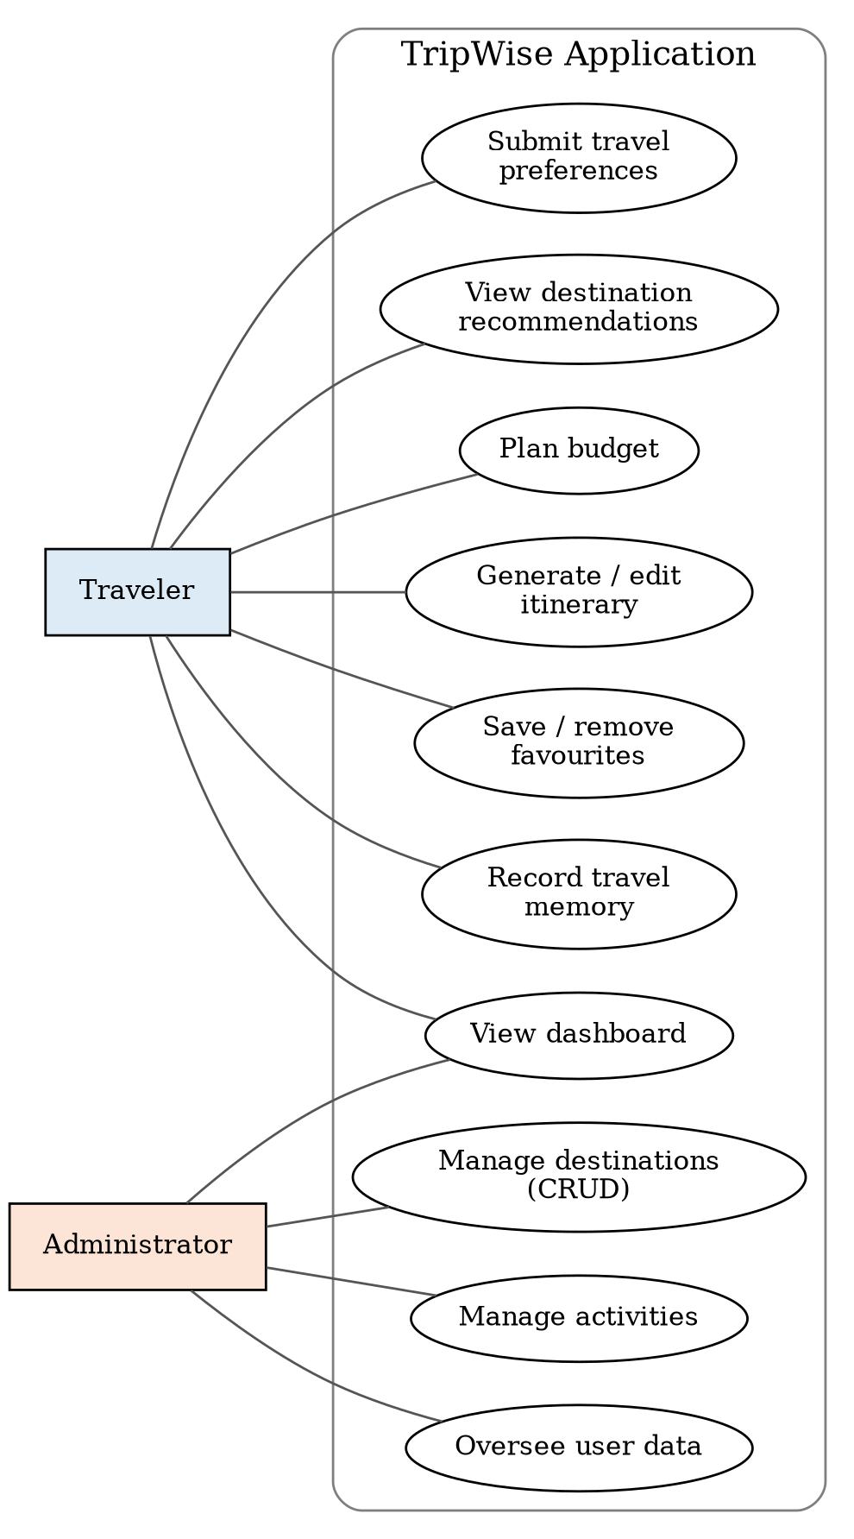
Figure 3.1: Use Case Diagram of TripWise
Table 3.5: Use Case Description – Get Destination Recommendations
Use Case ID | UC-01
Use Case Name | Get Destination Recommendations
Actor(s) | Traveler
Pre-condition | The Traveler is logged in and at least one destination exists in the database.
Main Flow | 1. Traveler opens Find My Destination and enters budget, days, travel type, interests and region. 2. System validates that budget and duration are positive. 3. System filters by region, interests, duration and budget. 4. System ranks destinations by matching interests. 5. System displays recommendations with explanations. 6. Traveler saves favourites.
Alternate Flow | A1: Budget or duration is zero or negative – the form shows an error and is not submitted. A2: No destination matches – a helpful no-match message is shown.
Post-condition | Ranked recommendations are stored and visible; the traveler can open the budget planner or generate an itinerary.
Related FR | FR-04 to FR-10, FR-14

Table 3.6: Use Case Description – Generate Day-by-Day Itinerary
Use Case ID | UC-02
Use Case Name | Generate Day-by-Day Itinerary
Actor(s) | Traveler
Pre-condition | A destination with stored activities has been selected and the number of days is known.
Main Flow | 1. Traveler selects destination and number of days. 2. System retrieves the activities stored for the destination. 3. System distributes activities across Morning, Afternoon and Evening slots for each day. 4. System creates one record per activity with description and estimated cost. 5. Traveler reviews and edits the itinerary.
Alternate Flow | A1: The itinerary already exists – the old records are replaced and no duplicates are created. A2: The destination has no activities – the system informs the traveler.
Post-condition | A complete itinerary for exactly the selected number of days is stored and can be edited.
Related FR | FR-12, FR-13
CHAPTER 4

SYSTEM DESIGN

4.1 System Architecture

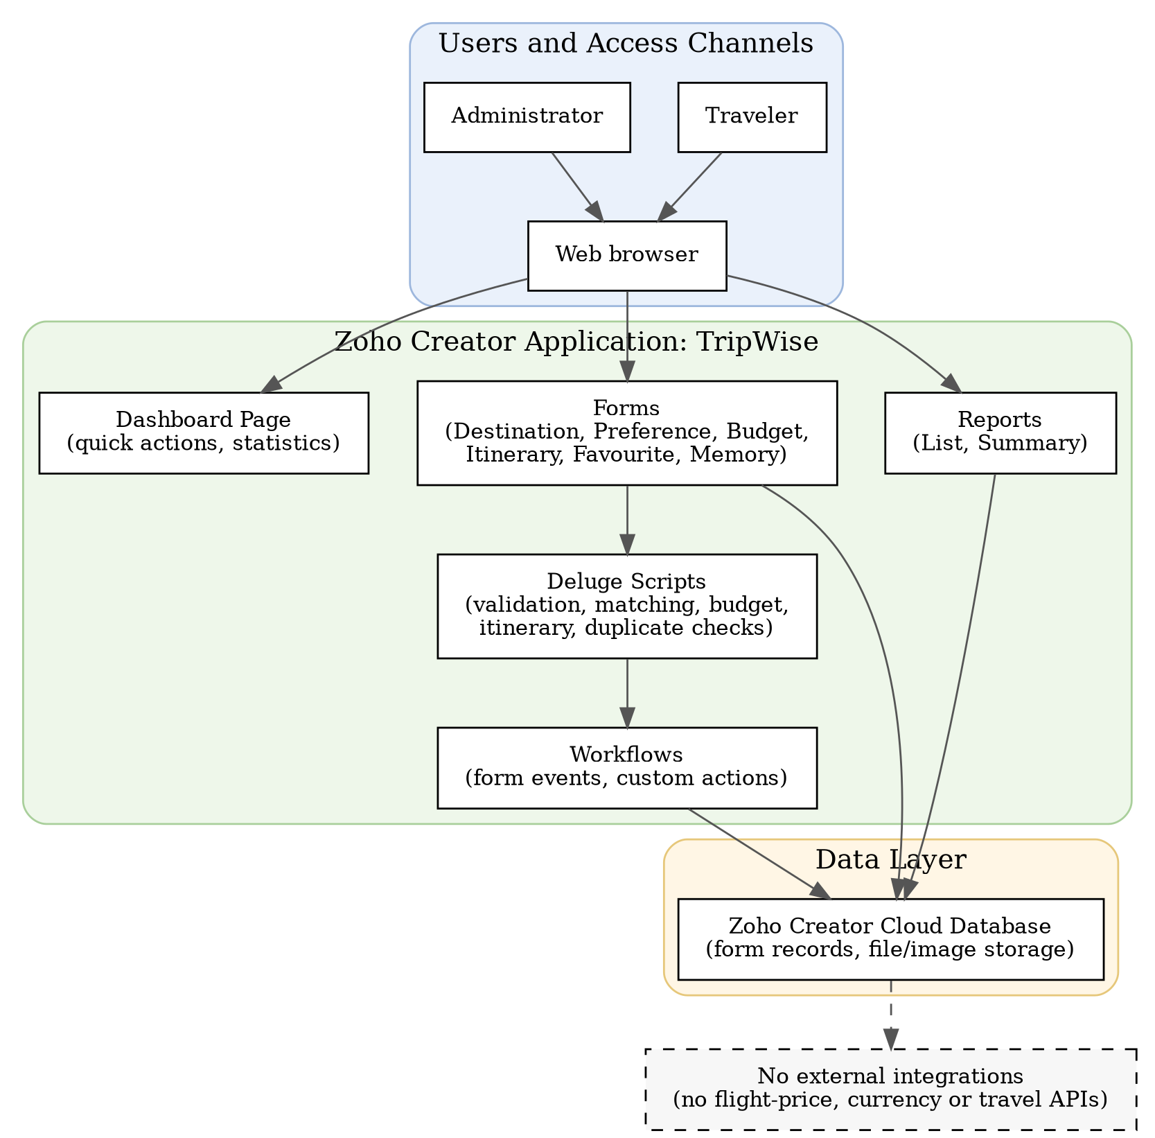
Figure 4.1: System Architecture of TripWise
TripWise follows a simple layered architecture. The access layer consists of the two user roles, Traveler and Administrator, who reach the application through a web browser. The application layer is the Zoho Creator application itself: forms capture data, reports present it, a dashboard page gives quick access to all features, Deluge scripts implement validation, matching, budget calculation, itinerary generation and duplicate checks, and workflows trigger these scripts on form events and custom actions. The data layer is the Zoho Creator cloud database that stores all form records, images and uploaded files. No integration layer exists because TripWise relies entirely on stored destination data and does not call flight, currency or other travel APIs.

4.2 Data Model

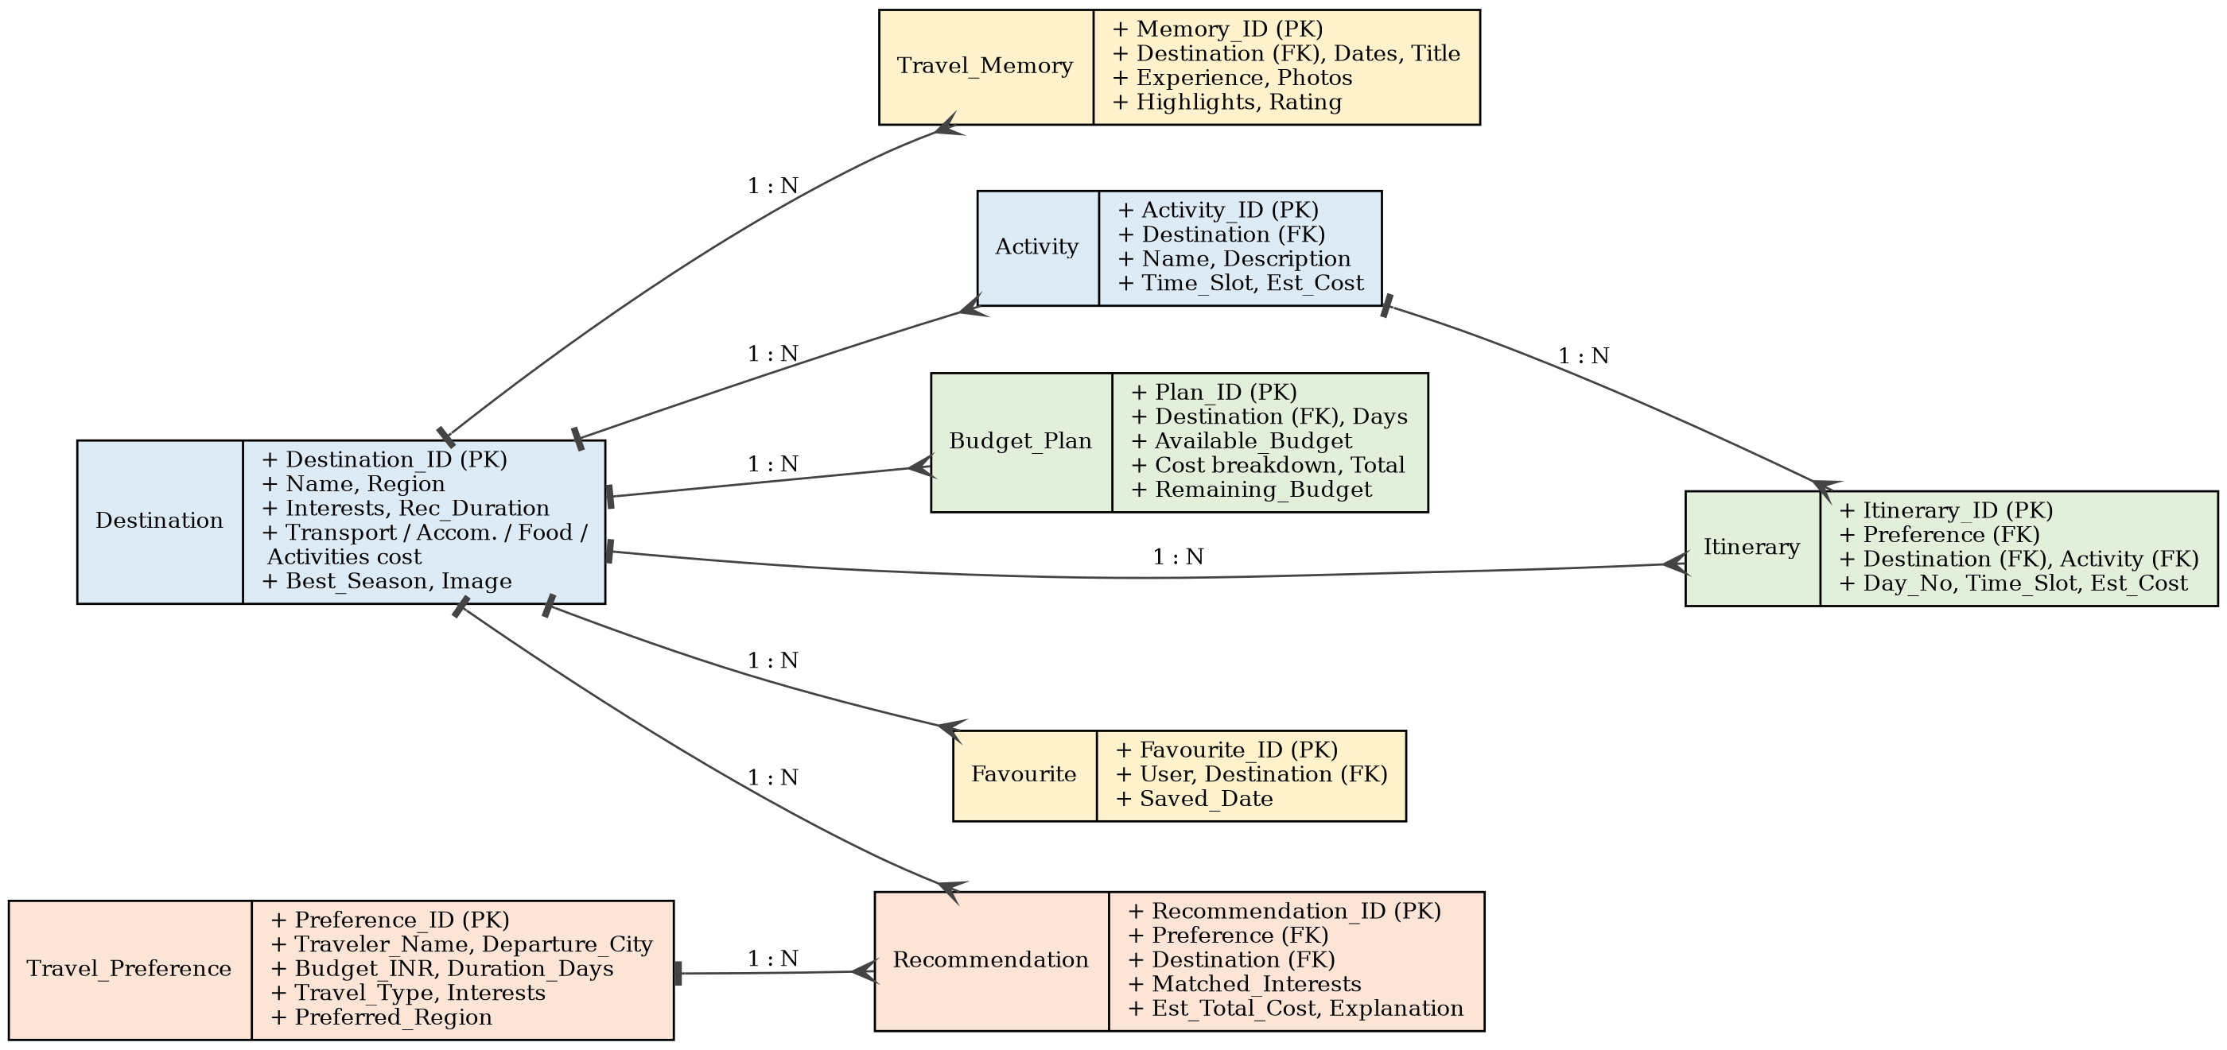
Figure 4.2: Entity–Relationship Diagram of TripWise
Table 4.1: Entities and Relationships
Entity (Form) | Key Fields | Related To | Relationship Type | Implemented Using
Destination | Destination_ID, Destination_Name, Region, Interests, Recommended_Duration, Transportation_Cost, Accommodation_Per_Day, Food_Per_Day, Activities_Per_Day, Best_Season | Activity, Recommendation, Budget_Plan, Itinerary, Favourite, Travel_Memory | One-to-Many | Lookup field in each child form
Activity | Activity_ID, Destination, Activity_Name, Time_Slot, Estimated_Cost | Destination; Itinerary | Many-to-One; One-to-Many | Lookup to Destination; lookup in Itinerary
Travel_Preference | Preference_ID, Traveler_Name, Total_Budget, Duration_Days, Travel_Type, Interests, Preferred_Region | Recommendation | One-to-Many | Lookup in Recommendation
Recommendation | Recommendation_ID, Preference, Destination, Matched_Interests, Estimated_Total_Cost, Explanation | Travel_Preference; Destination | Many-to-One | Lookup fields
Budget_Plan | Plan_ID, Destination, Travel_Days, Available_Budget, Estimated_Total, Remaining_Budget | Destination | Many-to-One | Lookup field
Itinerary | Itinerary_ID, Destination, Day_Number, Time_Slot, Activity, Estimated_Cost | Destination; Activity | Many-to-One | Lookup fields
Favourite | Favourite_ID, Destination, Saved_Date | Destination | Many-to-One | Lookup field; user via Added_User
Travel_Memory | Memory_ID, Destination, Start_Date, End_Date, Memory_Title, Rating | Destination | Many-to-One | Lookup field

4.3 Form Design
Table 4.2: Field Specification – Destination Form
Field Label | Link Name | Field Type | Mandatory | Validation / Default | Remarks
Destination ID | Destination_ID | Auto Number | — | Prefix DST- | System generated
Destination Name | Destination_Name | Single Line | Yes | No duplicate values | Unique destination name
Region | Region | Drop Down | Yes | Domestic / International
Interests | Interests | Multi Select | Yes | Nature, Adventure, Beaches, Culture, Food, Shopping, Sightseeing | Multi-interest tagging
Recommended Duration (days) | Recommended_Duration | Number | Yes | Greater than 0 | Used for duration check
Transportation Cost | Transportation_Cost | Currency (INR) | Yes | Not negative | Estimated return cost
Accommodation Cost per Day | Accommodation_Per_Day | Currency (INR) | Yes | Not negative
Food Cost per Day | Food_Per_Day | Currency (INR) | Yes | Not negative
Activities Cost per Day | Activities_Per_Day | Currency (INR) | Yes | Not negative
Best Travel Season | Best_Season | Single Line | No |  | Seasonal recommendation
Destination Image | Destination_Image | Image | No |  | Shown on dashboard and reports

Table 4.3: Field Specification – Activity Form
Field Label | Link Name | Field Type | Mandatory | Validation / Default | Remarks
Activity ID | Activity_ID | Auto Number | — | Prefix ACT- | System generated
Destination | Destination | Lookup (Destination) | Yes |  | Parent destination
Activity Name | Activity_Name | Single Line | Yes
Description | Description | Multi Line | No |  | Shown in itinerary
Time Slot | Time_Slot | Drop Down | Yes | Morning / Afternoon / Evening
Estimated Cost | Estimated_Cost | Currency (INR) | Yes | Not negative | Cost of the activity

Table 4.4: Field Specification – Travel Preference Form
Field Label | Link Name | Field Type | Mandatory | Validation / Default | Remarks
Preference ID | Preference_ID | Auto Number | — | Prefix TPF- | System generated
Traveler Name | Traveler_Name | Name | Yes
Departure City | Departure_City | Single Line | Yes
Total Budget (INR) | Total_Budget | Currency (INR) | Yes | Greater than 0 | Validated by DS-01
Duration (days) | Duration_Days | Number | Yes | Greater than 0 | Validated by DS-01
Travel Type | Travel_Type | Radio | Yes | Solo / Family / Friends / Couple
Interests | Interests | Multi Select | Yes | Same values as Destination
Preferred Region | Preferred_Region | Drop Down | Yes | Default: Any | Domestic / International / Any

Table 4.5: Field Specification – Recommendation Form
Field Label | Link Name | Field Type | Mandatory | Validation / Default | Remarks
Recommendation ID | Recommendation_ID | Auto Number | — | Prefix REC- | System generated
Preference | Preference | Lookup (Travel Preference) | Yes |  | Created by DS-02
Destination | Destination | Lookup (Destination) | Yes
Matched Interests | Matched_Interests | Multi Line | No |  | Interests common to both
Matched Count | Matched_Count | Number | Yes |  | Used for ranking
Estimated Total Cost | Estimated_Total_Cost | Currency (INR) | Yes | Within budget
Explanation | Explanation | Multi Line | Yes |  | Reason shown to the traveler

Table 4.6: Field Specification – Budget Plan Form
Field Label | Link Name | Field Type | Mandatory | Validation / Default | Remarks
Plan ID | Plan_ID | Auto Number | — | Prefix BUD- | System generated
Destination | Destination | Lookup (Destination) | Yes
Travel Days | Travel_Days | Number | Yes | Greater than 0
Available Budget | Available_Budget | Currency (INR) | Yes | Greater than 0
Transportation Cost | Transportation_Cost | Currency (INR) | — |  | Taken from destination
Accommodation Cost | Accommodation_Cost | Currency (INR) | — |  | Per-day cost × days
Food Cost | Food_Cost | Currency (INR) | — |  | Per-day cost × days
Activities Cost | Activities_Cost | Currency (INR) | — |  | Per-day cost × days
Estimated Total | Estimated_Total | Currency (INR) | — |  | Sum of all categories
Remaining Budget | Remaining_Budget | Currency (INR) | — |  | Budget – total; set by DS-03

Table 4.7: Field Specification – Itinerary Form
Field Label | Link Name | Field Type | Mandatory | Validation / Default | Remarks
Itinerary ID | Itinerary_ID | Auto Number | — | Prefix ITN- | System generated
Destination | Destination | Lookup (Destination) | Yes
Day Number | Day_Number | Number | Yes | 1 to selected days
Time Slot | Time_Slot | Drop Down | Yes | Morning / Afternoon / Evening
Activity | Activity | Lookup (Activity) | Yes
Estimated Cost | Estimated_Cost | Currency (INR) | No |  | Copied from activity
Notes | Notes | Multi Line | No |  | Edited by the traveler

Table 4.8: Field Specification – Favourite Form
Field Label | Link Name | Field Type | Mandatory | Validation / Default | Remarks
Favourite ID | Favourite_ID | Auto Number | — | Prefix FAV- | System generated
Destination | Destination | Lookup (Destination) | Yes |  | Duplicate check by DS-05
Saved Date | Saved_Date | Date-Time | — | Default: current time | Timestamp of saving
Traveler | Added_User | System field | — | Logged-in user | Links record to the user

Table 4.9: Field Specification – Travel Memory Form
Field Label | Link Name | Field Type | Mandatory | Validation / Default | Remarks
Memory ID | Memory_ID | Auto Number | — | Prefix MEM- | System generated
Destination | Destination | Lookup (Destination) | Yes
Start Date | Start_Date | Date | Yes
End Date | End_Date | Date | Yes | Not before start date | Validated by DS-06
Memory Title | Memory_Title | Single Line | Yes
Experience | Experience | Multi Line | Yes |  | Personal experience
Photos | Photos | File Upload | No | Images | Travel photographs
Highlights | Highlights | Multi Line | No
Rating | Rating | Radio | No | 1 to 5 | Experience rating

4.4 Process and Workflow Design

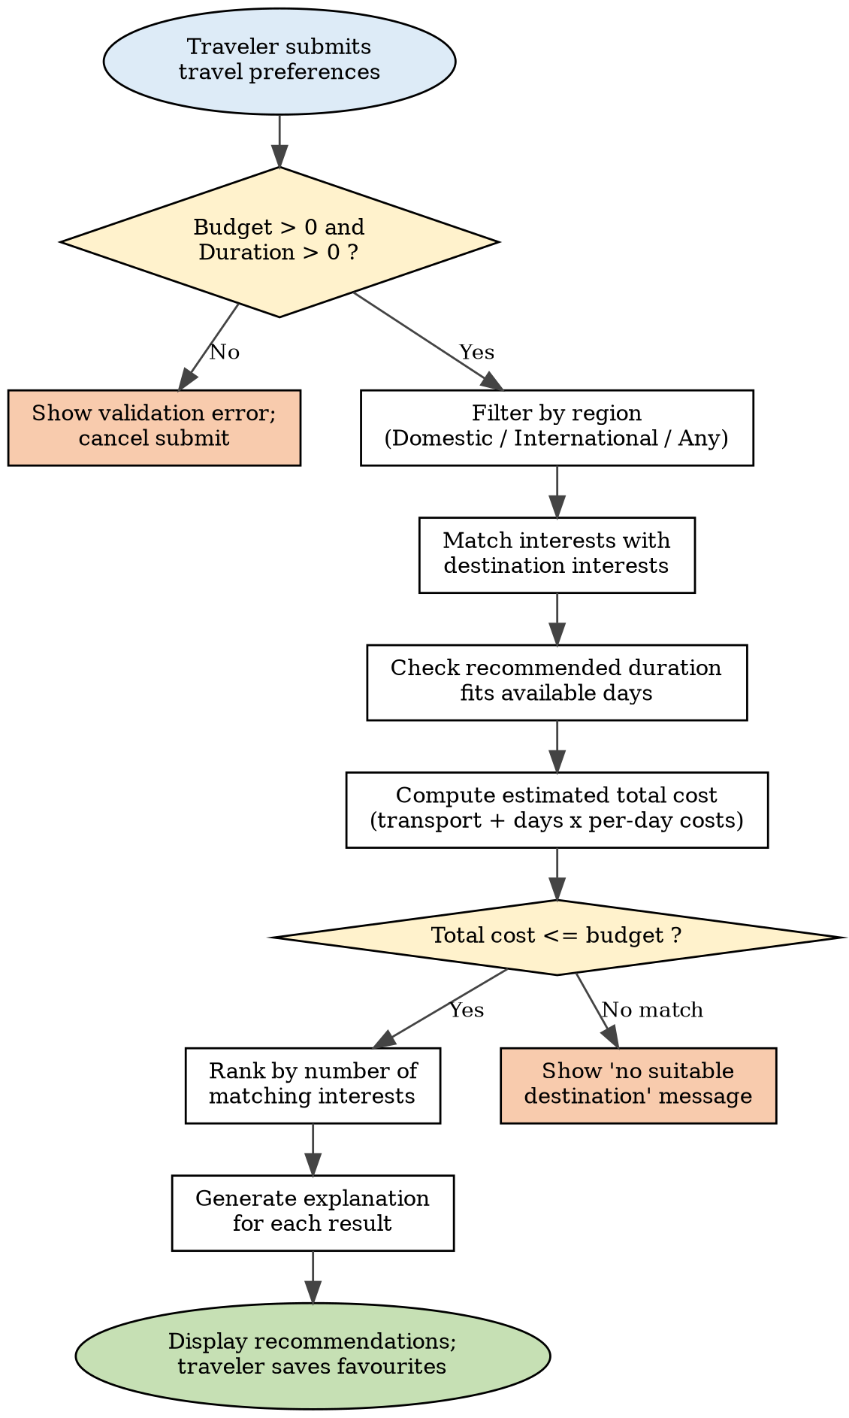
Figure 4.3: Process Flow for Destination Recommendation
The recommendation process (Figure 4.3) is triggered when a travel preference is submitted. Validation runs first (DS-01) and then the matching script (DS-02) filters by region, interests, duration and budget, ranks the results and writes the recommendations with their explanations.
The budget calculation process retrieves the cost data of the selected destination, multiplies the accommodation, food and activity costs per day by the number of days, adds the transportation cost to obtain the estimated total and subtracts it from the available budget (DS-03). The itinerary generation process retrieves the stored activities of the destination, distributes them over Morning, Afternoon and Evening slots for each day of the trip, stores one record per activity and replaces earlier records so that no duplicates arise (DS-04). In the memory recording process the traveler enters destination, dates, title, experience, photographs, highlights and rating, and the system stores the entry with a timestamp.

4.5 User Interface and Navigation Design

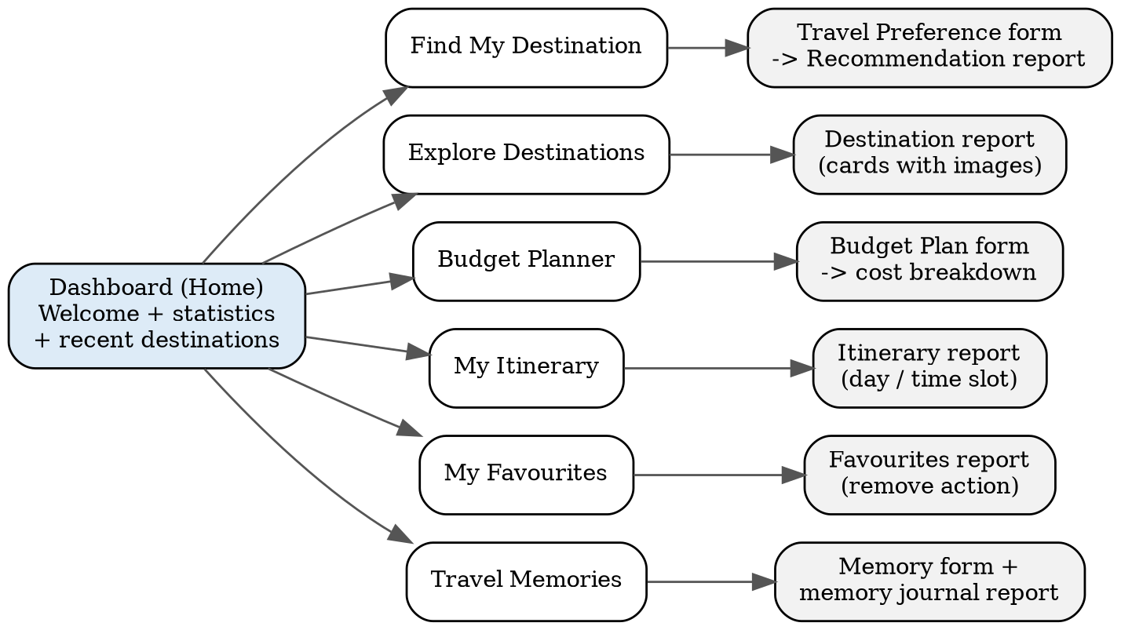
Figure 4.4: Navigation Structure of TripWise
The dashboard is the home screen. Its six quick action buttons (Find My Destination, Explore Destinations, Budget Planner, My Itinerary, My Favourites and Travel Memories) lead to the corresponding forms and reports. Summary statistics (total destinations, recommendations, favourites and travel memories) and a Recently Added Destinations list give a quick overview. The design uses a clean, modern, travel-themed layout with destination images.

4.6 Access Control Design
Table 4.10: Role–Permission Matrix
Component | Administrator | Traveler
Form: Destination | A E V D | V
Form: Activity | A E V D | V
Form: Travel Preference | V | A V (own)
Form: Recommendation | V | V (own)
Form: Budget Plan | V | A V (own)
Form: Itinerary | V | A E V (own)
Form: Favourite | V | A V D (own)
Form: Travel Memory | V | A E V (own)
Report: Explore Destinations | V | V
Page: Dashboard | V | V
CHAPTER 5

IMPLEMENTATION

5.1 Application Setup
TripWise was created in a Zoho Creator workspace as a new application named TripWise, built from scratch [confirm: from scratch / template / AI-assisted builder]. The application menu is organised into sections for the Dashboard, Destinations, Find My Destination, Budget Planner, My Itinerary, My Favourites and Travel Memories, with administrator-only sections for managing destinations and activities. A travel-themed theme with destination images gives the application a clean and modern look.

[Insert screenshot: TripWise application home and navigation sections]
Figure 5.1: TripWise Application Home and Navigation Sections

5.2 Forms and Data Capture
TripWise contains eight forms (Table 4.2 to Table 4.9): Destination, Activity, Travel Preference, Recommendation, Budget Plan, Itinerary, Favourite and Travel Memory. Auto Number fields give every record a readable identifier. Lookup fields connect child forms to Destination (and Recommendation to Travel Preference), which realises the one-to-many relationships of the ER diagram. Multi Select fields store the interests, a Radio field stores the travel type, Currency fields store INR amounts and Image and File Upload fields store destination pictures and travel photographs. Field validations enforce positive budgets and durations, non-negative costs and an end date that is not before the start date. Success messages confirm each submission, and the Travel Preference form is the entry point of the recommendation flow.

[Insert screenshot: Travel Preference form in the Form Builder]
Figure 5.2: Travel Preference Form in the Form Builder

[Insert screenshot: Travel Preference form in live mode]
Figure 5.3: Travel Preference Form in Live Mode

5.3 Reports
Table 5.1: Reports Implemented
Report Name | Type | Source Form | Filter / Grouping / Sorting | Custom Actions | Roles
Explore Destinations | List | Destination | Group by Region; sort by name | — | Administrator, Traveler
Manage Destinations | List | Destination | Sort by recently added | Add, Edit, Delete | Administrator
My Recommendations | List | Recommendation | Own records; sort by Matched_Count (descending) | Save to Favourites; Generate Itinerary | Traveler
My Budget Plans | List | Budget_Plan | Own records; sort by newest | — | Traveler
My Itinerary | List | Itinerary | Own records; group by Day_Number; sort by Time_Slot | Edit | Traveler
My Favourites | List | Favourite | Own records; sort by Saved_Date | Remove | Traveler
My Travel Memories | List | Travel_Memory | Own records; sort by Start_Date (newest first) | — | Traveler

[Insert screenshot: My Recommendations report]
Figure 5.4: My Recommendations Report

5.4 Pages and Dashboards
The Dashboard page is the home screen of the application. It shows a personalised welcome message, six quick action buttons (Find My Destination, Explore Destinations, Budget Planner, My Itinerary, My Favourites and Travel Memories), summary statistics for total destinations, total recommendations, total favourites and total travel memories, and a Recently Added Destinations list with images. The page was built with the Creator page builder, and the statistics are obtained by counting the records of the respective forms.

[Insert screenshot: Dashboard page]
Figure 5.5: TripWise Dashboard Page

5.5 Deluge Scripting
Table 5.2: Deluge Scripts Implemented
Script ID | Location / Trigger | Purpose | Deluge Concepts Used
DS-01 | Travel_Preference → On Validate | Reject budget or duration that is not positive | if-else, alert, cancel submit
DS-02 | Travel_Preference → On Success | Match region, interests, duration and budget; rank; write recommendations with explanations | for each, fetch, list, if-else, insert
DS-03 | Budget_Plan → On Validate | Calculate cost categories, estimated total and remaining budget | fetch, arithmetic, field assignment
DS-04 | Recommendation report → Custom action | Generate the day-by-day itinerary from stored activities without duplicates | fetch, loops, insert, delete
DS-05 | Favourite → On Validate | Prevent a duplicate favourite for the same user and destination | fetch, count, alert, cancel submit
DS-06 | Travel_Memory → On Validate | Ensure the end date is not before the start date | if-else, alert, cancel submit

Code 5.1: DS-01 – Validate budget and duration (Travel_Preference → On Validate)
// DS-01 | Form: Travel_Preference | Event: On Validate
if(input.Total_Budget <= 0 || input.Duration_Days <= 0)
{
alert "Budget and trip duration must be positive numbers.";
cancel submit;
}

Code 5.2: DS-03 – Budget calculation (Budget_Plan → On Validate)
// DS-03 | Form: Budget_Plan | Event: On Validate
dest = Destination[ID == input.Destination];
days = input.Travel_Days;
input.Transportation_Cost = dest.Transportation_Cost;
input.Accommodation_Cost = dest.Accommodation_Per_Day * days;
input.Food_Cost = dest.Food_Per_Day * days;
input.Activities_Cost = dest.Activities_Per_Day * days;
input.Estimated_Total = input.Transportation_Cost + input.Accommodation_Cost + input.Food_Cost + input.Activities_Cost;
input.Remaining_Budget = input.Available_Budget - input.Estimated_Total;

DS-01 stops the Travel Preference form from being saved when the budget or duration is zero or negative. DS-02 loops over the destinations, keeps those whose region matches the preference and whose recommended duration fits the available days, counts the interests shared with the traveler, computes the estimated total cost (transportation plus the per-day costs multiplied by the number of days) and inserts a Recommendation record with an explanation for every destination that is within the budget; the report sorts the records by the number of matches. DS-03 reads the cost data of the selected destination and fills the cost categories, the estimated total and the remaining budget. DS-04 creates one itinerary record per activity for each day and time slot, and deletes earlier records for the same user and destination so that regeneration never creates duplicates. DS-05 and DS-06 prevent duplicate favourites and invalid memory dates. [Confirm the script locations and add the results you observed during testing. Replace the draft code above with your final scripts.]

5.6 Workflows and Automation
Table 5.3: Workflows Implemented
Workflow Name | Type | Trigger / Event | Condition | Action(s) | Script Ref.
Preference Validation | Form Workflow | On Validate of Travel_Preference | Budget ≤ 0 or Duration ≤ 0 | Show alert and cancel submit | DS-01
Recommendation Generation | Form Workflow | On Success of Travel_Preference | Always | Insert matching destinations into Recommendation | DS-02
Budget Calculation | Form Workflow | On Validate of Budget_Plan | Always | Fill cost categories, total and remaining budget | DS-03
Itinerary Generation | Custom Action | Button on My Recommendations report | Always | Delete old records and insert new itinerary | DS-04
Duplicate Favourite Check | Form Workflow | On Validate of Favourite | Same user and destination already saved | Show alert and cancel submit | DS-05
Memory Date Check | Form Workflow | On Validate of Travel_Memory | End date before start date | Show alert and cancel submit | DS-06

[Insert screenshot: workflow configuration for recommendation generation]
Figure 5.6: Form Workflow Configuration for Recommendation Generation

5.7 Integrations
No external integrations were used in TripWise. The application relies on destination, cost and activity data stored by the Administrator and on rule-based logic, so it operates independently of live flight prices, currency conversion or external travel APIs. This was a deliberate scope decision: it keeps the application self-contained, avoids dependence on third-party availability and credentials, and keeps every calculation reproducible and explainable. Section 9.2 lists REST API integration (for example live prices or weather) as a future enhancement.

5.8 User Management and Role-Based Access
Two roles are defined: Administrator and Traveler. The Administrator profile has full access to the Destination and Activity forms and read access to all other data. The Traveler profile can add and view only the traveler-facing forms and reports, and report criteria restrict every personal report to records added by the logged-in user, as defined in Table 4.10. Users are invited to the application and assigned one of the two profiles.

[Insert screenshot: roles and permission profiles configuration]
Figure 5.7: Roles and Permission Profiles Configuration

5.9 AI and Analytics Features
The recommendation engine of TripWise is deliberately rule-based rather than AI-driven, so that every recommendation can be explained to the traveler through the matched interests, region, duration and cost. Zia and other AI features were therefore not used. Analytics are provided through the summary statistics on the dashboard, which count destinations, recommendations, favourites and travel memories. Zia-based personalisation is listed as a future enhancement.

[Insert screenshot: dashboard summary statistics]
Figure 5.8: Dashboard Summary Statistics

5.10 Pro-Code Extension
No pro-code extension was used in TripWise. All logic, including matching, budget calculation and itinerary generation, fits within Deluge scripts and form workflows, and no Catalyst function, custom widget or external service was needed. Pro-code extension would become relevant if heavy computation or live external data were added in future.

5.11 Mobile and Portal Access
TripWise is delivered as a web application. Zoho Creator applications can also be opened in the Zoho Creator mobile app by users who have access, so travelers can reach the dashboard, reports and forms from a phone. A customer portal was not configured because travelers are application users with the Traveler profile.

[Insert screenshot of the application on mobile, or delete this figure if mobile access was not tested]
Figure 5.9: TripWise on the Zoho Creator Mobile App
CHAPTER 6

TESTING AND DEBUGGING

6.1 Testing Strategy
Testing was carried out at three levels. Unit-level checks exercised each Deluge script on its own, using info statements to inspect intermediate values. Functional testing then verified every functional requirement of Table 3.2 through the test cases of Table 6.1, using realistic sample destinations and travel preferences. Finally, end-to-end scenarios (preferences → recommendations → budget → itinerary → favourites → memory) and user acceptance testing checked that the modules work together and meet the expectations of the two roles.

6.2 Test Cases
Sample test data: a destination with transportation cost INR 3,000, accommodation INR 2,000 per day, food INR 800 per day and activities INR 700 per day; for 4 days this gives accommodation 8,000, food 3,200, activities 2,800 and an estimated total of INR 17,000.
Table 6.1: Test Cases
TC ID | FR Ref. | Test Description | Input / Steps | Expected Result | Actual Result | Status
TC-01 | FR-01 | Administrator adds a destination | Enter all destination fields and submit | Record is saved and appears in Explore Destinations | [ ] | [Pass / Fail]
TC-02 | FR-01 | Administrator edits and deletes a destination | Edit a cost; delete another record | Edit is saved; deleted record disappears from reports | [ ] | [Pass / Fail]
TC-03 | FR-02, FR-03 | Multi-interest tagging and cost storage | Tag a destination with Nature and Beaches, region Domestic, enter all four costs | All interests, region and costs are stored | [ ] | [Pass / Fail]
TC-04 | FR-04 | Submit valid travel preferences | Budget 25,000; 4 days; Couple; Beaches; Domestic | Record created, success message shown, recommendations generated | [ ] | [Pass / Fail]
TC-05 | FR-05 | Zero budget | Budget 0; valid duration | Error message; form not submitted | [ ] | [Pass / Fail]
TC-06 | FR-05 | Negative duration | Duration −3; valid budget | Error message; form not submitted | [ ] | [Pass / Fail]
TC-07 | FR-06 | Region matching | Preferred region Domestic | Only Domestic destinations are recommended | [ ] | [Pass / Fail]
TC-08 | FR-07 | Interest ranking | Select Beaches and Food | Destinations with more matching interests are listed first | [ ] | [Pass / Fail]
TC-09 | FR-08 | Duration compatibility | Available days shorter than a destination's recommended duration | That destination is not recommended | [ ] | [Pass / Fail]
TC-10 | FR-09 | Budget filtering | Budget lower than every destination's total | No destination whose estimated total exceeds the budget is shown | [ ] | [Pass / Fail]
TC-11 | FR-10 | No-match message | Use the input of TC-10 | A helpful no-match message is displayed | [ ] | [Pass / Fail]
TC-12 | FR-10 | Explanation generation | Open any recommendation | Explanation lists the matched interests, region and cost fit | [ ] | [Pass / Fail]
TC-13 | FR-11 | Budget calculation | Sample test data; 4 days; available budget 20,000 | Accommodation 8,000; food 3,200; activities 2,800; total 17,000; remaining 3,000 | [ ] | [Pass / Fail]
TC-14 | FR-12 | Itinerary generation | Select a destination and 3 days | 3 days with Morning, Afternoon and Evening activities and costs | [ ] | [Pass / Fail]
TC-15 | FR-13 | Itinerary regeneration | Generate the same itinerary twice | No duplicate records are created | [ ] | [Pass / Fail]
TC-16 | FR-13 | Itinerary editing | Change one activity and save | Change is stored and shown in the report | [ ] | [Pass / Fail]
TC-17 | FR-14 | Save favourite | Click Save to Favourites | Record created with the saved date and the user | [ ] | [Pass / Fail]
TC-18 | FR-14 | Duplicate favourite | Save the same destination again | Alert shown; duplicate not created | [ ] | [Pass / Fail]
TC-19 | FR-14 | Remove favourite | Click Remove | Favourite disappears from My Favourites | [ ] | [Pass / Fail]
TC-20 | FR-15 | Create travel memory | Enter all fields, upload a photo, rate 5 | Memory is saved and visible in the journal | [ ] | [Pass / Fail]
TC-21 | FR-16 | Dashboard statistics | Add one record to each form | Totals on the dashboard increase accordingly | [ ] | [Pass / Fail]

6.3 Debugging Deluge Scripts
Scripts were debugged by writing intermediate values (matched interests, computed totals and remaining budget) with info statements while testing in live mode, by testing each script with extreme inputs such as zero and negative values, and by checking the resulting records in the reports. [Describe any additional debugging tool you used and the errors found.]

[Insert screenshot: Deluge debug output for the recommendation script (DS-02)]
Figure 6.1: Deluge Debug Output for the Recommendation Script (DS-02)

6.4 Defect Log
Table 6.2: Defect Log
Bug ID | Description | Root Cause | Fix Applied | Status
[BUG-01] | [ ] | [ ] | [ ] | [Closed]
[ ] | [ ] | [ ] | [ ] | [ ]

6.5 User Acceptance Testing
Table 6.3: User Acceptance Feedback
User | Role Tested | Feedback | Action Taken
[ ] | [ ] | [ ] | [ ]
[ ] | [ ] | [ ] | [ ]
CHAPTER 7

DEPLOYMENT, SECURITY AND GOVERNANCE

7.1 Environments and Deployment Strategy
TripWise was developed in the Development environment of Zoho Creator, tested with sample data in a Stage environment and then published to Production. Only tested changes were moved forward, and production data was kept separate from test data. [Confirm the environments you actually used and the date of deployment.]

[Insert screenshot: environments and publish to production]
Figure 7.1: Environments and Publish to Production
Table 7.1: Deployment Checklist
S.No. | Checklist Item | Done (✓)
1 | All test cases executed in Development / Stage | [ ]
2 | Sample/test data removed or isolated | [ ]
3 | Roles, permissions and users configured in Production | [ ]
4 | Connections authorised in Production | [ ]
5 | Schedules and workflows enabled | [ ]
6 | Application published and URL verified | [ ]
7 | Version / release notes recorded | [ ]

7.2 Performance Optimisation
Performance was kept in mind in the design of the scripts. Destinations are read once and processed in a single loop, fetch tasks use criteria instead of looping over whole forms wherever possible, reports are filtered and sorted at source, and the itinerary is generated in one action rather than record by record through the user interface. Measured before-and-after results are recorded in Table 7.2.

Table 7.2: Performance Optimisation Results
Optimisation Applied | Component | Before | After | Improvement
[Replaced fetch inside loop with single criteria fetch] | [DS-03] | [ ] | [ ] | [ ]
[Filtered report by default criteria] | [All Orders report] | [ ] | [ ] | [ ]
[ ] | [ ] | [ ] | [ ] | [ ]

7.3 Security Features
Table 7.3: Security Controls Implemented
Security Control | Where Applied | Threat Mitigated
Role-based profiles and permissions | All forms, reports and the dashboard | Unauthorised access to administrative functions
Record-level report criteria (Added_User) | My Recommendations, Budget Plans, Itinerary, Favourites and Memories | One traveler viewing another traveler's data
Input validation | DS-01, DS-06 and field validations | Invalid input and wrong cost calculations
Duplicate prevention | DS-05 and itinerary regeneration (DS-04) | Data inconsistency and inflated record counts
HTTPS-hosted platform with login | Zoho Creator application access | Interception of data in transit and anonymous access

7.4 Governance and Administration
Governance is handled through the administration features of Zoho Creator. The Administrator profile controls who can maintain destination data, users are added and assigned profiles by invitation, and the audit trail records changes to application data so that edits to destination costs can be traced. Destination data is changed only by the Administrator, which keeps the cost estimates that drive the recommendations consistent.

[Insert screenshot: audit trail and administration settings]
Figure 7.2: Audit Trail and Administration Settings
CHAPTER 8

RESULTS AND DISCUSSION

8.1 Application Output
The working application is demonstrated with one realistic scenario. A traveler from [departure city] opens the dashboard and chooses Find My Destination. She enters a total budget, the number of days, the travel type, her interests and her preferred region (Figure 8.1). After the preference is validated and submitted, the recommendation engine lists the matching destinations ranked by the number of matching interests, each with an explanation and its estimated total cost (Figure 8.2). She opens the budget planner for the best destination to see the transportation, accommodation, food and activity costs, the estimated total and the remaining budget, and then generates a day-by-day itinerary with morning, afternoon and evening activities (Figure 8.3). Finally she saves the destination as a favourite, and after the trip she records a travel memory with photographs, highlights and a rating.

[Insert screenshot: travel preferences submitted]
Figure 8.1: Scenario Step 1 – Submitting Travel Preferences

[Insert screenshot: ranked recommendations with explanations]
Figure 8.2: Scenario Step 2 – Ranked Recommendations with Explanations

[Insert screenshot: budget breakdown and generated itinerary]
Figure 8.3: Scenario Step 3 – Budget Breakdown and Generated Itinerary

8.2 Achievement of Objectives
Table 8.1: Mapping of Objectives to Outcomes
Objective (Sec. 1.3) | Implemented Through | Outcome / Evidence
To design a normalised data model and forms | Sections 4.2, 4.3 and 5.2 | Eight related forms with lookup relationships (Figures 4.2, 5.2 and 5.3)
To automate matching, budget calculation, itinerary generation and duplicate prevention | Sections 5.5 and 5.6 | Scripts DS-01 to DS-06 and the workflows of Table 5.3
To provide a dashboard and role-based reports | Sections 5.3 and 5.4 | Reports of Table 5.1 and the dashboard of Figure 5.5
To use native Zoho Creator capabilities only | Section 5.7 | No external integration; all features built with forms, reports, pages, workflows and Deluge
To deploy securely with governance controls | Chapter 7 | Production deployment (Table 7.1) and security controls (Table 7.3)

8.3 Comparison with the Existing System
Table 8.2: Existing System versus Proposed Application
Parameter | Existing System | Proposed Application | Improvement
Destination shortlisting | Manual research across several websites and blogs | Automatic matching by region, interests, duration and budget | One submission replaces repeated searching
Cost estimation | Manual arithmetic | Automatic breakdown of transport, stay, food and activities | Consistent, calculation-error-free estimate
Budget check | Compared by hand, often late | Only destinations within budget are recommended; remaining budget is displayed | Early budget certainty
Itinerary preparation | Written by hand in notes | Generated from stored activities in time slots and editable | Faster planning with full control
Shortlist and memories | Scattered notes, photos and messages | Favourites with dates and a travel memory journal with photos, highlights and ratings | One organised record per traveler
Data access control | None | Role-based access; travelers see only their own records | Privacy and controlled data maintenance

8.4 Limitations of the Low-Code Approach
Low-code development brought speed and simplicity to TripWise, but it also has limits. Recommendations follow explicit rules and cannot learn from past behaviour without Zia or external services. Costs are estimates stored by the Administrator because live prices need external APIs. Complex processing is awkward in Deluge and may hit platform execution limits for large data volumes, and the application depends on the Zoho platform and its pricing. The workarounds adopted were to keep rules transparent and simple, to let the Administrator update estimates regularly and to keep scripts short and criteria-based.

8.5 Reflection on the No-Code → Low-Code → Pro-Code Spectrum
On the no-code to pro-code spectrum, most of TripWise sits at the no-code end: forms, lookups, reports, the dashboard page, roles and permissions and the audit trail were configured visually. The low-code part consists of the six Deluge scripts for validation, matching, calculation, itinerary generation and duplicate prevention. No pro-code components were needed. This distribution shows that a useful business application can be delivered mostly by configuration, with code used only where rules cannot be expressed visually.
CHAPTER 9

CONCLUSION AND FUTURE ENHANCEMENTS

9.1 Conclusion
TripWise demonstrates that a complete travel planning application can be built on Zoho Creator using only native capabilities. A traveler enters a budget, number of days, interests and a preferred region and receives ranked and explained destination recommendations, a detailed budget breakdown and an editable day-by-day itinerary. Favourites and a travel memory journal keep plans and experiences in one place, while the Administrator maintains the destination database that drives the rules.
The project met its objectives of designing a normalised data model, automating the planning logic with Deluge, providing role-based reports and a dashboard, avoiding external dependencies and deploying the application with governance controls. The low-code approach reduced development effort and allowed the application to be maintained as data, although rule-based logic and stored cost estimates remain its main limitations.

9.2 Future Enhancements
- Integrate REST APIs for live flight, hotel and weather data in place of stored cost estimates
- Add currency conversion for international destinations
- Use Zia-based predictive personalisation learned from favourites and past trips
- Add online booking and a payment gateway
- Support shared group itineraries and itinerary export for Solo, Family, Friends and Couple trips

9.3 Learning Outcomes and Career Relevance
Developing TripWise provided hands-on experience of the complete low-code life cycle: data modelling with forms and lookups, reports and pages, Deluge scripting, workflows, role-based access, testing, deployment and governance. The project showed how citizen developers and professional developers can work on the same platform, and it builds skills for careers as low-code developers, business analysts and solution consultants as organisations adopt platforms such as Zoho Creator.

REFERENCES
[1] W. Rosam and O. Kalnichevski, Low-Code Development: A Practical Guide. New Delhi, India: BPB Publications.
[2] Zoho Corporation, “Zoho Creator Help Documentation.” [Online]. Available: https://www.zoho.com/creator/help/ (Accessed: [DD Month YYYY]).
[3] Zoho Corporation, “Deluge Script Reference Guide.” [Online]. Available: https://www.zoho.com/deluge/ (Accessed: [DD Month YYYY]).
[4] Zoho Corporation, “Zoho Creator Learning Centre.” [Online]. Available: https://www.zoho.com/creator/resources/ (Accessed: [DD Month YYYY]).
[5] Gartner, Inc., “Magic Quadrant for Enterprise Low-Code Application Platforms,” Gartner Research, [Year].
[6] [Author(s)], “[Title of paper on low-code development],” IEEE Transactions on Software Engineering, vol. [ ], no. [ ], pp. [ ], [Year].
[7] [Author(s)], “[Title],” ACM Digital Library, [Year]. doi: [ ].

APPENDIX A – ZOHO CREATOR FEATURE COVERAGE CHECKLIST
Table A.1: Feature Coverage Checklist
Unit | Zoho Creator Feature | Done | Where in the Application | Report Section | Figure / Code No.
I | Application created & sections/menu organised | [Y / N] | [ ] | 5.1 | [ ]
II | Forms with ≥ 8 distinct field types | [Y / N] | [ ] | 5.2 | [ ]
II | Lookup field (relationship between forms) | [Y / N] | [ ] | 4.2, 5.2 | [ ]
II | Subform (parent–child data) | [Y / N] | [ ] | 4.2, 5.2 | [ ]
II | Field validations / layout rules | [Y / N] | [ ] | 5.2 | [ ]
II | List report with filter, grouping, custom action | [Y / N] | [ ] | 5.3 | [ ]
II | Kanban / Calendar / Timeline / Map report | [Y / N] | [ ] | 5.3 | [ ]
II | Pivot table / chart report | [Y / N] | [ ] | 5.3 | [ ]
II | Page / dashboard built with UI Builder | [Y / N] | [ ] | 5.4 | [ ]
II | Deluge – form events (validate / success / field actions) | [Y / N] | [ ] | 5.5 | [ ]
II | Deluge – functions, fetch, loops, collections | [Y / N] | [ ] | 5.5 | [ ]
II | Email / in-app notifications | [Y / N] | [ ] | 5.5, 5.6 | [ ]
II | Form workflow | [Y / N] | [ ] | 5.6 | [ ]
II | Scheduled workflow | [Y / N] | [ ] | 5.6 | [ ]
II | Approval process | [Y / N] | [ ] | 5.6 | [ ]
II | Blueprint | [Y / N] | [ ] | 5.6 | [ ]
II | Batch / report workflow | [Y / N] | [ ] | 5.6 | [ ]
II | Testing & debugging evidence | [Y / N] | [ ] | 6 | [ ]
III | Integration with a Zoho service | [Y / N] | [ ] | 5.7 | [ ]
III | Connection / REST API call (invokeurl) | [Y / N] | [ ] | 5.7 | [ ]
III | Webhook or Creator REST API | [Y / N] | [ ] | 5.7 | [ ]
III | Users, roles and permission profiles | [Y / N] | [ ] | 5.8 | [ ]
III | Record-level access criteria / customer portal | [Y / N] | [ ] | 5.8 | [ ]
III | Zia / AI feature | [Y / N] | [ ] | 5.9 | [ ]
III | Analytics (charts / Zoho Analytics) | [Y / N] | [ ] | 5.9 | [ ]
IV | Performance optimisation applied & measured | [Y / N] | [ ] | 7.2 | [ ]
IV | Deployment across environments | [Y / N] | [ ] | 7.1 | [ ]
IV | Security controls (encryption, OAuth, permissions) | [Y / N] | [ ] | 7.3 | [ ]
IV | Governance (audit trail, administration) | [Y / N] | [ ] | 7.4 | [ ]
V | Pro-code extension (Catalyst / widgets / custom functions) | [Y / N] | [ ] | 5.10 | [ ]
V | Low-code limitations & spectrum analysis | [Y / N] | [ ] | 8.4, 8.5 | [ ]
— | Mobile app / portal access | [Y / N] | [ ] | 5.11 | [ ]

Total features implemented: [ ] / 32

APPENDIX B – COURSE OUTCOME MAPPING
Table B.1: Mapping of Course Outcomes to Report Chapters
CO | Course Outcome Statement | Evidenced In | Self-Assessed Level | Examiner Level
CO1 | Explain the principles, architecture, and business value of low-code application development using Zoho Creator. | Ch. 1, 2 | [ ]
CO2 | Develop business applications using Zoho Creator forms, reports, workflows, and Deluge scripting. | Ch. 4, 5 (5.1–5.6), 6 | [ ]
CO3 | Integrate Zoho Creator applications with Zoho services and external systems using APIs, connections, and role-based security. | Ch. 4.6, 5.7–5.9 | [ ]
CO4 | Deploy, secure, and manage Zoho Creator applications across development and production environments following governance best practices. | Ch. 7 | [ ]
CO5 | Evaluate low-code development strategies, AI-assisted application development, and the transition from citizen developer to professional developer. | Ch. 5.9, 5.10, 8.4, 8.5, 9.3 | [ ]

APPENDIX C – COMPLETE DELUGE SOURCE CODE
C.1 DS-02 – Recommendation Engine (Travel_Preference → On Success)
// DS-02 | Form: Travel_Preference | Event: On Success
for each dest in Destination
{
regionOK = (input.Preferred_Region == "Any" || dest.Region == input.Preferred_Region);
if(regionOK && dest.Recommended_Duration <= input.Duration_Days)
{
matches = 0;
matched = List();
for each interest in input.Interests
{
if(dest.Interests.contains(interest))
{
matches = matches + 1;
matched.add(interest);
}
}
total = dest.Transportation_Cost + (dest.Accommodation_Per_Day + dest.Food_Per_Day + dest.Activities_Per_Day) * input.Duration_Days;
if(matches > 0 && total <= input.Total_Budget)
{
insert into Recommendation
[
Added_User = zoho.loginuser
Preference = input.ID
Destination = dest.ID
Matched_Count = matches
Matched_Interests = matched.toString(", ")
Estimated_Total_Cost = total
Explanation = "Matches your interests (" + matched.toString(", ") + ") and fits your budget."
];
}
}
}

C.2 DS-05 – Duplicate Favourite Check (Favourite → On Validate)
C.3 DS-04 – Itinerary Generation, and DS-06 – Memory Date Check: [paste your final scripts here]
// DS-05 | Form: Favourite | Event: On Validate
dup = Favourite[Destination == input.Destination && Added_User == zoho.loginuser];
if(dup.count() > 0)
{
alert "This destination is already in your favourites.";
cancel submit;
}

APPENDIX D – USER MANUAL

D.1 Accessing the Application
Open the TripWise application link in a web browser (or in the Zoho Creator mobile app) and sign in with the Zoho account that was invited to the application. The dashboard opens after login.

D.2 Instructions for the Traveler
- Open Find My Destination, enter your name, departure city, total budget in INR, number of days, travel type, interests and preferred region, and submit.
- Review the ranked recommendations and read the explanation of each destination.
- Open the Budget Planner for a destination and enter the days and your budget to see the cost breakdown and remaining budget.
- Open My Itinerary to generate or edit the day-by-day plan for the destination.
- Click Save to Favourites on a recommendation; open My Favourites to view or remove saved destinations.
- After a trip, open Travel Memories, enter the destination, dates, title, experience, photographs, highlights and rating, and save.

D.3 Instructions for the Administrator
- Open Manage Destinations and click Add to create a destination with region, interests, recommended duration, per-day costs, transportation cost, best season and image.
- Edit or delete a destination from the same report when costs or details change.
- Open the Activity form to add activities with a time slot and estimated cost for each destination.
- Use the dashboard statistics and reports to review the data entered by travelers.

APPENDIX E – EVALUATION RUBRIC
(For Examiner Use Only)
Student Name | [ ] | Register No. | [ ]
Project Title | [ ] | Date | [ ]

Table E.1: Evaluation Rubric for the Individual Project
S.No. | Criterion | Indicators | Max. Marks | Marks Awarded
1 | Problem Definition & Requirement Analysis | Clarity of problem, measurable objectives, complete FR/NFR, use cases | 10
2 | System Design | Architecture, ER/data model, form specifications, workflow design, permission matrix | 10
3 | Forms, Reports & Pages | Variety of field types, lookups/subforms, report types, UI Builder dashboards | 15
4 | Deluge Scripting & Workflows | Correctness and depth of scripts; form, schedule, approval, Blueprint, batch workflows | 15
5 | Integration, RBAC & AI | Zoho/external integrations, connections, roles & permissions, Zia/analytics | 10
6 | Testing, Deployment, Security & Governance | Test coverage, environments, optimisation, security controls, audit | 10
7 | Live Demonstration | End-to-end working of the application across roles; feature checklist verified | 15
8 | Project Report | Adherence to template and format, clarity, figures, references | 5
9 | Viva-Voce | Understanding of the platform, design decisions and low-code concepts | 10
 | TOTAL |  | 100

Table E.2: Performance Level Descriptors
Level | % of Max. Marks | Descriptor
Excellent | 90–100 | Feature implemented completely, correctly and beyond the basic requirement; student explains design choices confidently.
Good | 70–89 | Feature implemented correctly with minor gaps; explanation adequate.
Satisfactory | 50–69 | Feature partially implemented or works only for the main path; limited explanation.
Needs Improvement | < 50 | Feature missing, non-functional or not understood by the student.

Signature of Internal Examiner  Name: ____________________ | Signature of External Examiner  Name: ____________________

APPENDIX F – VIVA-VOCE RECORD SHEET
(For Examiner Use Only)
Student Name | [ ] | Register No. | [ ]
Department / Section | [ ] | Date of Viva | [ ]
Application URL Verified | Yes / No | Demo Duration | ______ min
Table F.1: Viva-Voce Questions and Responses
Q.No. | Question / Topic Asked | Unit | Response (E / G / S / NI) | Remarks
1
2
3
4
5
6
7
8
E – Excellent G – Good S – Satisfactory NI – Needs Improvement
Table F.2: Marks Summary
Component | Max. Marks | Marks Awarded
Criteria 1–8 (Appendix E) | 90
Viva-Voce | 10
TOTAL | 100

Examiners’ Remarks:
____________________________________________________________________
____________________________________________________________________
INTERNAL EXAMINER  Name: ____________________ | EXTERNAL EXAMINER  Name: ____________________

