Week 6 – 2:

ROLL NO.:241501041

Name: Desika P

Q1) Given an array of numbers and a window of size k. Print the maximum of numbers inside the window for each step as the window moves from the beginning of the array.

Input Format

Input contains the array size, no of elements and the window size

Output Format

Print the maximum of numbers

Constraints

1 <= size <= 1000

Sample Input 1

8

1 3 5 2 1 8 6 9

3

Sample Output 1

5 5 5 8 8 9

For example:

Input Result

8

1 3 5 2 1 8 6 9

3

5 5 5 8 8 9

10

3 7 5 1 2 9 8 5 3 2

3

7 7 5 9 9 9 8 5

Code:

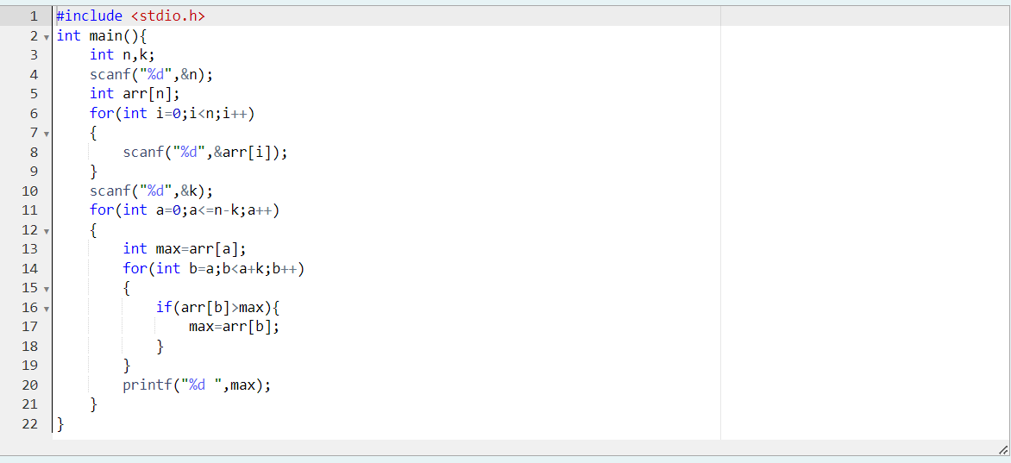

OUTPUT:

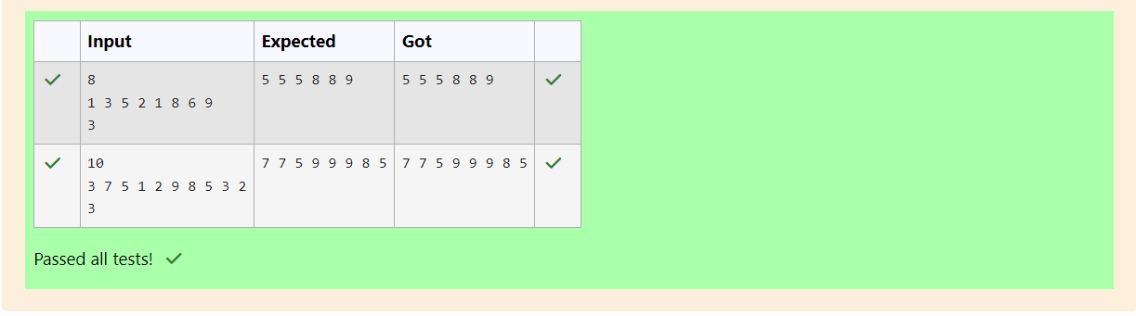

Q2) Given an array and a threshold value find the output.

Input: {5,8,10,13,6,2}

Threshold = 3

Output count = 17

Explanation:

Number          Parts               Counts

5 {3,2}              2

8 {3,3,2}              3

10 {3,3,3,1}          4

13 {3,3,3,3,1}        5

6 {3,3}                2

2 {2}                    1

Input Format

N - no of elements in an array

Array of elements

Threshold value

Output Format

Display the count

Sample Input 1

6

5 8 10 13 6 2

3

Sample Output 1

17

For example:

Input Result

6

5 8 10 13 6 2

3

17

7

20 35 57 30 56 87 30

10

33

Code:

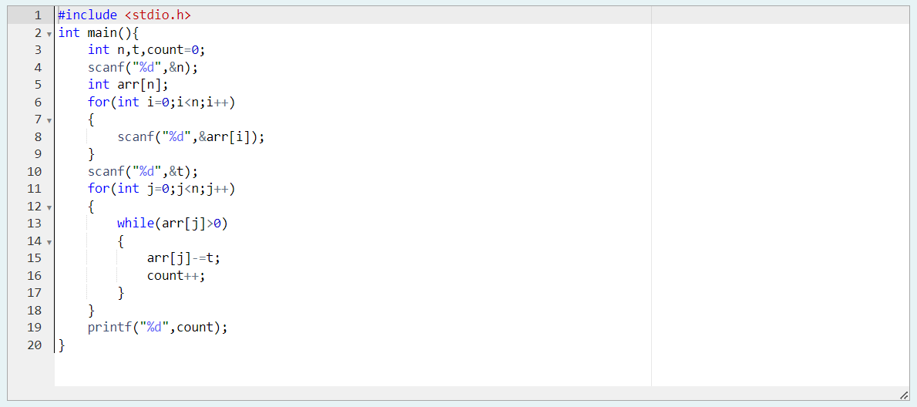

OUTPUT:

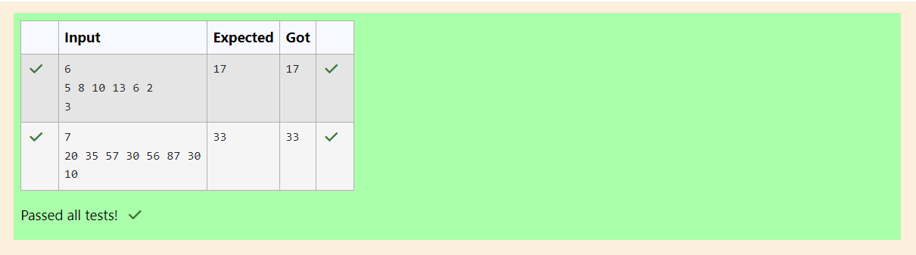

Q3) Output is a merged array without duplicates.

Input Format

N1 - no of elements in array 1

Array elements for array 1

N2 - no of elements in array 2

Array elements for array2

Output Format

Display the merged array

Sample Input 1

5

1 2 3 6 9

4

2 4 5 10

Sample Output 1

1 2 3 4 5 6 9 10

For example:

Input Result

5

1 2 3 6 9

4

2 4 5 10

1 2 3 4 5 6 9 10

Code:

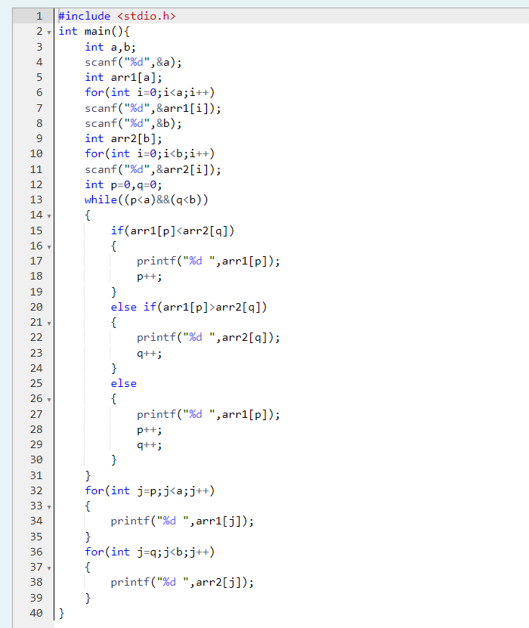

OUTPUT:

