**Week of April 23, 2023**

https://github.com/DesireeWilson/FinalProject

I am working by myself. This week, I performed differential gene expression analysis on the following genes in Gleason low (less than 7) vs Gleason high (greater than 7) samples: MYBPC1, SLC7A4, CDC42EP5, BCAS1, PAK1IP1, ANPEP, SLC23A1, HS.270778, GLB1L2, GCNT2, TNFRSF19, CUX2, POTEG, NCAPD3, LOC728606, SLC22A3, C9ORF61, SRD5A2, FLJ31568, SERPINF2, PGM5, LOC645993, ZDHHC8P, CNTNAP2, F12, CXCL14, CTHRC1, ZNF467, CDC20. Unfortunately, NO PROBES are statistically significant between Gleason 3+4 vs Gleason 4+3. Just for kicks and giggles, I also performed survival analysis looking at time to biochemical recurrence in Gleason 3+4 to Gleason 4+3 cases. Unfortunately, there is no difference between the two groups. ☹

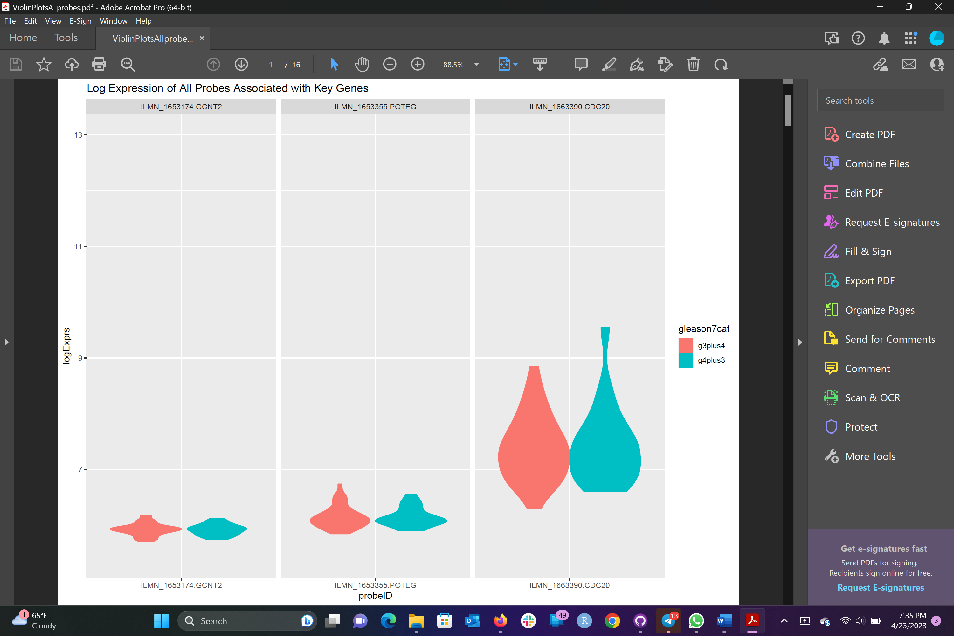

This is just one of the violin plots but as you can see, there is no difference between Gleason 3+4 “g3+4” vs Gleason 4+3 “g4+3” cases. ☹

And as you can see in the Kaplan-Meier curve, the proportion of Gleason 3+4 to Gleason 4+3 who experienced biochemical recurrence does change over time. However, there is no difference between Gleason 3+4 and Gleason 4+3 cases that experience biochemical recurrence. This means Gleason 3+4 cases have the same likelihood of experiencing biochemical recurrence as Gleason 4+3 cases. ☹Since there is no difference in gene expression between Gleason 3+4 and Gleason 4+3, I cannot categorize the samples based on gene expression (such as TULP4-high vs TULP4-low for example).