Week of April 9, 2023
https://github.com/DesireeWilson/FinalProject

I am working by myself. This week, I created a density plot and a correlation heatmap in order to determine if any samples were outliers. The great thing about datasets stored in the GEO repository is the data is already normalized. This is evident in both the density plot and correlation heatmap. Just to double check, I also performed a correlation test. All sample correlation pairs were statistically significant, meaning the correlation between the samples are highly correlated. I forgot I had to create exploratory data analysis (EDA) plots. Later this week, I will perform differential gene expression analysis on the following genes in Gleason low (less than 7) vs Gleason high (greater than 7) samples: MYBPC1, SLC7A4, CDC42EP5, BCAS1, PAK1IP1, ANPEP, SLC23A1, HS.270778, GLB1L2, GCNT2, TNFRSF19, CUX2, POTEG, NCAPD3, LOC728606, SLC22A3, C9ORF61, SRD5A2, FLJ31568, SERPINF2, PGM5, LOC645993, ZDHHC8P, CNTNAP2, F12, CXCL14, CTHRC1, ZNF467, CDC20. From here, I will also perform survival analysis as well.

Density Plot
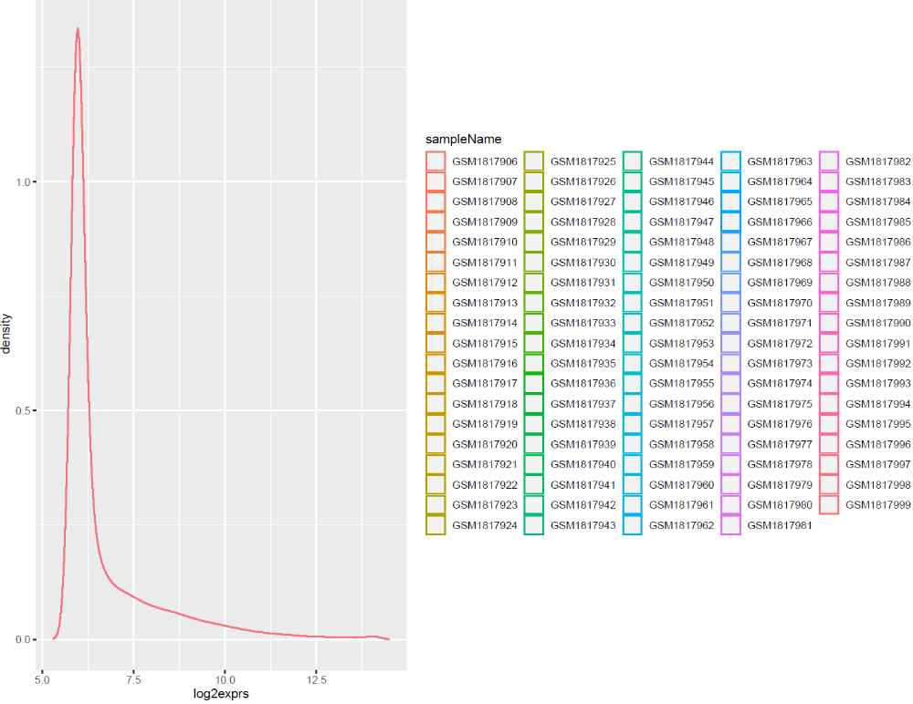

Sample Correlation Matrix Heatmap
