Mining Frequent Closed Itemsets with

Charm/dCharm Algorithms
Test report
Version 1.0
03.05.2019

VERSION HISTORY

Version # | Implemented  By | Creation  Date | Approved  By | Approval  Date | Reason
1.0 | Desislava Andreeva | 28.04.2019 | Adelina Aleksieva | 09.05.2019

Table of Contents
1.0 Introduction 4
1.1 Purpose 4
2.0 Tests Summary 4
2.1 Unit test 1 4
2.2 Unit test 2 4
2.3 Unit test 3 4
2.4 Unit test 4 5
2.5 Unit test 5 5
2.6 Unit test 6 5
2.7 Functional test 1 5
2.8 Functional test 2 6
2.9 Functional test 3 6
3.0 Test Assessment 8
4.0 Test Results 8
4.1 Unit Testing 8
4.2 Functional Testing 9
5.0 Test Instances 9
5.1 Resolved Test Incidents 9
5.2 Unresolved Test Incidents 9
APPENDIX A: Test Report Approval 11

1.0 Introduction

1.1 Purpose
This Test Report provides a summary of the results of White and Black box tests performed as outlined within this document.

2.0 Tests Summary

The document combines the reports from Unit and Functional testing performed on Mining Frequent Closed Itemsets with Charm/dCharm Algorithms product.

2.1 Unit test 1
Check if getMapValueNumber() function maps the specific event item to the correct number.
Test Owner: Desislava Andreeva
Test Date: 29/04/2019
Test Results: PASSED
Additional Comments: Message will be generated if successful. JUnit framework is used to implement the test case.

2.2 Unit test 2
Check if getMapValueNumber() function maps the specific component item to the correct number.
Test Owner: Desislava Andreeva
Test Date: 29/04/2019
Test Results: PASSED
Additional Comments: Message will be generated if successful. JUnit framework is used to implement the test case.

2.3 Unit test 3
Check if getMappedValue() function maps the given number to its specific event item value.
Test Owner: Desislava Andreeva
Test Date: 29/04/2019
Test Results: PASSED
Additional Comments: Message will be generated if successful. JUnit framework is used to implement the test case.

2.4 Unit test 4
Check if getMappedValue() function maps the given number to its specific component value.
Test Owner: Desislava Andreeva
Test Date: 29/04/2019
Test Results: PASSED
Additional Comments: Message will be generated if successful. JUnit framework is used to implement the test case.

2.5 Unit test 5
Check if convertToTransactionDataset() converts the specified input file with structure: Time;Event context;Component;Event name;Description;Origin;IP address to transaction dataset successfully.
Test Owner: Desislava Andreeva
Test Date: 29/04/2019
Test Results: PASSED
Additional Comments: The function returns CSVC_OK if successful, CSVC_IO_ERR and CSVS_FILE_NOT_FOUND on error. Message will be generated if successful. JUnit framework is used to implement the test case.
Note: The input file should exists and should have the specified structure.

2.6 Unit test 6
Check if convertResultsForUsers() converts the specified result file to understandable format.
Test Owner: Desislava Andreeva
Test Date: 29/04/2019
Test Results: PASSED
Additional Comments: The function returns CSVC_OK if successful, CSVC_IO_ERR and CSVS_FILE_NOT_FOUND on error. Message will be generated if successful. JUnit framework is used to implement the test case.
Note: The file should exists and should be real output file from data mining algorithm.

2.7 fUNCTIONAL test 1
Test the behavior of the software when files with extensions different that .txt (.txt or .csv for database file) are entered as input.
Test Owner: Desislava Andreeva
Test Date: 29/04/2019
Test Results: PASSED
Additional Comments: This case is executed manually. The test should PASS when you are unable to continue until entering file with .txt (.csv) extension.
Example output: Enter the file path where the input database is kept (Should be .txt or .csv file):
D://file.pdf
Enter the file path where the input database is kept (Should be .txt or .csv file):
D://database.db
Enter the file path where the input database is kept (Should be .txt or .csv file):
D://database.txt
Enter the file path where the converted data will be kept (Should be .txt file):
D://cnvt.docx
Enter the file path where the converted data will be kept (Should be .txt file):
D://cnvt.txt
Enter the file path where the data mining result will be kept (Should be .txt file):
D://output.xml
Enter the file path where the data mining result will be kept (Should be .txt file):
D://output_re.txt
Enter the file path where the formatted result will be kept (Should be .txt file):
D://formatted
Enter the file path where the formatted result will be kept (Should be .txt file):
D://formatted_result.txt
Enter the minsup value:

2.8 fUNCTIONAL test 2
Test the behavior of the software when not existing input (database) file path is entered.
Test Owner: Desislava Andreeva
Test Date: 29/04/2019
Test Results: PASSED
Additional Comments: This test case is executed manually. Proper messages should be printed, explaining the reason for the failure.
Example output: Enter the file path where the input database is kept (Should be .txt or .csv file):
./example_database.txt
Enter the file path where the converted data will be kept (Should be .txt file):
example_converted_data.txt
Enter the file path where the data mining result will be kept (Should be .txt file):
example_output.txt
Enter the minsup value:
0.1
convertToTransactionDataset: Database file not found!
Converted file not found!
============= CHARM v96r6 Bitset - STATS =============
Transactions count from database : 0
Frequent closed itemsets count : 0
Total time ~ 5 ms
Maximum memory usage : 1.4401016235351562 mb
===================================================

2.9 fUNCTION test 3
Test the behavior of the software when all input data is valid. Example: “./logs_BCS37_20181103.csv”, “D://converted_input.txt”, “D://mining_output.txt”, “D://formatted_result.txt”, “0.1”;
Test Owner: Desislava Andreeva
Test Date: 29/04/2019
Test Results: PASSED
Additional Comments: This test case is executed manually. All statistics should be printed if test finishes successfully.
Example output: Enter the file path where the input database is kept (Should be .txt or .csv file):
./logs_BCS37_20181103.csv
Enter the file path where the converted data will be kept (Should be .txt file):
D://converted_input.txt
Enter the file path where the data mining result will be kept (Should be .txt file):
D://mining_output.txt
Enter the file path where the formatted result will be kept (Should be .txt file):
D://formatted_result.txt
Enter the minsup value:
0.1
0.1
============= CHARM v96r6 Bitset - STATS =============
Transactions count from database : 2390
Frequent closed itemsets count : 8
Total time ~ 192 ms
Maximum memory usage : 4.923240661621094 mb
===================================================

Support of 284 transactions for the itemset of:

* Forum
* System
* File

Support of 340 transactions for the itemset of:

* Forum
* System

Support of 313 transactions for the itemset of:

* User report
* System
* File

Support of 452 transactions for the itemset of:

* User report
* System

Support of 455 transactions for the itemset of:

* User report

Support of 1741 transactions for the itemset of:

* System
* File

Support of 1747 transactions for the itemset of:

* File

Support of 2381 transactions for the itemset of:

* System

convertResultsForUsers: Formatted result saved in D://formatted_result.txt

3.0 Test Assessment
The following picture illustrates the coverage of unit tests. We should take into account that function which coverage is 0% is the one for interacting with the user (which we don’t test while unit testing).
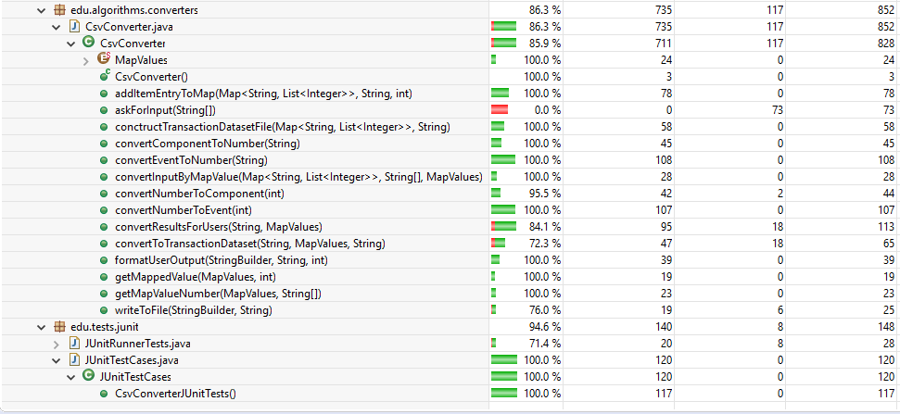

4.0 Test Results

4.1 UNIT Testing
Unit testing activities were performed during the development. The table below summarizes the results of unit testing:
Test Case ID | Date  Tested | Tester  Name | Pass/Fail | Severity of Defect | Summary of Defect | Comments
2.1 | 28/04/19 | Desislava Andreeva | Pass | Major | No deviation | Expected results
2.2 | 28/04/19 | Desislava Andreeva | Pass | Major | No deviation | Expected results
2.3 | 28/04/19 | Desislava Andreeva | Pass | Major | No deviation | Expected results
2.4 | 28/04/19 | Desislava Andreeva | Pass | Major | No deviation | Expected results
2.5 | 28/04/19 | Desislava Andreeva | Pass | Major | No deviation | Expected results
2.6 | 28/04/19 | Desislava Andreeva | Pass | Major | No deviation | Expected results

4.2 Functional Testing
The table below summarizes the test cases employed for functional testing and the test results obtained for each test case:

Test Case ID | Date | Tester | Pass/Fail | Severity of Defect | Summary of Defect | Comments
2.7 | 30/04/19 | Desislava Andreeva | Pass | Major | No deviation | Expected results
2.8 | 30/04/19 | Desislava Andreeva | Pass | Major | No deviation | Expected results
2.9 | 30/04/19 | Desislava Andreeva | Pass | Major | No deviation | Expected results

5.0 Test Instances

5.1 Resolved Test Incidents
During testing some flaws in the application were found. Such as:

- No adequate errors returned from functions to help the developers to trace the problem;
- No adequate messages returned to help the user to understand the problem;

Note: All tests cases status is marked as “Pass” because these flaws were fixed immediately and tested again.

5.2 Unresolved Test Incidents

The behavior of the application is not tested when:

- input file has structure different than Time;Event context;Component;Event name;Description;Origin;IP;
- Output (result) file has structure different than:

2 5 9 #SUP: 328
5 9 #SUP: 451
9 #SUP: 455
2 5 #SUP: 1788
2 #SUP: 1794
5 #SUP: 2367

APPENDIX A: Test Report Approval

Signature: |  | Date: | 09.05.2019
Name: | Adelina Aleksieva
Role: | Project Manager

