1. **Status of QC work**

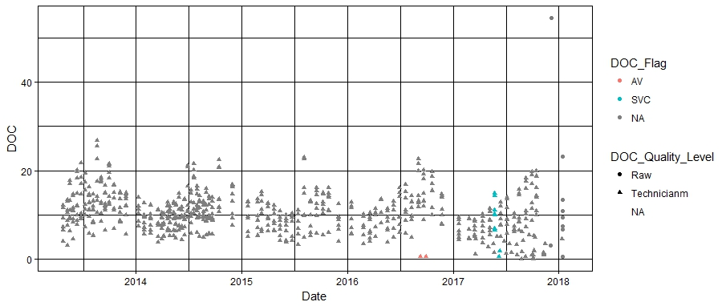

**Figure 1**. Status of QC work for all DOC samples collected for the FGS surveys

ggplot(fgs_all_02092018, aes(x=Date, y=DOC)) + geom_point(aes(shape=DOC_Quality_Level, color=DOC_Flag)) + theme_linedraw()

1. **DOC range and flags per FGS survey**

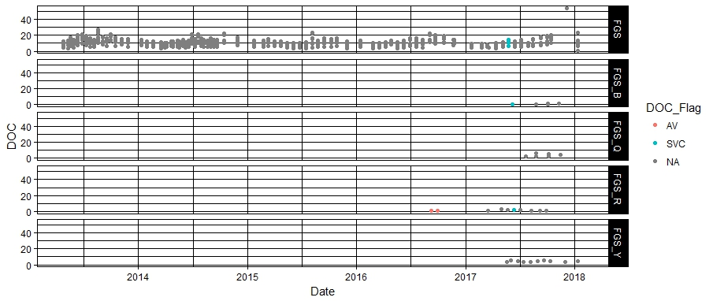

**Figure 2.** Status of DOC range and flags per FGS survey for all the samples collected

ggplot(fgs_all_02092018, aes(x=Date, y=DOC)) + theme_linedraw() + geom_point(aes(color=DOC_Flag)) + facet_grid(Survey~.)

1. **DOC per Site**

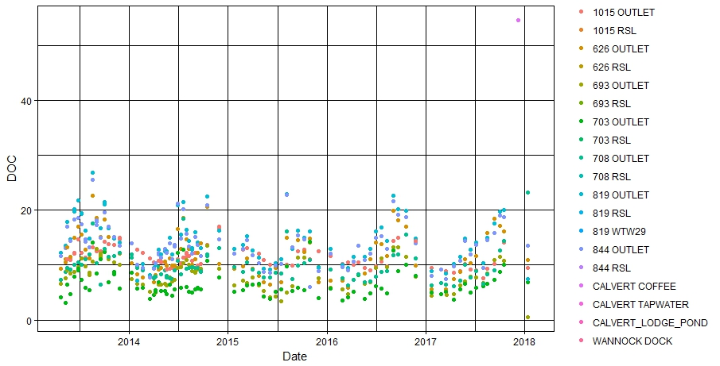

**Figure 3.** Status of DOC range per site for all the samples collected for the FGS surveys

ggplot(subset(fgs_all_02092018, Survey == "FGS"), aes(x=Date, y=DOC)) + geom_point(aes(colour=Site_ID)) + theme_linedraw()