1. 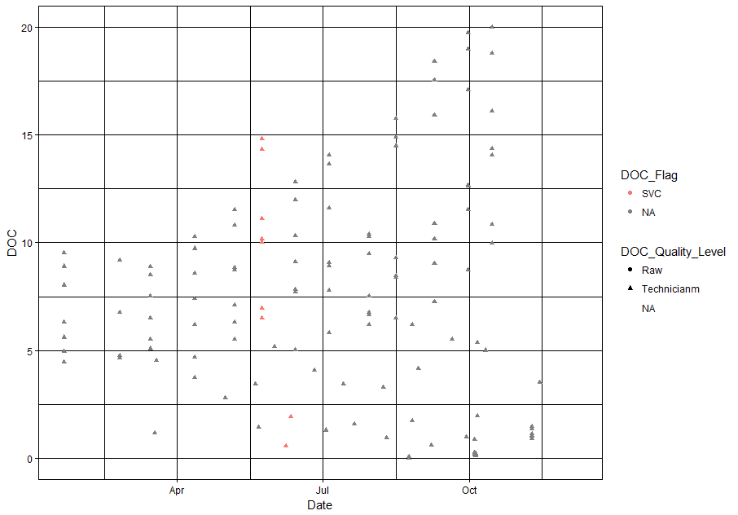**Status of QC work**

**Figure 1**. Status of QC work for the DOC samples collected during 2017 for the FGS surveys

ggplot(Data_fgs_all_25012018, aes(x=Data, y=DOC)) + geom_point(aes(shape=DOC_Quality_Level, color=DOC_Flag)) + theme_linedraw()

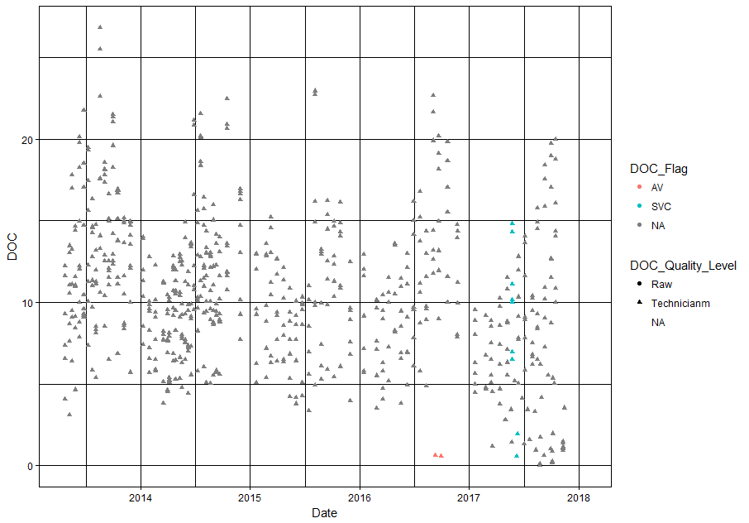

**Figure 2.** Status of QC work for all the DOC samples collected for the FGS surveys

1. **DOC range and flags per FGS survey**

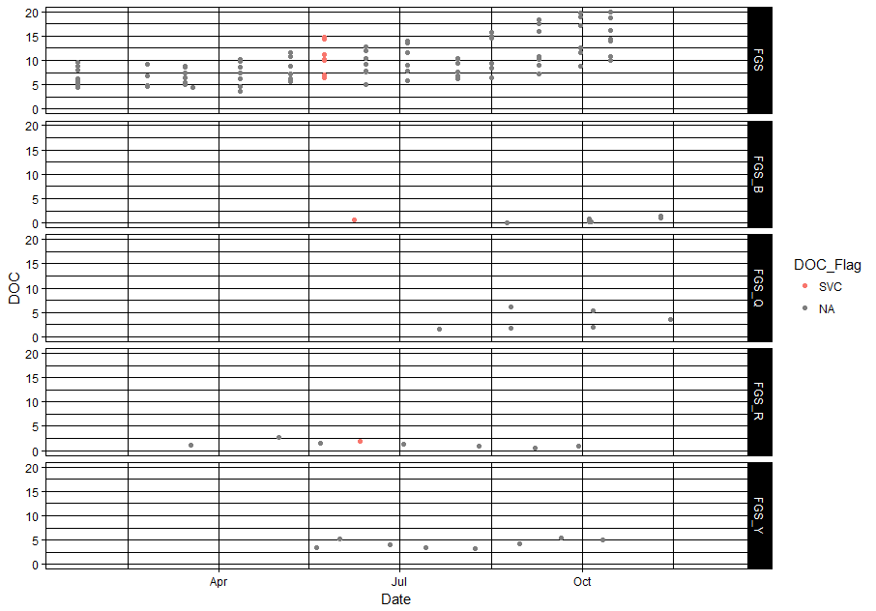

**Figure 3.** Status of DOC range and flags per FGS survey for the samples collected during 2017

ggplot(Data_fgs_all_25012018, aes(x=Date, y=DOC)) + theme_linedraw() + geom_point(aes(color=DOC_Flag)) + facet_grid(Survey~.)

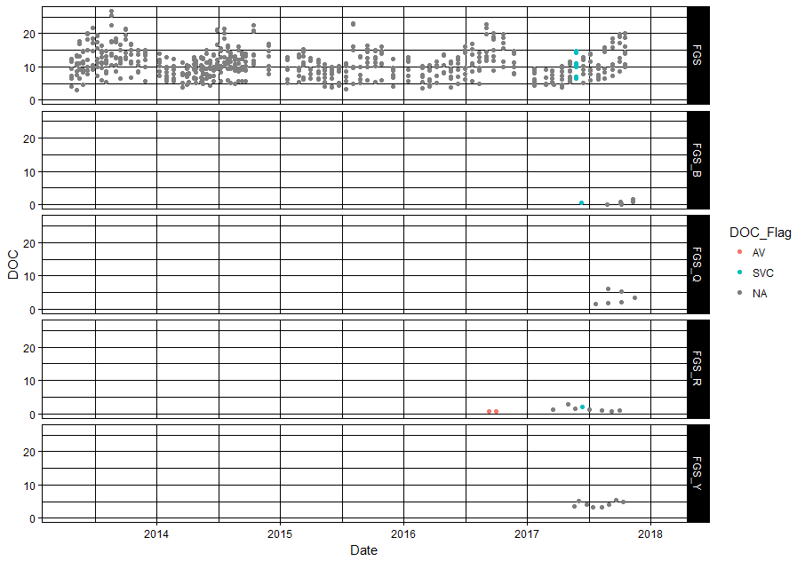

**Figure 4.** Status of DOC range and flags per FGS survey for all the samples collected

1. **DOC per Site**

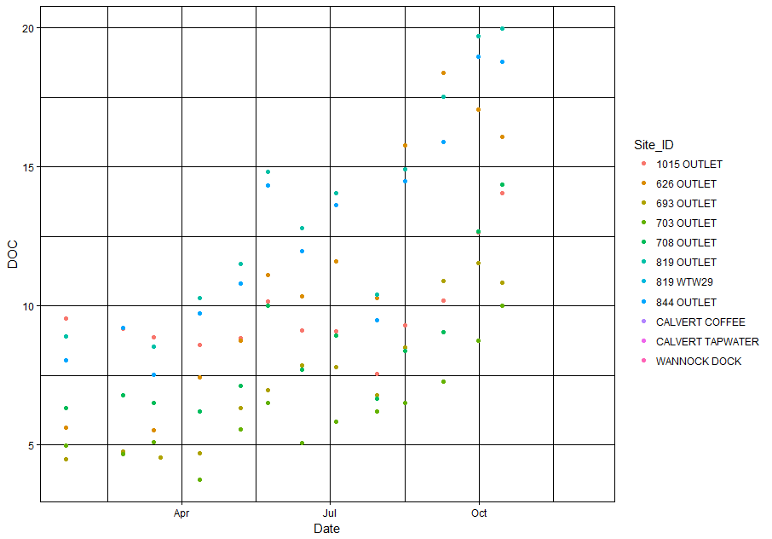

**Figure 5.** Status of DOC range per site for the samples collected during 2017

ggplot(subset(Data_fgs_all_25012018, Survey == “FGS”), aes(x=Date, y=DOC)) + geom_point(aes(colour=Site_ID)) + theme_linedraw()

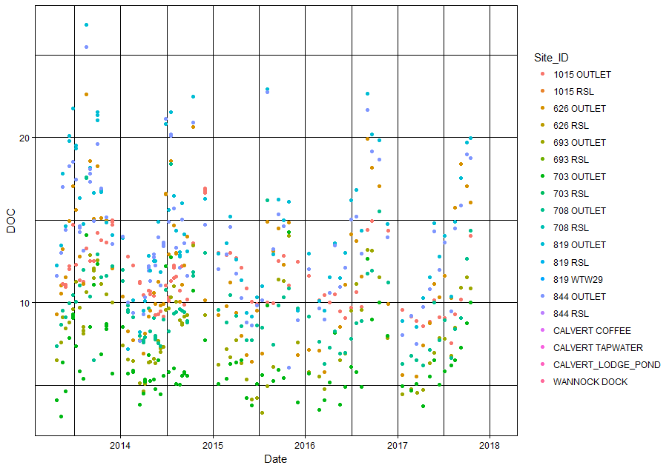

**Figure 6.** Status of DOC range per site for all the samples collected for the FGS surveys