10_0.1

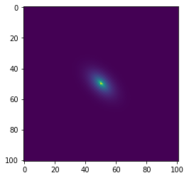

10_ori

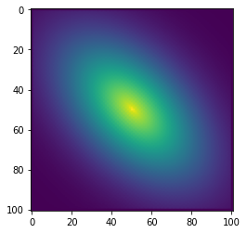

RU10_0.1

RU10_ori

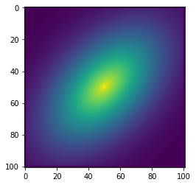

33_ori

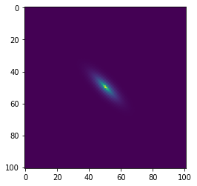

33_log

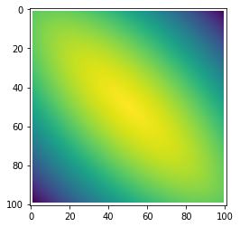

33_0.1

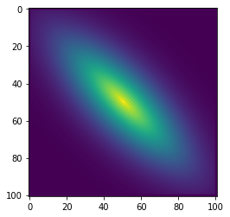

66_ori

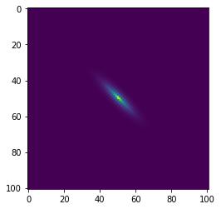

66_log

66_0.1

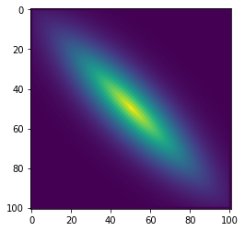

100_ori

100_0.1

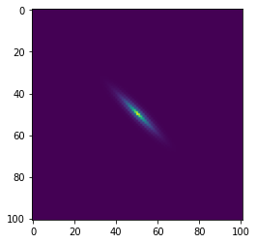

200_ori

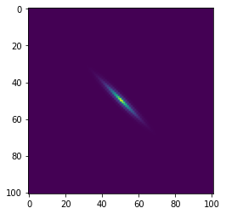

200_log

200_0.1

rd_ori

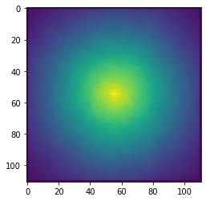

rd_log

rd_0.1

rd_dist

66_ori

66_log

66_0.1

Rd3_ori

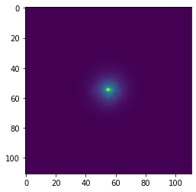

Rd3_log

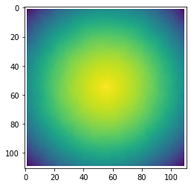

Rd3_dist

