IT 3203 Project Milestone #3 Report
Responsive and Mobile Web Design
Student: Desmond Shah
Project: Modern Web Development Research
Website URL: https://desmondshah.github.io/project-milestone-1/
Report date: May 4, 2026

Project Overview
This milestone finalizes the research website and updates the design so the same pages work across desktop, tablet, and phone screen sizes. The site includes the required home page, resources page, key concepts page, three topic pages, about page, quiz page, one external CSS file, and one external JavaScript file.

Responsive Design Principles Used
- Fluid layout: the page shell uses a max-width with percentage-based spacing so content can shrink instead of forcing a fixed desktop width.
- Flexible grids: CSS Grid sections use minmax() columns on large screens and stack into one column at tablet widths.
- Mobile navigation: the shared navigation becomes a right-side off-canvas drawer on narrow screens, controlled by a burger button that changes into an X when opened.
- Flexible images: images use max-width: 100% and fixed width/height attributes so they scale while preserving aspect ratio.
- Responsive tables: table wrappers allow horizontal scrolling on small screens instead of breaking the page layout.
- Touch-friendly quiz controls: inputs, labels, and buttons have large minimum heights and become full width on phone screens.

Key CSS Evidence
/* Responsive rules stack the layout for tablets and phones. */
@media (max-width: 940px) {
.hero, .page-intro, .section-grid, .card-grid, .glossary, .quiz-shell {
grid-template-columns: 1fr;
}
}

@media (max-width: 560px) {
.main-nav { position: fixed; right: 0; transform: translateX(100%); }
body.nav-open .main-nav { transform: translateX(0); }
}

Testing Report
The site was tested at three screen settings. Screenshots below show the actual rendered results from Microsoft Edge through Playwright. The phone-width test represents a smartphone-sized viewport; the final submission should also be opened on an actual phone after GitHub Pages is published.

Test 1: Desktop Browser
Environment: Microsoft Edge, 1440 x 1100 viewport, local server at http://127.0.0.1:8000/. Result: the home page uses a two-column hero area, the full navigation remains visible, and the research table starts below the first fold without layout overlap.
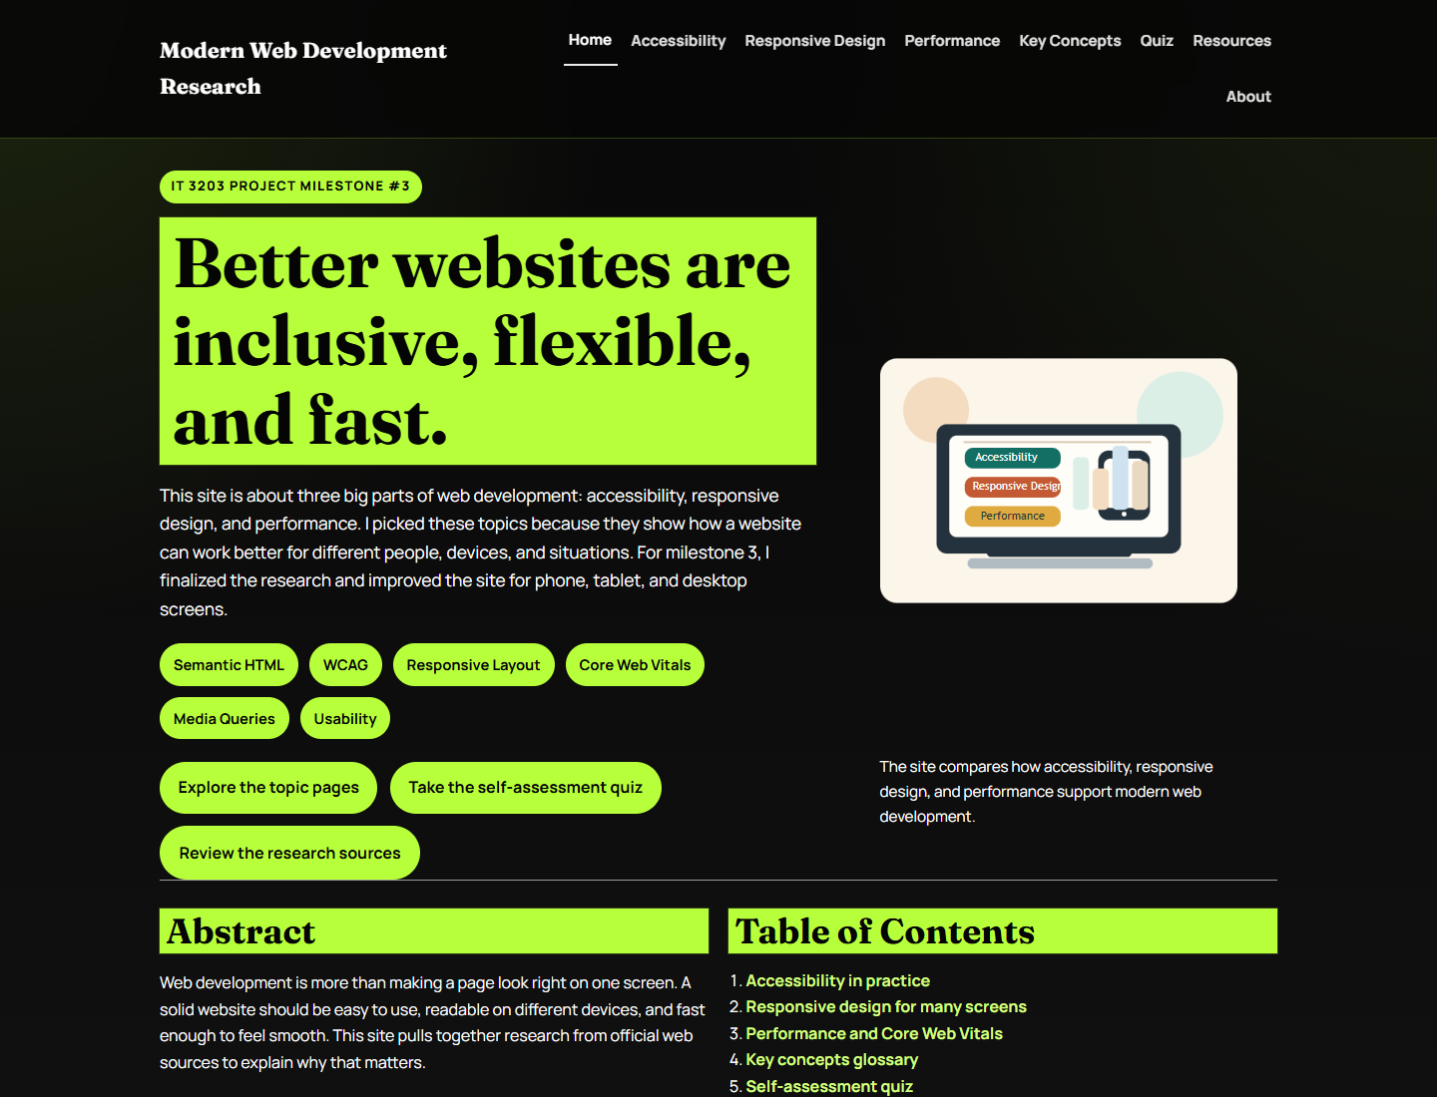

Test 2: Tablet Width
Environment: Microsoft Edge, 768 x 1100 viewport. Result: the responsive design page keeps readable line lengths, the navigation wraps cleanly, and the main visual scales inside the content width.
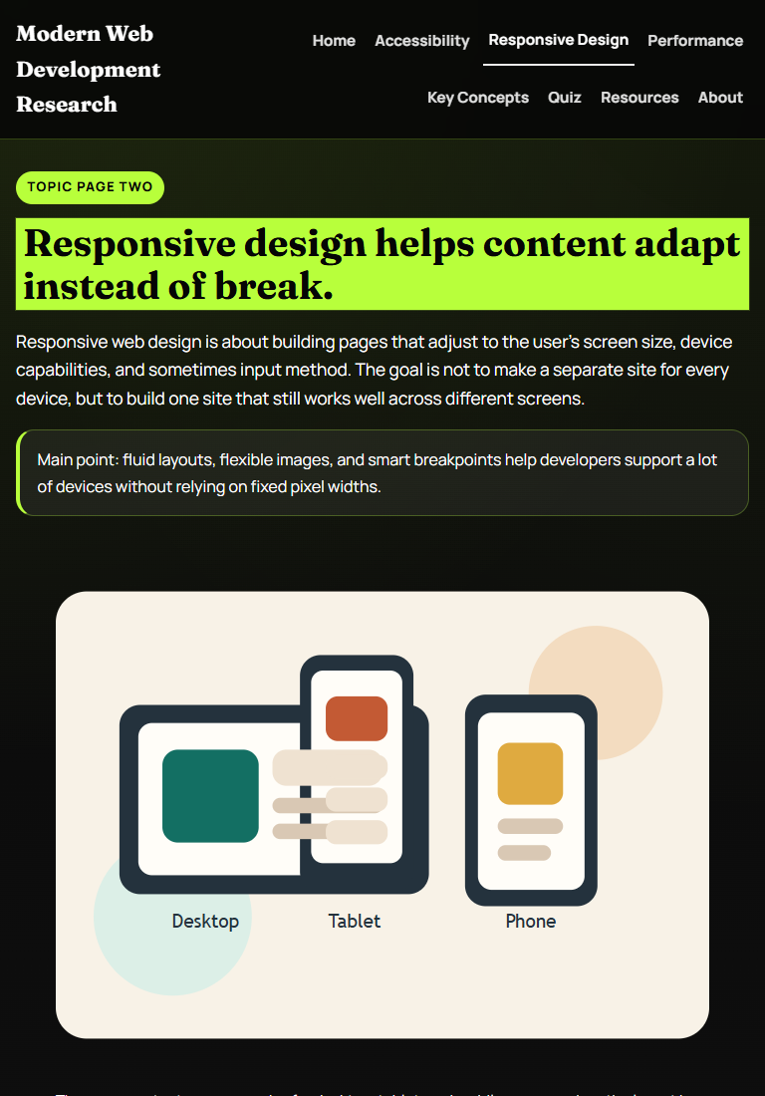

Test 3: Smartphone Width
Environment: Microsoft Edge, 390 x 1200 viewport. Result: the quiz page stacks into a single column, the header uses a compact burger button, the navigation opens as a right-side drawer, and form controls remain touch-friendly.
