Washing the Stain: Punitive Decoupling and the Sacrificial Cost for Connected Firms
Chao Feng, Hongcong Chu, Xinmin Zhang, Miao Wang
ABSTRACT
We exploit the abrupt severance of firm-government ties triggered by official downfalls to examine how political stigma reshapes local governments’ investment-promotion decisions. We find that stigmatized firms experience a significant contraction in local expansion, particularly pronounced for locally entrenched incumbents. We attribute this pattern to punitive decoupling: incumbent officials strategically suppress tainted firms to signal political reliability and enhance promotion prospects. This behavior is amplified in competitive bureaucracies with dispersed promotion opportunities. A key consequence is that local governments substitute toward politically safe but less productive firms, leading to aggregate resource misallocation in expanding industries. Overall, our findings reveal how political logic systematically overrides economic logic during campaign-style governance, with structural efficiency costs.

Keywords Political Connections · Government · Bureaucratic Incentives · Resource Misallocation · Anti-corruption

- Introduction
In emerging economies characterized by institutional weakness, political connections often substitute for formal institutions, enabling firms to circumvent bureaucratic friction and capture scarce resources (Fisman, 2001; Khwaja and Mian, 2005). Consequently, firms are strongly incentivized to cultivate political ties as a prerequisite for expansion. While extensive literature documents that the severance of these connections diminishes market value (Acemoglu et al., 2016), restricts credit access (Ding et al., 2023; Leuz and Oberholzer-Gee, 2006), curtails government procurement (Colonnelli and Prem, 2022), or undermines judicial protection (Zhang, 2023), these studies predominantly frame such outcomes as the passive depreciation of relational capital. Yet political severance does not always resemble routine personnel turnover. During high-stakes political episodes characterized by heightened uncertainty and intensified scrutiny (Bermiss and Greenbaum, 2016; Broschak and Block, 2014), firms may undergo an abrupt transformation from valued strategic partners to political liabilities. In such environments, the critical inquiry shifts from calculating firm-level losses to understanding the strategic bureaucratic response when previously connected firms become politically risky.
In this paper, we examine how the abrupt downfalls of connected officials reconfigure local investment promotion behavior toward politically stigmatized firms. Specifically, we analyze whether these firms encounter institutional resistance in local expansion after tie severance and, beyond documenting this effect, we clarify the mechanisms that generate such resistance and assess whether it induces misallocation by displacing efficiency-based selection.
China provides an ideal empirical setting for this analysis, given its "Regionally Decentralized Authoritarian System" (Xu, 2011), under which local officials actively compete for investment while facing intense career concerns regarding visible political risks. As detailed in Section 2.1, major expansion projects in China, particularly large production bases and other large-scale facilities, typically necessitate coordinated administrative approvals regarding land allocation, fiscal support, and cross-agency facilitation. At the provincial level, these decisions are ultimately governed by the "four leading bodies," comprising the Provincial Party Committee, the Government, the People's Congress, and the Political Consultative Conference. Occupying the apex of provincial authority, these bodies dictate investment priorities and exert broad jurisdictional influence relative to subordinate governments. Consequently, the abrupt downfall of these provincial officials constitutes a shock capable of precipitating rapid, systemic shifts in investment promotion policy and enforcement.
Empirically, we exploit provincial official removals that occurred during China's 2012 anti-corruption campaign to isolate plausibly exogenous variation in the severance of firm–official ties. As detailed in Section 2.2, enforcement was centrally initiated and implemented. Furthermore, the timing and geographic scope of provincial investigations remained largely unpredictable to local actors, while observed removal patterns do not align with systematic factional targeting. These features collectively distinguish these abrupt downfalls from routine political turnover.
To operationalize this quasi-experimental design, we compile granular data on political ties and firm expansion. We compile biographical records for 3,870 senior provincial officials (2007–2024) and 3,185 CEOs from 2,467 listed firms, and identify firm–official connections using shared hometown and alumni links. We then track within-province expansion using a geocoded registry of 154,436 subsidiaries and 39,960 branches of these firms (1950–2024), focusing on large-scale facilities that typically require high-level administrative coordination. To estimate causal effects, we employ a stacked difference-in-differences (stacked DID) design centered on a ±5-year window around each event. This framework utilizes 120 qualifying events from 2012 to 2019, out of 127 provincial official downfalls during the period.
Three main findings emerge from our analysis. First, following the downfall of connected provincial officials, politically stigmatized firms significantly retrench their within-province expansion. Specifically, the probability of establishing a large-scale facility declines by 2.07 percentage points, a magnitude equivalent to approximately 31% of the sample mean. This impact is immediate and persists for approximately three years. We systematically rule out a comprehensive set of alternative explanations including firm distress, compliance shocks, nationwide retrenchment, intensified market discipline, and disrupted local business ties. The inability of these factors to explain the observed pattern indicates a shift in government administrative treatment rather than a firm-driven withdrawal or market-based correction.
Second, we attribute this contraction to a targeted administrative response we term punitive decoupling. Conceptually, the shock heightens the political liability associated with supporting tainted firms, thereby increasing the relative weight officials assign to political risk versus economic payoffs. Consistent with this shift in the officials' objective function, this response is most pronounced among locally entrenched incumbent "dragon" firms and intensifies when officials face stronger promotion incentives. Notably, neither superior firm productivity (TFP) nor residual political ties attenuate this penalty. Furthermore, the effect is exacerbated in provinces characterized by dispersed promotion opportunities, a finding consistent with the logic of intensified career competition and peer monitoring.
Third, punitive decoupling imposes substantial aggregate efficiency costs. Constrained by binding investment promotion quotas, local governments pivot toward politically safe yet less productive firms, a phenomenon we term panic substitution. These substitute firms exhibit significantly lower TFP compared to the constrained firms. Consequently, the post-shock alignment between scale and efficiency among entrants in expanding industries declines by approximately 12% at the province-industry level. This finding implies that while the shock successfully reconfigures government-business networks, it does so at the expense of aggregate regional productivity.
We acknowledge that endogeneity concerns cannot be entirely eliminated. Nevertheless, our identification strategy mitigates these issues through an event-based fixed effects framework. This approach sharpens comparisons within specific event windows and effectively absorbs confounding variation from firm-specific and industry-time factors. Furthermore, we validate our findings using a comprehensive battery of robustness checks, placebo tests, and sensitivity analyses. With these methodological caveats in mind, this study makes substantive contributions to several distinct strands of literature.
First, this study contributes to the literature on bureaucratic incentives and government-business relations by formalizing the concept of Punitive Decoupling. Extant research predominantly emphasizes officials' categorical avoidance or strategic distortion under anti-corruption pressure (e.g., Fang and Zhang, 2025; Gerardino et al., 2024) or the restoration of market discipline (Colonnelli et al., 2022; Fang et al., 2023; Zhong and Zheng, 2025). However, these frameworks fail to account for the empirical paradox observed herein. Specifically, they do not explain why officials strategically suppress high-value “local dragon firms” at the expense of efficiency. We address this puzzle by developing a signaling game model that unveils an active signaling mechanism. Unlike the repression of political enemies in the Anti-Rightist Campaign studied by Qian and Bai (2021), our mechanism operates through active signaling against reputational taint. When prior economic partners become politically risky, passive avoidance may prove insufficient. Consequently, officials escalate to high-visibility punitive decoupling to convey political reliability to superiors. In doing so, we provide novel evidence that nonmarket ties can rapidly flip from assets to liabilities, thereby sharpening our understanding of backlash dynamics in nonmarket strategy (Lyon and Maxwell, 2025).
Second, while the literature on bureaucratic promotion prioritizes competition intensity (e.g., Fang et al., 2025; Francois et al., 2023), it offers limited insight into how the structure of promotion opportunities shapes behavior. By adopting an Industrial Organization (IO) market structure lens, we demonstrate that a dispersed promotion structure functions analogously to a competitive political market. This configuration intensifies peer monitoring and induces conservative, risk-averse administrative responses to external political shocks. Conversely, concentrated promotion prospects weaken internal discipline and engender administrative slack. This structural perspective complements broader research on promotion system design and monitoring (Grabner et al., 2025) by clarifying when internal competitive structures amplify, rather than merely scale, the behavioral distortions induced by political shocks.
Third, this study unpacks the administrative transmission channel that remains largely unexplored in existing work on political and policy shocks. Recent studies indicate that political shifts can reshape firm behavior (e.g., Fang et al., 2023; Rajgopal et al., 2025; Zhong and Zheng, 2025). However, these analyses often rely on staggered designs susceptible to negative weighting bias while typically focusing on aggregate outcomes or a narrow set of top leaders. We overcome these limitations by employing a stacked difference-in-differences (stacked DID) design and constructing comprehensive biographical profiles for the entire provincial officials. We link these records to geocoded establishment data on subsidiaries and branches. This approach enables a granular mapping of how political network disruptions propagate through the investment promotion apparatus to shape corporate expansion decisions.
- Institutional background
In the following sections, we will outline the institutional background of investment promotion by Chinese local governments, highlighting the critical importance for firms of establishing political connections with officials of the provincial "four leading bodies" in this domain. We will then explore the consequences faced by firms when such connections are severed during political movements, focusing on China's anti-corruption campaign since 2013 as an exogenous shock suitable for investigating this issue.

2.1 The role of provincial "four leading bodies" in China's investment promotion
Following the 1994 tax-sharing reform, the decentralization of fiscal revenue and expenditure empowered local governments to secure tax bases while assuming greater development responsibilities. Coupled with a promotion system primarily based on GDP evaluation, these institutional arrangements create strong incentives for economic growth. This unique structure of “Regionally Decentralized Authoritarianism” has thus fostered a nationwide “political tournament” across all levels of government (Li and Zhou, 2005; Xu, 2011). To secure promotion by outperforming peers in neighboring jurisdictions, officials prioritize the attraction of external investment, a strategy termed Zhao shang yin zi. Local governments solicit Foreign Direct Investment (FDI) and large domestic enterprises through preferential policies, including tax rebates, discounted land, fiscal subsidies, and regulatory forbearance. Although this intense competition for mobile capital is often characterized as a "race to the bottom" (Cai and Treisman, 2005), this government-led allocation model has been instrumental in sustaining high capital formation, accelerating industrialization, and absorbing labor over the past decades.
While municipal and county governments act as the frontline agents of investment promotion, the strategic direction and ultimate authority rest with the provincial leadership, a collective entity known as the "four leading bodies"(Si tao ban zi)^{[1]}. These bodies consist of the provincial Party Committee, the People's Government, the People's Congress, and the Chinese People's Political Consultative Conference. While each has distinct functions, their overlapping authority and coordinated actions collectively shape the entire investment landscape for firms operating within their jurisdiction. Unless otherwise specified, the term "provincial-level local officials" in this paper refers to the members of this collective leadership.
However, within this collective governance structure, investment promotion is far from a rigid administrative routine; rather, it is a complex undertaking involving multi-departmental coordination and informal bargaining. Specifically, strict controls are imposed on construction land quotas under China's planning system. These quotas devolve from the central government, and the provincial People's Government, serving as the primary executive authority, is responsible for distributing its annual allotment among subordinate municipalities and counties (Ang, 2016). This "quota management" regime empowers provincial officials to modulate the investment attraction capacity of different regions through strategic differentiation in land supply. Since land serves as a critical development instrument for local governments, provincial authorities tend to channel quotas toward areas with high growth potential (Glaeser et al., 2017). This selective allocation underscores the pivotal influence of provincial leadership in shaping regional investment outcomes.
Furthermore, while the central government establishes the regulatory framework for subsidies and tax incentives, provincial governments retain significant discretion in implementation. Given that promotion is closely tied to jurisdictional economic growth (Li and Zhou, 2005), officials are incentivized to extend preferential support to key projects. Crucially, firms cannot bypass provincial jurisdiction to access these benefits. In the case of subsidies, for instance, local allocations substantially exceed central transfers, and corporate applications entail a multi-tiered review process that culminates in final approval by provincial departments (Fang et al., 2023).
Meanwhile, securing large-scale investments necessitates intricate coordination across disparate agencies, including development and reform commissions and bureaus overseeing land, environment, and taxation. Situated at the apex of the provincial hierarchy, the Party Committee and the People's Government are uniquely positioned to overcome administrative fragmentation. By convening coordination meetings and conducting on-site executive sessions, they effectively accelerate project implementation. This mobilization capacity, often termed "concentrating resources to accomplish major tasks," constitutes a defining feature of the Chinese institutional context.
Beyond administrative execution, the provincial CPPCC functions as a vital platform for elite networking and co-optation. It facilitates informal exchange between political leaders and business elites, thereby cementing the government-business nexus that underpins investment activities. In parallel, the Provincial People's Congress institutionalizes the investment environment by enacting local statutes governing commerce, trade, and intellectual property protection.
Thus, diverging from Western market paradigms, investment promotion in China is intrinsic to the institutional logic of the political tournament. By leveraging control over critical resources and the strategic deployment of policy instruments, provincial officials wield substantial discretion in steering capital flows and shaping the local industrial landscape.
Although this discretionary environment creates potential for rent-seeking, the incentive structure inherent in the political tournament does not necessarily foster outright bribery. Senior officials, particularly members of the provincial "four leading bodies," prioritize political advancement above immediate pecuniary gain. For instance, regarding industrial land allocation, officials typically prioritize economic growth to bolster their promotion prospects rather than engaging in immediate private extraction, resulting in lower corruption levels in this domain (Fang and Zhang, 2025). Similarly, while subsidy allocation is susceptible to relational influence, it retains a significant meritocratic component (Fang et al., 2023). Instead, the primary channel through which officials influence firm behavior is the broader mechanism of political connections. Serving as a critical non-market strategy, these connections enable firms to navigate the complex administrative landscape. They facilitate access to essential resources such as preferential loans and government contracts while mitigating policy uncertainty (Zhong and Zheng, 2025). This fosters a symbiotic government-business nexus wherein firms, particularly State-Owned Enterprises (SOEs), often internalize the career incentives of local politicians into their investment decisions (Fang et al., 2025). Indeed, empirical evidence indicates that corporate cross-regional investments frequently track the geographical transfers of connected political leaders (Shi et al., 2021).
Consequently, investment promotion in China transcends the simplistic narrative of outright bribery; rather, it constitutes a complex dynamic wherein political connections serve as the primary mechanism for aligning corporate interests with the career incentives of officials. Within this framework, provincial authorities emerge as the pivotal actors. This context motivates our central inquiry: What consequences do firms face in the local investment promotion arena when their connections to these officials are forcibly severed during a political campaign, thereby branding them as "politically tainted"?

2.2 Anti-corruption and the severing of political connections: A quasi-natural experiment
To answer the question posed in the previous section, we must rigorously isolate the exogenous shock to political connections. Our identification strategy is based on the anti-corruption campaign launched by President Xi Jinping in 2012, as it provides a compelling empirical setting. While the CPC has historically conducted stringent anti-corruption drives, often coincidental with leadership transitions, the post-2012 campaign is unprecedented in scale. Table 1 presents a stark contrast: as of September 30, 2025, the total number of implicated provincial-level local government officials far surpasses the cumulative count from the preceding 30 years, with the average annual number being more than six times higher than in the pre-campaign era. Furthermore, Fig. 1 shows that no province has been immune to this anti-corruption campaign and that the downfalls of provincial-level local officials have occurred continuously, rather than being a short-term phenomenon confined to periods of leadership transition. Together, these points highlight both the intensified nature of this campaign compared to previous efforts and its profound impact on the bureaucratic system. Consequently, we characterize this campaign as a systemic shock sufficient to fundamentally alter the "rules of the game" governing investment promotion by local governments.
[Insert Table 1 about here]
[Insert Fig. 1 about here]
Given the scale of investigations post-2012, a potential identification concern is that the campaign functioned as a targeted political purge rather than an indiscriminate shock. If investigations were systematically driven by factional allegiance, the severance of political connections would be endogenous and potentially anticipated. While prior studies find negligible evidence of factional bias (Francois et al., 2023; Zhong and Zheng, 2025), their analyses are restricted to data prior to 2016 and focus on different administrative hierarchies—specifically, the Central Committee (Francois et al., 2023) or municipal-or-higher Party standing committees (Zhong and Zheng, 2025). In contrast, our study examines the provincial officials over an extended period (2012–2024). We therefore conduct a dedicated factional analysis within this specific population to validate the exogeneity of the anti-corruption shock.
Using our unique biographical database of officials (see Section 3 for details), we follow the methodology of Francois et al. (2023) and Zhong and Zheng (2025) to classify officials into seven factions based on their career trajectories and affiliations^{[3]}. We then employ a parametric survival model with multi-dimensional controls and a piecewise baseline hazard to estimate an official's risk of downfall (the detailed methodology and results are presented in Appendix A). Our results show that compared to the 17th Party Congress period (2012), the hazard of investigation increased significantly during the 18th (2013-2017), 19th (2018-2022), and 20th (2023-2024) Congress periods. This indicates that the anti-corruption campaign has sustained a high-intensity posture since 2012, although coefficient magnitudes suggest a slight moderation during the 19th Congress relative to the 18th and 20th. Furthermore, the investigation hazard exhibits a robust inverted U-shaped relationship with both age and tenure, and is elevated for male and highly educated officials. Notably, provincial officials serving exclusively in the People's Congress or the CPPCC face a lower hazard compared to their counterparts in the Provincial Government or Party Committee. We attribute this to the executive branches' direct control over resource allocation, which generates structural opportunities for rent-seeking. Crucially, we find no evidence that the post-2012 campaign was driven by factional targeting, thereby validating the exogeneity assumption of our identification strategy.
Both the efficacy of the campaign and its validity as the cornerstone of our identification strategy hinge on the secrecy and comprehensiveness of its execution. These attributes are underpinned by the launch of the Central Inspection Tours (Zhong yang xun shi), an institutional innovation distinct from prior anti-corruption efforts. Specifically, the Central Commission for Discipline Inspection (CCDI) deploys Central Inspection Teams (CITs) to conduct unannounced, sweeping audits across all provincial jurisdictions, targeting Party organs, government bodies, and State-Owned Enterprises (SOEs). This systematic approach marks a significant departure from ad hoc methods such as random spot checks or whistleblower-reliant investigations. As illustrated in Fig. 1, the CCDI has achieved universal coverage through distinct inspection cycles: the first completed between June 2013 and September 2014, the second between February 2018 and December 2020, and the third between April 2025 and September 2025. These patterns demonstrate that the Zhong yang xun shi has evolved into a fully institutionalized and routinized mechanism.
A remaining concern is that CCDI enforcement decisions might be endogenous to local socio-economic conditions. To address this, we construct proxy variables across three key dimensions. First, to proxy for social stability and public safety, we employ the annual frequency of mass incidents (Mass) derived from ACLED and the Harvard Dataverse ICEWS, as well as severe safety accidents (Accident) sourced from CSMAR. Second, economic performance is measured by the annual GDP growth rate (Growth_GDP). Third, fiscal health is captured by the annual fiscal gap (Gap). We then estimate a Probit model to predict the likelihood of a provincial-level investigation or a CIT inspection in a given year. As detailed in Appendix B, the results indicate no significant predictive power of these variables, thereby mitigating concerns regarding selection bias based on local development metrics.
Once inspection arrangements are internally finalized, and to forestall obstruction by local officials, the CCDI adheres to a "three undetermined" policy, whereby the leadership, timing, and location of inspections remain strictly confidential until deployment. Consequently, investigations frequently manifest as abrupt removals, colloquially termed "flash purges." In such instances, officials remain active in public duties immediately prior to detention, catching both the public and colleagues unawares. For instance, on April 10, 2025, Shanxi Governor Jin Xiangjun presided over a meeting to disseminate the directives of a Central Inspection Tour mobilization conference; only two days later, he was placed under investigation (China News Service Online, https://m.cyol.com/gb/articles/2025-04/13/content_0zNaNNHvQg.html). Similarly, Qin Yuhai chaired a session of the Henan Provincial People's Congress Standing Committee on September 12, 2014, prior to the announcement of his investigation on September 21. More dramatically, his photography series, "Shui Mo Yun Tai," remained on display in the Beijing subway even after his downfall was public knowledge (People's Daily Online, http://politics.people.com.cn/n/2014/0922/c1001-25708423.html).
Fig. 1 further corroborates the stochastic nature of these interventions. Beyond the unpredictable scheduling of regular tours, inspection protocols exhibit no rigid temporal cadence. For instance, following the inaugural cycle, the CCDI deviating from prior patterns by unexpectedly initiating "look-back" (Hui tou kan) re-inspections in March 2016, conducting an unprecedented three rounds within a single year. Subsequently, in October 2018, a specialized inspection targeting poverty alleviation was deployed. Moreover, a significant four-year hiatus separated the conclusion of the second cycle in December 2020 from the commencement of the third in April 2025. This latest wave proved distinctively intensive, featuring consecutive, back-to-back rounds that compressed an entire inspection cycle into a mere six months.
Simultaneously, to ensure impartiality and circumvent the influence of local networks, team members are assigned to provinces outside of their native regions and are rotated after each mission (lasting two to three months, as illustrated in Fig. 1), thereby minimizing the risk of collusion. Furthermore, unlike cases involving lower-ranking officials, all evidence or clues regarding corruption among provincial-level officials are reported directly to the CCDI, bypassing local discipline commissions (Fang and Zhang, 2025).
In summary, we posit that the severance of political connections, precipitated by this top-down disciplinary intervention, constitutes an unanticipated shock for both firms and local governments. Given that the anticorruption campaign is exogenous, stochastically timed, and devoid of factional bias, this institutional context offers an ideal quasi-natural experimental setting for identifying the causal effects of connection loss.

- Methodology

3.1 Data and sample
Our initial sample comprises Chinese A-share firms listed on the Shanghai and Shenzhen exchanges, spanning the period 2007–2024. We focus on this universe due to its high data availability and economic significance, which renders these firms primary targets in the investment promotion tournaments of local governments. To ensure data consistency, we exclude firms in the financial sector and those designated as Special Treatment (ST, *ST) or Particular Transfer (PT) due to financial distress. Furthermore, consistent with the identification strategy detailed in the subsequent section, we exclude firms delisted on or before 2012 and those conducting Initial Public Offerings (IPOs) in or after 2019. This screening process yields a baseline sample of 3,409 unique firms.
We then construct several novel datasets to analyze the causal impact of abrupt political tie severance on firm expansion. First, to map the formation and dissolution of political connections, we compile two original biographical databases. These records encompass detailed characteristics including gender, ethnicity, birth information, native place, educational backgrounds, and career trajectories for both the CEOs in our sample and senior officials across all 31 provincial-level administrative divisions in China. Second, to quantify firm expansion within local jurisdictions, we assemble a geocoded registry covering the establishment of all holding subsidiaries and branches for these listed firms. This dataset captures key attributes including size classification, establishment date, ownership structure, and precise geolocation. The following sections detail the construction of these datasets.

3.1.1 Databases for measuring political connections
As detailed in the preceding section, provincial officials belonging to the "four leading bodies" play a pivotal role in the investment promotion process. Accordingly, we constructed a comprehensive biographical database documenting the universe of officials who served in these capacities across China's 31 provincial-level administrative divisions from 2007 to 2024.
Our primary data sources were the Database of Local Party and Government Leaders developed by China Economic Net (https://district.ce.cn/zt/rwk/index_21094.shtml) and China Vitae (http://www.chinavitae.com/). However, the homepages for these databases often displayed error messages such as "ERROR: ACCESS DENIED" or "China Vitae is currently down for maintenance." We were able to overcome this by using the Wayback Machine (https://web.archive.org/), a digital archive of the World Wide Web created by the Internet Archive that has preserved over 946 billion web pages, which allowed us to access and collect the necessary information from archived versions of these sites. We then manually cross-verified the data using other authoritative official Chinese sources, such as Xinhua News Agency (https://www.news.cn/), People's Daily (http://www.people.com.cn/), and the "government affairs disclosure" sections of provincial government websites, to ensure maximum accuracy. Through this process, we identified the tenures of 3,231 unique officials who served in the provincial "four leading bodies" during this period. We ultimately obtained complete information for 3,870 of these individuals. Of the remaining 121 officials, 68 had no available information, while 53 were missing key data points; 40 of the latter group were affiliated with the People's Liberation Army (PLA).
Next, to operationalize the exogenous shock established in the preceding section, we compiled a dataset of provincial officials from the "four leading bodies" investigated between 2012 and 2024, based on official CCDI archives. We define the precise "event date" as the day the CCDI publicly announced the investigation. Following the promulgation of the "Eight-Point Regulation" (Ba xiang gui ding) on December 4, 2012, a date widely regarded as the campaign's inception (Fang and Zhang, 2025), investigation announcements for senior officials have been centrally standardized by the CCDI. This immediate enforcement is exemplified by the investigation of Li Chuncheng, the first provincial official targeted merely two days post-regulation. For the two cases in our 2012 sample predating this regulation, we identify the event date based on the initial public disclosure of disciplinary measures^{[2]}.
Then, we sought to identify the listed firms connected to the aforementioned officials. To do this, we begin by manually collecting detailed biographical information for the 3,185 individuals who served as CEO of the 2,467 firms in our initial sample during the sample period. This information is compiled from three primary sources: the China Corporate Figure Characteristic Series from the CSMAR database, the Chairman and CEO Research Database from the CNRDS platform, and Baidu Baike (https://baike.baidu.com/).
Second, we operationalize political connections by drawing on social network theory, which posits that economic actions are embedded within social structures that facilitate the transmission of information and resources (Portes, 2024; Uzzi, 2018). Specifically, we define a firm-government connection based on two dimensions: hometown ties (shared birth city or Hukou registration) and alumni ties (graduation from the same university at any degree level). This approach is grounded in the sociological principle of "homophily," where individuals with shared backgrounds form preferential bonds (McPherson et al., 2001). In the Chinese context, geographically based "strong ties" are pivotal for resource acquisition (Bian, 1997), while alumni-based "weak ties" serve as critical channels for accessing non-redundant information (Granovetter, 1973). Distinct from Zhong and Zheng (2025), we explicitly incorporate Hukou registration to capture deep-seated regional identities. Demographic statistics underscore the salience of these traditional markers: approximately 99.5% of the 3,870 provincial officials (the youngest in 1983) and 97.4% of the 3,185 CEOs (the youngest in 1995) in our sample were born before 1978. This cohort effect suggests that their social identity formation predates the cultural shifts associated with China's opening-up, rendering traditional ties like Hukou particularly potent proxy for social capital.
Our identification of these political connections is ultimately clustered into firm-province-year level observations. Specifically, a firm is considered to have a political connection with a given province in a given year if its CEO for that year has a tie to any provincial-level official serving in that province. This matching process yields a total of 268,981 firm-province-year observations of political connections. Among these, 1,923 connections were impacted by an anti-corruption shock, corresponding to 852 unique firms that, in a given province and year, had at least one connected official who was subsequently investigated for corruption.

3.1.2 Database of corporate expansion
To proxy for firm performance in local government investment promotion, we quantify firm expansion within each provincial jurisdiction by compiling comprehensive records of all holding subsidiaries and branches associated with our sample firms. We sourced data on holding subsidiaries from the CSMAR Database and the CnOpenData platform. To ensure data completeness, we augmented these records by manually extracting detailed information on all branch offices from Qichacha, a corporate registration platform.
To ascertain the precise geographic distribution of these entities, we first stratified the sample into domestic (mainland China) and external (Hong Kong, Macau, Taiwan, and overseas) jurisdictions. For mainland entities, we utilized the AutoNavi Geocoding API to convert textual address strings into high-precision geospatial coordinates. Subsequently, we employed reverse geocoding to map these coordinates to specific provincial jurisdictions. To mitigate parsing errors stemming from administrative redistricting or toponymic changes, we cross-validated our data against municipal-level Point of Interest (POI) datasets from both AutoNavi and Baidu Maps spanning the 2012–2024 period. Given that the AutoNavi API lacks coverage outside the Greater China region, this procedure served as a secondary verification filter, enabling the definitive classification of entity location and their assignment to provincial administrative units.
Furthermore, we matched these entities with China's business registration database to obtain more granular details. However, given the general lack of comprehensive investment and sales data for these entities within mainland China, in addition to utilizing the "registered capital" entry, we classified them by size (large vs. non-large) based on their full Chinese names^{[4]}.
After excluding entries with missing key data (such as the establishment date), our final dataset contains 154,436 subsidiaries and 39,960 branches established in mainland China by the 2,467 sample firms, with establishment dates ranging from 1950 to 2024.

3.2 Empirical strategy
To study the causal effect of becoming 'politically tainted' (due to an associated official's downfall) on firm expansion within the context of local government investment promotion, we employ a difference-in-differences (DID) approach to address endogeneity concerns. Specifically, the exogenous variation of the anti-corruption shocks across both time and space (as detailed in Section 2.2) helps mitigate concerns about reverse causality and rules out the possibility that the observed effects are driven by broad macroeconomic trends or policies.
However, because the anti-corruption shocks occur at different times (i.e., staggered treatment timing) and treatment effects may be heterogeneous across units and time, traditional two-way fixed effects (TWFE) models can be biased by heterogeneous treatment effects, leading to flawed estimates of the average treatment effect on the treated (Goodman-Bacon, 2021). To avoid this, several studies have used the staggered dynamic estimators proposed by Borusyak et al. (2024), Callaway and Sant’Anna (2021) and Sun and Abraham (2021) to assess the impact of anti-corruption shocks, often defining the treatment start time as the first instance of a shock within the sample period (e.g., Zhang, 2023; Zhong and Zheng, 2025). A concern with this approach, however, is that firms may be repeatedly exposed to anti-corruption shocks. Such a design risks conflating the effect of the initial shock with that of subsequent shocks, potentially overstating the impact of a single event. To address this identification challenge, we follow Cengiz et al. (2019) and adopt a stacked event study design, which allows us to construct a clean and independent control group for each valid anti-corruption shock.
Fig. 2 illustrates our stacked event study procedure. First, we define the observation window as the five years before and after an official's downfall, creating an 11-year panel centered on the event time (t=0). This window length is chosen for two reasons: (i) substantial evidence indicates that the effects of the anti-corruption campaign on politically connected firms and remaining officials are not exceedingly long-term, with effects diminishing or becoming insignificant after approximately four to five years (e.g., Fang and Zhang, 2025; Zhang, 2023); and (ii) robustness checks using alternative window lengths in our context show that the outcomes revert to pre-event levels within four years (see Appendix C). Second, to form the control group, we select firms that are not subjected to any other similar shock within this [-5, +5] event window, thereby minimizing potential interference from other events. Third, the treatment group consists of firms impacted by the focal event. However, any firm that is also affected by another event during this same window is excluded from our treatment sample. An additional implicit requirement is that all firms must have continuous observations spanning the event date. Finally, we stack all the event-specific datasets into a single pooled sample for the regression analysis. Our final dataset includes 120 downfall events (occurring between 2012 and 2019, out of a total of 127 provincial official downfalls in this period), covering 2,241 firms and 2,592,749 observations.
Table 2 presents the descriptive statistics. We find that in the pre-event period, there are no significant differences in the main characteristics between firms in the treatment and control groups. This indicates that our group matching design ensures a high probability that the observed differences in provincial expansion between the two groups are caused by the specific event.
[Insert Fig. 2 about here]
[Insert Table 2 about here]
Then, we estimated the effects with the following model specification:
(1)
where j, i, p, d, and t denote the specific event dataset, firm, province, industry, and year, respectively. As the official associated with each event serves in only one province, we restrict our analysis of firm expansion to the province where the event occurs. The dependent variable, Expansion_{ijt}, is an indicator that equals 1 if firm i in event dataset j establishes at least one new large-scale institution (i.e., a large subsidiary or branch) in the focal province in year t, and 0 otherwise.
Our primary variable of interest is the interaction term , for which we estimate the coefficient . is a time-invariant indicator equal to 1 for firms affected by the event in dataset j, while is an indicator for the post-shock period. Thus, the interaction term equals 1 for treated firms in all post-event years, and 0 otherwise.
The vector includes a set of firm-level annual characteristics that may influence a firm's expansion strategy, covering four dimensions: internal efficiency, financial condition, corporate governance, and life cycle. Specifically, internal efficiency, which is fundamental to the success of any expansion, represents the firm's overall efficiency in converting factor inputs into outputs. We measure this using Total Factor Productivity (TFP_{it}), estimated following the methodology of Ackerberg et al. (2015). Financial condition reflects the availability of resources for expansion. We measure this with two variables: leverage (Lev_{it}), calculated as the ratio of total liabilities to total assets, and the cash flow ratio (Cashflow_{it}), defined as the ratio of net cash flow from operating activities to total assets. Corporate governance reflects the firm's ownership structure and decision-making mechanisms, which determine the motives and efficiency of expansion decisions. We proxy for this using the ownership stake of the largest shareholder (Top1_{it}), calculated as the percentage of total shares held by the top shareholder. Finally, life cycle reflects the firm's developmental stage and market experience. We measure this using firm age (FirmAge_{it}), calculated as the natural logarithm of one plus the current year minus the firm's establishment year.
Furthermore, since our analysis of firm expansion is confined to the province where the event occurs, we control for a set of unique, time-varying firm-province characteristics (). This set includes: (1) Connection_{ijt}, a dummy variable equal to 1 if the firm's CEO is connected to a remaining (i.e., non- disgraced) official in the provincial government, and 0 otherwise; (2) Memory_{ijt}, a dummy variable for the CEO's native-place ties, equal to 1 if the CEO's hometown or native place is in the province, and 0 otherwise; and (3) AllBig_{ijt}, the cumulative number of the firm's existing establishments in the province as of the previous year, transformed as log(1+number). These variables are included to absorb any potential influence on a firm's expansion strategy arising from these specific firm-province linkages.
In each event-specific dataset, j, we include firm fixed effects () and industry-by-year fixed effects (). It is worth noting that while our treatment status is defined at the firm level, the event itself occurs at the province level. therefore also non-parametrically controls for all time-varying, province-specific macroeconomic shocks within the event window. Consequently, this comprehensive set of fixed effects absorbs any time-invariant, firm-specific propensity to be affected by the event; the unique macroeconomic conditions of the event province in each year of the event window; and any distinct, industry-wide development trends in each year of the event window. This comprehensive set of fixed effects allows us to minimize potential biases from a wide range of observable and unobservable confounding factors. Our standard errors are clustered at the firm level.
- Empirical results and analyses

4.1 Regression-free evidence
Fig. 3 illustrates the evolution of the average probability of expansion in the focal province for firms "politically tainted" by their connection to a disgraced official (the treatment group) and for "clean," unaffected firms (the control group) over the event window. Prior to the event, the average expansion probabilities of the two groups follow parallel trends, although the treatment group's probability is consistently higher. Following the event, however, their paths diverge sharply. The control group's average expansion probability experiences a slight decline in the first year post-event but begins to recover in the second year, eventually returning to the pre-event level and remaining stable thereafter. In contrast, the treatment group's average expansion probability drops sharply in the first year, with the decline continuing until the third year post-event. In the fourth and fifth years, it begins to recover toward the pre-event level, a finding consistent with our analysis in Appendix C, which shows that the impact of the anti-corruption campaign gradually dissipates within four years.
While Fig. 3 provides preliminary evidence of an association between the unexpected severing of political connections and a firm's provincial expansion, a more definitive analysis is presented in the subsequent empirical sections.
[Insert Fig. 3 about here]

4.2 Baseline results
Table 3 reports the estimation results from the Difference-in-Differences (DID) model specified in Equation (2). Each column corresponds to a different empirical specification, varying in the inclusion of control variables, fixed effects, and the level of standard error clustering. Column (1) includes firm and year fixed effects within each event dataset. Column (2) builds on Column (1) by adding controls for firm-level characteristics and firm-province linkages. Column (3), our preferred specification, replaces the year fixed effects with industry-by-year fixed effects; as explained in the previous section, this comprehensive set of fixed effects allows us to minimize potential biases from multiple confounding factors. Recognizing that in addition to serial correlation within firms, there may be cross-firm correlation within provinces, Column (4) builds on Column (3) by adopting two-way clustering of standard errors at both the firm and province levels. The results across all four columns consistently show that, compared to "clean" firms, firms "politically tainted" by their connection to a disgraced official experience a significant decrease in their probability of expansion in the focal province following the downfall event. The magnitude is also economically significant. Focusing on our preferred specification (Column (3)), the probability of expansion is reduced by 2.07%, which represents approximately 30.988% of the overall sample mean (0.0668, Table 2).
[Insert Table 3 about here]
[Insert Fig.4 about here]
Following the event study methodology proposed by Jacobson et al. (1993), we rule out the possibility that our main results are biased by unobserved confounding pre-trends. Panel A of Fig.4 shows that firms in the treatment and control groups exhibited similar trends in their expansion behavior within the focal province prior to the event. However, we also note in Panel A that no significant difference emerges between the two groups in the event year itself. A plausible explanation for this is that if an official's downfall occurs in the second half of the year, the response by local governments and connected firms is delayed, and the resulting impact on investment promotion within that same calendar year is correspondingly smaller. This may confound our results. Therefore, we restrict the estimation to the subsample of events occurring in the first half of the year. The results, presented in Panel B of Fig.4, confirm this hypothesis: a significant difference between the treatment and control groups emerges in the event year itself. Furthermore, the post-event findings here are consistent with those in Fig. 3 and Appendix C, indicating that the impact of the shock is primarily concentrated within the first three years post-treatment.
Additionally, the latest literature on the Difference-in-Differences theory indicates that pre-treatment trend tests cannot serve as valid empirical evidence for the parallel trends assumption (Roth, 2022). Specifically, traditional pre-treatment trend tests often fail to detect hidden time trends in many cases, contain too much noise, and may cause biases and distortions in estimation and inference. To address this, Rambachan and Roth (2023) proposed a counterfactual testing method for cases where the parallel trends assumption is violated, specifically studying the impact on the estimation and confidence intervals of treated units when the parallel trends assumption is violated. Following Biasi and Sarsons (2022) and Rambachan and Roth (2023), we conduct a sensitivity test using smooth restrictions. The specific process and results are presented in Appendix D. We find that for the results in Columns (2) to (4) of Table 3, our conclusions remain robust when the pre - treatment trend deviations are 18%, 20%, and 14% of their respective standard deviations, respectively.

4.3 Robustness checks and validity tests
We proceed to a series of rigorous tests to validate the core identification assumptions of our stacked difference-in-differences design and confirm the robustness of our baseline findings. Specifically, we address potential concerns regarding anticipation effects, conduct placebo tests, examine the "dose-response" relationship of the political shock, and ensure that our estimates are robust to functional form assumptions.
Suddenness of Downfalls. Despite establishing the exogeneity of the anti-corruption campaign, a primary identification threat remains: well-connected firms might anticipate the political crackdown and strategically retrench prior to an official's formal downfall. To address this, we further classify downfall events based on their "suddenness." Specifically, we systematically reviewed news reports and official government announcements, defining a "sudden" event as one where the official engaged in public activities, such as attending official meetings or public functions, within one month prior to the announcement of the investigation. We find that 70.27% of the events in our dataset fall into this category. Accordingly, we construct a dummy variable, Blitz, for these sudden events and incorporate it into a triple-difference (DDD) framework. If our baseline results were driven by insider information, the estimated effect should be weaker for these unanticipated shocks. However, as shown in Column (1) of Table 4, the additional negative impact associated with these strictly exogenous shocks is significant, while our baseline effect remains robust. This finding effectively mitigates concerns regarding anticipation effects.
Placebo Test. To assess whether our findings are specific to the large-scale investment promotion mechanism, we conduct a placebo test employing Expansion_S, a dummy variable for the firm's establishment of a small subsidiary or branch in the province during the year, as the dependent variable. In contrast to major capital projects, these small investments require minimal political capital or administrative vetting and are rarely the primary targets of government investment promotion efforts. Consistent with our expectations, the results in Column (2) of Table 4 show that the estimated coefficient for this placebo dependent variable is statistically indistinguishable from zero. This null result reinforces our conclusion that the observed contraction reflects a targeted suppression of politically sensitive capital investment, rather than a general decline in firm activity.
Intensity and Relevance. We further corroborate this causal connection by examining whether the treatment effect scales with the intensity of the political shock, specifically testing for the existence of a "dose-response" relationship.
"Avalanche-style" Corruption. To exploit spatial and temporal heterogeneity in campaign intensity, we investigate instances of "avalanche-style" (Ta fang shi) corruption. Specifically, we rank province-year observations by the frequency of provincial official downfalls between 2012 and 2024. We construct a binary indicator, Collapse, which equals one for observations exceeding the sample median, signifying the occurrence of a systemic scandal. Incorporating this variable into a DDD framework, the results in Column (3) of Table 4 reveal that the decoupling effect is significantly amplified in provinces beset by such systemic scandals. This suggests that our micro-level findings resonate closely with macro-level political turbulence, reinforcing the internal validity of our identified mechanism through a dose-response logic.
Connection Intensity. We further differentiate treated firms based on the intensity of their social embedding with the disgraced official. Specifically, distinguishing between those sharing both hometown and alumni ties and those sharing only one. We define a dummy variable, Strength, equal to 1 for firms with high-intensity connections, and incorporate it into a DDD framework. The results in Column (4) of Table 4 indicate that firms with tighter connections experience significantly more severe suppression of expansion. This confirms that the observed effect is indeed driven by the "connection" itself, thereby mitigating concerns regarding potential confounders.
Department Relevance. Given that investment promotion relies heavily on administrative approvals and resource allocation, we stratify our sample of disgraced officials based on their decision-making authority. Specifically, we differentiate between incumbent leaders of the Provincial Party Committee and the Provincial Government, who wield substantive authority over investment promotion, and those in advisory or ceremonial roles, such as retired officials or members of the People's Congress and the CPPCC. We define a dummy variable, Category, equal to 1 for the former group. The results in Column (5) of Table 4 indicate that the significant negative effect is driven exclusively by the former. This finding provides compelling evidence of the intrinsic link between the suppression of firm expansion and the mechanisms of investment promotion.
Stacked PSM-DID. Although we have demonstrated that there are no significant differences between the treatment and control groups in our baseline regression, to further mitigate potential concerns regarding sample selection bias, we employ a PSM-DID approach within the stacked dataset. Details regarding the specific matching procedures, balance tests and event study results are provided in Appendix E. Columns (6) through (8) of Table 4 report the regression results based on 1:1, 1:3, and 1:5 nearest neighbor matching, respectively, confirming the robustness of our baseline findings.
[Insert Table 4 about here]

4.4 Alternative explanations
Thus far, we have established a robust empirical fact: firms connected to disgraced officials experience suppressed expansion into the target province post-event, relative to other firms. In this section, we systematically test five main alternative explanations for this finding, covering both internal firm-level and external market-level factors. Our evidence indicates that none of these mainstream economic explanations can fully account for the phenomenon we observe.

4.4.1 Internal firm-level drivers
Financial Distress. The first and most common competing hypothesis is that the firm's expansion slowdown is purely a financial issue. The downfall of a connected official could lead to the withdrawal of bank credit and the deterioration of financing channels (Khwaja and Mian, 2005), plunging the firm into financial distress and forcing it to curtail investment due to external financing constraints (Duchin et al., 2010). Column (1) of Table 5 directly tests this hypothesis. We replace the dependent variable with the Z-Score, a measure of corporate financial distress (see Appendix F for details on its construction), and employ the same specification as the baseline regression. The results show that the coefficient on the interaction term (0.1226) is not statistically significant. This indicates that the shock from the severed connection, at least on average, did not systematically cause firms to fall into observable financial distress. Therefore, the "financial distress" hypothesis is unlikely to be the primary driver of our baseline finding.
Corporate Malfeasance. The second possible explanation is that the connected firms are themselves non-compliant, and the official's downfall triggers a "cascading investigation" that exposes this wrongdoing, thereby forcing the firm to become disciplined. That is, regulatory bodies, such as the China Securities Regulatory Commission (CSRC), may re-examine the firm's compliance in light of the official's case. If the connected firm has a history of significant non-compliance, it would subsequently receive more severe administrative penalties or disciplinary actions compared to other firms. This regulatory punishment, rather than another mechanism, would then be the direct cause for the freeze on its expansion activities (Correia, 2014). To test this, we use an indicator for CSRC sanctions (Penalty) as the dependent variable in Column (2) of Table 5. The coefficient on Treat×Post (-0.0062) is likewise statistically insignificant. We find no evidence that the severed connection significantly increases the probability of the firm itself facing regulatory sanctions. This does not imply, of course, that these connected firms were not subject to heightened scrutiny post-event; in fact, such scrutiny likely occurred. Rather, our findings, viewed in this context, suggest that these firms were not inherently more non-compliant than their peers, at least on average.
Voluntary Strategic Shift. The third explanation is that the halt in expansion was not forced, but rather a deliberate strategic choice. The shock of the severed connection may have served as a "wake-up call," prompting management to reassess the risks of its non-market strategy. Alternatively, the shock may have simply coincided with an unobserved, unrelated shift in corporate strategy, leading the firm to deliberately contract its nationwide operations or divert expansion to unaffected regions. We test this hypothesis by examining the effect of Treat × Post on the firm's expansion in other, non-connected provinces (OtherStrategy). As shown in Column (4) of Table 5, the coefficient on Treat×Post (-0.0127) is insignificant. This indicates that the negative shock is highly localized: it selectively suppresses expansion only in the specific province where the official fell and does not cause a broader, nationwide strategic contraction or diversion. Furthermore, we also test the effect of Treat×Post on the firm's nationwide expansion strategy (Strategy). The result in Column (3) shows a coefficient (-0.0241) that is significant. This suggests that investment expansion in the politically connected province was critically important to the firm's overall market strategy, underscoring the severity of the adverse impact from the severed connection.

4.4.2 External market-level drivers
Return to Market Efficiency. The fourth, and theoretically significant, alternative explanation is that the phenomenon we observe is precisely a manifestation of the restoration of "market discipline." This view posits that the anti-corruption campaign purified the business environment, allowing market competition to return to fundamentals, and resources (such as subsidies) to flow preferentially to high-efficiency firms (Fang et al., 2023). According to this logic, the suppression of firm expansion occurred because the firms themselves were inefficient and reliant on political patronage; having lost their protection, they were "weeded out" by an "efficient market." We test this hypothesis in Column (5) of Table 5 by adding an interaction term between Treat×Post and a dummy variable for the firm's TFP level (Dummy_TFP) to the baseline model. The results show that the main effect of Treat×Post (-0.0156) remains significantly negative, while the interaction term Treat×Post×Dummy_TFP (-0.0089) is statistically insignificant. This finding directly refutes the "market discipline" hypothesis. It indicates that the negative shock was pervasive; firms were similarly impacted regardless of whether their TFP was high or low. This illustrates that our core finding is not driven by a return to the logic of market efficiency.
Business Partner Severance. The final explanation is that firms are crowded out by other business partners in the market. Following an official's downfall, local banks, suppliers, or joint venture partners might sever their business ties, due to concerns about the "tainted" firm's future contractual performance or their own political risk, a phenomenon tantamount to a collapse of relational contracts (Uzzi, 2018). In Column (6) of Table 5, we test the firm's likelihood of obtaining local bank loans (BankLoan) and find the coefficient on Treat×Post (-0.0059) is not significant. In Columns (7) and (8), we find the negative shock is not significant for joint-venture expansions (JointExpansion) but is significant for wholly-owned expansions (SoleExpansion). Taken together, we find no strong evidence that a "business network collapse" is the primary driver of our baseline findings. However, we do uncover an interesting phenomenon: the suppressive effect of the severed political connection on a firm's local expansion operates primarily by reducing its establishment of wholly-owned large institutions, while its establishment of joint-venture large institutions appears unaffected.
[Insert Table 5 about here]
- Punitive decoupling and "sacrificial costs": Theory and evidence
We have now established a robust yet perplexing empirical fact: Firms "politically tainted" by their association with a disgraced official, compared to their "clean" counterparts, experienced suppressed expansion into the target province following the official's downfall. Crucially, we demonstrate that this effect is not attributable to mainstream alternative explanations, including corporate financial distress, regulatory non-compliance, strategic retrenchment, a reversion to market discipline, or the dissolution of business ties. This, in turn, presents a deeper puzzle: If these factors are not the drivers, what is the true mechanism underlying this expansion suppression? In this section, we first construct a theoretical framework rooted in bureaucratic behavior, which we term Punitive Decoupling. Subsequently, we derive a series of unique, testable hypotheses from this theory and proceed to test them empirically.

5.1 Theoretical framework: Punitive decoupling and signaling
To unravel this puzzle, we delve into the subtle shifts in incentives within the local bureaucracy following the anti-corruption shock. The existing literature offers two powerful but distinct frameworks for understanding bureaucratic responses to political pressure. First, one stream of research identifies a passive, preventative risk-aversion mechanism. Under this theory, intense campaigns compel officials, for the sake of "self-preservation," to preemptively distance themselves from broad categories of market actors (namely, private firms) that might expose them to future "suspicion of corruption" (Fang and Zhang, 2025). Second, another stream highlights a more active, loyalty-signaling mechanism. In historical periods of high political distrust, such as China's Anti-Rightist Campaign, bureaucrats demonstrably used overly zealous punishment against designated political targets to credibly signal their own loyalty and political reliability in service of their career incentives (Qian and Bai, 2021). However, neither framework fully captures the unique dilemma we observe. Our scenario is distinct from the passive risk aversion against a broad category (private firms) found in Fang and Zhang (2025), and it also differs from the active punishment of a pure political enemy (rightists) studied by Qian and Bai (2021). Instead, our study is concerned with a contemporary crisis management problem: namely, how do officials respond when a (formerly valuable) economic partner, not a political foe, is publicly and explicitly labeled with a "Political Taint"?
In such a scenario, a simple, passive "risk-aversion" strategy (e.g., Fang and Zhang, 2025) is insufficient. Such an "ambiguous stance" is highly likely to be interpreted by superiors as "failing to thoroughly sever ties with the old network" or as simple "inaction." Therefore, for remaining officials with strong career ambitions, the most rational strategy is to adopt a more aggressive Punitive Decoupling. This behavior constitutes a proactive form of "political signaling," aligning in spirit with the framework proposed by Qian and Bai (2021) while extending its application to a distinct economic setting. By publicly and punitively decoupling from this known "tainted" firm, officials send a clear, credible, and "costly signal" to their superiors (i.e., the central government) to demonstrate their own "probity" and their absolute reliability under the new political order. This behavior is a "rational" choice made in service of their future political careers.
To formalize this logic, we construct a simple signaling game model. Consider the decision scenario of a remaining local official (Official). Following a shock, defined here as the downfall of a fellow official (potentially a superior or a peer) within the same province's "four leading bodies", a firm (Firm) applies to this official for approval of a new expansion project. The official can choose to approve (A=1) or not approve (A=0).
The official's type, O, is their private information. The official is one of two types: "Careerist" (O=C), whose primary objective is to succeed in the political tournament and seek promotion, and who is thus highly concerned with the central government's evaluation of their “political alignment”; or "Economic" (O=E), whose primary objective is to develop the local economy. The central government's prior belief that an official is a "Careerist" is .
The firm's type, F, is also one of two types: a "Tainted" firm (F=T), whose connected official has just fallen, or a "Clean" firm (F=C), which has no such background. Any expansion project, if approved, yields a deterministic total economic and social benefit V > 0.
The official's utility function, U, consists of two components. For the "Economic" official (O=E), utility is derived solely from the project's economic benefit:
(2)
For the "Careerist" official (O=C), the utility function also includes a political payoff component related to the central government's assessment:
(3)
Here, represents the central government's posterior belief that the official is a "Careerist" after observing their action. is the political payoff derived from this reputation, and we assume , implying that the political payoff increases as the central government's belief in the official's "correct political alignment" strengthens. The central government observes the official's action A and the firm's type F, and updates its belief accordingly using Bayes' rule: .
Our core focus is on how a "Careerist" official (O=C) treats a "Tainted" firm (F=T). A Careerist official will approve the "Tainted" firm's project if and only if the total utility from approval is greater than the utility from non-approval:
(4)
This condition can be restated as follows: the official will approve the project if and only if the economic benefit, V, is sufficient to compensate for the political reputation loss incurred by endorsing the "tainted" project:
(5)
We define as the Reputational Cost of approving the "tainted" project. According to Bayes' rule, the posterior probability is:
(6)
(7)
A key assumption here is that the central government believes an "Economic" official is more likely to approve a "Tainted" firm's project (as they are solely motivated by the total economic and social benefit V), whereas a "Careerist" official will be more cautious and thus more likely to demonstrate the correct political alignment. This implies:
(8)
Under this assumption, we can deduce that . This implies that approving a 'tainted' project harms the official's reputation, while rejecting it enhances it. It therefore follows that the Reputational Cost H > 0.
Now, we link this theoretical framework to our empirical findings. Our core argument is that the effectiveness of an official's signal hinges on the Visibility of the action and the Motive Strength of the official.
First, the strength of a signal is determined by its cost and visibility. To transmit the most potent signal of "thoroughly severing ties with the old network," the most effective strategy is to select the most conspicuous "political target." Project approval for such a prominent "local dragon" firm, defined here as an entity whose AllBig exceeds the annual provincial-industry median, conveys a significantly more potent negative political signal. Consequently, the reputational cost H that the official must bear is higher. We model this as , where . Consequently, the approval condition becomes more difficult to satisfy. This leads to the following hypothesis:
Hypothesis 1. The negative shock from the connection severance will be significantly more severe for firms that are more deeply entrenched and influential in the province.
Second, if this behavior is a “signal” intended to serve political careers, then the strength of this motive should be correlated with the official's career incentives. Officials with stronger promotion incentives (Incentive) will place a higher value on the political payoffs derived from their reputation, . We model the R function as , where . For a 'tainted' firm's expansion project, the official's approval condition remains . Since is a function of and is, in turn, an increasing function of promotion incentives, it follows that officials with stronger promotion motives face a higher Reputational Cost . Consequently, the approval condition becomes more difficult to satisfy. This leads to our second hypothesis:
Hypothesis 2. For a “tainted” firm, the probability of its expansion project being approved is lower when the remaining local officials have stronger promotion incentives.
Finally, if the political logic of punitive decoupling is overwhelming, it should override pure market logic. Although the project's economic value is part of the approval condition, the project will be rejected as long as . Therefore, we predict:
Hypothesis 3. A firm's own productive efficiency (TFP) will fail to provide an effective shield against this strong political pressure.
Similarly, a firm's other existing safe political connections, specifically those with the remaining, non-disgraced officials in the provincial "four leading bodies", do not directly enter the decision-making official's utility function, . Nor can these connections help to mitigate the reputational cost, $H$, as this cost stems directly from the central government's political evaluation of that specific official's action. Therefore, we predict:
Hypothesis 4. A “tainted” firm's extant, safe political connections cannot provide an effective buffer against the suppression of its expansion.
In the following subsection, we use empirical data to provide initial evidence for the existence of Punitive Decoupling within the bureaucratic system and to sequentially test the hypotheses derived from this theory.

5.2 Empirical evidence on punitive decoupling
We provide preliminary evidence for punitive decoupling
by examining the link between the promotion probability of provincial "four leading bodies" officials and their support for the expansion of tainted firms during the anti-corruption campaign. Specifically, we first define a promotion dummy variable for each official (equal to 1 if the official is promoted to a higher-level post in that year). We then regress this promotion dummy on Pro_Expansion (defined as the ratio of expanding tainted firms to all tainted firms within the official's jurisdiction) and Aff_Expansion (the ratio of expanding tainted firms affiliated with the official to all tainted firms affiliated with that official), while controlling for the official's personal characteristics, provincial development conditions, ties to the Politburo, and factional affiliation. The specific promotion ascertainment procedures, model, and covariate vector construction are detailed in Appendix G.
The results are presented in Table 6. In Column (1), both Pro_Expansion and Aff_Expansion are significantly negative. Controlling for other factors, a one standard deviation (0.1762) increase in Pro_Expansion is associated with a 0.65% decrease in promotion probability (-0.0369 × 0.1762), which is approximately 9.17% of the sample mean (0.0709). Similarly, a one standard deviation (0.1412) increase in Aff_Expansion is associated with a 0.46% decrease in promotion probability (-0.0325 × 0.1412), or 6.47% of the mean. In Column (3), we introduce Province × Year fixed effects to further control for confounders; Pro_Expansion is absorbed by these fixed effects, but the coefficient on Aff_Expansion remains similar to that in Column (1). In Columns (2) and (4), we replace the general promotion probability with the probability of the official being transferred to a central ministry. The results indicate that this pattern persists for appointments to the central government, while the weights of these two key variables appear reversed. Furthermore, in Appendix H, we employ a Probit model with the same set of covariates to predict officials' ex-ante promotion probability, and the results confirm the patterns identified in Table 6^{[5]}. Taken together, these results provide evidence for the key premises underlying our punitive decoupling model.
[Insert Table 6 about here]
Hypothesis 1. We define a new dummy variable, Big, which equals 1 if the firm is a "local dragon firm" in the province (i.e., its AllBig value exceeds the annual median for its industry in that province), and 0 otherwise. We then test this using a Difference-in-Differences-in-Differences (DDD) specification. The results, presented in Column (1) of Table 7, support our hypothesis. Concurrently, this is situated within two broad contextual factors in China. On one hand, strong native-place sentiment means the public often takes great pride in, and actively promotes, locally-born entrepreneurs. On the other hand, officials frequently visit these "local worthies" (xiangxian), aiming to leverage these native ties to promote development and strengthen local identity. Consequently, firms whose CEOs have native-place ties to the province (Memory) may also wield significant local influence. We, therefore, conduct an additional test using a DDD specification with the Memory variable. The results, shown in Column (2) of the same table, exhibit a pattern similar to that in Column (1), again supporting our hypothesis.
Hypothesis 2. Following Fang et al. (2025), we employ a Probit model to predict the annual ex-ante promotion probability for officials within China's provincial "four leading bodies." The variable construction in this model follows the same logic as the LPM used to validate the key premises of our punitive decoupling framework. We posit that a higher ex-ante promotion probability implies stronger career incentives for these officials. The detailed procedures and results are presented in Appendix H, where visual analysis confirms that our predicted probabilities align closely with observed reality. We then calculate the mean promotion probability for all officials in each province-year. We define a dummy variable, Promotion_1, which equals 1 if this mean exceeds the annual median across all provinces, and 0 otherwise. In Column (3) of Table 7, we introduce the interaction term between Treat×Post and Promotion_1. The coefficient on this interaction is significantly negative, indicating that, overall, in provinces with stronger promotion incentives, the likelihood of a "tainted" firm's expansion project being approved is lower.
Given that the core decision-makers for local investment promotion are the Party Committee and the provincial government, we restrict the calculation of the mean promotion probability to officials serving in these two bodies. We then construct the dummy variable Promotion_2 following the same procedure used for Promotion_1. The results in Column (4) show that the interaction between Treat×Post and Promotion_2 is significantly negative, with a slightly larger magnitude. This suggests that the suppressive effect intensifies when we focus on the core decision-making circle possessing actual approval authority.
Finally, to verify that this effect is indeed driven by the desire for promotion, we filter out "low-incentive noise" by focusing on the top 10% of officials with the highest promotion prospects in each province-year. We calculate the mean probability for this elite group and construct the dummy variable Promotion_3 following the previous procedures. The results in Column (5) show that the suppressive effect reaches its maximum magnitude compared to the previous two columns. This provides compelling evidence that the high opportunity cost of promotion drives officials to exhibit extreme risk aversion during the anti-corruption campaign, leading them to block the expansion of "tainted" firms within their jurisdictions.
However, our prediction of promotion probabilities covers the period 2012–2023^{[6]}; while this encompasses the vast majority of our sample, it is not exhaustive. Therefore, to cover the entire sample period, we employ an alternative dummy variable Promotion_4: whether an election for the leadership of the relevant departments of the provincial "four leading bodies" was held in the province that year. This serves as another proxy for strong promotion incentives. The specific temporal distribution of these elections is detailed in Appendix H. The results in Column (6) indicate that if a relevant election was held in the province during the year, the probability of a "tainted" firm's expansion project being approved is significantly lower.
Collectively, this evidence confirms Hypothesis 4, highlighting that promotion incentives serve as a critical channel exacerbating the suppression of "tainted" firm expansion during the anti-corruption campaign. In other words, this suppression is inextricably linked to the career aspirations of the remaining local officials.
Hypothesis 3. As previously demonstrated in the analysis in Section 4.4.2, the results presented in Column (5) of Table 5 confirm Hypothesis 3.
Hypothesis 4. In Column (7) of Table 7, we introduce the interaction term between Treat×Post and Connection (as defined in Section 3.2). The results indicate that the coefficient on this interaction term is not statistically significant, even at the 10% level, lending support to our hypothesis.
[Insert Table 7 about here]
Overall, the empirical results align tightly with our theoretical framework. The data confirms that punitive decoupling is not random but a rational political strategy driven by career incentives: supporting tainted firms significantly reduces officials' promotion probabilities. Consequently, to signal absolute reliability, remaining officials with strong promotion incentives actively suppress the expansion of high-profile "dominant local firms," even when these entities generate substantial benefits for local development. Simultaneously, they decouple from tainted firms with which they themselves share connections. This indicates that, in the wake of anti-corruption shocks, the logic of political signaling overrides market efficiency.
- Remaining stories

6.1 Monopoly or perfect competition: Which market structure maximizes bureaucratic risk aversion?
We have confirmed that the strength of promotion incentives is a key driver propelling officials to engage in punitive decoupling. However, focusing solely on the average level of incentives may obscure the complex strategic dynamics within the bureaucracy.
While the ultimate appointment of senior officials typically entails inter-provincial transfer, the ex ante evaluation process functions as a localized tournament. Within the provincial "four leading bodies," officials engage in relative performance competition to secure finite advancement quotas allocated by the central government. Consequently, a fundamental question arises regarding the rationality of this leadership collective: does a monopolistic structure characterized by "single-player dominance" better facilitate the enforcement of will, or does a competitive structure characterized by "rivals of equal strength" better stimulate mutual monitoring? This deep question regarding the "distributional structure" of incentives has not yet been fully explored in the existing literature.
To address this, drawing on Industrial Organization theory and the literature on "fractionalization" in political economy (Alesina et al., 2003), we introduce the Herfindahl-Hirschman Index (HHI) to measure the concentration of promotion opportunities within each province. Specifically, we view the provincial "four leading bodies" as a political market: a low HHI indicates that promotion opportunities are dispersed among multiple viable competitors, whereas a high HHI implies that these opportunities are monopolized by a select few.
In Table 8, we introduce interaction terms between Treat×Post and the HHI, as well as its alternative measures (CR3 and Gini; see Appendix I for construction details). The results show that the coefficients on these interaction terms are significantly positive. Given that the baseline effect is negative, this implies that a higher concentration of promotion opportunities significantly attenuates officials' motivation for punitive decoupling. This finding offers three profound theoretical insights into bureaucratic behavior:
First, it reveals that "structure" is as critical as "magnitude." Holding the average promotion probability constant, a competitive structure engenders stronger anti-corruption compliance than a monopolistic one.
Second, within the Chinese political context, it demonstrates the operation of the "Veto Points" mechanism proposed by Tsebelis (2002), revealing the unintended consequences of collective leadership. In a low-HHI environment, where multiple officials are contending for promotion, the intensified competitive landscape generates stronger pressure for "mutual monitoring." To avoid being implicated by the implosion of tainted projects under a colleague's purview, or to gain leverage over rivals within the tournament, members of the leadership collective adopt a stance of "collective defense," thereby resulting in a more rigorous freeze on approvals.
Finally, this result implies a "Slacking Effect" characteristic of monopolistic structures. In high-HHI provinces, promotion prospects are monopolized by a select few core officials (Lazear and Rosen, 1981). For the vast majority of marginal officials who lack promotion expectations, there is insufficient incentive to rigorously adhere to risk-averse anti-corruption strategies. This absence of internal monitoring dynamics ultimately leads to a reduction in the overall degree of decoupling.
[Insert Table 8 about here]

6.2 Is there a real economic cost to punitive decoupling?
In the preceding sections, we demonstrated that the punitive decoupling systematically suppresses the expansion of "tainted" firms, especially those that are prominent and deeply embedded local enterprises. However, this decoupling does not occur in a vacuum; rather, it unfolds against the backdrop of the fiercely "involutionary" (Nei juan) investment promotion tournaments characterizing Chinese local governance.
Chinese local officials operate under a rigorous, top-down "Target Responsibility System," where investment promotion metrics constitute a core component of their performance evaluation. In practice, this pressure is unrelenting: investment targets are frequently ratcheted up across administrative levels and treated as binding "military orders." This intensity has even spawned extreme phenomena such as "universal mobilization," where non-economic agencies like education bureaus and women's federations are assigned multi-million RMB investment quotas, and officials failing to meet these targets face the severe political risk of "last-place elimination" (Economic Information Daily, http://jjckb.xinhuanet.com/2014-10/29/content_525442.htm, https://www.jjckb.cn/2021-03/22/c_139825789.htm).
Subject to these binding constraints, the strategic decoupling from efficient yet "tainted" firms, although fortifying political safety, inevitably generates a substantial growth deficit. To offset this contraction, officials may be compelled to resort to second-best alternatives, soliciting substitutes that are politically innocuous yet economically inferior. To empirically examine whether this substitution, governed by political logic, engenders substantive efficiency losses, we conduct a tri-dimensional analysis focusing on: the relative quality of market entrants, the competitive dynamics between incumbents and entrants, and the aggregate degree of resource misallocation at the province-industry level.
First, to examine whether the quality of firms expanding in the focal province exhibited a systematic decline following the anti-corruption shock, we estimate Model (9) based on a subsample of firms that expanded in each province and year. The dependent variable, TFP_Abnormal_{it}, captures the quality of expansion, defined as the Total Factor Productivity of firm i in year t, standardized by industry and year. We maintain the stacked event study design to ensure that the comparison is conducted within a clean event window. In contrast to Model (1), to avoid collinearity, we include firm fixed effects within each event dataset, as well as province-by-year and industry-by-year fixed effects; all other specifications remain consistent with Model (1). Here, we focus on the coefficient , which represents the difference in relative productivity between firms that successfully entered the province after the event shock and those that entered before the shock. The regression results, presented in Column (1) of Table 9, show that this coefficient is significantly negative. This indicates that the relative productivity of firms that "won" entry into the province following the anti-corruption shock is significantly lower than that of pre-shock entrants. However, the magnitude of this decline is marginal, representing approximately 0.64% of the pre-shock firms' standard deviation (-0.0065/1.0215).
(9)
Second, to capture the dynamics of "Gresham's Law" more precisely, we conduct a direct efficiency comparison between the "safe substitutes" introduced post-shock and the "unsafe incumbents" displaced from the pre-shock era. To this end, we construct Model (10) using the stacked dataset, restricting our sample to two specific groups of firms. The first group consists of "tainted" firms that had successfully established a presence in the province prior to the anti-corruption shock but, having been implicated by their political connections, ceased further entry into that market (representing the "winners under the old order"). The second group comprises politically "clean" firms that were established in other provinces prior to the shock but only initiated entry into the focal province following the shock (representing the "substitutes under the new order"). The core explanatory variable, Entrant_Type_{ij}, is a dummy variable that equals 1 for the latter group and 0 for the former. In contrast to Model (1), to avoid collinearity, we include firm fixed effects, event fixed effects, and province-by-year and industry-by-year fixed effects; all other specifications remain consistent with Model (1). The regression results presented in Column (2) of Table 9 show that the coefficient is significantly negative. These findings indicate that the politically untainted new entrants, introduced to fulfill investment promotion targets, demonstrate significantly lower production efficiency than the incumbent firms affected by the political shock. The observed efficiency loss is equivalent to approximately 5.23% of the incumbents' standard deviation (-0.0580/1.1083).
(10)
Finally, if this inefficient substitution at the micro-level is pervasive, it must inevitably manifest at the macro-level as a deterioration in regional resource allocation efficiency. To capture this aggregate effect, we depart from the stacked dataset framework to construct a province-industry-year level panel dataset and employ the Olley-Pakes (OP) covariance as a proxy for resource allocation efficiency (see Appendix J for the detailed dataset construction and index calculation procedures). In Model (11), the dependent variable, OP_{dpt}, measures the degree of alignment between "scale" and "efficiency" among firms expanding in industry d of province p in year t. In contrast to the previous multiple-shock specification, we here define the treatment variable, Post_{pt} as equal to 1 for all years following a province's initial exposure to an anti-corruption shock, thereby capturing the long-term institutional impact of this regime change. The model controls for province fixed effects and industry-by-year fixed effects. The set of control variables is identical to the Provincial Development vector used in the Table 6 specification (see Appendix G). The final results presented in Column (3) of Table 9 indicate that the distortive practices of local governments ultimately undermined the market's "survival of the fittest" mechanism, resulting in severe resource misallocation at the province-wide level, with a decline of 11.99% (-0.0044/0.0367) relative to the pre-campaign mean. This implies that the positive alignment between "scale" and "efficiency" among entering firms in the province's expanding industries was severely weakened, representing a reduction of approximately one-tenth.
(11)
[Insert Table 9 about here]
- Conclusion
This study identifies an unintended consequence of China’s campaign-style governance, revealing that firms politically tainted by associations with investigated officials sharply curtail their within-province expansion following an official’s downfall. These effects are primarily concentrated among influential local incumbents, commonly known as "dragon" firms. The evidence points toward punitive decoupling, which constitutes a career-driven signaling response where promotion-seeking officials withdraw support from tainted firms, as opposed to a simple restoration of market discipline. This strategic response imposes substantial efficiency costs. Constrained by rigid investment targets, local governments substitute toward politically safe yet less productive firms, thereby undermining allocative efficiency and reducing the alignment between scale and efficiency among new entrants in expanding industries by an average of 12%.
Our findings offer insights into the design of government-business relations in environments where political risk is salient. While campaign-style discipline can enhance integrity, it may also prompt officials to disproportionately prioritize political exposure within routine economic governance, leading to administrative inertia and targeted disengagement from high-quality incumbent firms. Consequently, a fundamental policy challenge involves mitigating the career risks associated with legitimate, arm's-length engagement. Two policy levers are especially pertinent. First, clearer ex ante rules that delineate permissible interactions can reduce ambiguity and diminish the incentive for over-deterrence. Second, reforms that relax rigid, quota-based performance systems can alleviate the pressure for politically safe substitution when incumbent projects become sensitive, thereby enhancing the allocative efficiency of investment promotion.
While grounded in the Chinese institutional context, the underlying logic of our analysis extends beyond this specific setting. In other transition economies characterized by clientelistic networks and volatile political oversight, abrupt political shocks may similarly pivot officials’ objectives toward visible risk mitigation. This shift often prompts the dismantling of established economic relationships, thereby externalizing political adjustment costs onto aggregate welfare. The broader implication is that anti-corruption and political oversight interventions should be evaluated not only by their capacity to curb rent-seeking but also by the secondary incentive distortions they impose on the officials responsible for economic governance.
Several pertinent questions remain for future inquiry. While our analysis elucidates how political stigma constrains within-province expansion via administrative channels, it does not explore the mechanisms by which affected firms undertake internal organizational restructuring within the same jurisdiction once outward expansion is curtailed. Furthermore, an important next step involves examining whether stigma reshapes other state-mediated transactions in the focal province, including government procurement and regulatory interactions, as well as how these shifts translate into heterogeneous local firm responses over time.

Notes
- Specifically, the leadership collective referred to in this paper as the "four leading bodies" (Si tao ban zi) comprises the following official positions: (1) from the Provincial People's Government, the Governor, Executive Vice-Governors, and Vice-Governors; (2) from the Provincial Party Committee, the Secretary, Deputy Secretaries, and Standing Committee Members; (3) from the Provincial Committee of the Chinese People's Political Consultative Conference (CPPCC), the Chairman and Vice-Chairmen; and (4) from the Standing Committee of the Provincial People's Congress, the Chairman and Vice-Chairmen.
- For the two earliest cases, which occurred before the formal start of the anti-corruption campaign, we date the downfall to the first official signal of political trouble. Wang Lijun's downfall is dated to February 2012, when he was announced to be undergoing "vacation-style treatment" (Chongqing Municipal People's Government Information Office, https://web.archive.org/web/20120209122703/http://www.weibo.com/1988438334/y4vJU2SYC), rather than his formal prosecution in September 2012. (Xinhua reports, https://web.archive.org/web/20120905124728/http://news.xinhuanet.com/legal/2012-09/05/c_112974426.htm). Similarly, Bo Xilai's downfall is dated to March 2012, when he was removed from his post as Party Secretary of Chongqing by the CPC Central Committee, not to the announcement by the CPC Central Committee of a formal investigation in April 2012. Both of these officials fell before the issuance of the "Eight-Point Regulation" (Ba xiang gui ding) on December 4, 2012—an event widely considered the official start of President Xi's anti-corruption campaign (Fang and Zhang, 2025). Subsequent cases, such as that of Li Chuncheng (the first provincial-level official investigated after the regulation, on December 6, 2012), have been consistently and uniformly first announced by the Central Commission for Discipline Inspection (CCDI).
- Specifically, we classify officials into seven factions. Faction 1 includes officials who have served in Shanghai's "four leading bodies." Faction 2 comprises those who completed undergraduate or higher education at Tsinghua University, a key training ground for China's political elites. We assign officials with experience as military officers or in the public security system to Faction 3. Faction 4 consists of individuals from strategic state-controlled sectors, such as the petroleum, electric power, broadcasting, finance, defense, or natural resources industries. Faction 5 is composed of "princelings," defined as descendants of high-ranking CPC leaders from the revolutionary era. Officials with long-term service (over three years) in the Communist Youth League (CYL) system are categorized as Faction 6. Finally, Faction 7, the "secretarial faction," includes officials who have held key administrative roles—such as division chief or director in the general offices of provincial-or-higher Party committees or governments, or secretary-general/deputy secretary-general of these bodies—as such experience implies a high probability of having previously served as a personal secretary (Mi shu) to a senior leader. However, it should be noted that while an individual may have ties to multiple factions, their primary factional affiliation is determined by their most dominant network of affiliation (Francois et al., 2023).
- Specifically, in the Chinese context, certain naming conventions typically denote smaller, functionally specific operational units. For systematic analysis, we identify and classify these into six main categories. The first and largest category consists of customer-facing sales and marketing terminals, which includes several sub-groups: i.e., small- to medium-sized general retail points such as branch stores, supermarkets, convenience stores, storefronts, retail departments, and trading firms; brand-focused outlets like specialty stores, flagship stores, directly-operated stores, franchise stores, and retail counters; transaction- and client-focused sales offices, namely distributorships, distribution departments, business departments, sales departments, business halls, and real estate sales offices; and experience- and promotion-oriented venues, such as experience stores, experience centers, sales centers, and marketing centers. The second category is service-oriented units providing after-sales and customer support, encompassing service centers, customer service centers, after-sales service centers, maintenance centers, customer service departments, call centers, service stations, repair departments, and maintenance departments. The third category includes logistics and warehousing nodes, i.e., distribution centers, delivery stations, sorting centers, transit stations, warehousing departments, warehouses, and cold storage facilities. A fourth category covers functional administrative and liaison units, such as local offices, representative offices, liaison offices, and administrative offices. The fifth category comprises other operational units for specific business functions, namely divisions, project departments, workstations, procurement stations, and agencies. Finally, the sixth category includes a range of industry-specific outlets, such as energy service points (gas stations, natural gas station, and charging stations); financial service outlets (savings offices and sub-branches); hospitality venues (restaurants and guesthouses); and retail and cultural locations (pharmacies, drugstores, bookstores, cinema complexes, and movie theaters).
- Specifically, based on the Probit estimates, and controlling for other factors, a one standard deviation increase in Pro_Expansion (0.1762) is associated with a 0.78 percentage point decrease in the promotion probability (calculated as -0.0444 × 0.1762), which is approximately 11.03% of the sample mean (0.0709). Similarly, a one standard deviation increase in Aff_Expansion (0.1412) is associated with a 0.80 percentage point decrease in the promotion probability (calculated as -0.0569 × 0.1412), or 11.33% of the mean. The LPM estimates appear to understate this adverse effect compared to the Probit estimates.
- As detailed in Appendix G, attempting to estimate the ex-ante promotion probability of officials for the 2012–2024 period using a Probit model with province-by-year fixed effects results in the exclusion of a substantial number of observations. Conversely, while using the Linear Probability Model (LPM) for prediction allows for the retention of all observations, it yields a large number of negative probability estimates, which is theoretically inconsistent. Consequently, accepting the unavailability of certain provincial development indicators (i.e., Gap and Growth_GDP) for 2024, we employ the model specified in Equation (3) of Appendix H to estimate ex-ante promotion probabilities for the 2012–2023 period.

Figures and tables

Figures
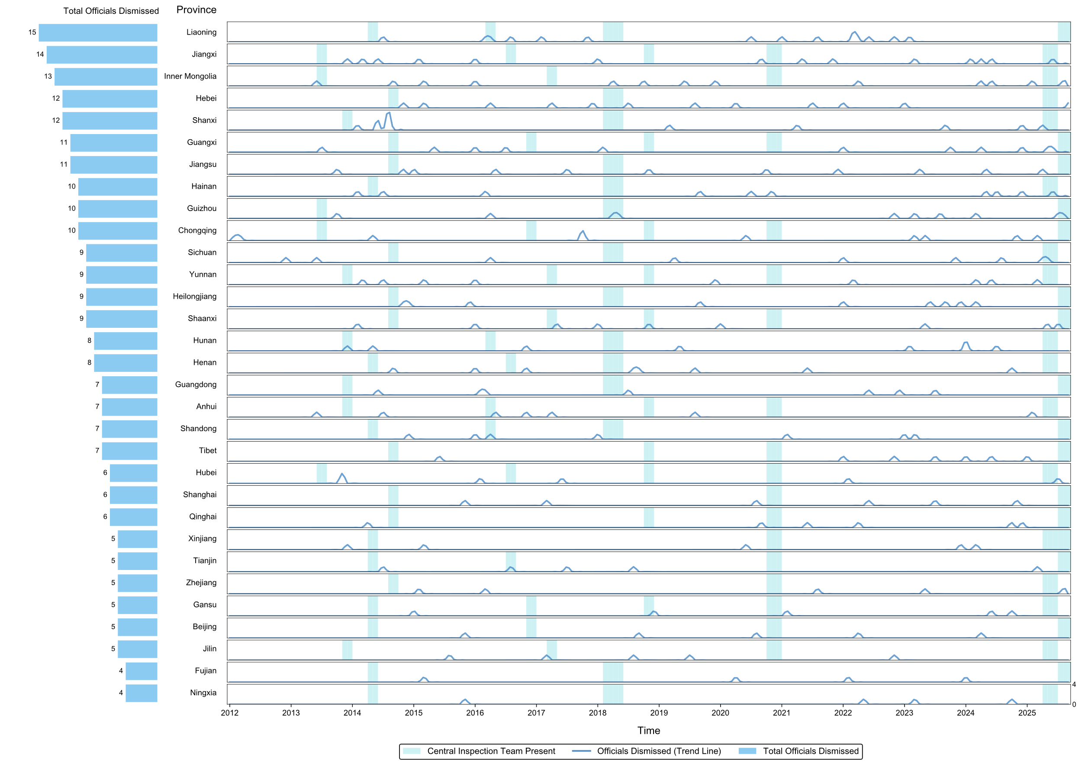
Fig. 1. Timeline of the downfall of provincial-level local officials and the deployment of Central Inspection Tours across provinces, January 2012–September 2025. Notes: This figure displays the spatiotemporal distribution of two key aspects of the anti-corruption campaign. It maps the downfall of 254 provincial-level officials from January 2012 to September 2025, and the thirteen rounds of Central Inspection Tours (Zhong yang xun shi) targeting provincial jurisdictions from June 2013 to September 2025, which together constituted three comprehensive inspection cycles. Within each provincial subplot, the smooth curve represents the monthly trend in the number of provincial-level official downfalls, with the scale ranging from 0 to 4. The cyan-shaded areas indicate periods when a Central Inspection Team was present in the province. Provinces on the y-axis are sorted from top to bottom by their cumulative number of official downfalls over the entire sample period. The bar chart on the left visually represents this total for each province; while the length of each bar is normalized for comparison, the accompanying numerical label indicates the actual raw count. We primarily date an official's downfall to the month the Central Commission for Discipline Inspection (CCDI) first announces that they are under investigation^{[2]}. The figure also highlights key milestones in the Central Inspection Tours. The first full round of inspections covering all provincial jurisdictions was completed by September 2014. The first "look-back" inspections began in March 2016, and an unprecedented three rounds of inspections were conducted in that year. October 2018 saw the first special inspection focused on poverty alleviation. After a four-year interval post-2020, a new wave of inspections began in April 2025. For the first time, it featured two consecutive rounds targeting provincial jurisdictions with no months in between, completing a full cycle in just six months.

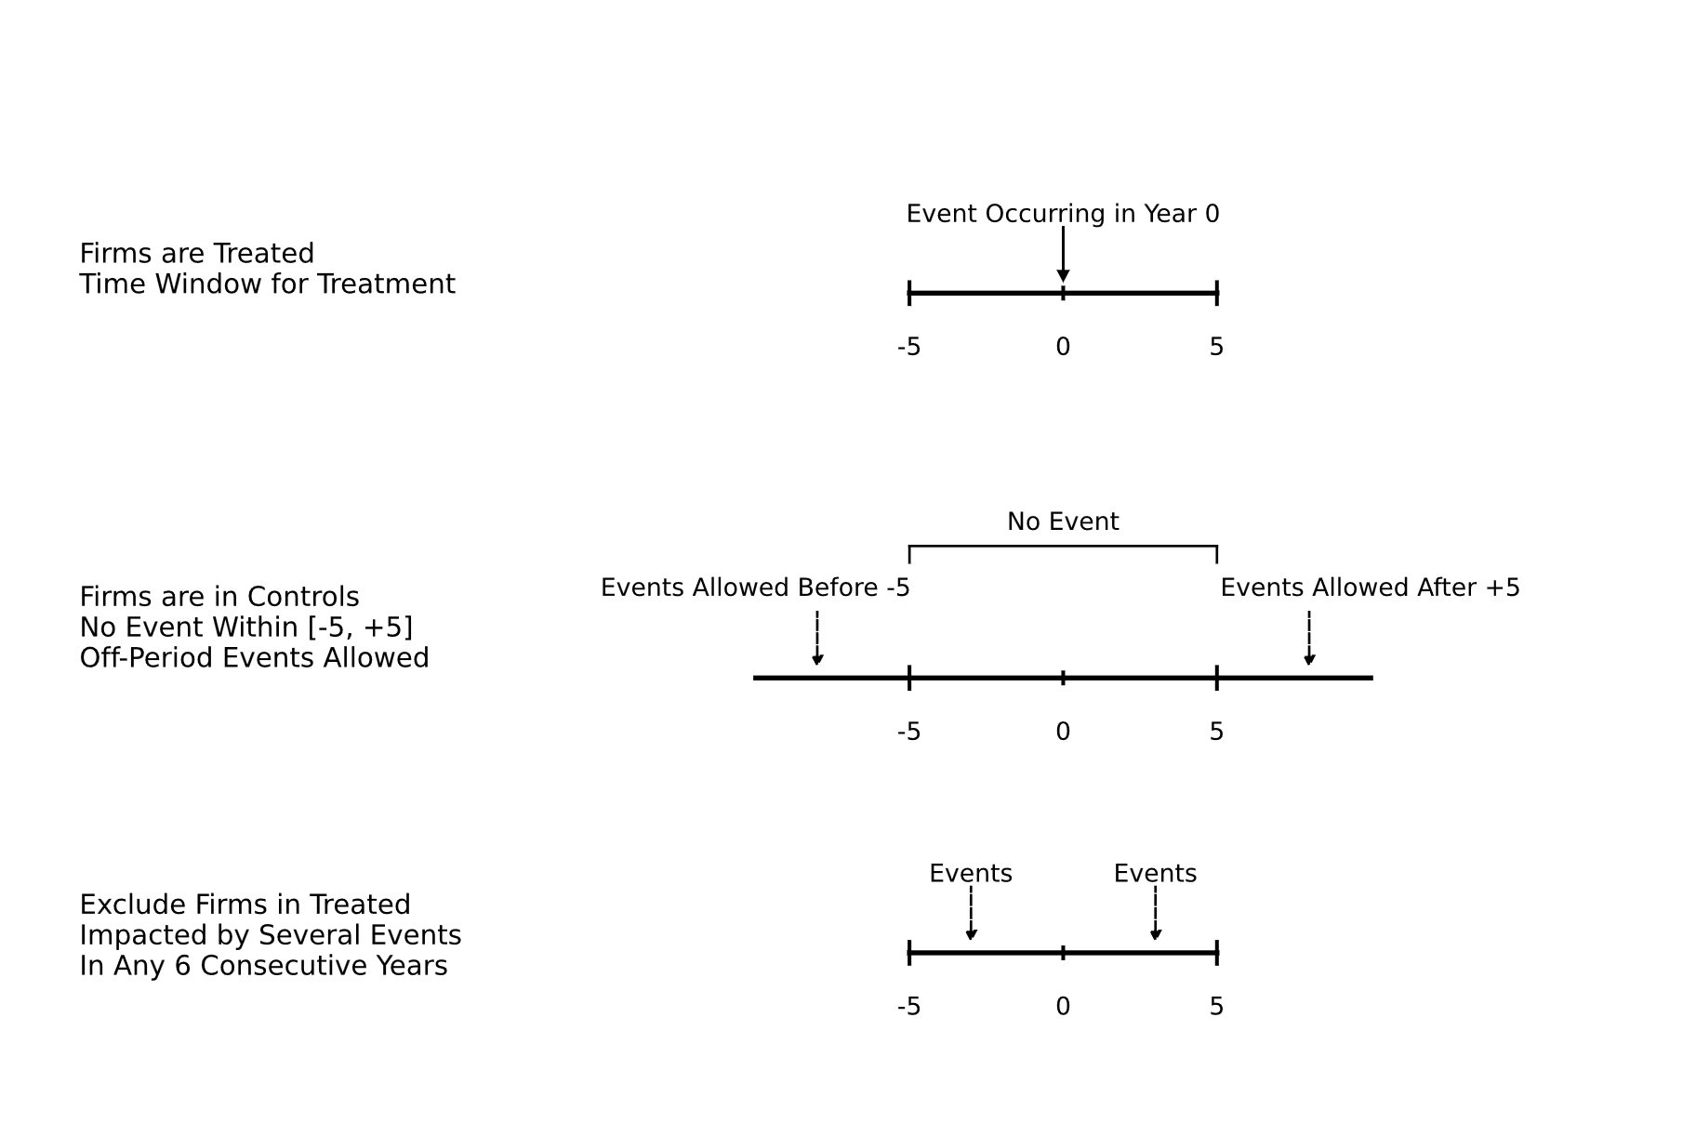
Fig. 2. Constructing a stacked dataset and illustrating the identification strategy. Note. Our baseline regression sample is composed of multiple event-specific datasets. Each dataset includes a treated firm and a corresponding set of "clean" control firms, covering an 11-year panel in event time (t ∈ [-5, 5]), with the event occurring at t=0. The accompanying figure illustrates this dataset construction. The first row depicts the time window for the treatment shock, caused by the removal of a politically connected official. The second row outlines the matching strategy for the control group; to be included, a control firm must not be exposed to any other similar shock within five years before or after the event at t=0. The third row shows our exclusion criteria: any firm impacted by multiple events within a six-year window is removed from the treatment sample. There is also an implicit requirement that all firms must have continuous observations spanning the event date. Based on these conditions, we construct clean treatment and control groups for each valid event and use the resulting stacked dataset for our empirical analysis.

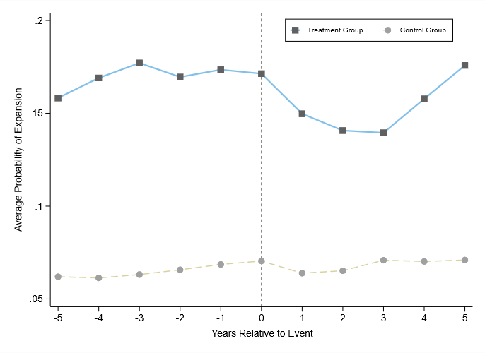
Fig. 3. Changes in firm expansion before and after the anti-corruption shock. Note. This figure illustrates the evolution of the average probability of expansion in the focal province for firms in the treatment and control groups over the event window. The light yellow dashed line represents the control group, while the light blue solid line represents the treatment group.

Panel A. Results for Full Sample of the Baseline Specification
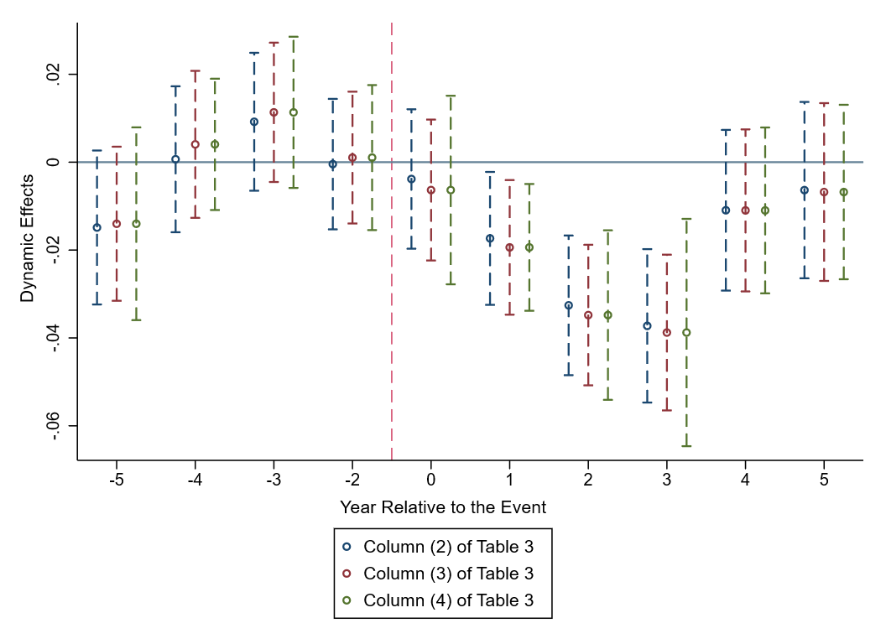

Panel B. Results for Subsamples of the Baseline Specification
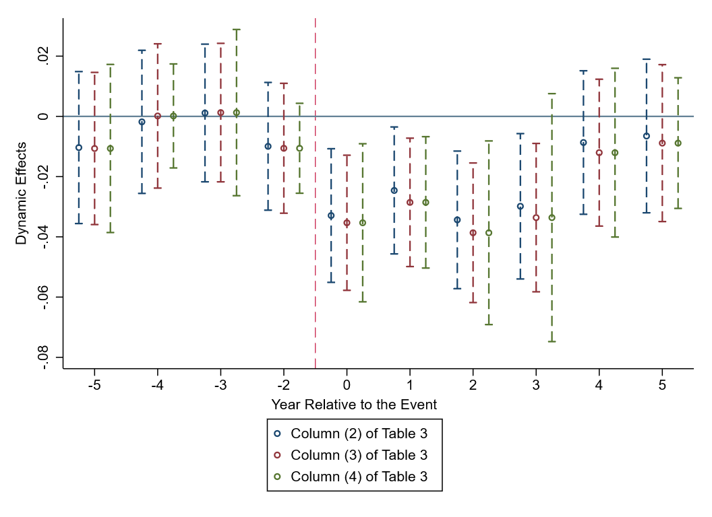

Fig.4. Event study estimations: Effects of the anti-corruption campaign on firm expansion. Note. Panel A plots the estimated coefficients and 90% confidence intervals for the dynamic effects of the anti-corruption campaign on firm expansion. Panel B shows the estimates for the subsample of events that occur in the first half of the year. The empirical specifications used are identical to those in Columns (2) - (4) of the baseline regression (Table 3), respectively.

Tables

Table 1
Discrepancy in the quantity of provincial level local officials dismissed prior to and during the anticorruption campaign.
Stage | Number of officials dismissed | Annual average
1982 - end of 2011 | less than 90 | less than 3
2012 – Sep. 2025 | 254 | 18.47
Note. The table represents the discrepancy in the quantity of provincial level local officials dismissed prior to and during the anticorruption campaign. Data from 2012 onward have been manually compiled from publicly available government sources, such as the website of the Central Commission for Discipline Inspection. The statistics for the 1982–2011 period are sourced from a speech delivered by Cui Hairong, then-Deputy Director of the National Bureau of Corruption Prevention, at the 5th ICAC International Conference in Hong Kong on May 11, 2012. In his remarks, he stated: "In the 30 years from 1982 to 2011..., more than 90 provincial- and ministerial-level officials were held judicially responsible for corruption." This statistical category is broad, encompassing numerous officials not serving in local governments (e.g., those in State Council ministries, large central SOEs, financial institutions, and key universities). We, therefore, infer that the number of provincial-level local government officials who fell from power due to corruption during these three decades was less than 90. Although the website of the National Bureau of Corruption Prevention is no longer accessible, the content of the speech can be retrieved from the official records on the website of the Permanent Mission of the People's Republic of China to the United Nations and Other International Organizations in Vienna: https://vienna.china-mission.gov.cn/drugandcrime/crime/201205/t20120517_8882644.htm.

Table 2
Sample descriptive statistics.
 | Total Sample |  |  |  | Group Sample
Variables | Obs | Mean | Sd |  | Mean | Mean |  | p-value
Panel A: Main variable |  |  |  |  | Treated |  | Controlled
Expansion | 2,590,449 | 0.0668 | 0.250 |  | Post=0
Panel B: Firm Characteristics
TFP | 28,497 | 8.807 | 1.136 |  | 8.777 | 8.756 |  | 0.381
Lev | 28,497 | 0.457 | 0.211 |  | 0.456 | 0.455 |  | 0.458
Cashflow | 28,497 | 0.0474 | 0.0760 |  | 0.0410 | 0.0477 |  | 0.923
Top1 | 28,497 | 0.348 | 0.156 |  | 0.371 | 0.354 |  | 0.200
FirmAge | 28,497 | 2.922 | 0.383 |  | 2.858 | 2.612 |  | 1.000
Panel C: Firm-Province Linkages
Connection | 2,590,449 | 0.0294 | 0.169 |  | 0.0333 | 0.0305 |  | 0.461
Memory | 2,590,449 | 0.0278 | 0.164 |  | 0.0271 | 0.0235 |  | 0.936
AllBig | 2,590,449 | 0.332 | 0.691 |  | 0.666 | 0.274 |  | 0.000

Note. The left panel of this table presents descriptive statistics for the main variables in our regression sample. As the firm-level characteristics are measured as firm-year observations, all statistics are reported at this level for consistency. The right panel of the table displays the means of the control variables for the treatment and control groups in the pre-shock period across all event datasets, along with the differences between the two groups. Standard errors for the difference-in-means test are clustered at the firm level.

Table 3
Effects of the anti-corruption campaign on firm expansion: baseline results.
 | (1) | (2) | (3) | (4)
Variables | Expansion | Expansion | Expansion | Expansion
Treat×Post | -0.0172*** | -0.0175*** | -0.0207*** | -0.0207***
 | (0.0061) | (0.0061) | (0.0062) | (0.0074)
Observations | 2,590,449 | 2,590,449 | 2,589,871 | 2,589,871
R-squared | 0.279 | 0.282 | 0.287 | 0.287
Controls: Firm Characteristics | No | Yes | Yes | Yes
Controls: Firm-Province Linkages | No | Yes | Yes | Yes
FEs: Event-Specific Firm | Yes | Yes | Yes | Yes
FEs: Event-Specific Year | Yes | Yes | No | No
FEs: Event-Specific Industry×Year | No | No | Yes | Yes

Note. This table reports the results of the staggered difference-in-differences model on firm expansion. Column (1) includes firm and year fixed effects within each event dataset. Column (2) adds controls for firm-level characteristics and potential firm-province linkages. Column (3), our preferred specification, replaces year fixed effects with industry-by-year fixed effects. Standard errors in Columns (1)–(3) are clustered at the firm level, while Column (4) employs two-way clustering at both the firm and province levels. * p < 0.1, ** p < 0.05, *** p < 0.01.

Table 4
Robustness checks and validity tests.
 | (1) | (2) | (3) | (4) | (5) | (6) | (7) | (8)
Variables | Expansion | Expansion_S | Expansion | Expansion | Expansion | Expansion | Expansion | Expansion
Treat×Post | -0.0146** | 0.0004 | -0.0207** | -0.0208*** | -0.0186*** | -0.0238*** | -0.0209*** | -0.0213***
 | (0.0067) | (0.0008) | (0.0081) | (0.0041) | (0.0060) | (0.0083) | (0.0075) | (0.0067)
Treat×Post×Blitz | -0.0295***
 | (0.0085)
Treat×Post×Collapse |  |  | -0.0445***
 |  |  | (0.0121)
Treat×Post×Strength |  |  |  | -0.1083*
 |  |  |  | (0.0557)
Treat×Post×Category |  |  |  |  | -0.0289***
 |  |  |  |  | (0.0083)
Observations | 2,589,871 | 2,589,871 | 2,589,871 | 2,589,871 | 2,589,871 | 20,550 | 39,510 | 57,473
R-squared | 0.287 | 0.393 | 0.287 | 0.287 | 0.287 | 0.425 | 0.453 | 0.474
Controls: Firm Characteristics | Yes | Yes | Yes | Yes | Yes | Yes | Yes | Yes
Controls: Firm-Province Linkages | Yes | Yes | Yes | Yes | Yes | Yes | Yes | Yes
FEs: Event-Specific Firm | Yes | Yes | Yes | Yes | Yes | Yes | Yes | Yes
FEs: Event-Specific Industry×Year | Yes | Yes | Yes | Yes | Yes | Yes | Yes | Yes

Note. This table presents our robustness checks and discussions on endogeneity. Column (1) displays the test for anticipation effects, while Column (2) presents the placebo test. Columns (3) through (5) illustrate the "dose-response" relationship between the treatment effect and the political shock. Finally, Columns (6) through (8) sequentially report the regression results from the Stacked PSM-DID analysis using 1:1, 1:3, and 1:5 nearest neighbor matching, respectively. Standard errors are in the parentheses and are clustered at firm level. * p < 0.1, ** p < 0.05, *** p < 0.01.

Table 5
Addressing alternative explanations.
 | (1) | (2) | (3) | (4) |  | (5) | (6) | (7) | (8)
 | Internal Firm-level Drivers |  |  |  |  | External Market-level Drivers
Variables | Z-Score | Penalty | Strategy | OtherStrategy |  | Expansion | BankLoan | JointExpansion | SoleExpansion
Treat×Post | 0.1226 | -0.0062 | -0.0241** | -0.0127 |  | -0.0156* | -0.0059 | -0.0355 | -0.0154***
 | (0.1405) | (0.0073) | (0.0119) | (0.0120) |  | (0.0083) | (0.0078) | (0.0285) | (0.0049)
Dummy_TFP |  |  |  |  |  | 0.0212***
 |  |  |  |  |  | (0.0026)
Treat×Post×Dummy_TFP |  |  |  |  |  | -0.0089
 |  |  |  |  |  | (0.0131)
Observations | 2,589,871 | 2,589,871 | 2,589,871 | 2,589,871 |  | 2,589,871 | 1,032,419 | 2,589,871 | 2,589,871
R-squared | 0.515 | 0.105 | 0.297 | 0.295 |  | 0.286 | 0.492 | 0.207 | 0.193
Controls: Firm Characteristics | Yes | Yes | Yes | Yes |  | Yes | Yes | Yes | Yes
Controls: Firm-Province Linkages | Yes | Yes | No | No |  | Yes | Yes | Yes | Yes
FEs: Event-Specific Firm | Yes | Yes | Yes | Yes |  | Yes | Yes | Yes | Yes
FEs: Event-Specific Industry×Year | Yes | Yes | Yes | Yes |  | Yes | Yes | Yes | Yes

Note. This table presents tests of five alternative explanations, across two dimensions, for the observed slowdown in firm expansion. The dependent variable in Column (1) is Z-Score, a measure of firm financial health, for which we use the raw calculated value without further manipulation (see Appendix C for the detailed methodology). In Column (2), the dependent variable, Penalty, is a dummy variable equal to 1 if the firm received an administrative penalty or disciplinary action from the China Securities Regulatory Commission (CSRC), and 0 otherwise. The dependent variables in Columns (3) and (4), Strategy and OtherStrategy, respectively, are dummy variables indicating whether the firm undertook a large-scale institutional expansion nationwide or in other domestic regions outside the focal province (1 if yes, 0 otherwise). In Column (5), Dummy_TFP is a dummy variable that equals 1 if a firm's total factor productivity exceeds the annual industry median, and 0 otherwise. The total factor productivity is calculated using the same methodology as described in our variable construction section. The dependent variable in Column (6), BankLoan, is a dummy indicating whether the firm obtained a loan from a local bank or financial institution within the province (1 if yes, 0 otherwise); for this analysis, due to the data spans 2013-2024, we restrict the sample to observations where the event occurs in 2018 or 2019. Finally, the dependent variables in Columns (7) and (8), JointExpansion and SoleExpansion, respectively, are dummy variables indicating whether the firm's expansion in the province was through a large joint-venture or a large wholly-owned institution (1 if yes, 0 otherwise). Standard errors are in the parentheses and are clustered at firm level. * p < 0.1, ** p < 0.05, *** p < 0.01.

Table 6
The effect of tainted firm expansion on the promotion probability of provincial "Four Leading Bodies" officials and their probability of appointment to central ministries.
 | (1) | (2) | (3) | (4)
Variables | Promotion | Central | Promotion | Central
Pro_Expansion | -0.0369*** | -0.0078***
 | (0.0034) | (0.0020)
Aff_Expansion | -0.0325*** | -0.0155*** | -0.0263*** | -0.0138***
 | (0.0083) | (0.0030) | (0.0077) | (0.0037)
Observations | 17,584 | 17,584 | 18,824 | 18,824
R-squared | 0.199 | 0.148 | 0.203 | 0.153
Controls: Provincial Development | Yes | Yes | No | No
Controls: Official Characteristics | Yes | Yes | Yes | Yes
Controls: Politburo Linkages | Yes | Yes | Yes | Yes
Controls: Affiliated Factions | Yes | Yes | Yes | Yes
FEs: Province | Yes | Yes | No | No
FEs: Year | Yes | Yes | No | No
FEs: Province×Year | No | No | Yes | Yes

Note. This table presents the effect of tainted firm expansion on the promotion probability of provincial "four leading bodies" officials in Columns (1) and (3), and on their probability of appointment to central ministries in Columns (2) and (4). Columns (1) and (2) include controls for the province's development status (Mass, Accident, Gap, Growth_GDP), individual official characteristics (Age, Age², Tenure, Tenure², Male, Nation, Education), the official's ties to the Politburo (PSC_Member, Ordinary_Member), and the official's factional affiliation (Faction1 - Faction7). These columns include separate province and year fixed effects. Columns (3) and (4) include Province×Year fixed effects; therefore, the controls for provincial development status (Mass, Accident, Gap, Growth_GDP) and core explanatory variable Pro_Expansion are not included, as they are absorbed by these fixed effects. Since some provincial development indicators (Gap, Growth_GDP) for 2024 are not yet available, the sample period for Columns (1) and (2) is 2012–2023, whereas Columns (3) and (4) cover the 2012–2024 period. Values in parentheses are standard errors, clustered at the provincial level. *, **, and *** indicate statistical significance at the 10%, 5%, and 1% levels, respectively.

Table 7
Evidence of punitive decoupling.
 | (1) | (2) | (3) | (4) | (5) | (6) | (7)
Variables | Expansion | Expansion | Expansion | Expansion | Expansion | Expansion | Expansion
Treat×Post | 0.0066 | -0.0089 | -0.0146* | -0.0149* | -0.0144* | -0.0124** | -0.0173***
 | (0.0044) | (0.0060) | (0.0083) | (0.0085) | (0.0082) | (0.0052) | (0.0060)
Treat×Post×Big | -0.0599***
 | (0.0132)
Treat×Post×Memory |  | -0.0485***
 |  | (0.0175)
Treat×Post×Promotion_1 |  |  | -0.0252***
 |  |  | (0.0088)
Treat×Post×Promotion_2 |  |  |  | -0.0256***
 |  |  |  | (0.0092)
Treat×Post× Promotion_3 |  |  |  |  | -0.0258***
 |  |  |  |  | (0.0091)
Treat×Post× Promotion_4 |  |  |  |  |  | -0.0145**
 |  |  |  |  |  | (0.0056)
Treat×Post×Connection |  |  |  |  |  |  | -0.0248
 |  |  |  |  |  |  | (0.0199)
Observations | 2,589,871 | 2,589,871 | 2,249,464 | 2,249,464 | 2,249,464 | 2,589,871 | 2,589,871
R-squared | 0.301 | 0.287 | 0.297 | 0.297 | 0.297 | 0.287 | 0.287
Controls: Firm Characteristics | Yes | Yes | Yes | Yes | Yes | Yes | Yes
Controls: Firm-Province Linkages | Yes | Yes | Yes | Yes | Yes | Yes | Yes
FEs: Event-Specific Firm | Yes | Yes | Yes | Yes | Yes | Yes | Yes
FEs: Event-Specific Industry×Year | Yes | Yes | Yes | Yes | Yes | Yes | Yes

Note. This table presents regression evidence supporting three hypotheses derived from the punitive decoupling theory. The results in Columns (1) and (2) collectively support Hypothesis 1, while those in Columns (3) through (6) provide evidence for Hypothesis 2. Finally, the results in Column (7) confirm Hypothesis 4. Standard errors are in the parentheses and are clustered at firm level. * p < 0.1, ** p < 0.05, *** p < 0.01.

Table 8
Bureaucratic competition structure and Punitive Decoupling.
 | (1) | (2) | (3)
Variables | Expansion | Expansion | Expansion
Treat×Post | -0.0328*** | -0.0305*** | -0.0342***
 | (0.0058) | (0.0058) | (0.0057)
Treat×Post×HHI | 0.0186***
 | (0.0066)
Treat×Post×Gini |  | 0.0137**
 |  | (0.0066)
Treat×Post×CR3 |  |  | 0.0228***
 |  |  | (0.0066)
Observations | 2,249,464 | 2,249,464 | 2,249,464
R-squared | 0.297 | 0.297 | 0.297
Controls: Firm Characteristics | Yes | Yes | Yes
Controls: Firm-Province Linkages | Yes | Yes | Yes
FEs: Event-Specific Firm | Yes | Yes | Yes
FEs: Event-Specific Industry×Year | Yes | Yes | Yes

Note. This table presents the variation in the degree of punitive decoupling by remaining local officials across different distributional structures of bureaucratic promotion incentives. The regression specifications and data structure are identical to those used in Columns (3) through (5) of Table 7. Standard errors are in the parentheses and are clustered at firm level. * p < 0.1, ** p < 0.05, *** p < 0.01.

Table 9
Economic efficiency losses from Punitive Decoupling.
 | (1) | (2) | (3)
Variables | TFP_Abnormal | TFP_Abnormal | OP
Post | -0.0065* |  | -0.0044**
 | (0.0038) |  | (0.0022)
Entrant_Type |  | -0.0580*
 |  | (0.0314)
Observations | 132,105 | 42,128 | 8,270
R-squared | 0.909 | 0.928 | 0.366
Controls: Firm Characteristics | Yes | Yes | No
Controls: Provincial Development | No | No | Yes
FEs: Event-Specific Firm | Yes | No | No
FEs: Firm | No | Yes | No
FEs: Event | No | Yes | No
FEs: Province | No | No | Yes
FEs: Province×Year | Yes | Yes | No
FEs: Industry×Year | Yes | Yes | Yes

Note. This table presents the results regarding the economic efficiency losses resulting from punitive decoupling. Standard errors are reported in parentheses. In Columns (1) and (2), standard errors are clustered at the firm level, while in Column (3), they are clustered at the province level. * p < 0.1, ** p < 0.05, *** p < 0.01.

References
Acemoglu, D., Johnson, S., Kermani, A., Kwak, J., & Mitton, T. (2016). The value of connections in turbulent times: Evidence from the united states. Journal of Financial Economics, 121(2), 368–391.
Ackerberg, D. A., Caves, K., & Frazer, G. (2015). Identification properties of recent production function estimators. Econometrica, 83(6), 2411–2451.
Alesina, A., Devleeschauwer, A., Easterly, W., Kurlat, S., & Wacziarg, R. (2003). Fractionalization. Journal of Economic Growth, 8(2), 155–194.
Ang, Y. Y. (2016). How China escaped the poverty trap. Cornell University Press.
Bermiss, Y. S., & Greenbaum, B. E. (2016). Loyal to whom? The effect of relational embeddedness and managers’ mobility on market tie dissolution. Administrative Science Quarterly, 61(2), 254–290.
Bian, Y. (1997). Bringing strong ties back in: Indirect ties, network bridges, and job searches in China. American Sociological Review, 62(3), 366.
Biasi, B., & Sarsons, H. (2022). Flexible wages, bargaining, and the gender gap. The Quarterly Journal of Economics, 137(1), 215–266.
Borusyak, K., Jaravel, X., & Spiess, J. (2024). Revisiting event-study designs: Robust and efficient estimation. The Review of Economic Studies, 91(6), 3253–3285.
Broschak, J. P., & Block, E. S. (2014). With or without you: When does managerial exit matter for the dissolution of dyadic market ties? Academy of Management Journal, 57(3), 743–765.
Cai, H., & Treisman, D. (2005). Does competition for capital discipline governments? Decentralization, globalization, and public policy. American Economic Review, 95(3), 817–830.
Callaway, B., & Sant’Anna, P. H. C. (2021). Difference-in-differences with multiple time periods. Journal of Econometrics, 225(2), 200–230.
Cengiz, D., Dube, A., Lindner, A., & Zipperer, B. (2019). The effect of minimum wages on low-wage jobs. The Quarterly Journal of Economics, 134(3), 1405–1454.
Colonnelli, E., Lagaras, S., Ponticelli, J., Prem, M., & Tsoutsoura, M. (2022). Revealing corruption: Firm and worker level evidence from brazil. Journal of Financial Economics, 143(3), 1097–1119.
Colonnelli, E., & Prem, M. (2022). Corruption and firms. The Review of Economic Studies, 89(2), 695–732.
Correia, M. M. (2014). Political connections and SEC enforcement. Journal of Accounting and Economics, 57(2), 241–262.
Ding, H., Hu, Y., Kim, K. A., & Xie, M. (2023). Relationship-based debt financing of Chinese private sector firms: The role of social connections to banks versus political connections. Journal of Corporate Finance, 78, 102335.
Duchin, R., Ozbas, O., & Sensoy, B. A. (2010). Costly external finance, corporate investment, and the subprime mortgage credit crisis. Journal of Financial Economics, 97(3), 418–435.
Fang, H., Li, M., & Wu, Z. (2025). Tournament-style political competition and local protectionism: Theory and evidence from China. Journal of Public Economics, 248, 105421.
Fang, H., & Zhang, R. (2025). Corruption stereotype and the unintended consequences of an anti-corruption campaign: Evidence from the real estate sector in China. Journal of Public Economics, 249, 105474.
Fang, L., Lerner, J., Wu, C., & Zhang, Q. (2023). Anticorruption, Government Subsidies, and Innovation: Evidence from China. Management Science, 69(8), 4363–4388.
Fisman, R. (2001). Estimating the value of political connections. American Economic Review, 91(4), 1095–1102.
Francois, P., Trebbi, F., & Xiao, K. (2023). Factions in nondemocracies: Theory and evidence from the Chinese communist party. Econometrica : Journal of the Econometric Society, 91(2), 565–603.
Gerardino, M. P., Litschig, S., & Pomeranz, D. (2024). Distortion by audit: Evidence from public procurement. American Economic Journal: Applied Economics, 16(4), 71–108.
Glaeser, E., Huang, W., Ma, Y., & Shleifer, A. (2017). A real estate boom with Chinese characteristics. Journal of Economic Perspectives, 31(1), 93–116.
Goodman-Bacon, A. (2021). Difference-in-differences with variation in treatment timing. Journal of Econometrics, 225(2), 254–277.
Grabner, I., Künneke, J., & Moers, F. (2025). Promotion decisions and the adoption of explicit potential assessment. Management Science, 71(11), 9233–9255.
Granovetter, M. S. (1973). The strength of weak ties. American Journal of Sociology, 78(6), 1360–1380.
Jacobson, L. S., LaLonde, R. J., & Sullivan, D. G. (1993). Earnings losses of displaced workers. The American Economic Review, 83(4), 685–709. JSTOR.
Khwaja, A. I., & Mian, A. (2005). Do lenders favor politically connected firms? Rent provision in an emerging financial market. The Quarterly Journal of Economics, 120(4), 1371–1411.
Lazear, E. P., & Rosen, S. (1981). Rank-order tournaments as optimum labor contracts. Journal of Political Economy, 89(5), 841–864.
Leuz, C., & Oberholzer-Gee, F. (2006). Political relationships, global financing, and corporate transparency: Evidence from indonesia. Journal of Financial Economics, 81(2), 411–439.
Li, H., & Zhou, L.-A. (2005). Political turnover and economic performance: The incentive role of personnel control in China. Journal of Public Economics, 89(9–10), 1743–1762.
Lyon, T. P., & Maxwell, J. W. (2025). Political polarization and nonmarket strategy over the policy life cycle. Management Science, mnsc.2025.00819.
McPherson, M., Smith-Lovin, L., & Cook, J. M. (2001). Birds of a feather: Homophily in social networks. In Annual Review of Sociology (Vol. 27, Issue Volume 27, 2001, pp. 415–444). Annual Reviews.
Portes, A. (2024). Social capital: Its origins and applications in modern sociology. New Critical Writings in Political Sociology, 53–76.
Qian, J., & Bai, S. (2021). The zeal of the outgroup: Loyalty signaling, bureaucratic compliance, and variation of state repression in authoritarian regimes. Comparative Politics, Forthcoming.
Rajgopal, S., Srivastava, A., & Zhao, R. (2025). Economic substance behind texas political anti-ESG sanctions. Management Science, mnsc.2024.05180.
Rambachan, A., & Roth, J. (2023). A more credible approach to parallel trends. The Review of Economic Studies, 90(5), 2555–2591.
Roth, J. (2022). Pretest with caution: Event-study estimates after testing for parallel trends. American Economic Review: Insights, 4(3), 305–322.
Shi, X., Xi, T., Zhang, X., & Zhang, Y. (2021). “moving umbrella”: Bureaucratic transfers and the comovement of interregional investments in China. Journal of Development Economics, 153, 102717.
Sun, L., & Abraham, S. (2021). Estimating dynamic treatment effects in event studies with heterogeneous treatment effects. Journal of Econometrics, 225(2), 175–199.
Tsebelis, G. (2002). Veto players: How political institutions work. Princeton University Press.
Uzzi, B. (2018). Social structure and competition in interfirm networks: The paradox of embeddedness. In The sociology of economic life (pp. 213–241). Routledge.
Xu, C. (2011). The fundamental institutions of China’s reforms and development. Journal of Economic Literature, 49(4), 1076–1151.
Zhang, P. (2023). Anti-corruption campaign, political connections, and court bias: Evidence from Chinese corporate lawsuits. Journal of Public Economics, 222, 104861.
Zhong, W., & Zheng, Y. (2025). Do political connections stifle firm innovation? Natural experimental evidence from China’s anti‐corruption campaigns. Strategic Management Journal, smj.3690.

Washing the Stain: Punitive Decoupling and the Sacrificial Cost for Connected Firms
Online Appendix

February 12th, 2026

Contents
Appendix A. Empirical evidence that the anti-corruption campaign is not a political purge. 1
Appendix B. Impact of local condition on anti-corruption enforcement and the deployment of Central Inspection Tours. 4
Appendix C. Persistent effects of anticorruption shocks. 5
Appendix D. Violations of Parallel Trends Assumption. 6
Appendix E. Stacked PSM-DID. 7
Appendix F. Calculation of the Z-Score. 9
Appendix G. The effect of tainted firm expansion on the promotion probability of provincial "Four Leading Bodies" officials: LPM estimates. 10
Appendix H. Predicting the ex-ante promotion probability of provincial "Four Leading Bodies" officials: Probit estimates. 14
Appendix I. The structure of bureaucratic competition. 19
Appendix J. Calculation procedures for the resource allocation efficiency index. 20
References 22

Appendix A. Empirical evidence that the anti-corruption campaign is not a political purge.
To directly test the "factional purge" hypothesis within the anti-corruption campaign, we employ a parametric survival model for our analysis. Specifically, we use a piecewise exponential model, which flexibly captures the dynamic process of an official's investigation risk (i.e., the hazard rate) over time.
First, we define the data structure for the survival analysis in this study. The "failure event" of interest is an official's downfall during the anti-corruption campaign. The "survival time" is defined as the official's tenure in their current post. The hazard rate function, H_{i}(t), that we estimate is given by the following equation. This function adopts a proportional hazards form, which clearly illustrates how various covariates influence the baseline hazard rate through a multiplicative effect.
(1)
In this model, the hazard rate of downfall for official i at tenure-year t, denoted as H_{i}(t), is modeled as an exponential function of several sets of covariates. These variables are categorized as follows:
- Period Fixed Effects : This is a series of dummy variables based on the Party Congress cycles (17th, 18th, 19th, and 20th). These dummies allow the baseline hazard to shift across different macro-political periods, which constitutes the "piecewise" feature of the model.
- Time-Varying Individual and Positional Characteristics : This category includes Age and Age², the official's age and its quadratic term, to capture the non-linear relationship between risk and age. It also includes Tenure and Tenure², the official's years of service in the province and its quadratic term, which form the core dynamic component of the model to directly capture the inverted U-shaped process of risk over time. Both the Age and Tenure variables are transformed as log(1+value). Additionally, this set includes a series of dummy variables to control for risk differentials across institutional types: Pro (serving in the Provincial Government or Party Committee), NPC (serving in the People's Congress), and CPPCC (serving in the Political Consultative Conference). Each dummy equals 1 if an official holds a position in the corresponding institution in a given year, and 0 otherwise.
- Time-Invariant Individual Characteristics : This set includes control variables representing the official's gender, ethnicity, and educational background. Specifically, Male is a dummy variable equal to 1 if the official is male, and 0 otherwise; Nation represents a set of dummy variables for the official's ethnicity; and Education is a dummy variable that equals 1 if the official holds a bachelor's degree or higher, and 0 otherwise.
- Core Test Variables for Factional Affiliation : This category consists of a set of dummy variables, Faction1 through Faction7, representing an official's affiliation with different political factions. Each variable is coded as 1 if the official belongs to the corresponding faction, and 0 otherwise.
The model is estimated assuming an Exponential Distribution. The reported coefficients are raw regression coefficients rather than hazard ratios. The table below presents our estimation results. Standard errors, clustered at the official level, are reported in parentheses. *, **, and *** indicate statistical significance at the 10%, 5%, and 1% levels, respectively.

 | (1)
Dependent Variable | H_{t}
Age_{t} | 340.5250***
 | (116.6024)
Age²_{t} | -41.9130***
 | (14.4225)
Tenure_{t} | 4.8543***
 | (0.9354)
Tenure²_{t} | -0.9428***
 | (0.2511)
Pro _{t} | -0.4411*
 | (0.2394)
NPC _{t} | -0.8355***
 | (0.2643)
CPPCC _{t} | -0.7566***
 | (0.2747)
(Continued)
Male _{t} | 1.2872***
 | (0.4563)
Nation _{t} | -0.0092
 | (0.0290)
Education _{t} | 3.1548***
 | (0.7138)
Faction1 | -0.2256
 | (0.4574)
Faction2 | -0.5321
 | (0.7176)
Faction3 | 0.3858
 | (0.2955)
Faction4 | 0.3436
 | (0.2433)
Faction5 | 0.3508
 | (1.0104)
Faction6 | -0.0627
 | (0.3098)
Faction7 | -0.1217
 | (0.3546)
Time18th | 3.6384***
 | (0.4631)
Time19th | 3.3012***
 | (0.4731)
Time20th | 3.6089***
 | (0.4978)
Observations | 19,753
Log pseudo likelihood | -597.059

Note. Since our "survival time" of interest is defined as an official's tenure in their current position, we treat multiple posts held by an official within the same year due to inter-provincial transfers as distinct survival spells. We then exclude the corresponding annual observations for officials who, for at least two consecutive years, served in different provinces with each tenure lasting no more than one year, as these short, successive appointments do not represent a continuous "survival time" for our analysis. This process yields a final panel dataset containing 19,753 official-year observations.

Appendix B. Impact of local condition on anti-corruption enforcement and the deployment of Central Inspection Tours.
This table below presents the Probit regression results, which test the hypothesis that the downfall of provincial-level officials and the deployment of Central Inspection Tours are exogenous to local development conditions. The sample period is from 2012 to 2024. The number of mass incidents (Mass) and the number of major and serious safety accidents (Accident) are transformed as log(1 + value). The fiscal gap (Gap) is calculated as (General Budget Expenditure - General Budget Revenue) / General Budget Revenue. Growth_GDP is the real annual GDP growth rate. All explanatory variables are lagged by one period, and the models include province and year two-way fixed effects. Standard errors, clustered at the province level, are reported in parentheses.

 | (1) | (2)
Dependent Variable | Downfall_{t} | CIT_{t}
Gap_{t-1} | 0.0154 | -0.0015
 | (0.0584) | (0.0150)
Mass_{t-1} | 0.0748 | 0.0170
 | (0.1845) | (0.2156)
Accident_{t-1} | 0.0095 | 0.0251
 | (0.0454) | (0.0358)
Growth_GDP_{t-1} | -0.1267 | 0.5663
 | (0.5222) | (0.4017)
Constant | 0.3516 | 0.1416
 | (0.2248) | (0.2173)
Year FE | Yes | Yes
Province FE | Yes | Yes
Observations | 403 | 403
R-squared | 0.066 | 0.404

Appendix C. Persistent effects of anticorruption shocks.
This table examines the persistent effects of the anti-corruption shock on firm expansion. Columns (1) and (2) report the estimated effects in the fourth and fifth years post-shock, respectively, relative to the pre-shock period. Column (3) presents the average treatment effect over these two years. The empirical model includes controls for firm-level characteristics and potential firm-province linkages, and incorporates firm, province-by-year, and industry-by-year fixed effects within each event dataset. Standard errors, clustered at the firm level, are reported in parentheses. *, **, and *** indicate statistical significance at the 10%, 5%, and 1% levels, respectively.
 | (1) | (2) | (3)
Variables | Expansion | Expansion | Expansion
Treat×Post | 0.0114 | 0.0169 | 0.0088
 | (0.0124) | (0.0141) | (0.0106)
Time Window | [-5, -1] ∪ [4] | [-5, -1] ∪ [5] | [-5, -1] ∪ [4,5]
Observations | 1,443,976 | 1,426,187 | 1,611,473
R-squared | 0.311 | 0.312 | 0.302
Controls: Firm Characteristics | Yes | Yes | Yes
Controls: Firm-Province Linkages | Yes | Yes | Yes
FEs: Event-Specific Firm | Yes | Yes | Yes
FEs: Event-Specific Industry×Year | Yes | Yes | Yes

Appendix D. Violations of Parallel Trends Assumption.
Specifically, we propose our test consists in (a) constructing a set Δ of possible deviations from the parallel trends assumption, and (b) constructing the confidence intervals associated with these deviations, which involves constructing confidence intervals that allow for deviations from linearity up to a parameter M. First, we use formula (1) to calculate Δ, where δ is defined as the trends and M is allowed to range from zero (linear pre-trends) to the standard error of the coefficient of the point where the treatment commences to take effect.
(2)
Then, we estimate of the confidence interval for the parameter δ which is the period when the treatment begins to take effect. The results are shown in the figures below.
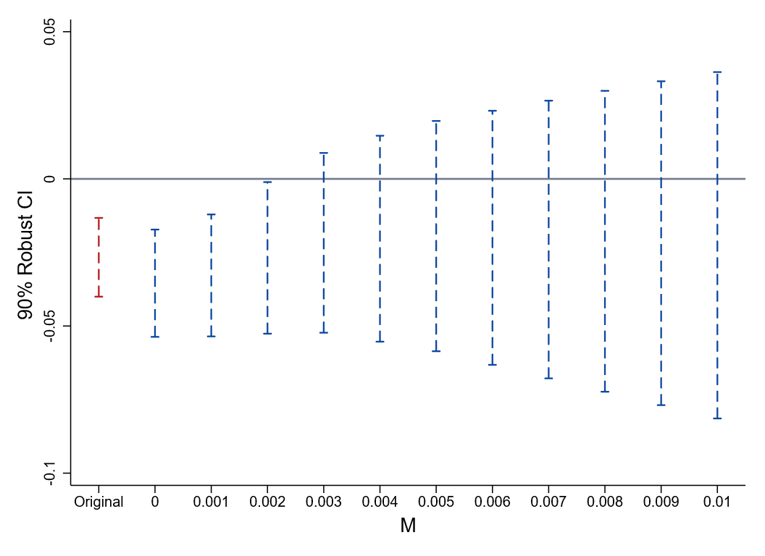
Panel A. Columns (2) of the baseline regression (Table 3) Panel B. Columns (3) of the baseline regression (Table 3)
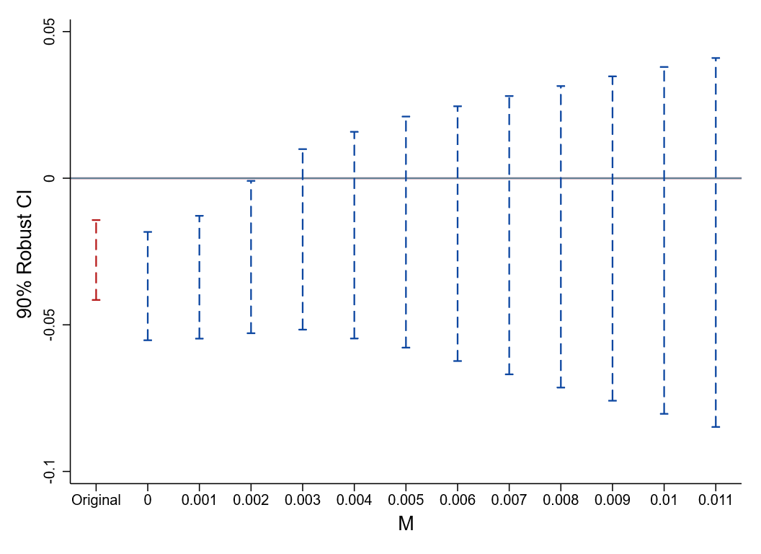

Panel C. Columns (4) of the baseline regression (Table 3)
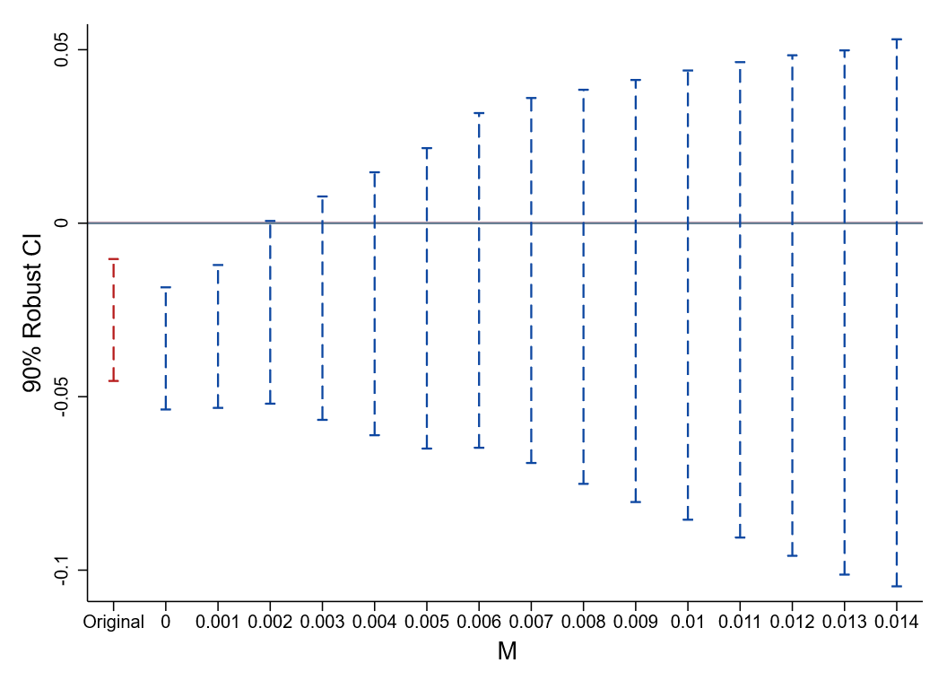

Appendix E. Stacked PSM-DID.
We employ a Propensity Score Matching-Difference-in-Differences (PSM-DID) approach within the stacked dataset. Specifically, using data from the pre-shock period, we include the control variables from the baseline regression as covariates and estimate a Logit model to predict the probability of treatment assignment for each firm within each event dataset. Based on these firm characteristics, we then match treated firms with control firms within each event-specific dataset using 1:1, 1:3, and 1:5 nearest neighbor matching algorithms. Finally, we perform the regression analysis on these matched samples.

 | Nearest neighbor 1:1 |  |  | Nearest neighbor 1:3 |  |  | Nearest neighbor 1:5
Variables | Mean Control | Difference |  | Mean Control | Difference |  | Mean Control | Difference
Panel A: Firm Characteristics
TFP | 8.932 | 0.0183 |  | 8.900 | 0.0157 |  | 8.869 | 0.0106
 | (1.177) | (0.0544) |  | (1.167) | (0.0489) |  | (1.149) | (0.0475)
Lev | 0.443 | 0.0089 |  | 0.454 | 0.0047 |  | 0.453 | 0.0044
 | (0.213) | (0.0096) |  | (0.214) | (0.0085) |  | (0.213) | (0.0083)
Cashflow | 0.0496 | -0.0011 |  | 0.0471 | -0.0003 |  | 0.0475 | -0.0007
 | (0.0778) | (0.0023) |  | (0.0766) | (0.0021) |  | (0.0762) | (0.0020)
Top1 | 0.352 | -0.0094 |  | 0.347 | -0.0028 |  | 0.348 | -0.0047
 | (0.165) | (0.0074) |  | (0.160) | (0.0064) |  | (0.159) | (0.0063)
FirmAge | 2.924 | -0.0158 |  | 2.925 | -0.0079 |  | 2.925 | -0.0037
 | (0.379) | (0.0157) |  | (0.380) | (0.0143) |  | (0.382) | (0.0139)
Panel C: Firm-Province Linkages
Connection | 0.0951 | 0.0029 |  | 0.0773 | 0.0093 |  | 0.0713 | 0.0096
 | (0.293) | (0.0087) |  | (0.267) | (0.0068) |  | (0.257) | (0.0066)
Memory | 0.163 | 0.0104 |  | 0.145 | 0.1622 |  | 0.135 | 0.1561
 | (0.369) | (0.0099) |  | (0.352) | (0.1105) |  | (0.341) | (0.1086)
AllBig | 0.547 | 0.0007 |  | 0.523 | -0.0001 |  | 0.488 | -0.0010
 | (0.999) | (0.0021) |  | (0.961) | (0.0016) |  | (0.922) | (0.0016)

The table above presents the results of the balance tests. For each matching specification, the left column reports the pre-event mean and standard error (in parentheses) for the control group, while the right column displays the difference between the treatment and control groups, estimated by regressing the treatment indicator on each individual covariate. These regressions include event fixed effects, and standard errors are clustered at the firm level. The results indicate that the treatment and control groups exhibit good balance across all dimensions.
As illustrated in the figure below, following the event study methodology proposed by Jacobson et al. (1993) and its specific implementation by Zhao et al. (2026), we rule out the possibility that our results are biased by unobserved confounding pre-trends.

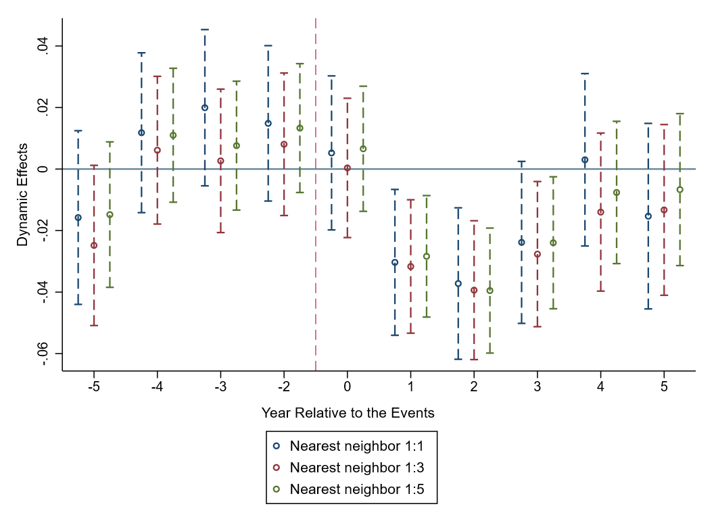

Appendix F. Calculation of the Z-Score.
We adopt the classic Altman Z-score model (Altman, 1968) to measure a firm's financial distress risk. The Z-score model is a multivariate discriminant analysis tool that predicts the probability of bankruptcy by combining multiple indicators of a firm's financial health. For the purposes of this study, the Z-score is calculated as follows:
(3)
In the formula above, the financial ratios are defined as follows: is Working Capital / Total Assets; is Retained Earnings / Total Assets; is Earnings Before Interest and Taxes (EBIT) / Total Assets; is Total Shareholders' Equity / Total Liabilities; and is Operating Revenue / Total Assets.
To interpret the resulting Z-score, we follow the critical value standards established by Altman (1968), using 1.81 and 2.67 as the benchmarks for classifying a firm's financial status. The specific criteria are as follows: A Z-score greater than 2.67 indicates that the firm is in good financial health with a low probability of bankruptcy (the "Safe Zone"). A Z-score below 1.81 indicates the firm is already in financial distress and faces a high bankruptcy risk. If the Z-score falls between 1.81 and 2.67, the firm is in the "Gray Zone," signaling significant financial instability and a high likelihood of future distress.

Appendix G. The effect of tainted firm expansion on the promotion probability of provincial "Four Leading Bodies" officials: LPM estimates.
Our dependent variable, Promotion, is a 0/1 dummy variable. While Probit and Logit models are often preferred in theory for such variables, our baseline specification employs a Linear Probability Model (LPM). This choice offers significant advantages in our setting, as our specification includes high-dimensional fixed effects, such as province-by-year interactions.
In non-linear models like Probit, the inclusion of such granular fixed effects is highly susceptible to the "perfect prediction" problem: if, within a given province-by-year cell, all officials share the same outcome (all 0s or all 1s), the maximum likelihood estimation fails to converge and automatically drops these observations. As shown in Appendix H, attempting to estimate our model with Probit and province-by-year fixed effects results in the exclusion of 2,909 observations. In contrast, the LPM is not susceptible to this issue. It retains and utilizes information from all observations, making its estimates more robust in the presence of high-dimensional fixed effects.
Given these, we estimate the effect with the following baseline model specification:
(4)
where i, j, and t denote the official, province, and year, respectively. The dependent variable p_{it} is the promotion dummy variable. We ascertain an official's promotion status based on their career trajectory.
For inter-provincial transfers, we construct a comprehensive index with two dimensions—geography and position—to define an official's "actual serving rank" (i.e., their true niche in the bureaucratic ecosystem) and use this to identify promotion. Specifically, we first classify China's provincial administrative divisions into six tiers based on their strategic importance in the national political-economic landscape, economic scale, and political influence (as shown in Table G1). Concurrently, based on the internal power structure and administrative conventions of the "four leading bodies," we subdivide the main provincial leadership posts into ten ranks (as shown in Table G2). An official's "actual serving rank" is defined as the sum of their geographic tier and their position rank. When an official's transfer results in a decrease in this composite index value, we code it as a promotion.
For officials transferred from a local post to a central department, we compare the administrative levels of the new and old positions. If the central position's rank is equal to or higher than their original provincial-level rank (e.g., moving from a full provincial-level post to a full ministerial-level post), the transfer is also considered a promotion. Furthermore, any position changes due to normal retirement, death in office, or corruption allegations ("downfall") are not defined as promotions.
The vector includes our core explanatory variable of interest, Aff_Expansion (the ratio of expanding tainted firms affiliated with the official to all tainted firms affiliated with that official), as well as the official's ties to the Politburo. These ties are measured by PSC_Member (a dummy equal to 1 if connected to any incumbent Politburo Standing Committee member, 0 otherwise) and Ordinary_Member (a dummy equal to 1 if connected to any incumbent ordinary Politburo member, 0 otherwise). In defining these connections, in addition to shared alma mater, hometown, or native place, we also consider a co-working relationship—specifically, whether the Politburo member ever served with the official in the same level "four leading bodies" system during their local tenure. We consider a connection to exist if any one of these four potential linkages is satisfied.
The vector includes our core explanatory variable, Pro_Expansion (defined as the ratio of expanding tainted firms to all tainted firms within the official's jurisdiction), as well as indicators of provincial development status. The latter include the number of mass incidents (Mass), the number of major and serious safety accidents (Accident), the fiscal gap (Gap), and the real annual GDP growth rate (Growth_GDP), all of which are measured identically to those in Appendix B.
The vector includes individual official characteristics (Age, Age², Tenure, Tenure², Male, Nation, Education) and factional affiliations (Faction1 - Faction7). These variables are defined and measured identically to those in Appendix A.
and are respectively the province and year fixed effects.
Furthermore, drawing on the findings from our event study analysis and the results in Appendix C, we define the window of influence for a tainted firm's expansion on an official's promotion as the year of the connected official's downfall and the three subsequent years. Based on this window, we then stack the annual expansion behaviors of tainted firms—which are tied to multiple, distinct downfall events—to calculate our Pro_Expansion and Aff_Expansion variables.
Table G1. Provincial-Level Geographical Hierarchy and Rationale
Tier | Provinces / Municipalities | Rationale for Classification
Tier 1 | Beijing, Shanghai, Guangdong | The nation's political center (Beijing), financial hub (Shanghai), and largest economic province (Guangdong), possessing absolute national political and economic influence.
Tier 2 | Tianjin, Chongqing, Jiangsu, Zhejiang, Shandong | Major municipalities (Tianjin, Chongqing) and strong coastal economic provinces (Jiangsu, Zhejiang, Shandong), serving as critical national growth poles.
Tier 3 | Fujian, Hubei, Hunan, Henan, Sichuan | Key coastal province (Fujian) and populous, economically significant provinces in central/southwestern China (Hubei, Hunan, Henan, Sichuan); regional hubs connecting east and west.
Tier 4 | Anhui, Jiangxi, Liaoning, Hebei | Central provinces undertaking industrial transfer (Anhui, Jiangxi), the region surrounding the capital (Hebei), and an old industrial base (Liaoning).
Tier 5 | Guangxi, Shaanxi, Yunnan, Heilongjiang, Jilin | Border, inland, and northeastern provinces; often regional centers but with comparatively smaller economic scales.
Tier 6 | Shanxi, Guizhou, Hainan, Inner Mongolia, Gansu, Ningxia, Qinghai, Xinjiang, Tibet | Provinces with relatively lagging economic development, reliance on natural resources or fiscal transfers, or frontier regions with special policy considerations (Xinjiang, Tibet).

Table G2. Ranking of Posts within the Provincial "Four Leading Bodies"
Rank | Position Title
Rank 1 | Provincial Party Secretary
Rank 2 | Governor (Municipal Mayor)
Rank 3 | Chairman of the Provincial People's Congress
Rank 4 | Chairman of the Provincial CPPCC
Rank 5 | Deputy Provincial Party Secretary
Rank 6 | Executive Vice Governor (Municipal Executive Vice Mayor)
Rank 7 | Member of the Provincial Party Standing Committee
Rank 8 | Vice Governor (Municipal Vice Mayor)
Rank 9 | Vice Chairman of the Provincial People's Congress
Rank 10 | Vice Chairman of the Provincial CPPCC

Appendix H. Predicting the ex-ante promotion probability of provincial "Four Leading Bodies" officials: Probit estimates.
We adopt the specification as shown in Equation (3) and use a Probit model to predict the ex-ante promotion probability of officials. The variable construction for all vectors, as well as the choice of fixed effects and clustered standard errors, are identical to those in Equation (2) in Appendix G.
(5)
Table H1 presents our estimation results. Standard errors, clustered at the provincial level, are reported in parentheses. *, **, and *** indicate statistical significance at the 10%, 5%, and 1% levels, respectively.
Table H1. Estimation Results.
 | (1) | (2) | (3) | (4)
Variables | Promotion | Promotion | Promotion | Promotion
Pro_Expansion | -0.4808*** | -0.0444***
 | (0.0465) | (0.0041)
Aff_Expansion | -0.6167*** | -0.0569*** | -0.5751*** | -0.0575***
 | (0.2062) | (0.0191) | (0.2153) | (0.0215)
Observations | 17,584 | 17,584 | 15,915 | 15,915
Controls: Provincial Development | Yes | Yes | No | No
Controls: Official Characteristics | Yes | Yes | Yes | Yes
Controls: Politburo Linkages | Yes | Yes | Yes | Yes
Controls: Affiliated Factions | Yes | Yes | Yes | Yes
FEs: Province | Yes | Yes | No | No
FEs: Year | Yes | Yes | No | No
FEs: Province×Year | No | No | Yes | Yes

Note. Columns (1) and (3) of this table report the coefficients from the Probit regression, and Columns (2) and (4) report the corresponding average marginal effects. In contrast to Appendix A, to accurately ascertain annual promotion status, we retain only the highest-ranking position for officials holding multiple posts within the same year due to inter-provincial transfers. This procedure yields a final panel dataset comprising 18,824 official-year observations spanning the 2012–2024 period.
As detailed in Appendix G, attempting to estimate the ex-ante promotion probability of officials for the 2012–2024 period using a Probit model with province-by-year fixed effects results in the exclusion of a substantial number of observations. Conversely, while using the Linear Probability Model (LPM) for prediction allows for the retention of all observations, it yields a large number of negative probability estimates, which is theoretically inconsistent. Consequently, accepting the unavailability of certain provincial development indicators (i.e., Gap and Growth_GDP) for 2024, we employ the model specified in Equation (3) to estimate ex-ante promotion probabilities for the 2012–2023 period.
The resulting distributions of these estimated probabilities are presented in Panel H1. Panels H2 and H3 further illustrate the distribution of promotion probabilities across different departments within the provincial "four leading bodies." Comparing Panels H2 and H3, we observe that members of the Provincial Government and Party Committee possess higher promotion probabilities relative to those in the People's Congress and CPPCC. This aligns with the political reality in China, where the latter institutions are typically perceived as "second-line" or "quasi-retirement" positions, with their core leadership often comprising cadres approaching the end of their careers. Table H2 provides the election schedules for the various departments of the provincial "four leading bodies" during our sample period. This further corroborates the validity of our predictions: during election years, the overall promotion probability for members of focal departments is significantly higher than in other years. While "off-cycle promotions" do occur in non-election years, they are extremely rare.
Panel H1. Distribution of Promotion Probabilities for All Members of the Provincial "Four Leading Bodies,"
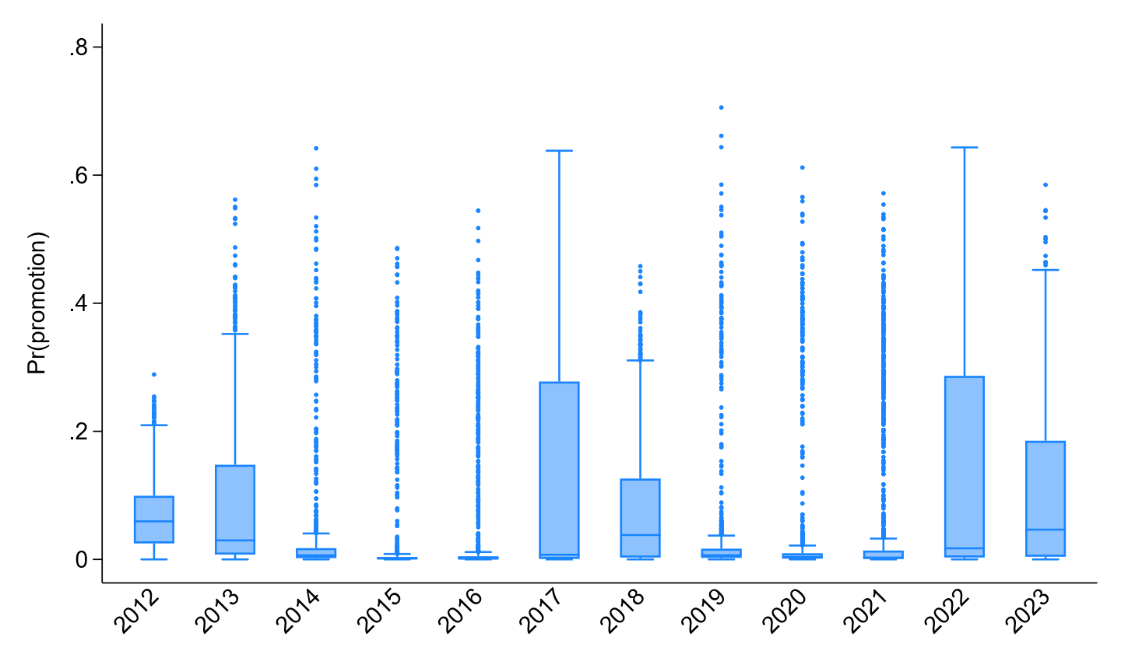
Panel H2. Distribution of Promotion Probabilities for All Members of the Provincial Party Committee and Provincial Government
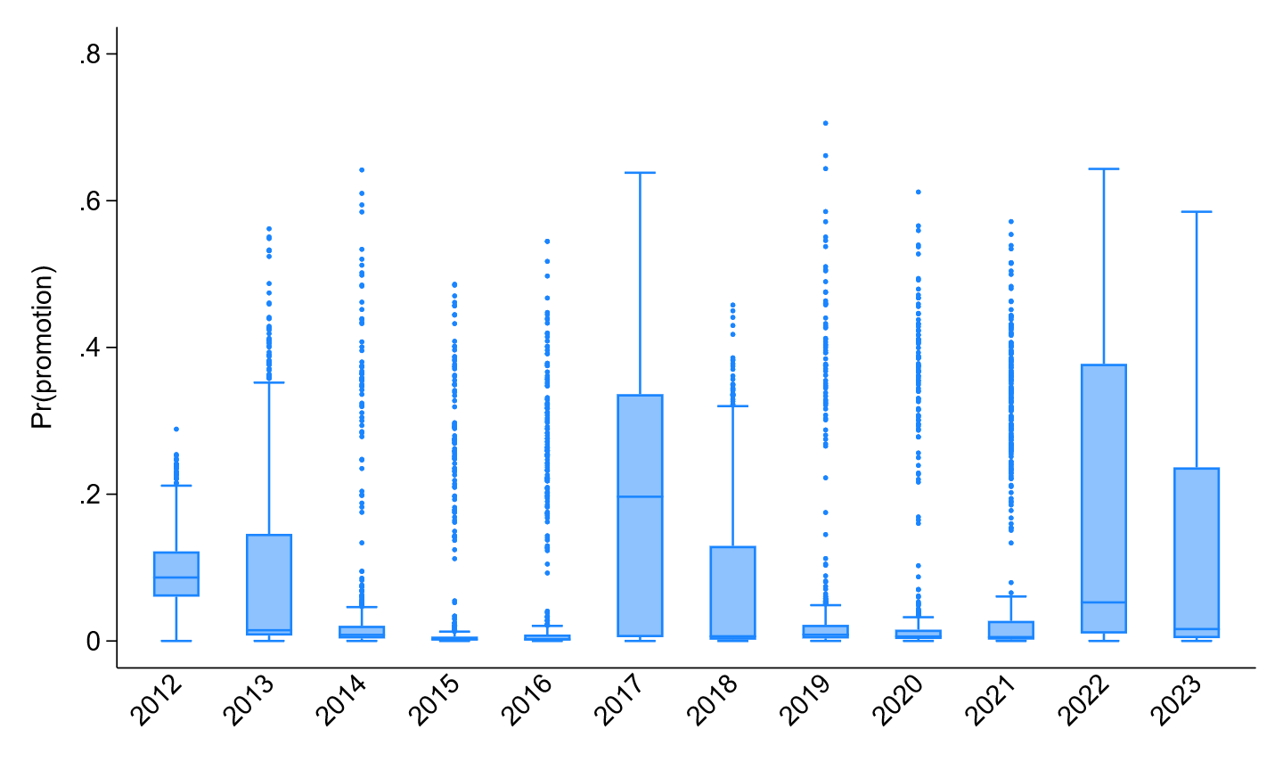
Panel H3. Distribution of Promotion Probabilities for All Members of the Provincial People's Congress and Provincial CPPCC
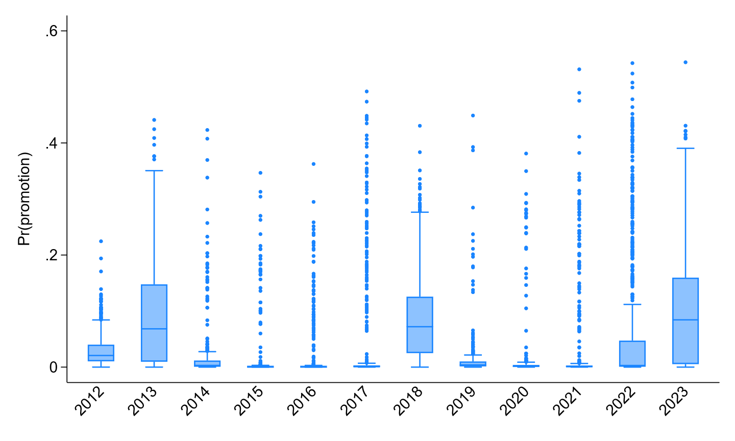

Table H2. China Provincial Leadership Elections (2007-2024)
Year | Election Event (Targets) | Provinces by Month
2007 | Provincial Party Committee | Apr: Guizhou, Gansu, Hainan, Heilongjiang  May: Shaanxi, Shanghai, Guangdong, Chongqing, Sichuan, Tianjin, Jilin, Qinghai, Beijing  Jun: Ningxia, Shandong, Hubei, Zhejiang
2008 | Provincial Gov., Congress, CPPCC | Jan: All 31 Provinces, Autonomous Regions, and Municipalities
2009 | None | -
2010 | None | -
2011 | Provincial Party Committee | Oct: Xinjiang, Anhui, Henan  Nov: Shanxi, Jiangxi, Jiangsu, Guangxi, Fujian, Hebei, Hunan, Inner Mongolia, Yunnan, Tibet, Liaoning
2012 | Provincial Party Committee | Apr: Guizhou, Hainan, Heilongjiang  May: Shaanxi, Gansu, Ningxia, Qinghai, Sichuan, Tianjin, Chongqing, Jilin, Hubei, Guangdong, Shanghai  Jun: Shandong, Zhejiang  Jul: Beijing
2013 | Provincial Gov., Congress, CPPCC | Jan-Feb: All 31 Provinces, Autonomous Regions, and Municipalities
2014 | None | -
2015 | None | -
Table H2. (Continued)
2016 | Provincial Party Committee | Oct: Xinjiang, Anhui, Henan, Shanxi  Nov: Jiangxi, Hunan, Hebei, Fujian, Guangxi, Yunnan, Inner Mongolia, Tibet  Dec: Jiangsu, Liaoning
2017 | Provincial Party Committee | Apr: Guizhou, Hainan, Heilongjiang  May: Shaanxi, Shanghai, Guangdong, Chongqing, Tianjin, Qinghai, Ningxia, Gansu, Sichuan, Jilin, Shandong  Jun: Beijing, Zhejiang, Hubei
2018 | Provincial Gov., Congress, CPPCC | Jan: All 31 Provinces, Autonomous Regions, and Municipalities
2019 | None | -
2020 | None | -
2021 | Provincial Party Committee | Oct: Xinjiang, Henan, Shanxi, Anhui  Nov: Jiangxi, Jiangsu, Hunan, Guangxi, Fujian, Yunnan, Tibet, Inner Mongolia, Hebei  Dec: Liaoning
2022 | Provincial Party Committee | Apr: Guizhou, Hainan  May: Heilongjiang, Guangdong, Qinghai, Ningxia, Shaanxi, Gansu, Sichuan, Chongqing, Shandong  Jun: Tianjin, Hubei, Jilin, Zhejiang, Shanghai, Beijing
2023 | Provincial Gov., Congress, CPPCC | Jan-Feb: All 31 Provinces, Autonomous Regions, and Municipalities
2024 | None | -

Appendix I. The structure of bureaucratic competition.
The three indicators measuring the bureaucratic competition structure within the provincial "four leading bodies" (HHI, CR3, and Gini) are calculated based on each official's annual ex-ante promotion probability, as predicted by the Probit model detailed in Appendix H. Specifically, we define as the predicted promotion probability for official i in province j in year t, and N as the total number of members in the "four leading bodies" of that province during that year.
The Herfindahl-Hirschman Index (HHI) of promotion opportunities quantifies the degree to which promotion prospects are monopolized within the leadership collective. Drawing on Industrial Organization theory, we conceptualize the bureaucratic system as a political market. This index is calculated as the sum of the squared shares of promotion incentives held by all officials. The specific calculation formula is as follows:
(6)
The Concentration Ratio (CR3) measures the extent to which promotion incentives are captured by the "core circle" of officials with the highest advancement prospects. It is calculated by aggregating the shares of the top three ranked officials:
(7)
The Gini Coefficient of Incentive Inequality (Gini) captures the overall degree of inequality in the distribution of promotion incentives among officials within a province, based on the Lorenz curve. We employ the standard Gini formula calculated from the relative mean difference of promotion probabilities, where denotes the arithmetic mean of the promotion probabilities for officials in province j in year t:
(8)

Appendix J. Calculation procedures for the resource allocation efficiency index.
To quantify the macro-level impact of "punitive decoupling" and "panic substitution" on regional resource allocation efficiency, we follow the classic methodology of Olley & Pakes (1996) to construct an OP covariance metric () at the province-industry-year level. This metric measures the degree to which the "scale" (national market position) and "efficiency" (productivity) of new entrants are positively aligned during expansion activities within a given province.
Ideally, the OP covariance would be calculated based on a firm's actual output share within the specific province. However, given that the annual reports of Chinese listed firms do not disclose granular sales data by province, and that paid-in capital data for subsidiaries in business registration records suffer from extensive missing values, we are unable to directly observe a firm's precise local market share. Consequently, we employ the listed parent company's share of national industry operating revenue as a proxy for the scale of firm expansion. This approach is grounded in a plausible economic assumption: a firm's revenue scale in the national market reflects its overall capacity for resource mobilization. Therefore, conditional on undertaking a large-scale expansion (Expansion = 1), a firm with a larger national market share is likely to commit a larger scale of factor inputs locally.
denotes the total factor productivity of listed firm i in year t, estimated using the Ackerberg et al. (2015)’s method.
Next, we measure the relative scale of firm i in year t within industry d at the national level, where denotes the total operating revenue of listed firm i in year t:
(9)
In contrast to the baseline stacked event dataset, we focus directly on the set of all firms, denoted as , that successfully entered (i.e., expanded into) industry d of province p in year t. Within this set, we calculate the covariance between scale and efficiency as follows:
(10)
Here, denotes the mean national market share of all expanding firms in industry d of province p in year t, and denotes the mean productivity of these firms.
A significant decline (or a negative value) in implies that within the province's expansion wave, "giants" (firms with high national shares) tend to be "underperformers" (firms with low efficiency). This aligns with the theoretical expectation that local governments introduce large but inefficient "substitute" firms to fulfill investment promotion quotas.

References
Ackerberg, D. A., Caves, K., & Frazer, G. (2015). Identification properties of recent production function estimators. Econometrica, 83(6), 2411–2451.
Altman, E. I. (1968). Financial ratios, discriminant analysis and the prediction of corporate bankruptcy. The Journal of Finance, 23(4), 589–609. JSTOR.
Jacobson, L. S., LaLonde, R. J., & Sullivan, D. G. (1993). Earnings losses of displaced workers. The American Economic Review, 83(4), 685–709. JSTOR.
Olley, G. S., & Pakes, A. (1996). The dynamics of productivity in the telecommunications equipment industry. Econometrica, 64(6), 1263–1297. JSTOR.
Zhao, Y., Yang, Y., & Zhang, N. (2026). Flood shocks, heterogeneous risk exposure, and housing market dynamics in China. Journal of Development Economics, 178, 103581.

School of Economics and Business Administration, Chongqing University, Chongqing 400030, China
Corresponding E-mail: littlefc@126.com
School of Business Administration, China University of Petroleum (Beijing) at Karamay, Karamay 834000, China
School of Economics and Business Administration, Chongqing University, Chongqing 400030, China
Business School, Zhengzhou University, Zhengzhou 450001, China
Anecdotal evidence vividly illustrates this dynamic. First, official reports confirm the prevalence of administrative obstructionism. In 2023, the Shanxi Provincial Commission for Discipline Inspection and Supervision identified "new officials reneging on old obligations" (Xin guan bu li jiu zhang) as a systemic impediment to the business environment. They explicitly noted that officials' failure to honor existing legal commitments and contractual agreements during "investment promotion" and "project advancement" directly resulted in project stagnation (CCDI News, http://www.lvliang.gov.cn/szdt/szfxw/dt/202312/t20231211_1820106.html). Second, the economic repercussions of this shock are pronounced at both the regional and firm levels. Following the downfall of senior officials such as Nie Chunyu, the former Party Secretary of Lvliang, in 2014, projects of local firms connected to them immediately stalled (People's Daily, http://finance.people.com.cn/money/n/2014/0901/c218900-25575763.html). Simultaneously, Lvliang’s economic growth rate plummeted from the highest to the lowest in Shanxi Province that year (Phoenix Finance, https://finance.ifeng.com/a/20150303/13525999_0.shtml). Furthermore, industry-level data corroborate this link. Between 2023 and 2025, anti-corruption investigations targeting over 350 healthcare officials coincided with reports from multinational corporations in Shanghai citing extended delays in tendering and delivery processes (Control Risks, https://www.controlrisks.com/our-thinking/insights/china-s-healthcare-sector-in-2025-anti-corruption-and-beyond). Finally, micro-level observations offer further insight into the shift in bureaucratic behavior. Through long-term contact with a branch director of a Land and Resources Bureau in a prefecture-level city in Zhejiang, we observed a distinct behavioral pivot around 2015: his attendance at weekend family dinners increased significantly, while the frequency and quantity of gifts received from entrepreneurs declined notably.
Specifically, we identified 3,991 unique officials who served in the provincial "four leading bodies" during this period. We ultimately obtained complete information for 3,870 of these individuals. Of the remaining 121 officials, 68 had no available information, and 53 were missing key data points; notably, 40 of the latter group were affiliated with the People's Liberation Army (PLA).
To ensure comparability with the period prior to the current anti-corruption campaign, the term "provincial-level local government officials" in these statistics refers broadly to officials of provincial rank serving in local governments, rather than being restricted solely to members of the provincial "four leading bodies."

