Q4 Creating Ransomware

Steps on how to run the program:

1. Generate a Pub Key for the attacker.

Code: gpg –gen-key

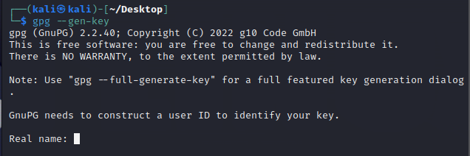

1. Enter name and Email.



1. Enter Passphrase.

Eg. Password123

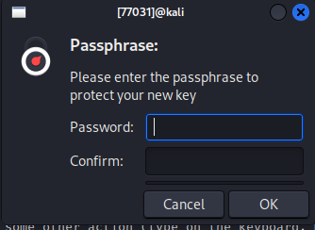

1. Generated Details.

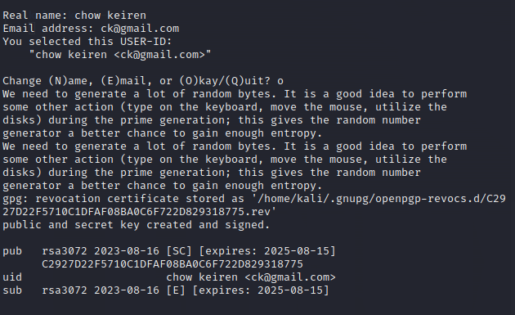

1. Save attacker pub key.

Code: gpg --armour --export “email” > pubkey.gpg.asc



1. Run ransomware.py

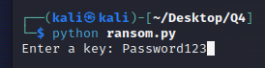

1. Popout Message

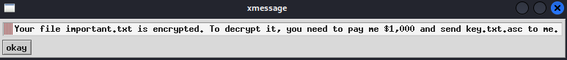

1. Files before and after

