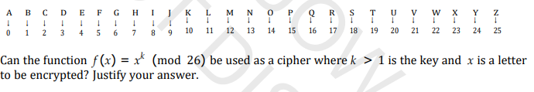

The function f(x) = x^k (mod 26) can be used as a substitution cipher, where each letter of the plaintext is mapped to another letter of the alphabet according to the key k, which is one to one mapping.

However, this method is not considered secure in modern cryptography, as the properties of modular arithmetic allow for the use of mathematical attacks to break the encryption. For example, if k is not a prime number relative to 26, then the function is vulnerable to a known plaintext attack, where an attacker can use knowledge of the plaintext and ciphertext to determine the value of k.

Furthermore, the function is deterministic, meaning that the same plaintext will always produce the same ciphertext when encrypted with the same key, making it vulnerable to frequency analysis attacks.

In the function f(x) = x^k (mod 26), it is possible for duplicate ciphertext to occur if there are duplicate inputs.

For example, if k is not a prime number relative to 26, then it is possible for two different letters of the alphabet to be mapped to the same letter. For instance, if k = 2, then both "A" and "M" would be mapped to "A" in the ciphertext.

The use of modular arithmetic ensures that the result of the exponentiation operation remains within the range of 0 to 25, which corresponds to the 26 letters of the alphabet. This is important because it ensures that the mapping between letters and numbers remains one-to-one, making it possible to reverse the process and find the original plaintext message.

In general, the possibility of duplicate ciphertext is a weakness of this method and makes it more vulnerable to certain types of cryptanalytic attacks. For this reason, this method is not recommended for use in modern cryptography, where stronger, more secure encryption methods are typically used.

If k is chosen to be a large prime number, the exponentiation operation becomes computationally infeasible to reverse without knowledge of the key. This makes the cipher secure against brute-force attacks, where an attacker tries all possible keys to find the original plaintext message.

Overall, the function f(x) = x^k (mod 26) can provide a strong cipher if k is selected carefully and kept secret.

In summary, while the function f(x) = x^k (mod 26) can be used as a substitution cipher