Firstly, when opening the file we see that it’s a .png file.

There seems to be nothing fishy about the file here ,so let’s run it through a steganography tool to see if anything is encoded into the file.

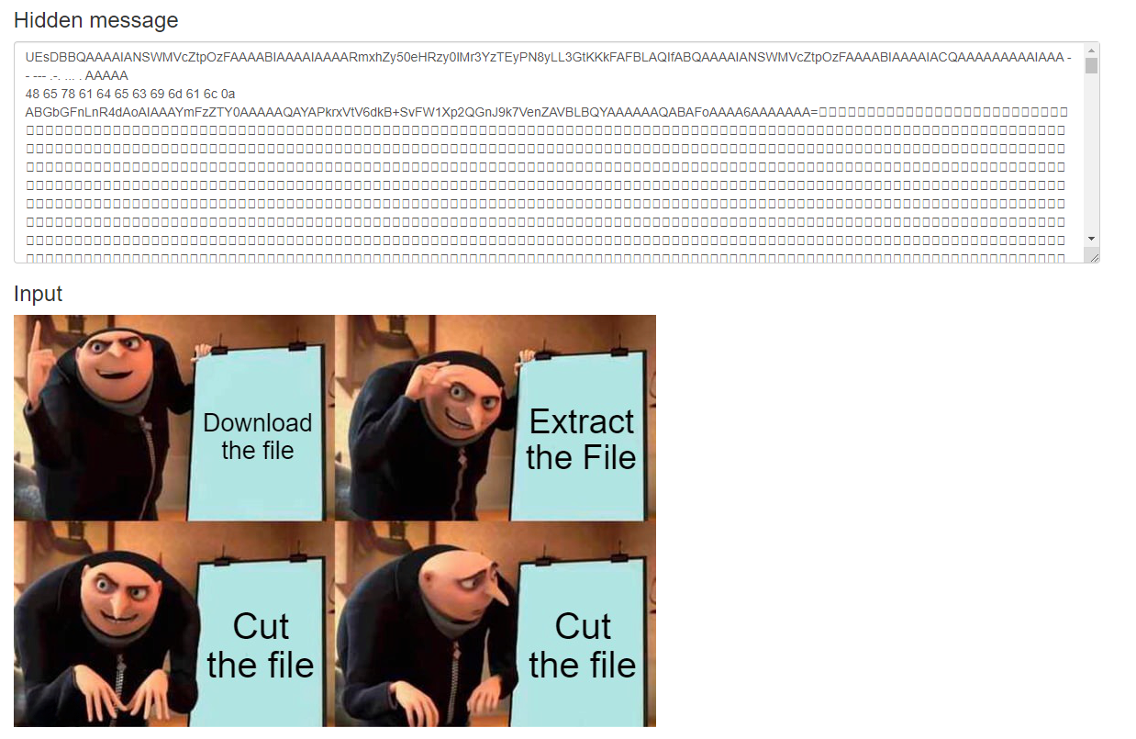

Here, we can see there is some suspicious looking string, lets try to put it in cyber chef to see if we can get anything from there

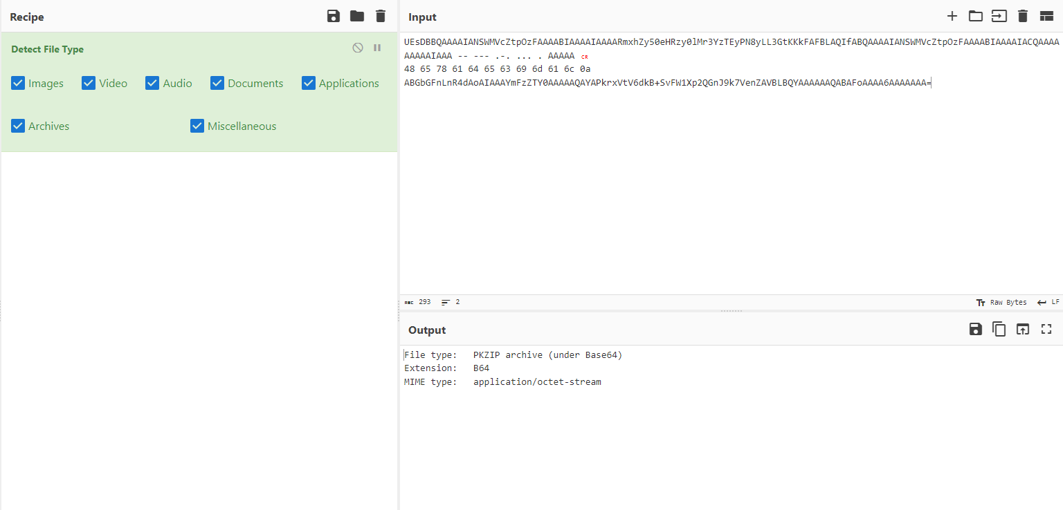

Using the magic tool we see that it is a zip file but its not opening?

Must be something wrong with the string

UEsDBBQAAAAIANSWMVcZtpOzFAAAABIAAAAIAAAARmxhZy50eHRzy0lMr3YzTEyPN8yLL3GtKKkFAFBLAQIfABQAAAAIANSWMVcZtpOzFAAAABIAAAAIACQAAAAAAAAAIAAA -- --- .-. ... . AAAAA

48 65 78 61 64 65 63 69 6d 61 6c 0a ABGbGFnLnR4dAoAIAAAYmFzZTY0AAAAAQAYAPkrxVtV6dkB+SvFW1Xp2QGnJ9k7VenZAVBLBQYAAAAAAQABAFoAAAA6AAAAAAA=

It appears to be a base 64 format as it ends with a “=” sign, but has suspicious other strings attached to it.

One part appears to be morse code.

The code spells out morse, lets cut it out for now

The other bits of foreign code seem to be hexadecimal lets try that.

Hmm, the hexadecimal part also says hexadecimal.

Lets try it again

Hmm, now in base 64 form we have a bit of string that says base64, this makes sense to cut it out as, the out morse for morse code ,and hexadecimal for hex.

And there we have it, the flag was in a zip file, but the zip file couldn’t be opened as there were some unneeded text in there.