4. METHODOLOGY
4.6 UI Components
4.6.1 Button
SFML offers only basic elements. For any type of UI responsive and interactive component such as a Button, different shapes available under the graphics.hpp / Graphics module is to be used. Basically for a button, a rectangular outlined shape with the button name horizontally and vertically centered inside the rectangular shape is required. SFML provides different shape which are inherited from sf::Shape. RectangleShape under the namespace sf is used to give the button an outline shape. The name for the button is fixed inside the RectangleShape using sf::Text element.
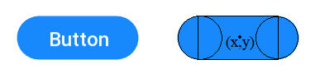
Figure 4.6: Button geometry

For additional styling of the Button, two circles object from sf::CircleShape is instantiated .The origin for each circle is repositioned at (circle.getRadius(), circle.getRadius()) (sf::CircleShape::getRadius() provides the radius of the circle shape). One of the circle is then positioned at the left boundary of the main rectangle, the other being at the right boundary. All the three shapes, main rectangle and two circles constitutes the button shape as shown in the figure 4.6.
The working of the button on click is done via a function wrapper. Std::function defined in the header functional.h is a general-purpose polymorphic function wrapper. Desired function in the form of lambda expression is bind to the button. Using sf::Event, the event for the mouse button click is detected and if at any instant the mouse cursor happens to click within the button shape boundary, the bind function is called. Button is rescaled for different action such as holding the button, hovering the button for some responsive animation purpose. At last, all these functionality is compiled as a Button class and each button can be easily created and used as Button::Object(“Button name”, button position, text character size, font to be used). To bind the triggering function, Button::Object::ButtonEvent(rendering window, event, lambda expression) method can be used.
4.6.2 Input Field
The basic design and the shape of the input text field is same as that of the button. It provides additional feature of typing the text within the field. Similar to the button geometry, the shape of the Inputfield consists of the main rectangle and two circle at each horizontal boundary.
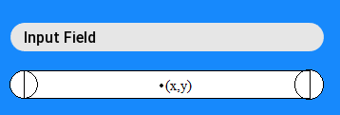
Figure 4.7: Input Field Geometry
Using the sf::Event::event, the position of the mouse and the mouse click is detected within the input field. On clicking within the field, the input field is in focused state which is denoted by an underscore. On typing, the real time keyboard input is polled via the sf::Event object and simultaneously changes are reflected to the text field. This component is also assembled in a Inputfield class. Instances of Inputfield can be easily created as Inputfield::input( input field position, font ).
4.6.3 Rounded Rectangle
Rectangular shapes can be easily created using sf::RectangleShape in SFML. Rectangle with rounded corners isn’t an option in SFML. To add rounded style to the right angled rectangle corner, there are two different ways. The first option is using the sf::ConvexShape. Sf::ConvexShape provides method to create polygon of required vertices point count. Each vertices can be set to the required point. For the rounded rectangle, eight point count polygon, not a octagon, can be used with four circles on each corner.
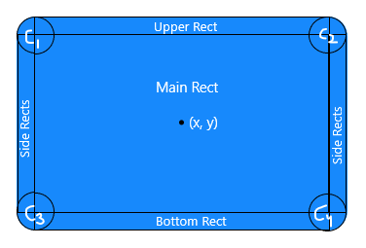
Figure 4.8: Rounded Rectangle Geometry
The latter way is to used multiple rectangles and four circles on each corner as shown in the figure 4.8. Based on the dimension and position of the main rectangle and the radius of the rounded corner, other filler rectangles are created.
Suppose the origin of the main rectangle is (x,y) and the radius of the rounded corner be z. Also let the dimension of the main rectangle be length = l and breadth = b. The position of each rect and circle are as follow:
C1 (x - l/2, y - b/2), C2 (x + l/2, y - b/2), C3(x - l /2, y + b/2), C4(x + l/2, y + b/2)
Left Side Rect (x – z/2, y), Right Side Rect (x + z/2, y)
Upper Rect (x, y - z/2), Bottom Rect(x, y + z/2)
4.6.4 Scrollable View
SFML provides sf::View used for rendering only a required small section of the main window. Using sf::View::view, we can create scroll like effect. It is possible using the sf::View::setViewPort. The method setViewPort takes a floatrect which defines the size of the view in the rendering window. The floatrect takes the float value ranging from 0 to 1. ‘0’representing 0 and 1 representing the whole size of the window in a given direction. The contents are then displayed only in the view and using the MouseScrollEvent from the sf::Event, the scrolling effect is attained.

