Project Roadmap 2026: Mathchines
Prepared for Desmond Appiah
Build with AI Internship Program 2026
Date: July 15, 2026
This document outlines the detailed 12-Week Project Roadmap for Mathchines during the Build with AI Internship Program 2026. It aligns the product development milestones, beta testing strategy, market launch preparations, and weekly reporting workflows.

1. Roadmap Overview
The roadmap is structured into four sequential execution phases over a 12-week runway:
- Phase 1: MVP Hardening & Content Compilation (Weeks 1–4)
- Stabilize the client-side database, expand static curriculum coverage, and optimize the AI explanation engine.
- Phase 2: Beta Testing & Quality Validation (Weeks 5–8)
- Recruit testing cohorts, execute structured learning sessions, and compile feedback.
- Phase 3: Product Iteration & Market Prep (Weeks 9–12)
- Implement fixes, draft GTM strategies, refine pitch decks, and produce visual marketing assets.
- Phase 4: Ongoing Compliance (Daily & Weekly)
- Submit EOD deliverables reports and track hub support activities.

2. Master Execution Diagram
The diagram below integrates all execution phases, weekly objectives, deliverables, and dependencies into a single visual roadmap:
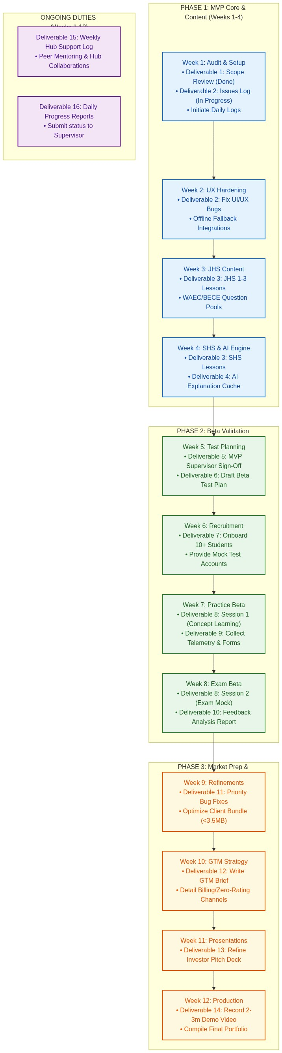

4. Work Package Specifications
Work Package A: MVP Completion (Weeks 1–5)
- Objective: Ensure the core learning loop works end-to-end under simulated network constraints.
- Key Tasks:
- Clean up state transitions in the adaptive quiz selector.
- Integrate offline-resilient error capturing to prevent the frontend crashing during API timeouts.
- Write full answer explanations for all 40 static practice questions.
Work Package B: Beta Validation (Weeks 5–8)
- Objective: Verify user engagement metrics, math scoring improvements, and offline database caching reliability.
- Key Tasks:
- Draft test cases focusing on Ama (struggling student), Kofi (accelerator), and Kwame (low-connectivity).
- Instrument local telemetry trackers in localStorage to record streaks, elapsed time, and difficulty progression.
- Collate findings into a central CSV repository.
Work Package C: Market Preparation (Weeks 9–12)
- Objective: Prepare Mathchines for scale and external communication with stakeholders.
- Key Tasks:
- Polish UI transitions and clean unused imports to ensure fast page load speeds.
- Structure slides in `PITCH_DECK.md` to be easily readable via markdown deck extensions.
- Record high-definition screencasts demonstrating the local database syncing capabilities.

