J



**JIMMA UNIVERSITY INSTITIUTION OF TECHNOLOGY**

**FACULTY OF COMPUTING**

**DEPARTMENT OF COMPUTER SCIENCE**

**ASSIGNMENT OF AI**

**TITLE: ROBOTS, COMPONENTS AND APPLICATION OF ROBOTS**

**Group 2**

NAME ID

1. MOSISA DEJENE……………………..2973/11
2. GAROMA TADESE…………………….2857/11
3. SHALOM BERSISA…………………...0819/10
4. MULUKEN HAILU…………………….2957/11

**ROBOTS**

**Definition**

Robots are any automatically operated [machine](https://www.britannica.com/technology/machine) that replaces human effort, though it may not resemble human beings in appearance or perform functions in a humanlike manner.

Also **,a robot is the product of robotics field, where programmable machines are built that can assist humans or mimics human actions. Robots were originally built to handle monotonous tasks(like building cars on an assembly line),but have since expanded well beyond their intial use to perform tasks like fighting fires, cleaning homes and assisting with incredibily intricate surgeries. Each robot has differing level of autonomy ranging from human controlled bots that carry out tasks that a human has full controlled over to fully autonomous bots that perform task without any external influences.**

**What Is Robotics?**

Robotics is the intersection of science, engineering and technology that produces machines, called robots, that substitute for (or replicate) human actions. Pop culture has always been fascinated with robots. R2-D2. Optimus Prime. WALL-E. These over-exaggerated, humanoid concepts of robots usually seem like a caricature of the real thing...or are they more forward thinking than we realize? Robots are gaining intellectual and mechanical capabilities that don’t put the possibility of a R2-D2-like machine out of reach in the future**.**

While the overall world of robotics is expanding, a robot has some consistent characteristics:

1. Robots all consist of some sort of mechanical construction. The mechanical aspect of a robot helps it complete tasks in the environment for which it’s designed. For example, the [Mars 2020 Rover’s wheels](https://mars.nasa.gov/mars2020/mission/rover/wheels/) are individually motorized and made of titanium tubing that help it firmly grip the harsh terrain of the red planet.
2. Robots need electrical components that control and power the machinery. Essentially, an electric current (a battery, for example) is needed to power a large majority of robots.
3. Robots contain at least some level of computer programming. Without a set of code telling it what to do, a robot would just be another piece of simple machinery. Inserting a program into a robot gives it the ability to know when and how to carry out a task.

**Types of Robots**

### Mechanical bots come in all shapes and sizes to efficiently carry out the task for which they are designed. All robots vary in design, functionality and degree of autonomy. From the 0.2 millimeter-long “RoboBee” to the 200 meter-long robotic shipping vessel “Vindskip,” robots are emerging to carry out tasks that humans simply can’t. **Generally, there are five types of robots:**

### **1) Pre-Programmed Robots**

Pre-programmed robots operate in a controlled environment where they do simple, monotonous tasks. An example of a pre-programmed robot would be a mechanical arm on an automotive assembly line. The arm serves one function — to weld a door on, to insert a certain part into the engine, etc. — and its job is to perform that task longer, faster and more efficiently than a human.

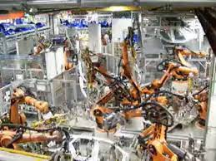

### **2) Humanoid Robots**

Humanoid robots are robots that look like and/or mimic human behavior. These robots usually perform human-like activities (like running, jumping and carrying objects), and are sometimes designed to look like us, even having human faces and expressions. Two of the most prominent examples of humanoid robots are [Hanson Robotics’ Sophia](https://www.hansonrobotics.com/sophia/) (in the video above) and Boston

’  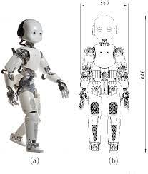

### **3) Autonomous Robots**

Autonomous robots operate independently of human operators. These robots are usually designed to carry out tasks in open environments that do not require human supervision. They are quite unique because they use sensors to perceive the world around them, and then employ decision-making structures (usually a computer) to take the optimal next step based on their data and mission. An example of an autonomous robot would be the Roomba vacuum cleaner, which uses sensors to roam freely throughout a home.

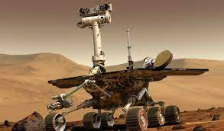

### **4) Teleoperated Robots**

Teleoperated robots are semi-autonomous bots that use a wireless network to enable human control from a safe distance. These robots usually work in extreme geographical conditions, weather, circumstances, etc. Examples of teleoperated robots are the human-controlled submarines used to fix underwater pipe leaks during the BP oil spill or [drones used to detect landmines](https://builtin.com/robotics/landmine-detecting-drones-could-help-save-lives) on a battlefield.

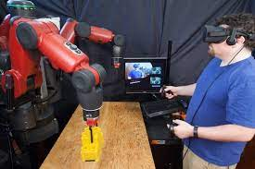

**5) Augmenting**

Augmenting robots either enhance current human capabilities or replace the capabilities a human may have lost. The field of robotics for human augmentation is a field where science fiction could become reality very soon, with bots that have the ability to redefine the definition of humanity by making humans faster and stronger. Some examples of current augmenting robots are robotic prosthetic limbs or exoskeletons used to lift hefty weights.

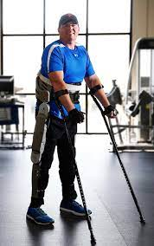

## 

**How do robots function?**

**Independent robots**

Independent robots are capable of functioning completely autonomously and independent of human operator control. These typically require more intense programming but allow robots to take the place of humans when undertaking dangerous, mundane or otherwise impossible tasks, from bomb diffusion and deep-sea travel to factory automation. Independent robots have proven to be the most disruptive to society, eliminating low-wage jobs but presenting new possibilities for growth.

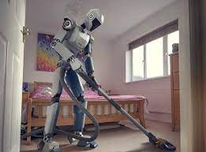

**Dependent robots**

Dependent robots are non-autonomous robots that interact with humans to enhance and supplement their already existing actions. This is a relatively new form of technology and is being constantly expanded into new applications, but one form of dependent robots that has been realized is advanced prosthetics that are controlled by the human mind.

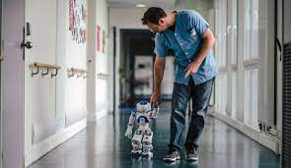

## **Main components of a robot**

Robots are built to present solutions to a variety of needs and fulfill several different purposes, and therefore, require a variety of specialized components to complete these tasks. However, there are several components that are central to every robot’s construction, like a power source or a central processing unit. Generally speaking, robotics components fall into these five categories:

### **Control system**

Computation includes all of the components that make up a robot’s central processing unit, often referred to as its control system. Control systems are programmed to tell a robot how to utilize its specific components, similar in some ways to how the human brain sends signals throughout the body, in order to complete a specific task. These robotic tasks could comprise anything from minimally invasive surgery to assembly line packing.

**Sensors**

Sensors provide a robot with stimuli in the form of electrical signals that are processed by the controller and allow the robot to interact with the outside world. Common sensors found within robots include video cameras that function as eyes, photoresistors that react to light and microphones that operate like ears. These sensors allow the robot to capture its surroundings and process the most logical conclusion based on the current moment and allows the controller to relay commands to the additional components.

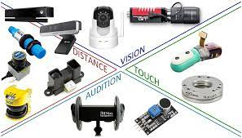

**Actuators**

As previously stated, a device can only be considered to be a robot if it has a movable frame or body. Actuators are the components that are responsible for this movement. These components are made up of motors that receive signals from the control system and move in tandem to carry out the movement necessary to complete the assigned task. Actuators can be made of a variety of materials, such as metal or elastic, and are commonly operated by use of compressed air (pneumatic actuators) or oil (hydraulic actuators,) but come in a variety of formats to best fulfill their specialized roles.

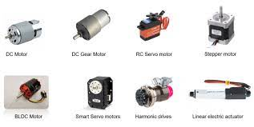

**Power Supply**

Like the human body requires food in order to function, robots require power. Stationary robots, such as those found in a factory, may run on AC power through a wall outlet but more commonly, robots operate via an internal battery. Most robots utilize lead-acid batteries for their safe qualities and long shelf life while others may utilize the more compact but also more expensive silver-cadmium variety. Safety, weight, replaceability and lifecycle are all important factors to consider when designing a robot’s power supply.

Some potential power sources for future robotic development also include pneumatic power from compressed gasses, solar power, hydraulic power, flywheel energy storage organic garbage through anaerobic digestion and nuclear power.

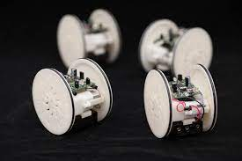

**End Effectors**

End effectors are the physical, typically external components that allow robots to finish carrying out their tasks. Robots in factories often have interchangeable tools like paint sprayers and drills, surgical robots may be equipped with scalpels and other kinds of robots can be built with gripping claws or even hands for tasks like deliveries, packing, bomb diffusion and much more.

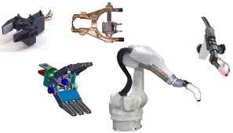

## **Uses of Robots**

Robots have a wide variety of use cases that make them the ideal technology for the future. Soon, we will see robots almost everywhere. We'll see them in our hospitals, in our hotels and even on our roads.

**Manufacturing**

The manufacturing industry is probably the oldest and most well-known user of robots. These robots and co-bots (bots that work alongside humans) work to efficiently test and assemble products, like cars and industrial equipment. It’s estimated that there are more than three million industrial robots in use right now.

**Logistics**

Shipping, handling and quality control robots are becoming a must-have for most retailers and logistics companies. Because we now expect our packages to arrive at blazing speeds, logistics companies employ robots in warehouses, and even on the road, to help maximize time efficiency. Right now, there are robots taking your items off the shelves, transporting them across the warehouse floor and packaging them. Additionally, a rise in last-mile robots (robots that will autonomously deliver your package to your door) ensure that you’ll have a face-to-metal-face encounter with a logistics bot in the near future.

**Home**

It’s not science fiction anymore. Robots can be seen all over our homes, helping with chores, reminding us of our schedules and even entertaining our kids. The most well-known example of home robots is the autonomous vacuum cleaner [Roomba](https://www.irobot.com/roomba). Additionally, robots have now evolved to do everything from autonomously mowing grass to cleaning pools.

**Travel**

Is there anything more science fiction-like than autonomous vehicles? These self-driving cars are no longer just imagination. A combination of data science and robotics, self-driving vehicles are taking the world by storm. Automakers, like Tesla, Ford, Waymo, Volkswagen and BMW are all working on the next wave of travel that will let us sit back, relax and enjoy the ride. Rideshare companies Uber and Lyft are also developing autonomous rideshare vehicles that don’t require humans to operate the vehicle.

**APPLICATIONS OF ROBOTS**

There are many jobs in industries like **manufacturing, agriculture, entertainment,** etc. which require boring monotonous work that also requires a lot of precision. In such situations, robots are better suited than humans because they are precise, intelligent, and don’t get bored like humans! There are also tasks like **space and underwater exploration** that are very dangerous and unsafe for humans. Here also, robots are the best fit because they never get tired and there is no chance of a robot getting killed! Because of these advantages, there are many applications of robots in almost all the industries you can imagine.

1. **Security**

Imagine if all the security guards are robots? Even thieves would be scared! That’s why robots are being proposed as security agents as they can protect humans, and they wouldn’t be in danger like human security guards would be. Currently, robotics companies are working on pairing robot guards with human security consultants. A very famous company in this field is Knightscope in the United States that has autonomous security robots capable of assisting human security guards with real-time, actionable intelligence. These robots can help with crimes such as armed robberies, burglaries, domestic violence, fraud, hit, and runs, etc.



**2. Space Exploration**

There are many things in space that are very dangerous for astronauts to do. Humans can’t roam on Mars all day to collect soil samples or work on repairing a spaceship from the outside while it’s in deep space! In these situations, robots are a great choice because there are no chances for the loss of human life then. So space institutions like NASA frequently use robots and autonomous vehicles to do things that humans can’t. For example, Mars Rover is an autonomous robot that travels on Mars and takes pictures of Martian rock formations that are interesting or important and then sends them back on Earth for the NASA scientists to study.

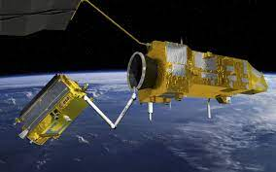

**3. Entertainment**

Robots are also a big draw in the entertainment industry. While they cannot exactly become actors and actresses, they can be used behind the sets in movies and serials to manage the camera, provide special effects, etc. They can be used for boring repetitive tasks that are not suitable for a human as cinema is, after all, a creative industry. Robots can also be used to do stunt work that is very dangerous for humans but looks pretty cool in an action movie. Theme parks like Disney World are also using autonomous robots to enhance the magical experience of their customers.

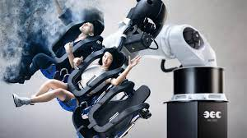

**4. Agriculture**

Agriculture is the sector that is the basis of human civilization. However, agriculture is also a seasonal sector that is dependent on ideal weather conditions optimal soil, etc. Moreover, there are many repetitive tasks in agriculture that are just a waste of farmer’s time and can be performed more suitable by robots. These include seeding, weed control, harvesting, etc. Robots are usually used for harvesting the crops which allow farmers to be more efficient. An example of a robot that is used to remove weeds in farms is the Ecorobotix. It is powered by solar energy and can be used to target and spray weeds using a complex camera system.

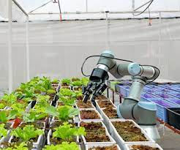

**5. Health Care**

Robots have changed healthcare a lot. And all for the better! They can help doctors in performing operations more precisely, be used as prosthetic limbs, provide therapy to patients, etc. The possibilities are limitless. One example of this is the ***da Vinci robot*** that can help surgeons in performing complex surgeries relating to the heart, head, neck, and other sensitive areas. There are other robotic devices that are created like exoskeletons that can be used to provide additional support for people undergoing rehabilitation after spinal injures, strokes, etc.

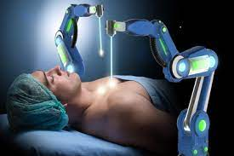

**6. Underwater Exploration**

Robots are a great option for exploring places that humans cannot reach easily, like the depths of the ocean! There is a lot of water pressure deep in the ocean which means humans cannot go that down and machines such as submarines can only go to a certain depth as well. A deep underwater is a mysterious place that can finally be explored using specially designed robots. These robots are remote-controlled, and they can go into depths of the ocean to collect data and images about the aquatic plant and animal life.

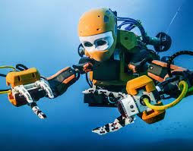

**7. Food Preparation**

Don’t want to cook? Don’t worry, there are robots that even can cook and create complete meals for you! These robot chefs can create food using hundreds of different recipes. All humans need to do is choose the recipe they want and provide the robot with pre-packaged containers of all the ingredients that are needed for that recipe. The robot can then cook the food on its own. Moley Robotics is one such robotics company that has created a robotic kitchen with a robot that can cook like a master chef! So no worries if you can’t cook food. Because now a robot can!

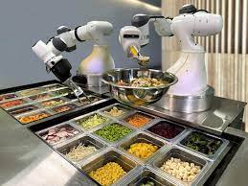

**8. Military**

Robots also have many applications in the military. They can be used as drones to keep surveillance on the enemy, they can also be used as armed systems to attack the opposing forces or as Medicare agents to help friendly forces. Some of the popular robots used in the Military sector include MAARS (Modular Advanced Armed Robotic System) which looks like a tank and contains tear gas and lasers to confuse enemies and even grenade launcher for desperate situations. DOGO is also a tactical combat robot that has a camera for spying on the activities of the enemy and a 9-millimeter pistol for emergency situations!

