

**JIMMA UNIVERSITY**

**JIMMA INSTITUTE OF TECHNOLOGY**

**FACULTY OF COMPUTING AND INFORMATICS**

**DEPARTEMENT OF COMPUTER SCIENCE**

**ARTIFICIAL INTELLIGENCE: ASSIGNMENT-I**

**GROUP ASSIGNMENT**

**Section: Two**

**Group member**

|  |  |  |  |
| --- | --- | --- | --- |
| **S.NO** | **FNAME** | **LNAME** | **ID NO** |
| **1** | ASTER | LEMMA | RU 2825/11 |
| **2** | TEKALIGN | JIRU | RU 3065/11 |
| **3** | ABDUREZAK | MUHEDIN | RU 2946/11 |
| **4** | ERMIAS | ABERE | RU 2818/11 |

**Submitted To: Mr Desalegn**

**Submission date: May 11, 2022**

**Jimma, Ethiopia**

Table of Contents

**1****Ethical and legal considerations of artificial intelligence and algorithmic decision‑making in personalized pricing** 1

1.1 Introduction 1

1.2 Ethical considerations: conceptual foundations 2

1.2.1 Legal constraints: conceptual foundations 2

**2****Legal and ethical consideration of artificial intelligence in health care: Who takes responsibility?** 4

2.1 Legal Considerations for Use and/or Development of Artificial Intelligence in Health Care 5

2.2 Ethical considerations 6

**3****Artificial Intelligence in Business: Legal & Ethical Considerations** 8

3.1 What are Some Legal Considerations For Your Business’ AI Development? 8

3.1.1 What are Some Ethical Considerations When Creating AI Solutions? 9

# **Ethical and legal considerations of artificial intelligence and algorithmic decision‑making in personalized pricing**

## **Introduction**

**Artificial intelligence (AI)**: the program that interprets and analyzes the data without explicit coding, makes predictions, and executes decisions to maximize a utility function (or goal). We limit our scope of AI to the subset of machine learning where programs learn to change when exposed to new data.

Pricing is a tremendously important component of the organizational marketing mix. Decision-making within the pricing function has evolved from an individual clerical task driven by instinct to a cross-functional team activity that drives strategic value. Evidence supports the assertion that developing significant pricing capabilities positively affects overall firm performance.

## Ethical considerations: conceptual foundations

Ethical considerations addressed by the literature include the degree to which deception (or perceived deception) creates individual harm. Analogously, information asymmetry and negative externalizations caused by price discrimination can result in widespread social injustice.Given this wide perceptual schism; it is unsurprising that concerns of deception, fairness, and social justice have attracted widespread attention.

* Deception as an ethical consideration
* Fairness as an ethical consideration
* Social justice as an ethical consideration
* **Deception as an ethical consideration**

Deception is an ethical framework considered by firms that deploy algorithmic pricing models.

* **Fairness as an ethical consideration**

Fairness is an ethical framework considered by firms that deploy algorithmic pricing models.

* **Social justice as an ethical consideration**

### Legal constraints: conceptual foundations

#### Antitrust as a legal constraint

#### Anti-discrimination as a legal constraint

#### Data privacy as a legal constraint

* **Antitrust as a legal constraint**

Antitrust factors are not legal constraints presently considered by firms that deploy algorithmic pricing models.

* **Anti-discrimination as a legal constraint**

Anti-discrimination doctrine is a legal constraint considered by firms that deploy algorithmic pricing models.

* **Data privacy as a legal constraint**

Data privacy doctrine is a legal constraint considered by firms that deploy algorithmic pricing models.

**Conceptual model and literature review**

Informed by the literature and significant practitioner experience, the following preliminary conceptual model is offered as a framework for the proposed qualitative studies.

[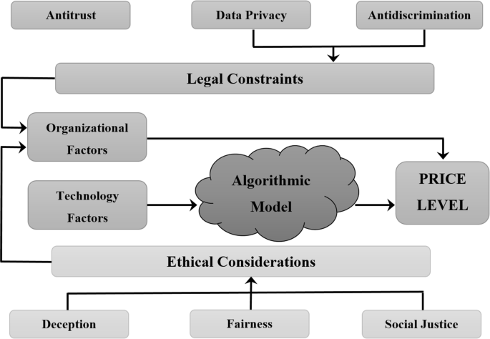](https://link.springer.com/article/10.1057/s41272-019-00225-2/figures/1)

# **Legal and ethical consideration of artificial intelligence in health care: Who takes responsibility?**

The legal and ethical issues that confront society due to Artificial Intelligence (AI) include privacy and surveillance, bias or discrimination, and potentially the philosophical challenge is the role of human judgment. Concerns about newer digital technologies becoming a new source of inaccuracy and data breaches have arisen as a result of its use. Mistakes in the procedure or protocol in the field of health care can have devastating consequences for the patient who is the victim of the error. Because patients come into contact with physicians at moments in their lives when they are most vulnerable, it is crucial to remember this. Currently, there are no well-defined regulations in place to address the legal and ethical issues that may arise due to the use of artificial intelligence in health care settings. This review attempts to address these pertinent issues highlighting the need for algorithmic transparency, privacy, and protection of all the beneficiaries involved and security of associated vulnerabilities.

## **Legal Considerations for Use and/or Development of Artificial Intelligence in Health Care**

Legal issues that health care providers and health care companies should consider when using and/or developing artificial intelligence (AI).

* statutory, regulatory and common law requirements
* ethical considerations
* reimbursement issues
* contractual exposure
* torts and private causes of action
* antitrust issues;
* employment and labor considerations;
* privacy and security risks;
* intellectual property considerations; and
* Compliance program implications.
* **Statutory, Regulatory and Common Law Requirements**

Regardless of whether you encounter AI as a health care provider or a developer (or both); there are statutory, regulatory and common-law requirements that may be implicated when considering AI in the health care space.

* **Ethical Considerations**

Where health care decisions have been almost exclusively human in the past, the use of AI in the provision of health care raises ethical questions relating to accountability, transparency and consent.

* **Reimbursement Issues**

The use of AI in both patient care and administrative functions raises questions relating to reimbursement by payors for health care services.

* **Contractual Exposure**

Both as a developer of AI or a health care provider utilizing AI, it is important to have clearly articulated contracts governing the sale and use of AI technology.

* **Torts and Private Causes of Action**

If AI is involved in the provision of health care (or other) services, both the developer and provider of the services may have liability under a variety of tort law principles.

* **Antitrust Issues**

The Antitrust Division of the Department of Justice (the DOJ) has made remarks regarding algorithmic collusion that may impact the use of AI in the health care space.

* **Employment and Labor Considerations**

The use of AI in the workforce will likely impact the structure of employment arrangements as well as employment policies, training and liability.

* **Privacy and Security Risks**

Speaking of confidentiality, the use and development of AI in health care poses unique challenges to companies that have ongoing obligations to safeguard protected health information, personally identifiable information and other sensitive information.

* **Intellectual Property Considerations**

It is of particular importance for AI developers to preserve and protect the intellectual property rights that they may be able to assert over their developments (patent rights, trademark rights, etc.)

* **Compliance Program Implications**

As technology evolves, so should a provider’s compliance program. When new technology such as AI is introduced, compliance program policies and procedures should be updated based on the new technology.

## Ethical considerations

There is a continuous debate regarding whether AI “fits within existing legal categories or whether a new category with its special features and implications should be developed.” The application of AI in clinical practice has enormous promise to improve health care, but it also poses ethical issues that we must now address.

* **To fully achieve the potential of AI in healthcare, four major ethical issues must be addressed:**

1. informed consent to use data
2. safety and transparency
3. algorithmic fairness and biases, and
4. Data privacy are all-important factors to consider.

Whether AI systems may be considered legal is not only a legal one but also a politically contentious one. The aim is to help policymakers ensure that the moral demanding situations raised by enforcing AI in health care settings are tackled proactively. The limitation of algorithmic transparency is a concern that has dominated most legal discussions on artificial intelligence. The rise of AI in high risk situations has increased the requirement for accountable, equitable, and transparent AI design and governance. The accessibility and comprehensibility of information are the two most important aspects of transparency. Information about the functionality of algorithms is frequently deliberately made difficult to obtain. Our capacity to trace culpability back to the maker or operator is allegedly threatened by machines that can operate by unfixed rules and learn new patterns of behavior. The supposed “evening” divide is a cause for alarm, as it threatens “both the moral framework of society and the foundation of the liability idea in law.” The use of AI may leave us without anyone to hold accountable for any sort of damage done.

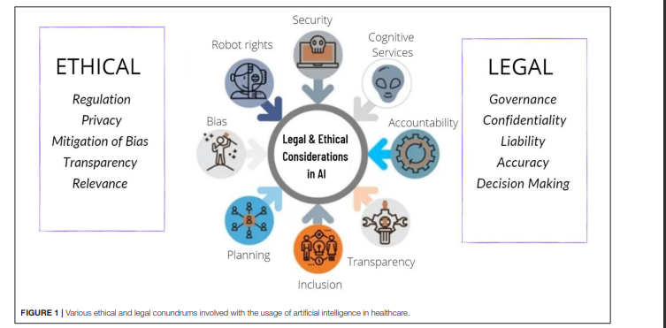

# **Artificial Intelligence in Business: Legal & Ethical Considerations**

Artificial intelligence (AI) is an area of computer science where intelligent machines and software systems are designed to mimic human behavior. AI solutions can be created for the healthcare, transport, financial and business, as well as manufacturing and retail sectors.

## What are Some Legal Considerations for Your Business’ AI Development?

* **Obtaining a patent for your AI invention**

An AI invention is patentable if it meets all three of these requirements:

1. **It is new.** An invention is new if the global public does not know of it in any way. The invention should therefore be kept confidential before a patent is filed for it. In this regard, an organization should consider preparing [non-disclosure agreements](https://singaporelegaladvice.com/law-articles/non-disclosure-agreement-guide" \t "C:/Users/ASTER%20LEMMA/Downloads/) and encrypting documents that mention the AI invention.
2. **It has an inventive step.** There must be an improvement over products and processes that are already available.
3. **It is capable of industrial application.** This means the AI invention can be made or used for practical purposes in any industry.

* **Is your AI invention protected by copyright?**

The three requirements for copyright to subsist in the source code or data compilation for an AI invention are:

1. **The work is original**. It should originate from the author and it must not be copied from another work.
2. **It has sufficient connection to a country**. The author is a country citizen or resident in country. Alternatively, the work is published in country.
3. **It is fixed on a tangible medium**. For instance, the work is in writing on a piece of paper.

* **What happens if an AI causes potential harm to a human?**

One such recommendation is a design framework that helps organizations regulate the level of human involvement in AI-facilitated decision-making. The design framework has two axes:

1. The probability of harm
2. The severity of harm to an end-user because of a decision made by the organization that involved the use of AI.

* **What happens if an AI invention causes a data breach?**

Another potential risk of using AI solutions is the possibility of the AI invention causing a data breach. A data breach could arise where, for example, personal data processed by the AI invention is leaked due to the negligence of the inventors, any person or employee involved.

To manage and monitor the data collected by their AI solutions, business owners and employees involved should regularly review the AI systems or logs to identify possible security issues. Organizations should also implement privacy policies and practices to inform employees of their rights and responsibilities when managing personal data, and ensure that the public is aware of how the organization uses the data collected or manages risks.

### What are Some Ethical Considerations When Creating AI Solutions?

1. **AI should not discriminate or violate internationally recognized human rights** such as a person’s right to liberty.
2. **Organizations should be able to explain the decision-making process within the AI invention** in non-technical terms to people. This allows the public to probe, understand and trust the AI solutions.
3. **The AI invention should be accurate and reviewable by third-parties,** which can be done by creating and keeping audit trails and logs. This ensures that the operations are verifiable and transparent.