About Cyberopoly

Cyberopoly is a game that is similar to the likes of monopoly but with a few twists and changes to fit our time constraints and ideas.  
  
Firstly lets talk about the start screen, The start screen will not allow the user to play unless they input a value of players between 2 to 4 and this will allow them to set the player amount by clicking the set players button below the input box. Once that is done, this will enable the play game button.   
  
Next, the players will be brought to the player select screen which will contain up to 4 total player piece selection controls, the game cannot be started unless all players select their icon which is their game piece. You’re able to cycle between the possible 5 pieces each player has, and when you’ve selected the one you want, click the set piece button and then do so for all players. Once that is done, now you can begin the game of Cyberopoly.

Before I get to the rules of the game lets explain the board, below will be an image of the board, and this board contains all the properties. Each property or space is labeled by name, except for a few. Those are the utilities like electric company, water works, the tax spaces of income and luxury tax, and the chance and community chest spaces. Each are shown by specific icons:

Chance spaces have a circle with a question mark in the middle.

Community Chest have Chest icons on their space

Water Works has a faucet with a drip of water

Electric Company has a light bulb

Income tax has a piggy bank

Luxury tax has a Diamond.

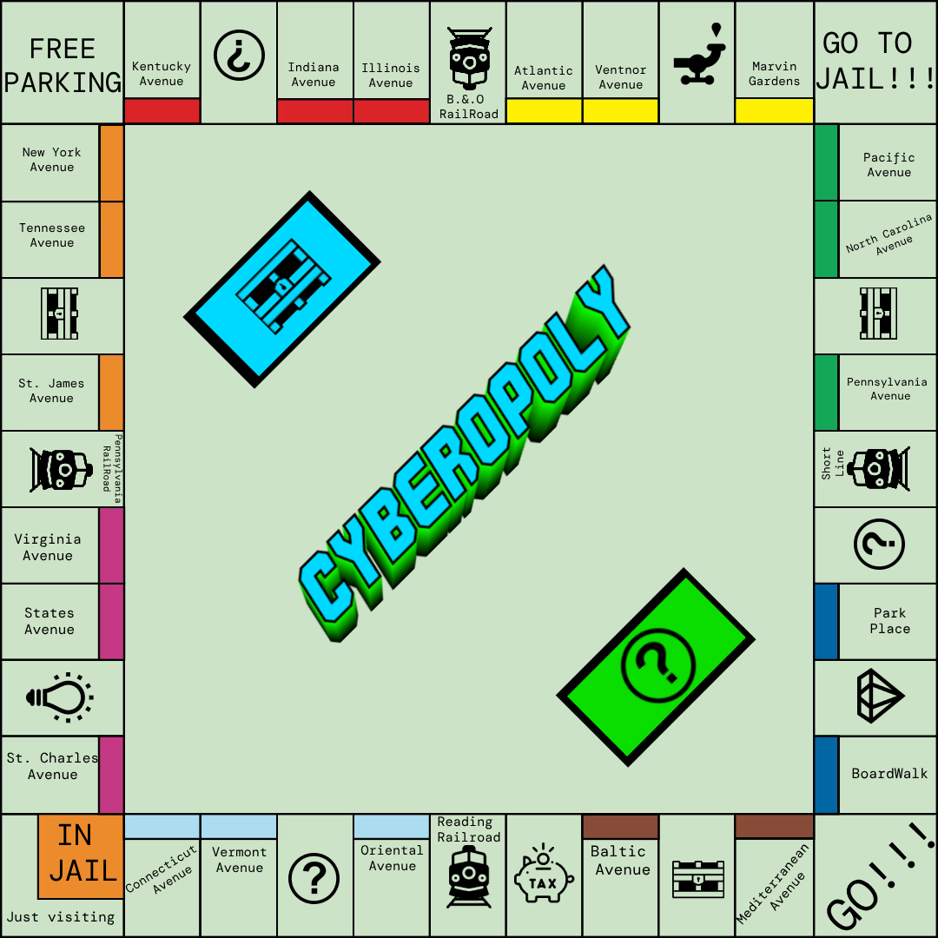

In the bottom right of the board on GOOO!!!! Is where all the players will start their journey.

All players will start with 1500 dollars, and due to time constraints and or the lack of knowledge with some programming aspects, we had to cut a few parts to this game, those are the color sets, houses and hotels, auctions, trading, and the possibility of a server where the game can be hosted so players can have their own client to play on and not all needing to play on one local client.

In Cyberopoly, many message boxes will popup which will let the player know what is currently going on during each interaction the game board so losing track of what is going on shouldn’t be easy. The game also offers quite a few buttons that will be used throughout the game:

Roll Dice: The main button that will be clicked the most during the course of the game, this button will handle all the rolling and calculating of what happens during the game by calling multiple functions to check the board location a player should be at, move the player, and more.

Mortage/Unmortgage: This button will be more niche in use, but when used this will create another popup that allows the user to mortgage or unmortgage their properties if they own any, if you try to click this without owning a property it will prevent the use of this button.

Pay Jail Fee: This button will only be, and can only be used while in jail. This button helps to handle jail related features, and if you have a get out of jail free card (GoojfCard) you don’t have to pay the jail fee and can get out free.

Buy Property: This button will be used quite a bit to purchase many properties throughout the game, you cannot buy a property that isn’t normally purchasable and will prevent a player from stealing an already bought property.

List Properties: This button creates a list below the player cash labels that lets the players see all properties and their values, like who owns the property, what the rent is, the price to purchase and more, this can be clicked any time to help the player figure out property data.

Pass Turn: The final button in the game you can click, and this one will only work after a player has roll dice and failed to roll a double. If a player rolls a double, this button stays disabled till roll dice is clicked again and if you roll doubles 3 times, you’re off to jail.  
  
Cyberopoly still has some tricks up it’s sleeve, after every 20 individual player turns which is 5 total rotations from Player 1 to Player 4, the game will have a ramping rent system due to what we call inflation. On top of that if the game lasts to 20 total turns, the game will end with checking which player owns the most cash and if a tie occurs, it comes down to chance of the dice roll. Whoever plays their cards right, might just end up as the games loser in the end during a draw situation.